Are you a confident driver?
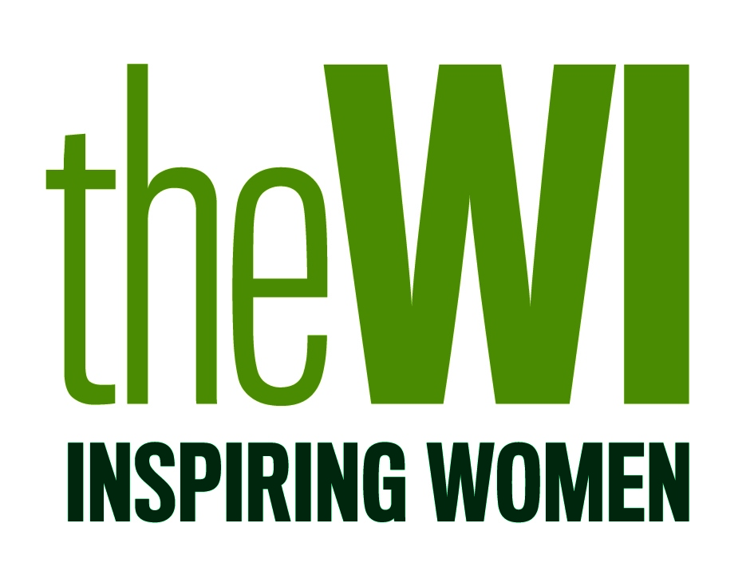

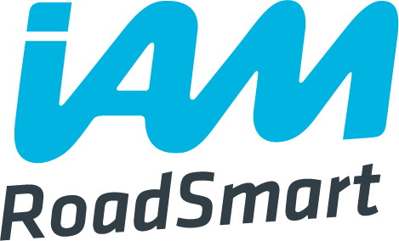
The WI and IAM RoadSmart join forces to develop women’s driving skills

Application Form

Please tick which Driving Day you would like to attend:

The British Motor Museum, Gaydon
Saturday 16 September 2017
Hayes International Motor Museum, Somerset
Saturday 23 September 2017

Surname (Ms/Mrs/Miss)
First Name
Address
Post Code
Telephone
Email
WI
Federation

Any dietary requirements?

Car Make and Registration

If you wish to take part in the practical driving activity, please tick to confirm that you have comprehensive
driving insurance.

I enclose my cheque for £55 (made payable to ‘NFWI’) to secure my place.

Signed

Date

