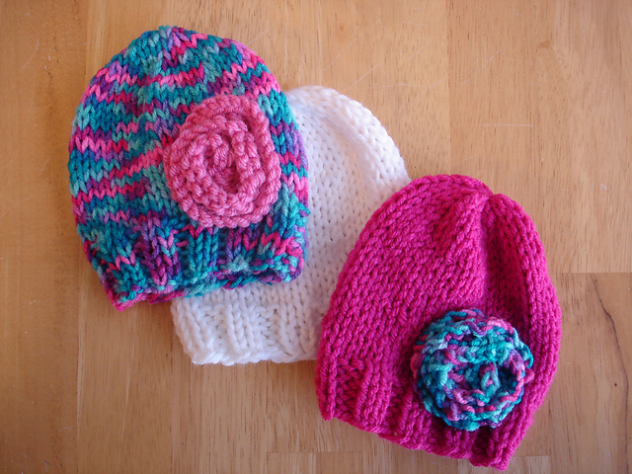

Lightning Fast NICU and Preemie Hats
By Jennifer Dickerson

These hats are knit with larger needles making them an extremely fast knitting project. If you plan to donate your hats, most hospitals require machine washable yarn so they can be washed and/or sterilized before being distributed to the babies.

Picture examples shown here are knit with worsted weight yarn, but feel free to experiment with other yarn weights or luxury yarns for gift giving.

This pattern includes two variations of the hat; one with a simple ribbed brim and one with a roll brim. Also included are instructions for a quick flower.

Materials:
- Worsted weight yarn in bright cheerful colors.
- US 10.5 (6.5mm) straight needles (hat is knit flat, then seamed)
- Tapestry Needle
Sizing:
- 11”-12” circumference
Gauge:
- 14 Stitches and 19 Rows = 4 inches
Abbreviations:
- CO - Cast On (I used the long tail cast on and left an extra long tail for seaming up later.
- BO - Bind off (knitwise)
- KFB - Knit front and back of stitch
- K2tog – Knit two stitches together

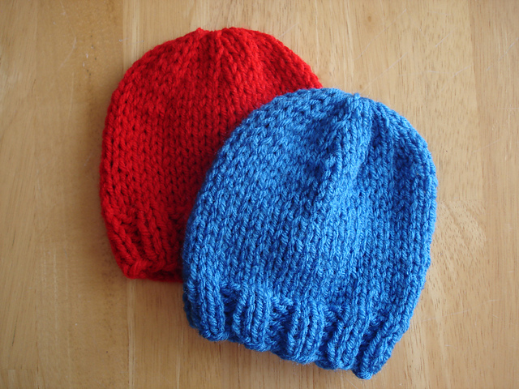

Ribbed Brim Hat:

CO 40 sts (leave an extra long tail for seaming up later)
Work 6 rows of K2, P2 ribbing
Switch to stockinette until hat measures 5” from CO edge.

Decrease:
Row 1: K2, K2tog across row
Row 2: Purl
Row 3: K1, K2tog across row
Row 4: Purl
Row 5: K2tog across row
Using tapestry needle, break yarn leaving a long tail. Thread through remaining stitches and pull tightly. Seam up the back and weave in ends.
- 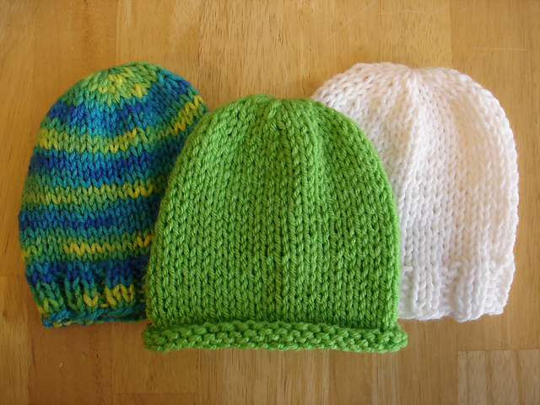
Instructions:

Roll Brim Hat:

CO 40 sts (leave an extra long tail for seaming up later)
Work in stockinette until hat measures 6” from CO edge.

Decrease:
Row 1: K2, K2tog across row
Row 2: Purl
Row 3: K1, K2tog across row
Row 4: Purl
Row 5: K2tog across row
Using tapestry needle, break yarn leaving a long tail. Thread through remaining stitches and pull tightly. Seam up the back and weave in ends.

