Woodseats Allotment Society
General Pest and Weed Control products
Are pest and weed control offerings are high quality products. The prices are very competitive and lower than garden centres, major DIY stores and eBay.
Doff - Slug Killer Blue Mini Pellets 1kg - £2.40
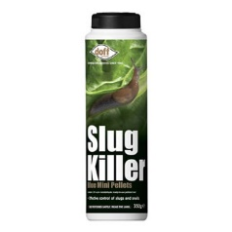
Fast and effective control of slugs and snails. Unique scatter shaker pack for even application of pellets. For application around all crops and ornamentals both outdoors and under glass. Before use, always follow the manufacturer’s instructions and keep out of the reach of children and pets.

Slug Killer Blue Rainproof Mini Pellets 250g - £2.30
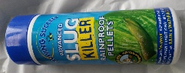
Fast and effective control of slugs and snails. More effective after rain than blue mini pellets. For application around all crops and ornamentals both outdoors and under glass. Before use, always follow the manufacturer’s instructions and keep out of the reach of children and pets.

Vitax - Yellow Sulphur Powder 225g - £1.00 (reduced price)
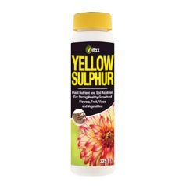
A dustable powder containing 97.5% w/w sulphur, Used to control powdery mildew on many fruit, flowers and vegetables. Helps to protect against storage rots of bulbs, corms and tubers. Before use, always follow the manufacturer’s instructions and keep out of the reach of children and pets.

Murphy - Derris Dust - £1.00 (reduced price)

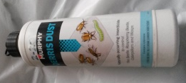
A naturally occurring insecticide for the control of flea beetle, raspberry beetle, caterpillars and wasps. Before use, always follow the manufacturer’s instructions and keep out of the reach of children and pets.

Jeyes - Fluid 300ml - £3.90
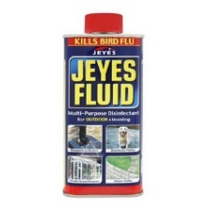
The original multi-purpose outdoor disinfectant. Clears, disinfects and deodorises outdoor living areas, gardens and animal housing.

Bio - Club Root Control - £0.95
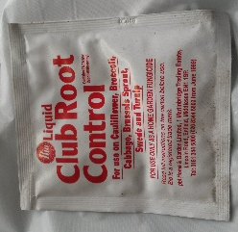
For use on cauliflower, broccoli, cabbage, Brussel sprouts, swede and turnip. Before use, always follow the manufacturer’s instructions and keep out of the reach of children and pets.

Bio - Dithane 945 (protective fungicide) - £1.00 (reduced price)
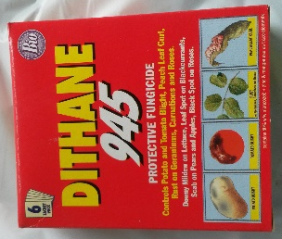
Fruit and Vegetable Disease Control, Potato Blight Scab, Roses, Corns, Squash, Cucumbers, Melons. Controls - Leafspots, Rust, Botrytis, Anthracnose, Early and Late Blights and Downy Mildew. Before use, always follow the manufacturer’s instructions and keep out of the reach of children and pets. 6 sachet pack

Bio - Chlorophos - £1.00 (reduced price)

For use on cauliflower, broccoli, cabbage and Brussel sprouts. Before use, always follow the manufacturer’s instructions and keep out of the reach of children and pets.

Murphy - Tumble Weed - £3.40
Strong, systemic concentrated weed killer for stubborn weeds. Kills annual and perennial weeds right down to the roots. Quickly breaks down on contact with soil to leave it ready for planting. Contains glyphosate. Coverage 500m². Before use, always follow the manufacturer’s instructions and keep out of the reach of children and pets.

Scotts - Path Clear (12gm) - £2.10
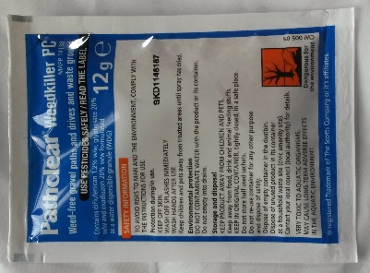
Kills weeds and prevents new ones. Creates invisible barrier that prevents new weeds for up to 3 months. Ideal for paths, drives and patios. No measuring, no mess. Treats 20m² per packet. Make up with 2¹/₂ litres of water.

Scotts - Weedol 2 (57gm) - £1.50
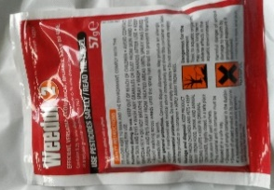
Fast acting weed killer, New plants can be safely planted once weed killer is dry. Rainproof in 10 minutes. Kills a wide range of annual and surface rotting weeds. Harmless to soil. Treats 30m² per packet. Make up with 3 litres of water.

Bio - Long Last - £1.00 (reduced price)

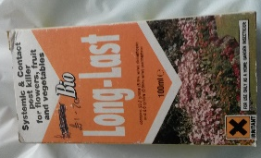
A systemic and contact pest killer for flower. Fruit and vegetables. Before use, always follow the manufacturer’s instructions and keep out of the reach of children and pets.

Murphy - Hormone Rooting Powder - £1.40

Promotes healthy rooting of many types of cuttings.

Ratak - Rat and Mouse Killer (2 sachets) - £1.50

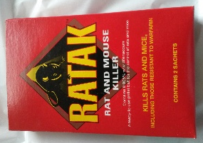
Kills rats and mice including those resistant to warfarin.

