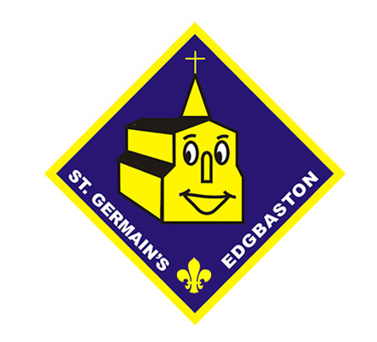 | 74th BIRMINGHAM SCOUTS GROUP  ST GERMAIN’S EDGBASTON  April – July Activity Calendar 2016

Date | Activity | Badge
14 April 16 | Game Night
21 April 16 | Tent Building | Camp + My Outdoor Challenge
28 April 16 | Build a fire | Camp + My Outdoor Challenge
5 May 16 | Knots | Camp + My Outdoor Challenge
12 May 16 | Talk about Nature Centre Trip | Explore
19 May 16 | Animal Activity | My Outdoor Challenge
26 May 16 | Pioneering Project | Camp
28 – 30 May | FAMILY CAMP
2 June 16 | HALF TERM
9 June 16 | Accident and Emergency | My Outdoor Challenge
16 June 16 | Natural Activity | My Outdoor Challenge
23 June 16 | Build a bug | My Outdoor Challenge
30 June | Bird Feeders | My Outdoor Challenge
7 July | Whose paw print? | My Outdoor Challenge
14 July | Water Fight

