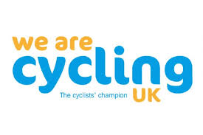
FANCY COMING
ON A RIDE?

Cyclists know that one of the best ways to see the scenery is from the saddle of a bike.
So, why not come and join us on a leisurely ride? Just 20 miles or so, out into the local countryside in the morning, and then back in time for Sunday lunch.
These free rides always start at 10AM on the first & third Sundays of the month, from April to September and are always led by experienced and helpful Club members.
So if you fancy a ride out with a friendly, regular group, come and join us.
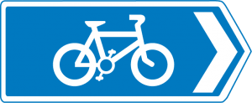
Just 20 miles or so, and always easy paced

Always led by friendly, helpful and experienced Club Members
10AM starts from the Water Tower Cafe on the Downs or the Fish Sculpture (on the Bristol/Bath Cycle Path near Morrisons)

Try cycling for pleasure with
Cycle Bristol CTC

 | DOWNS CAFE | FISHPONDS FISH
APRIL | 1st | 15th
MAY | 6th | 20th
JUNE | 3rd | 17th
JULY | 1st | 15th
AUGUST | 5th | 19th
SEPT | 2nd | 16th
For more information call Jane on 07816281672

