Tale of the Unexpected
In 1964 the Army in its wisdom, posted me to Fremington Camp with the objective of turning me into a DUKW driver. At this time, I was single, thin! and excited at the prospect.
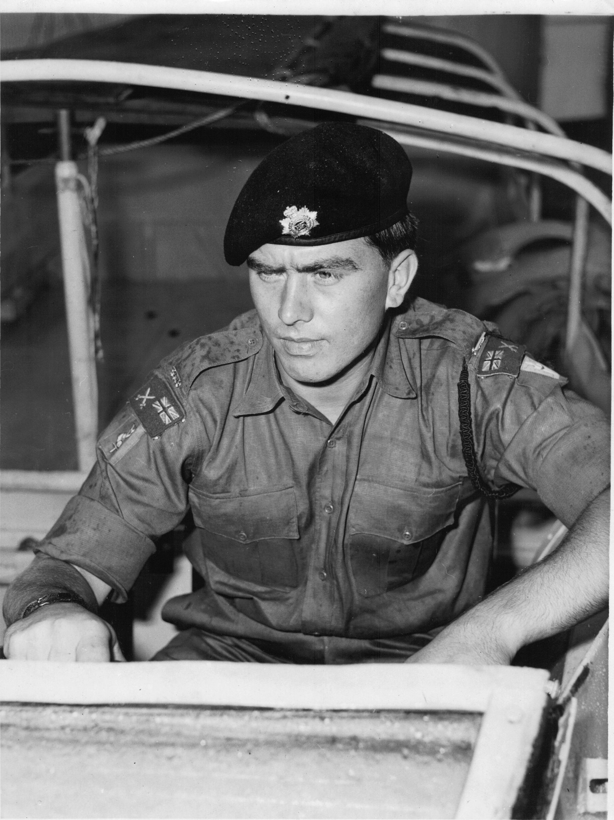

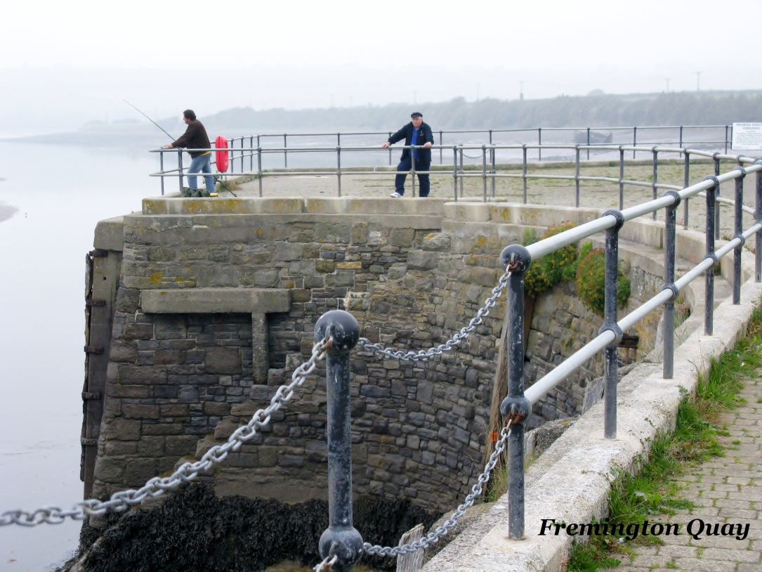
During the early years at the camp, I used to walk in my spare time, to Fremington Quay, taking with me my fishing tackle, which I slung over my shoulder. I spent hours on that quay, dangling a hook over the side, trying to land something bigger than a sardine! In 2010, whilst at the reunion, I made a point of returning to Fremington Quay to revive my old memories and to show my wife Susan, one of the many places that I have reminisced about.

Back home the reunion over. I delved once more into my hobby, that of researching into my ‘Family History’. Top of the list of my forebears to trace, was my mother’s father, namely one Horace Foster Setterfield and his father, whose Christian name at that time was unknown. After some involved ‘digging’ through various records, I eventually found him, in the 1901 census. He was aged 14 and a ‘Cook’ on the fishing smack ‘Sultan’, a sailing vessel out of Ramsgate, Kent. He was part of a four man crew and the Master was his father, Henry George Setterfield. The census had been written and signed by his father. The eerie part came, when I looked at where they were on this 31st March, 1901. They were tied up at Fremington Quay!!! They would have used the same steps and stood in the same place that I am standing some 99 years later.
Further research has revealed that they were most probably fishing the grounds between Lands End the Scilly Isles and up to the Old Head of Kinsale, Southern Ireland and across to St Anne’s Head, Pembrokeshire. One of the reasons for using Fremington Quay was the railway station, some 30 yards away. Freight wagons that had been packed with ice in Barnstaple, would convey the fish to the markets in London.
I think as coincidences go, this must rate pretty highly.

