Naoko Takata

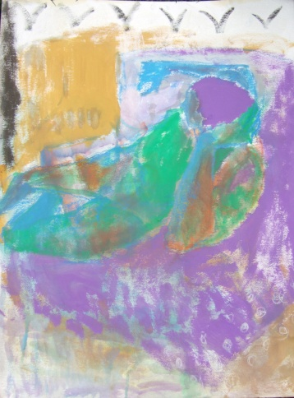
Naoko Takata is a Somerset based artist. She needed to look back when she arrived in England. And then her everyday life built up and became a pleasing event. Sitting, standing and resting pose were simple but it was harder to include the depth and texture that illustrated her feelings. Now there is a good harmony between human bodies and the back ground. This is as if she had blended into her new life. The colours made warm and cold sense of touch and invited our eyes to the body movement. The result is an equivocal image introducing Naoko’s world. Some ambiguous figures are reflected by the window or door; they show the possibility in and out. .

Megan Players

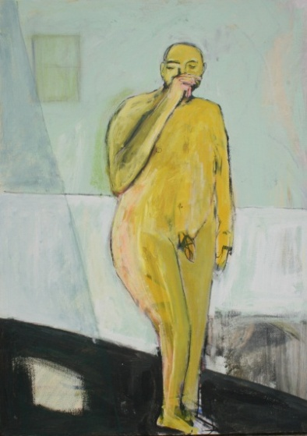
My work is about playing: being human. it's about the ins and outs of everyday life: brushing one's teeth and cooking the dinner. the ins and outs of existential confusion and irony: of feeling small in this big universe or trapped in some tiny space. it's about the energy between the model and myself: catching each other's eye as I follow the curve of their neck. it's about orange and blue & the way colours sing or sit awkwardly together.

i don't want to be fancy or record with photographic precision. i want to feel surprised by the marks my hand made when i wasn't looking. i want to feel the colour, the scratch, the flow like i am a stranger and this is a new land.

Penelope Harrington

Penelope Harrington made an unexpected discovery as if stepping onto a magic carpet, which has become a magical mystery tour of allowing an opening of passion and feeling as experienced when holding the charcoal or playing with colour onto the space as defined by the paper whilst looking at the model and empathizing with the visual impact of this. Feeling the open space within, joining in a celebration and dynamic play of entering into and joining deep places and spaces within as inspired by the different moods as expressed in the differing poses, as experienced in terms of both the visual image, and of feelings or imaginings that this transports us to.
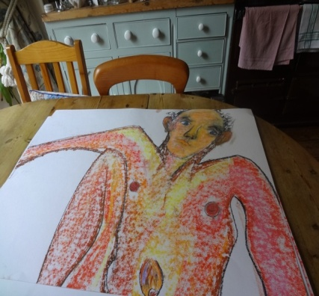
The experience and freedom to explore and define to follow the curve of the human form, to enjoy and be moved by the simple beauty and truth of this, to both capture and also allow this to evolve into more etheric dimensions of spirit and inspirational trance has been like learning a sacred dance, with Life, within Life and has been Life giving.
The sense of depth and of infinite potential in the moment has been profound and meditative as I and Thou become One. Artist as observer, Model, charcoal, pastels and paint all combine to become an Alchemy of Passionate Possibilities and Play.

Sally Livsey

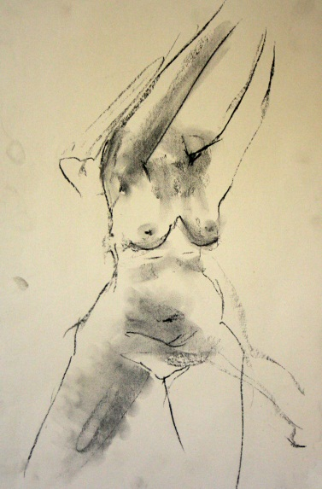
Sally Livsey’s current work with life models explores the elusive and transitory experience we all share of being present to ourselves. Using a variety of line and smudging with charcoal, pencil and inks she invites the viewer to contemplate beyond the boundaries of physicality.
Previously using paint, colour and texture to address issues of boundaries within relationships, her recent charcoal and ink work has a lighter touch.

“Where do I end and you begin?” This is a question that returns in many different forms in her work. Currently she is reintroducing paint and colour to respond in an abstract manner to the presence of the person who models. Her work is informed by her contemplative practice and playful approach.

