

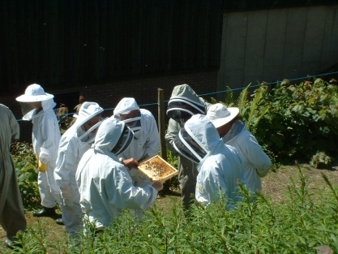

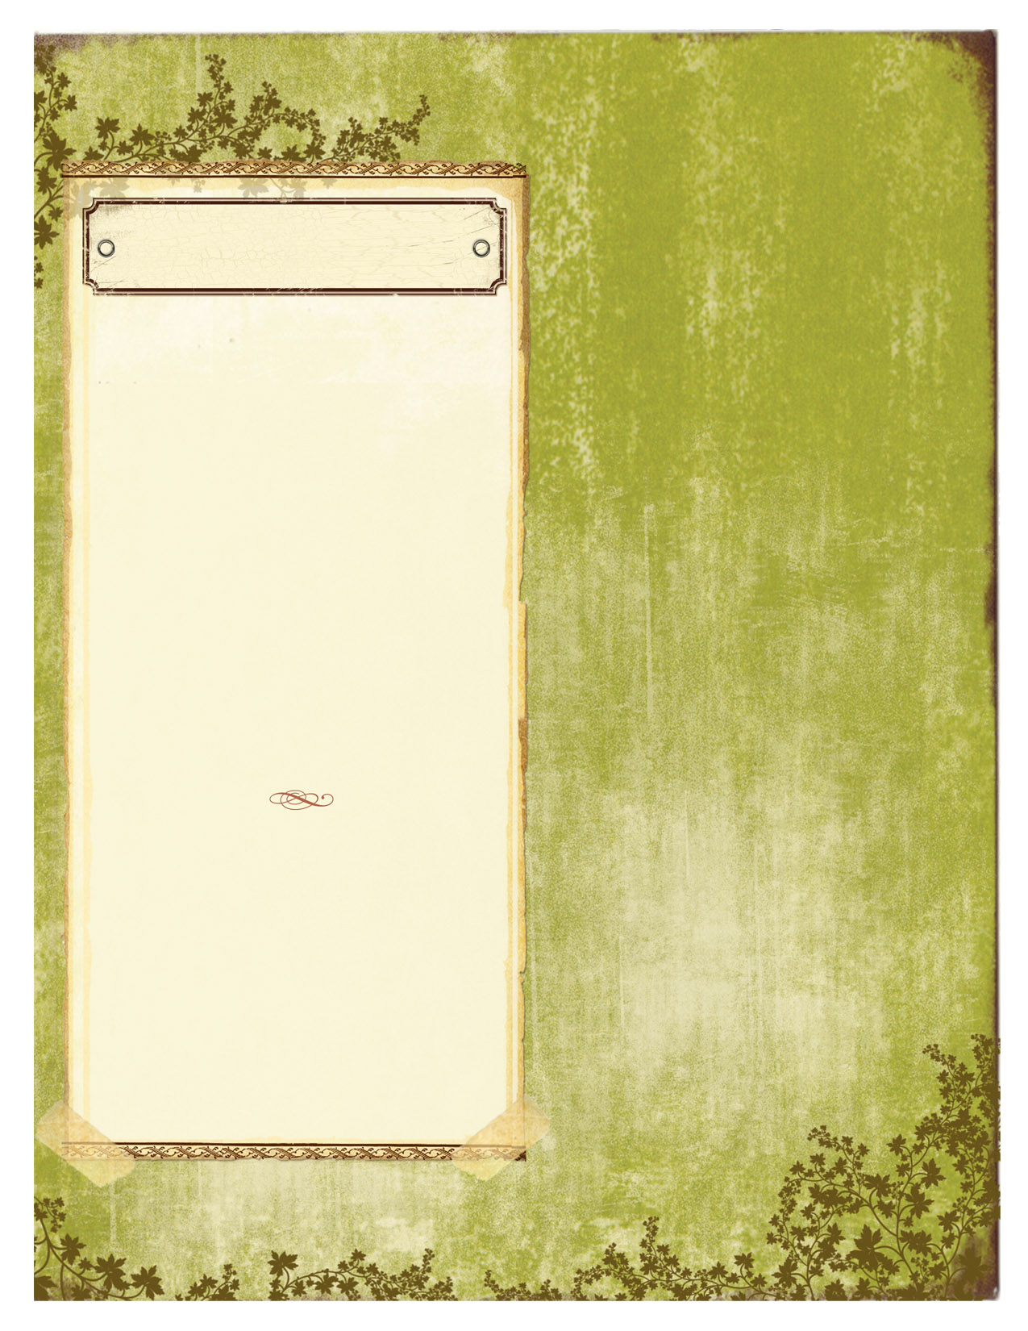

**LOANS FROM THE BRANCH**

From time to time we receive request to borrow items of equipment. Unfortuately the only item for loan is the honey extractor since all the other equipment is needed at the apiary for branch meeting and colonies. If you wish to borrow the honey extractor you must sign it out using the book in the portacabin. Please be aware that the period of loan is very limited because of the high demand this time of year.

**Bee Markings Colours**

Years ending 0 or 5 Blue

6 or 1 White

7 or 2 Yellow

8 or 3 Red

9 or 4 Green

ChairmanMr Bill Finnemore Tel 404184

Hon Sec Mrs J French Tel 338279

E-mail [jeanfrench1957@yohoo.co.uk](mailto:jeanfrench1957@yohoo.co.uk)

Hon Treasurer Bernie Talling Tel 709470

E-mail [Bernie868@hotmail.com](mailto:Bernie868@hotmail.com)

Editor F Poole e-mail [fred.poole@tesco.net](mailto:fred.poole@tesco.net)

**Branch Library**

The branch library is currently in the portacabin at the Lee Mill apiary. It has a wide range of material, old and new, available for loan. As well as books there is useful materiel like pamphlets, construction charts and DVD`s. The loan period is restricted to a maxium of three weeks so that popular items are able to circulate.

**Branch Honey**

Thanks to Mike and Bridget Hogan for extracting the branch honey again. They extracted approx; 80 lbs for which we have several buyers.

**Branch Meeting**

John O’Connell came up trumps again and offered Mike space in the factory to give the last beginners apiary program in comfort, and also enjoyed the film.

BEE BRIEF

PLYMOUTH BRANCH NEWSLETTER

AUGUST 2011

VOL. 1 ISSUE 1

Bees for Sale

Five frame nuclei £85.00

Full size colonies £100.00

Contact Mike Hogan

Plymouth 339921.

**QUEEN BEES FOR SALE**

**A batch of New Zealand queens landed at Heathrow a few weeks ago and have been put to work in local apiaries where young queens are being raised from their eggs. Any Plymouth branch members wishing to buy one of these mated queens or a nucleus of bees with a mated F1 NZ cross can contact our chairman Bill Finnemore on Plymouth 404184 for further details.**

Elburton Village Hall

Thursday 13th October 7.30 pm Speaker TBC.

Thursday 10th November. 7.30 pm AGM.

Sunday 11th December - Christmas Lunch.

Thursday 12th January - 7.30 pm.- Honey Show.

Thursday 9th February – 7.30 pm –Speaker TBC.

**Apiary Meetings 2011**

7th August – Improvers Meeting.

14th August – all members.

21st August - all members invited to Bill Finnemore’s garage honey extraction.

28th August – all members.

11th September – all members.

18th September – all members.

25th September – all members.

**Local Bee Suppliers**

**National Bee Supplies Tel: 0183754084**

**Beekeepers Supplies 01752 845783**

**John Harler Tel: 01364642517**

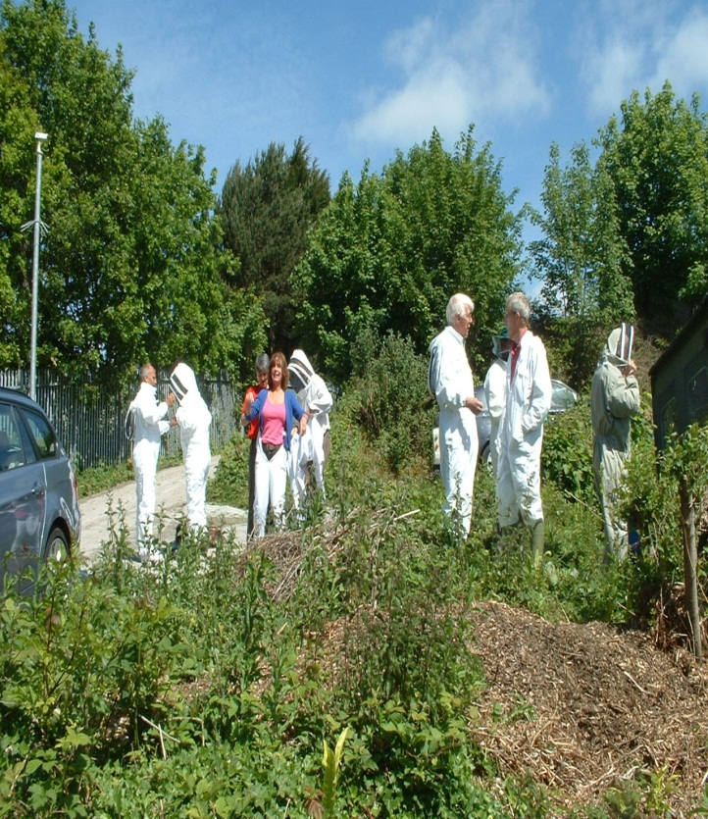

Winter Meetings

Continue newsletter text here. Continue newsletter text here. Continue newsletter text here. Continue newsletter text here. Continue newsletter text here. Continue newsletter text here. Continue newsletter text here. Continue newsletter text here. Continue newsletter text here. Continue newsletter text here. Continue newsletter text here. Continue newsletter text here. Continue newsletter text here. Continue newsletter text here. Continue newsletter text here. Continue newsletter text here. Continue newsletter text here. Continue newsletter text here Continue newsletter text here

Continue newsletter text here. Continue newsletter text here. Continue newsletter text here. Continue newsletter text here. Continue newsletter text here. Continue newsletter text here. Continue newsletter text here. Continue newsletter text here. Continue newsletter text here.

Continue newsletter text here. Continue newsletter text here. Continue newsletter text here. Continue newsletter text here. Continue newsletter text here. Continue newsletter text here. Continue newsletter text here. Continue newsletter text here. Continue newsletter text here. Continue newsletter text here. Continue newsletter text here. Continue newsletter text here.

Continue newsletter text here. Continue newsletter text here. Continue newsletter text here. Continue newsletter text here. Continue newsletter text here. Continue newsletter text here.

Continue newsletter text here. Continue newsletter text here. Continue newsletter text here. Continue newsletter text here. Continue newsletter text here. Continue newsletter text here. Continue newsletter text here. Continue newsletter text here.

Continue newsletter text here. Continue newsletter text here. Continue newsletter text here. Continue newsletter text here. Continue newsletter text here. Continue newsletter text here. Continue newsletter text here. Continue newsletter text here. Continue newsletter text here.