Welcome
We are now one year old
What is Scouting?
So impressed was he with the conduct of boys in the Makeking Cadet Corps during the Siege of Mafeking (Oct 1899-May 1900) during the Second Boer War, that Lieutenant General Lord Robert Baden-Powell began what is now The World Scout Movement in the United Kingdom in 1907 with an experimental camp on Brownsea Island, Dorset. Scouting has grown, and today, there are well over 28 million Members worldwide. The Aim of Scouting is to promote the development of young people in achieving their full physical, intellectual, social and spiritual potential – as individuals, as citizens, and as members of their local, national and international communities.
24th (St Luke’s) Bournemouth Scout Group Ethos
The 24th’s ethos is to maintain the aim of Scouting and those values inherent in the Scout Promise and Law:
The Scout Promise is:
On My Honour, I promise that I will do my best
To do my duty to God and to the Queen
To help other people
And to keep the Scout Law
The Scout Law is:
A Scout is to be trusted.
A Scout is loyal.
A Scout is friendly and considerate.
A Scout belongs to the worldwide family of Scouts.
A Scout has courage in all difficulties.
A Scout makes good use of time and is careful of possessions and property.
A Scout has self-respect and respect for others.

Section Leaders at the 24th will achieve this through engendering the characteristics of duty, honour, and loyalty, and promote in the individual courage (both moral and physical), humour in the face of adversity, selflessness and determination. We will achieve this by providing exciting and adventurous activities with progressive training, and concentrating on providing those activities in an outdoor environment where possible and practical.

Mission Statement
To develop our young people morally, socially, culturally and spiritually through an inspiring and challenging programme in order to equip them to be self-reliant, well-rounded and confident individuals well-suited to facing the challenges and opportunities of adult life.

Commitment
Personal Standards. The Scout Law and Promise provide the backbone of that which Scouting stands for, and where adhered to, will develop the attributes and characteristics that we seek in our young people and in society. Inherent in this is a standard of behaviour that the Group Scout Leader, Section Leaders and Executive Committee will expect from our in all Sections. We also expect the parents of our Scouts to support the Group in this.

Anti-Bullying Policy
“A Scout has self-respect and respect for others”

This Scout Law precludes bullying of any kind, and the 24th (St Luke’s) Bournemouth Scout Group operates a zero-tolerance policy on bullying of any kind including, but not limited to: name-calling, physical violence, threats of physical violence, intimidation, isolation, malicious gossiping (either verbally, or by text or email), abuse of others’ property (including stealing, hiding or damaging property). Scouts in all sections are encouraged to report any instances to a Leader, or another Scout in a position of responsibility (for instance, a Sixer in the Cub Scout Pack, or Patrol Leader in the Scout Troop).

Code of Conduct.
In order to get the most of Section meetings so that everyone has as much enjoyment and can learn as much as possible, the Group has a Code of Conduct which we expect all Scouts to adhere to. Expected behaviour is based upon everyone practicing the Scout Law and Promise – and obeying our anti-bullying policy. Additionally, it is important to note that we respect the Union Flag, and the formality of Flag-Break and Flag-Down. Well-placed pride in what we do and who we are is also important and this is reflected in our punctuality, and our standard of turn-out for meetings and Church parades (details will be given by Section Leaders on clothes to be taken and changed into that may be more suitable for activities undertaken during section meetings etc).

Parental Support
The support of the parents of our young people is very important in assisting us in achieving the goals of our ethos and mission statement. Scouting is not merely a different form of youth club – it is a disciplined way of combining fun, adventure, excitement and learning in order to develop our people into well-rounded members of society. We expect high standards, and your support in the maintenance of these standards is vital. However, this is the minimum way in which we would elicit your support. The Group will benefit incredibly through what other support you feel able to offer, examples of which might include:
Helping out at section meetings.

- Using your specific skills to support badge work (e.g. First Aider, Cook, Artist).

- Support external activities: Widegames, camps, hiking activities etc

- Supporting the Executive Committee in fund-raising activities

Please note. Direct support to the Group in the form of attendance at meetings, camps or transporting Scouts to and/or from activities may require a CRB check. The Group Scout Leader or your Section Leader will be able to advise and where one is required, it will be funded by the Scout Association.
Our Group
The 24th (St. Luke’s) Bournemouth Scout Group meet on a Tuesday evening, during term time, at:

St. Luke’s Church Hall, St. Luke’s Road, Winton, Bournemouth BH3 7LY

Beaver Colony (5.5 to 8 yrs) - 4.30pm to 5.30pm
Cub Pack (8 to 10.5 yrs) - 5.30pm to 7pm
Scout Troop (10 to 14 yrs) - 7pm to 9pm

Our Leaders:

Group Scout Leader: Jon-Paul Hughes 07779287894
Scout Leader: Jon-Paul Hughes 07779287894
Cub Leader (Akela): Julia Wilson 07949003161
Assistant Cub Leaders: Sam
Angela Parke

Beaver Leader: Doug Smith 07809756428
Beaver Parent Helpers: Hayley
Nikki
Linnie

Our Website: www.stlukesscouts.org.uk

Badges
Beavers, Cubs and Scouts can gain a wide range of badges and awards.

Membership Award
The Membership Award is the first badge you work towards. It allows you to find out what Scouting is all about.


Group Name Tape
The Group Name Tape tells people exactly what group you come from.

District & County Badge
Each County has its own badge. The County is then split into Districts. These badges serve to pinpoint your location in the UK. Our badge is for Bournemouth Avon District.

Challenge Badges
The Challenge Badges complement the Balanced Programme. These have been developed to extend skills and experience. There are different challenges for each section:

The Promise Challenge (All Sections)
The Fitness Challenge (All Sections)
The Creative Challenge (All Sections)
The Global Challenge (All Sections)
The Outdoor Challenge (All Sections)
The Friendship Challenge (Beavers)
The Community Challenge (Cubs & Scouts)
The Outdoor Plus Challenge (Cubs & Scouts)
The Adventure Challenge (Scouts)
The Expedition Challenge (Scouts)

Activity Badges

Activity Badges are another way of recognising the achievements of those who have learnt a new skill, or who have taken part in an activity for a certain period of time.
They should raise interest and extend a young person's skills throughout their time in Scouting.
There are 12 Activity badges available for Beavers, 35 for Cubs and 70 for Scouts.

There are also six Staged Activity badges for each section.


Chief Scout’s Award

This badge is the highest award available within each Scout Section.
It is gained by completing the Challenges relevant to each section.

Beaver Scouts gain the Bronze Award
Cub Scouts gain the Silver Award
Scouts gain the Gold Award





Uniform
Scouting is a uniformed organisation and the uniform tells everyone that you are a Scout. After your son/daughter has been coming along for 4 or 5 weeks we ask that they get their own uniform, so that they can be invested into Scouts. Uniforms can be purchased from the new Scout shop in Butchers Coppice, or ordered online at www.scoutshops.com, or can be bought from Rickards in Winton, Bournemouth.

Full Uniform consists of:

Beaver Scouts: Turquoise sweatshirt, smart navy trousers, black shoes, group neckerchief and woggle*.
Cub Scouts: Dark green sweatshirt, smart navy trousers, black shoes, group neckerchief and woggle*.
Scouts: Teal green shirt, smart navy trousers, black shoes, group neckerchief and woggle*.

*(The neckerchief and woggle will be provided by us at your son/daughter’s investiture)

Dress Down Uniform consists of:

i-Scout T-Shirt#, navy activity/combat trousers or shorts, activity appropriate footwear, group neckerchief and woggle.

# i-Scout Youth T-Shirts are available in 4 colours (Tangerine, Purple, Kiwi and Black). We shall advise you which colour is required for your son/daughter upon joining.

We shall let your son/daughter know what uniform is required from week to week depending upon each section’s activities.

It is expected that members of the 24th (St.Luke’s) Bournemouth Scout Group always wear their uniform with pride and respect. Regular uniform inspections will take place and will include general turnout i.e clean hands, brushed hair etc...
From time to time each section will undertake outdoor activities and weekend camps/sleep-overs. For any such occasion you will be given a more detailed kit list at the time, however, some of the items that may be required are:

Large rucksack/Kit bag
Small rucksack/day-sack
Sleeping bag and blanket
Insulated sleeping mat
Walking Boots
Wellington Boots
Torch or Headlight (with spare batteries)
Waterproof coat and over trousers
Woolly hat, scarf and gloves
Personal wash kit including towel
Cutlery set
Plate, bowl and mug (unbreakable)
Warm, old and comfortable clothing
More detailed list attached :- Suggested Kit list for Beaver Camp.xls
Where to put your badges
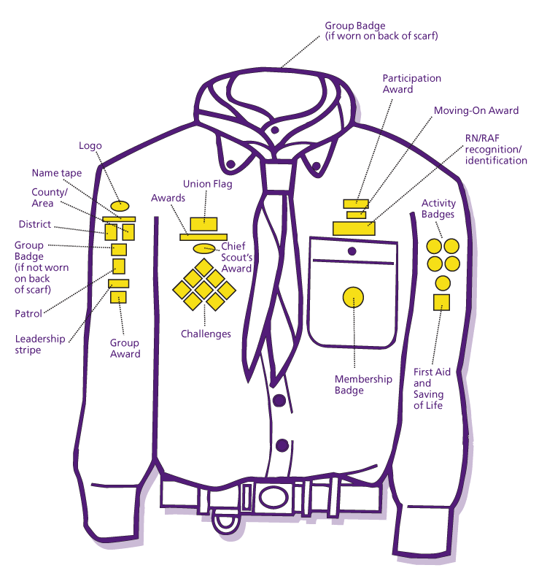

Money Matters
Subscription (Subs)
All members are required to pay £9.00 a month (£36 per term for subscription). Our preferred method of payment is by Standing Order 1st of the month, although you may pay by cheque or in cash. Subs are not optional and all payments are due on the first day of each month.
(In some circumstances you may arrange to pay subs on a weekly basis).
We shall discuss your individual arrangements when you son/daughter joins and issue any necessary forms or information required at that time i.e Standing order form.

Should you ever experience difficulties with paying subs please come and speak (in confidence) with one of the leaders as soon as possible.

Subscriptions go towards paying for a number of things including:
Annual fees to District, County and National bodies for insurance and leader training.
Running costs. Badges. Equipment needed for Troop meetings.

Other Costs
Each section will undertake a number of other activities, sleep-overs, camps etc.. that will incur additional cost. You will be given plenty of notice for such events and details of additional payments required.
These will all be optional events, although we would like to see as many as possible attend, so we will strive to provide these at the best value for money we can. Again, individual arrangements can be discussed at the time.

Fundraising
As a non-profit making, charitable organisation we exist entirely on our member’s subscription fees and monies raised through fundraising. As a Group we shall take part in fundraising activities throughout the year such as: sponsored events, bag packing at local supermarkets, fetes, fun days etc...

We are always looking for good ways to raise money and we welcome your ideas, suggestions and help. If any of you work for, or know of, companies/groups that run fundraising events please remember to volunteer our Group as a worthy cause.
All donations are gratefully received and put to good use.

Gift Aid
The Gift Aid Scheme enables us to claim an extra 28p from H M Revenue & Customs (Charities) for each £1.00 subscriptions we receive. It is vital that you complete a Gift Aid Declaration Form in order for us to claim this. A form will be provided upon joining.

