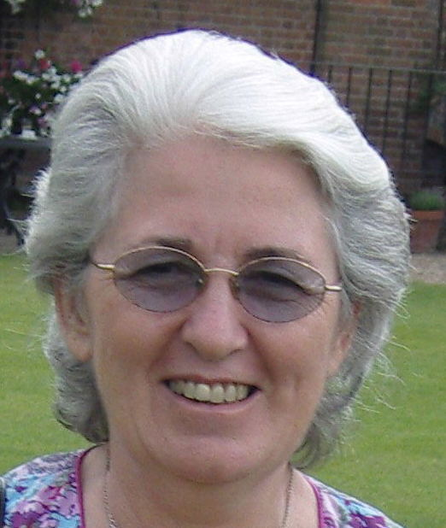
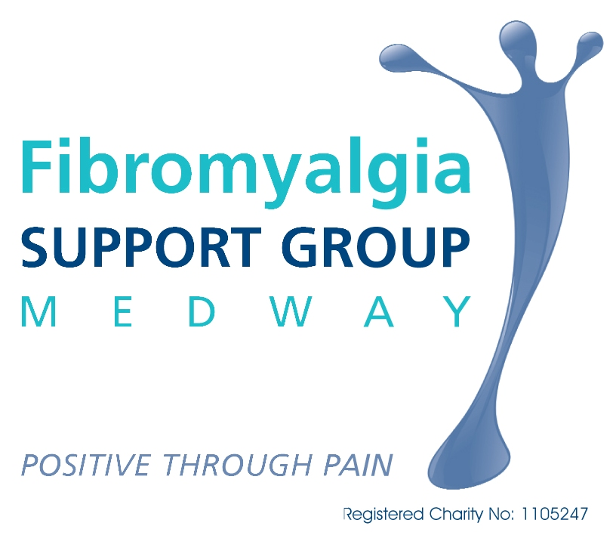
NEWSLETTER

16 Barberry Avenue, Chatham Kent ME5 9TE
Telephone: 01634 865925 E-mail: fibromedway@yahoo.co.uk
Website: www.fibrosupportmedway.btck.co.uk

February 2012 ISSUE 57

Next Meeting: Thursday 22nd March, at St Stephen’s Church Hall, Maidstone Road,

Chatham ME4 6JE. 1.00pm to 3.00pm

********************************************

MEETING DATES FOR 2012

Thursday 22nd March – Lesley Wright, Pain Specialist Nurse, Eastern & Coastal Kent PCT
Thursday 24th May - Dr Nick Read, Medical Adviser to the Gut Trust speaking about Irritable Bowel Syndrome
Thursday 26th July – Question & Answer Session
Thursday 27th September – 10th Birthday
Thursday 22nd November

All at the above address and time.

JANUARY MEETING

Another well-attended meeting. We had our AGM first. This was followed by an excellent talk by Dr Julian Spinks, a local GP, who spoke about the allergies and sensitivities associated with Fibromyalgia. Julian also updated us on the changes in the NHS. His talk was very interesting and informative.

More details will be in the next newsletter.

IMPORTANT NEWS – see page 12.
Also see Page 9 re Medway Council’s Benefits Service

RENEWAL OF MEMBERSHIP
Don’t forget to renew your membership if you haven’t already done so.

AWARENESS DAY
Saturday 12th May
Don’t forget to put this date in your diaries and bring along your friends, relatives, and anyone interested in finding out more about Fibromyalgia – even your GP, if interested. As for last year’s event, there will be tea/coffee, biscuits, and cakes all available free. This year the event will be held at Thomas Aveling School, Warren Wood, Rochester. More details to follow.

TELEPHONE ENQUIRIES

Please note that telephone calls to the group should be made on weekdays between 10am and 4pm. For those who are at work and unable to make telephone calls during those times, it would be appreciated if calls could be made during weekday evenings before 7.00pm.

SUPPORTERS’ HELPLINE

Ron Robson is available on 01634 865925 to take calls from supporters of those with Fibromyalgia, who just need to talk about their concerns.
FUNDING UPDATE

The balance in our Bank Account at the end of November 2011, was £3392.79.

Expenditure since then has been, £18.97 for Stationery £57 for Sundries, £260.31 for sales, and £247.42 for Photocopying.

This leaves a total of £2809.09

At the January meeting and during the past two months, we raised, £44 on the raffle, £18 for pens, £13.61 for refreshments, £664 in donations, £258.74 for sale of 024 Fibromyalgia, £3 for plugmates, £3 for DVDs, £4 for Notepads, and £150 from UK Fibromyalgia.

This gives a total of £1158.35 to be deposited in our bank account.

This gives us total of funds of £3967.44.

DONATIONS

I would like to acknowledge all donations sent in during the last two months. All donations help ensure the service remains at the present level. I am not able to respond to each one personally but please accept our thanks to you all. Thanks also for the lovely letters I receive. They are much appreciated

CHRISTMAS THANKS

Ron and I would like to thank all those who very kindly sent us Christmas cards and good wishes. It is very much appreciated.

FUNDING SUCCESS

We have, once again, been granted funding of £150 by UKFibromyalgia, for photocopying our helpful and informative articles for use at our Awareness Day in May.
Our thanks go to Martin Westby for allowing us this Grant from UKFibromyalgia (http://www.ukfibromyalgia.com). The Grant will be received at the beginning of April in time for the event.

PAINTRACKING
Your Personal Guide to Living Well with Chronic Pain By
Deborah Barrett, PhD, MSW

Just a reminder that the book I reviewed in the last newsletter, Paintracking, is available for pre-order at Amazon (www.amazon.co.uk) and will be available from 15th February 2012. This book is a must-have for anyone with Fibromyalgia. The articles that Deborah has written in the past have been very popular with members.

LIVING WITH CHRONIC PAIN CD

The Living with Chronic Pain CD that we have sold a large number of during the last eight years, is now available to download (free) or listen to (free) online at www.paincd.org.uk I do now have some for sale for £3 each for those who wish to have one.

024 PRICE CHANGE

Due to the exchange rate and import duty, if you are able to pick one up at meetings or collect one, the cost will be £10 each, but with postage and packing it will be £12 each.
Please make cheques payable to Fibromyalgia Support Group (Medway)

NORTH KENT GROUP
Contact: Philomena (Phyl): 0844 887 2348
or e-mail: fibromyalgia.nkent@yahoo.co.uk

MAIDSTONE GROUP MEETINGS
Contact: Heather Hammond: 0844 887 2442
or heather.hammond@mypostoffice.co.uk

SITTINGBOURNE & SHEPPEY SUPPORT GROUP MEETINGS
Contact Jean Spain: 01795 471324
Email: sandsfibrosupport@googlemail.com
VICIOUS CYCLE OF FIBROMYALGIA AND EMOTIONAL IMPACT

What to Do - You May have Problems to Face

- If you had been a healthy, active person and develop Fibromyalgia, the symptoms can create havoc in your life.
- Your inability to engage in activities you once enjoyed can cause you to become frustrated, angry, worried, or depressed.
- Your inability to meet the needs of your children, spouse, job, or community may contribute to a sense of inadequacy and worthlessness.
- Your friends may start to distance themselves.
- You may lose your job or marriage, causing serious financial distress and emotional pain.

These are all normal reactions to the losses you suffer when fibromyalgia strikes. You are not alone, however. Many people with other illnesses such as rheumatoid arthritis, heart disease, cancer, diabetes or other chronic illnesses have the same reactions.

Unfortunately, because fibro patients have no obvious physical or lab abnormalities, many have been told by their friends, family, or even their doctors that there is nothing wrong with them and their symptoms are all in their heads. “Just get the stress out of your life,” they say, “and you will be fine.” These people are wrong. Fibromyalgia is a real illness and its psychological impact should not be dismissed.

Fibromyalgia can affect your emotions

- Research has shown that up to 30% of fibromyalgia patients can experience psychological distress, including anxiety and/or depression.
- Researchers believe that some of the emotional reactions could be due to the way Fibromyalgia affects neurotransmitters and other regulatory systems in our bodies.
- Disturbances in hormones can lead to low blood sugar or thyroid hormone which can also produce depressive symptoms.
- Adrenal disturbances can lead to feelings of panic and anxiety.
- Immune system problems can cause people to feel fatigued or depressed.
- Just the fact that you cannot get a good night’s sleep is enough to make anyone irritable, anxious or depressed.

Studies have shown that when people were deprived of just a few nights’ sleep, they developed many of the same symptoms Fibromyalgia patients have, including emotional distress and problems with thinking, memory, and judgment. As any mother knows, children who are tired become irritable and tearful – why would adults be any different?

Researchers have found a problem in the stress response system in Fibromyalgia patients. This system is composed of the adrenals, hypothalamus, pituitary and thyroid glands. Due to a breakdown in regulation in this system, people with Fibromyalgia have trouble processing and handling stress – the stress response system may be unable to respond appropriately to even minor stressors. Not only is the disease causing enormous stress in your life, but it’s keeping you from handling it properly. The stress response system is in overload!

- It has been clearly shown that stress aggravates Fibromyalgia.
- Reducing stress and its impact may be easier said than done, however.
- All people (but especially Fibromyalgia patients) have stress in their lives which may be unavoidable.
- Counselling and/or stress management can help you cope with Fibromyalgia symptoms and improve your overall stress reactions.
- But while counsellors trained in treating Fibromyalgia patients can be very helpful, it requires work on your part as well.
- Making changes in yourself may not be easy, and it is natural to resist it.
- Some people are looking for a magic pill to take their problems away. It is very important to understand that there is no magic pill in Fibromyalgia.

Research shows that a combined multidisciplinary treatment approach is the most effective way to achieve symptom relief. Although it may not be a cure, many patients find that making appropriate changes in their lives can reduce their symptoms, in some cases by as much as 90%!

Fibromyalgia Not Only Affects You; It Affects Those Around You

Family Members - how are your family members handling your illness?

- They may have numerous feelings regarding the changes they see in you and may not be expressing their feelings for fear of causing you more worry, or they may not know what to say to you or how to express their thoughts.
- It is very difficult for others to understand how much pain you are in because fibromyalgia is an invisible illness.
- You look great, right? This can set up a vicious cycle in which you and your family members can become distrustful, disconnected, or estranged from each other.
- You may find yourself leaning on your family members or friends for emotional support. If you are asking too much of them, they could become resentful or they might feel inadequate to provide you with the aid that you need.

Wife – Husband – Partner Relationship

Ask yourself if you are requiring too much of your spouse or your friends. If you are, then it would be helpful to contact a professional you could speak to instead.
If you have a spouse or significant other, they may be worried about numerous things, such as: how long will the illness last, will your symptoms become worse over time, will your social life suffer, or how will they manage to take up the slack for household chores due to your disability?

If you cannot work due to your disability, they may be worried about financial responsibilities. They may become frustrated if you do not improve, or they could be angry.

Many spouses or significant others keep their feelings inside for fear of causing you more worry; some resort to anger and refuse to believe that you are really sick, still expecting you to handle all the household tasks you used to be able to accomplish prior to developing Fibromyalgia.

Intimate relations may become a thing of the past. Many Fibromyalgia patients are too tired or in too much pain to enjoy sexual relations. Side effects of the medications may also lead to a reduced sexual desire or problems with achieving orgasm. Partners may be afraid to initiate intimate relations for fear of causing you more pain. This can lead to frustration, anger or a feeling of loneliness within relationships. Talking about this problem can be very helpful; it can alleviate fears, worries or frustration. You may have to make more of an effort to include physical intimacy in your lives; making those times special by planning an evening out together at a romantic restaurant, lighting candles in your bedroom, or simply by setting aside time to be together can improve your intimate life considerably. If your partner is willing, they might perform a massage with some fragrant oils to help set the mood. Be creative. Just because you have Fibromyalgia does not mean that you can not have a satisfying sexual life with someone you love.

Couples counselling can be helpful if you are having difficulties addressing these issues by yourselves.

Some Fibromyalgia patients have reported that they have lost not only their health, but their partners or spouses due to the illness. This does not have to happen if steps are taken to communicate feelings to each other. If you find you have a difficult time talking about issues, a trained counsellor can aid you in sorting out any communication problems you have.

Friends

You may find that due to the limitations caused by fatigue or pain you have stopped socializing with friends. Maybe you can not walk with the group that you used to walk with, or go meet your friends at the local exercise gym. You may be too tired to attend church on Sunday mornings and too tired in the evening to socialise in groups that you once enjoyed. Maybe your friends do not call you anymore because you are unable to keep up with the activities you enjoyed with them in the past, before you developed Fibromyalgia. For people who have had symptoms for many years, they may have already learned how to pace themselves.

Many people find support groups valuable not only for information, but for finding others who you can share and exchange feelings and problems with. You may make a friend at your local support group who you can commiserate with or a new group of friends who you can exercise with.

Reaching out to make new friends who understand your limitations can reduce feelings of isolation and loneliness. Having a phone buddy, may help. Someone who you can call on the phone to share feelings with or just to chat about life could provide some support and connection.

Illness affects children, too

Often, people believe children do not need to know about problems in families. They think children are too young to understand or do not want to tell them for fear of causing them unnecessary worry. Children and adolescents do need to be educated about your Fibromyalgia. If they are not told, they may worry more. Sometimes children believe they have caused the illness by some act they did that we may not even be aware of. Their imaginations are very active. If we do not ask them how they are feeling or thinking they may not tell us. Children are often concerned that an illness may cause death to a parent. Letting them know how Fibromyalgia affects you at a level they can understand can alleviate many of their fears and concerns.

It is also important to find special time to spend with your children. Your fatigue and pain may keep you from being able to enjoy physical activities together, but there are many other fun things to do with children that do not require much exertion on your part.

Most young children and even adolescents love to play games, such as checkers, monopoly or snakes and ladders. This is also an activity the whole family can enjoy.
Reading a book to children before bedtime does not require a lot of exertion on your part and goes a long way to improving your relationship. Watching a movie together may be nice to do. Activities in which you interact with your children on a more personal level will bring you closer together.

It is extremely important that you do not lean on your children as emotional crutches. This can lead to problems for them in the future. Although it is appropriate to ask them to help you with physical activities you cannot perform, do not overdo it or ask for more than they can handle.

Be mindful of their age and capabilities. A five year old can perform tasks such as emptying the dishwasher, setting the table, or emptying small trash cans. Older children can handle more. Younger ones can pick up their own toys.

Don’t be afraid to seek help

Fibromyalgia patients are often reluctant to seek counselling to help them deal with the emotional impact of their illness. Many are sick and tired of being told that it’s all in their head, and agreeing to see a counsellor feels like an admission that this is true. On the other hand, they may have some fear that their symptoms are really psychological. Or they may be afraid that the counsellor will blame them for their symptoms – and, unfortunately, this does occasionally happen.

There are some counsellors out there who persist in the mistaken believe that Fibromyalgia is a purely emotional illness. That is why it is important to seek help from a knowledgeable therapist who has experience dealing with the problems of Fibromyalgia sufferers.
Counselling/psychological/taming the brain

20-50% of patients will develop depression or anxiety- usually due to living with a chronic illness and losses associated with the illness disability.

What helps?

- Cognitive behavioral therapy- time limited, not in depth- 70%improvement when used in conjunction with other treatments and better than just medication alone
- Changes negative thought patterns and behaviors to positive ones
- Stress management- meditation, relaxation techniques, appropriate breathing
- Biofeedback
- Education
- Balance, pace activities
- Avoid “toxic” relationships and activities
- Don’t overdo
- Positive attitude/ accept your limitations/be joyful for what you have
- Getting support from knowledgeable healthcare professionals
- Repeat the serenity prayer often
- Journal thoughts, feelings
- Become aware of what your body is saying to you
- Do at least one thing daily you enjoy – learn to say no
- Take care of flares when they start- have a plan in place
- Avoid isolationism- join a support group
- Change perfectionism – you can’t do everything
- Get help - it is not a sign of weakness

Walking the road to wellness is better when you don’t walk alone

Source of information: Rosalie Devonshire, M.S.W. L.C.S.W. - a Fibromyalgia survivor
Taking Charge of Fibromyalgia: Everything You Need to Know to Manage Fibromyalgia (2005 Edition) By Julie W. Kelly, M.S., R.N., and Rosalie Devonshire, M.S.W., is a great and highly useful guide to self-managing your FM treatment program, and is an excellent resource for patients, their families, and health care professionals. This is the updated 2005 version with all the latest treatment and resources information including new research and physician treatment protocols.
http://www.immunesupport.com

©2006 Pro Health, Inc.
http://www.Fibromyalgiasupport.com
Reprinted with the kind permission of Pro Health

MEDICINES MANAGEMENT PATIENT REFERENCE PANEL

Are you a patient with a long-term condition or regular experience of illness who would like to become part of a new patient reference group?

The group will act as a sounding board for patients’ views and opinions on medicines and how NHS manages the way medicines are prescribed.

To be a part of this panel you will need to meet one or more of the following:
- Experience of the NHS.
- A long-term condition.
- Experience of medicines.
- Insight into caring for others.
- Willing to work on a regular basis commenting on materials you are sent.

As a member of the virtual patient reference group you will not be required to meet, but will work mainly from home. Preferably all correspondence will be done via email, however there will be an initial meeting which will be face-to-face. There will be ongoing support from the Medicines Management Team and the Citizen Engagement Team, if needed.

If you are interested in becoming a member of this Virtual Panel Reference group please contact Fiona Gaylor, Engagement Coordinator, either by telephone 01634 335173 or by email: itsyournhsmedway@nhs.net

Taken from the NHS Medway Commissioning Group’s Newsletter for December 2011

PATIENT PARTICIPATION GROUPS

Are you interested in what goes on in your GP practice? Do you want to help your practice make improvements to the services they provide? If you are registered with one of the 26 surgeries that are already signed up, why not have your voice heard and get involved with their patient group.

There are already 26 practices signed up, for more information and to view the full list of surgeries that have signed up, contact Fiona Gaylor on 01634 335173 or visit our website: http://www.medwaypct.nhs.uk/explore-nhs-medway/get-involved/public-consultations/

Taken from the NHS Medway Commissioning Group’s Newsletter for December 2011

AN INDEPENDENT REVIEW OF THE WORK CAPABILITY ASSESSMENT – YEAR TWO

Professor Malcolm Harrington produced an 84 page paper in November 2011 which was presented to Parliament pursuant to Section 10 of the Welfare Reform Act 2007. This publication can be accessed online at: www.dwp.gov.uk/wca-review
Fibromyalgia Association UK (FMA UK) took part in this review and attended a meeting with Prof Harrington. Point 6 on page 84 of the recommendations is about considering pain and fatigue. This is copied below.

“Work on the specific wording of the sensory descriptors and an additional descriptor which addresses the impact of generalised pain and/or fatigue should be considered early on in the year three review”

FMA UK had a letter from DWP asking them to be involved in the guidance document for ATOS which is promising. They will continue to press for fair assessments and need to hear from people who have been through the system so that they can provide evidence and not hearsay (Contact: www.fmauk.org or 0844 826 9022).

Professor Harrington was very pleased to be asked to undertake a second Independent Review of the Work Capability Assessment (WCA). As he pointed out in his Foreword to the first Review, society and its citizens have responsibilities to each other. The citizen is expected to earn their own living, and, as a consequence of that, to pay taxes to support society. In turn society has responsibilities to the citizen, including supporting those who are unable to earn a living for themselves. Assessing a person’s fitness for work through the WCA is part of that: determining who can work and who needs state support. The WCA is the right concept. The first year Review showed that the process of administering it was not working as well as it could or should. Revisions at all stages of that process were required to make it fairer and more effective.

In his Executive Summary Professor Harrington stated:

1. The Work Capability Assessment (WCA) was designed to assess an individual’s eligibility for Employment and Support Allowance (ESA). It aims to distinguish between those people who could work; those people who could work at some point with the right support; and those people who cannot work and, therefore, need State support.
2. The first Independent Review, published in November 2010, found that the WCA was the right concept for achieving this aim but that it could be impersonal and mechanistic and that there was a lack of transparency in the process with poor communication between the various parties. This led to poor decision making and a high rate of appeals, many of which were successful.
3. A series of recommendations designed to improve the fairness and effectiveness of the WCA were proposed and were immediately accepted by the Government.

Implementation of year one recommendations
4. I am pleased to say that all the year one recommendations have been, or are being, implemented. The Department for Work and Pensions (DWP) moved swiftly to make the recommendations Departmental policy and DWP Operations2 and Atos Healthcare have enacted these policy changes.
5. The WCA has, in my view, noticeably changed for the better. However there is still further to go. Some of the improvements from my first Review have not reached all parts of DWP Operations.
6. To those who feel nothing has happened, I say: be patient. It is happening. The process is not yet perfect, but it is improving and will continue to do so over the course of the five Independent Reviews.

Key findings and themes from this Review
7. Whilst the year one Review, and associated recommendations, considered the WCA process and how that could be improved, the year two Review has focussed on a number of more specific issues which the first Review did not have time to consider in detail and which will support the recommendations from year one.

8. In this Review I propose a number of more detailed recommendations to improve further the process of the WCA and the criteria used to determine eligibility for ESA.

9. This Review sets out a series of recommendations which complement – and build on – the recommendations from the year one Review. They aim to improve the fairness and effectiveness of the assessment by:

- Better communications and sharing of information between all parts of the system This will mean that everyone involved knows their roles and responsibilities and that the purpose of the WCA and the reasons for decisions are better understood. This is particularly the case between Decision Makers and Personal Advisers within DWP Operations so that reasons for reaching a decision and what that decision actually means are clear. Although there is no clear evidence that ‘employability’ should feature in the WCA, Decision Makers and the Work Programme providers should liaise more closely so that the latter are better able to help people back into work. Whilst the First-tier Tribunal President considers it to be outside the remit of the Review, better communication between the First-tier Tribunal and Decision Makers so that reasons for upheld appeals are clear would also considerably add to the fairness and effectiveness of WCA process.
- Increasing and improving the transparency of the assessment DWP and Atos need to engage with representative groups and their clinical advisers to ensure that Decision Maker and healthcare professional guidance used during the WCA process is up-to-date and clinically sound; and the regular publication of Atos data will ensure consistency and that standards are not allowed to slip.
- Ensuring quality decisions are made Regular audit of Decision Maker’s performance is needed to ensure they are making consistent, robust and evidence-based decisions and that – as newly empowered Decision Makers – they are accountable for their decisions.
- Monitoring the impact of recommendations from the Independent Reviews This will help ensure, and provide evidence, that the changes are having the desired impact. This could be achieved by collecting indices for change on the rate and amount of progress made; and carrying out research into what happens to people who are placed in each group over time.
- Further decisions need to be made on the proposals for new mental, intellectual and cognitive descriptors once further research has compared the proposed descriptors with the current ones. I hope that it will be possible to consider similar research for the recently submitted proposals for refining the fluctuating conditions descriptors, or for them to join this process.

Costs and benefits
10. I recognise that, if adopted, these recommendations will have a cost implication attached to them. However, as with the year one recommendations, seen in the wider context the proposed changes are likely to be cost saving or cost neutral in the medium- to long-term by ensuring that decisions are right first time and by ensuring that all parties understand why a particular decision has been reached and its implications.

The Government’s response to this review is positive and the review is on-going.

COUNTRY LIFESTYLES

Country Lifestyles is a company who specialise in mobility products. In order to maintain a high standard they restrict their operation to Kent and south-east London but they are always willing to give advice regardless of your location.

Country Lifestyles Ltd, 1 Harrow Cottage,
Horseshoe Lane, Langley Kent ME17 1TD

Tel: 01622 863300
Email: countrylifestyles@talk21.com
MEDWAY COUNCIL & MACMILLAN BENEFITS SERVICE

It is with great sadness that I have to announce that Jo Brown and Debbie Brice have had to leave their employment with the Medway Council & Macmillan Benefits Service.

We have worked very closely with Jo over the last nine years, she has twice been a speaker at our meetings and attended our 2010 Awareness Day where she was in much demand for her services.

It appears that the service that has been such a great help to so many of our members will no longer exist in its present form. I do feel that Jo will be greatly missed by many for her knowledge of the Benefits system, her helpfulness, and the ease with which she was able to relate to people.

MEDWAY COUNCIL WELFARE BENEFITS ADVICE

Following on from the news about Jo and Debbie, I have now heard from Medway Council. It appears that, and I quote:

“the Council is reorganising the way that welfare benefits advice will be delivered in Medway so that we can continue to deliver services that are not part of our statutary duty but we recognise are valued and provide valuable support to people in vulnerable circumstances.

The reorganisation will mean that about ten officers will be available to provide welfare benefits advice up to making applications. In addition there will be two officers available to provide advocacy support for appeals. These two officers are joint funded with the Macmillan Cancer Trust.

The Council is confident that there is not only the capacity in terms of skills and experience in terms of maintaining the quality of advice available in Medway. This is because we have two members of the current Welfare Benefits Team who will continue to work with the Council in providing welfare benefits advice in the new Customer Contact Model. The new customer model is planned to begin on 23rd January. Whilst the model for support will change the outcomes for individuals should remain the same and the experience should improve.”

DISABILITY STRATEGY WORKSHOPS
Get involved!

A new discussion document called ‘Fulfilling Potential has been published by the Government which aims to help disabled people do the best they can and take part in their local area.

The Government would like to hear from disabled people and the people and organisations that support them. The deadline for responses is Friday, 9 March 2012 by 5.00pm.

The discussion document wants to find out what different people and groups think should be included in the new disability strategy. The Medway LINk is interested in setting up discussion workshops to enable Medway people to respond to this consultation. The LINk wants to talk about practical ideas that will make a real difference to the lives of disabled people. The focus is on three areas:

- Realising aspirations – making sure disabled people can get the right help and support to do the best they can.

- Increasing individual control – making sure disabled people are able to make their own choices and have control over their day-to-day lives.

- Changing attitudes and behaviours – changing the way people think and act towards disabled people.

If you are interested in getting involved in these workshops, contact the LINk.

The discussion document is available in both easy read and full length versions at: http://odi.dwp.gov.uk/odi-projects/fulfilling-potential.php/

If you have questions about this discussion document, contact the Disability Strategy Team, email:
fulfilling.potential@dwp.gsi.gov.uk
or telephone 020 7340 4000.

LINk Contact:
Name: Erika Collison
Telephone: 0800 980 3956 / 07817 536877
Email: erika@kmn-ltd.co.uk

YOUR CHANCE TO INFLUENCE THE FUTURE - HAVE YOUR SAY ON HEALTH RESEARCH
Get involved!

The Kent and Medway Research Network, which is part of the NHS, has been in existence for over three years. During that time, the Network has supported researchers across Kent who are looking for new and better treatments for a variety of different diseases through clinical trials.

They are now asking for your input to help decide and prioritise what sort of studies should be encouraged and supported in Kent, and want to listen to what you have to say about which conditions you think are the priorities for health research in Kent and Medway.

To give your views, you can complete a short online questionnaire:
http://www.crncc.nihr.ac.uk/about_us/ccrn/kent_medway/PPI/Health%20Research%20priority%20survey

The survey is completely anonymous, although ideally they would like you to include your gender, age group and whereabouts in the county you live so they can see if there are variations between different groups.

For more information, contact Dr Margaret Hall, Preston Hall Hospital, Royal British Legion Village, Aylesford, ME20 7NJ, telephone 01622 710161, email margarethall@nhs.net or visit the website: http://www.researchkm.nihr.ac.uk/default.aspx

DIGITAL TV SWITCHOVER HELP SCHEME

Television is switching to digital and will be starting in Kent and Medway from Wednesday, 30 May 2012. If you have five channels or fewer on any TV in your home, you will need to convert it to digital or you will lose channels.

The Help Scheme is run by the BBC and can help everyone who is aged 75 or over, eligible disabled, registered blind / partially sighted or anyone who has lived in a care home for six months or more with everything they need to switch one television to digital.

The standard option is available for an all-inclusive cost of £40. This help is free if you or someone you care for is eligible and also receives certain income-related benefits.

If you are not sure if you are eligible for help, telephone free on 0800 408 5900, email info@helpscheme.co.uk or visit the website: http://www.helpscheme.co.uk/en/helpscheme

To find out when you switch and what your digital options are, telephone Digital UK on 08456 505050 or use the postcode checker on the Digital UK website at:
www.digitaluk.co.uk

BENEFIT CLAIMANTS SUPPORTED IN THE HOUSE OF LORDS

On the 11th January, in victories that shocked even the most optimistic campaigners, the government was defeated in the Lords on three votes in succession.
The welfare reform bill was amended so that ESA for young people will not be axed, many cancer patients will continue to be exempt from the work capability assessment and contribution-based ESA for claimants in the work-related activity group will be paid for two years instead of just one.
Of course this isn’t the end of the matter and the government will now try to overturn their defeats.
The DWP and tribunals service have been changing the rules again.
Your ESA and DLA appeals can now be withdrawn simply by a decision maker telling a tribunal clerk, without providing any evidence whatsoever, that you told them on the telephone you no longer wish to carry on. It will then be your responsibility to try to get your appeal reinstated within a tight time-limit.

The shock change to the principle that appeals can only be withdrawn by the claimant themselves, and only in writing, was introduced last month in a bid to reduce the growing backlog of appeals.
The new rules apply provided that the decision maker has not yet prepared the bundle of papers and sent them to the tribunal service.
The Benefits and Works guides to ESA and to DLA appeals have now been updated to forewarn members and suggest strategies to ensure you are less likely to be affected. See www.benefitsandwork.co.uk
If you’re making a claim for DLA or ESA or appealing a decision, don’t leave it to luck – subscribe to www.benefitsandwork.co.uk and make sure you’re prepared for every trap set along the way

Reports from successful DLA and ESA claimants, using the Benefits and Work templates can be found on the website.


Taken from the Benefits and Work Newsletter – January 2011
MOVING ON

After a very happy, albeit busy, ten years of running the Fibromyalgia Support Group (Medway), we (Margaret & Ron) have decided that the time is right for us to move on and make way for others to take on the running of the Group.

It is a bittersweet moment as we have made many friends through the Group over the years and we have very much enjoyed all the work that we have been involved in and the contacts we have made with professionals. However, we feel the time is right for us to move on and go to pastures new.

We will be moving out of the area in the near future, but will be overseeing the transition to others in the next few months.

Volunteers are needed to help with the smooth running of the Group. Good organisational skills and Computer literacy are important, although not essential for all jobs, and the commitment would be no more than 2 hours a week - the hours required being flexible.

Please contact me if you feel you can help. It is important for all those with Fibromyalgia and their carers/supporters that this Group is able to continue.

Margaret & Ron

THE PAIN TOOLKIT
For people who live with persistent pain

A persistent pain problem can be difficult to understand and manage on an everyday basis.The Pain Toolkit is a simple information booklet that could provide you with some handy tips and skills to support you along the way to managing your pain.

It is not meant to be the last word in pain self-management but a handy guide to help you
get started - all you need to be is willing to

read it and take on board some of the suggestions.

Pete Moore, who has persistent pain, asthma and osteoarthritis, has put these tools together with the help of friends, family and health care professionals - special acknowledgement to the Bradford pain Rehabilitation Programme team and NHS Kirklees PCT.
These tools have helped many people and could also help you too! You can download The Pain Toolkit at:
http://www.paintoolkit.org/

Editor’s Note: We have copies of this booklet available at meetings

CAR WINDOW STICKERS

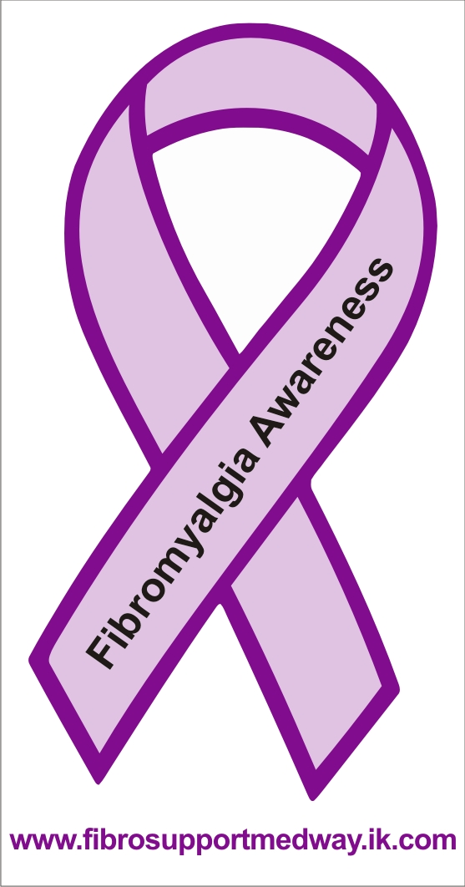
We sell Awareness Car Window Stickers. Send an SAE and £1 for each one to
16 Barberry Avenue, Chatham, Kent
ME5 9TE, or buy one at the meeting.

PERSONAL STORIES

It is good to see members sharing their personal stories, and I would like to encourage more of you to send in your own stories. It is always good for members to read about others and particularly if it is about a positive experience.

You never know when something you have felt, or tried, that has helped you, will help someone else. Don’t be discouraged if you have difficulty putting things into words, just give the bare bones and I will do the rest.

NEWSLETTER ITEMS

Items for inclusion in this newsletter are very welcome, but please note that the newsletter is about Fibromyalgia and related information, for those with Fibromyalgia, and their supporters. It would be helpful, if you are able, if you can send it via email.

The inclusion of articles and features in this newsletter does not necessarily infer endorsement by the group/Association. Any advice or recommendation of a medical nature, given in this newsletter, should always be discussed with a medical professional. The group/Association cannot be held responsible for omission and /or errors.

