The Green Spire

The Parish Magazine of

St Andrew, Orford with Longford

###### May 2016

School News 2

From the Vicar – the importance of Pentecost 3

Christian Aid Week 15-21 May 5

What are Rogation Days? 6

What’s on in May 7

Who’s On in May 9

A hymn for Pentecost 10

Gifts of the Spirit 11

News from The Fishermen’s Mission 14

Notice Board 16

The Annual Meeting18

Snippets from the *Church Times* 20

As I see it – by Churchmouse 21

Praying for the world-wide Church 23

From the Registers 26

Word-search 28

Prayer Intentions for May 29

The *Green Spire* is published monthly. Copies are 35p per month, or £3.50 for a year’s subscription – normally payable in January. Enquiries about advertisements welcome.

School News



April has been a ‘short month’ as far as school is concerned. The unusual holiday pattern meant that we were in for holy Week, taking Good Friday and Easter Monday as Bank Holidays before returning for the rest of the week. It did, however, prove helpful in our celebration of Easter. Children from Year 5 and Reception mounted a magnificent service which helped us think about the resurrection (which often gets lost when the children are off for a fortnight immediately after Easter). Everyone took part and the service was well attended by families too.

We are working hard to improve attendance as we know that children who miss school struggle to keep up. Part of our strategy is to reward children with good attendance. After the Easter service, everyone who had 100% attendance took part in an Easter Egg Hunt around school. And speaking of Easter Eggs, this year’s Easter egg raffle was a great success. Combined with an Easter Bingo (the prizes were Easter eggs!), we raised £230.50 which will be used to buy new playground equipment.

Then it was time for a well-deserved holiday. The fortnight flew by and it was soon time to return. The summer term will be busy but there’s also a lot to enjoy. There are a number of trips planned for the coming term, including a residential at the end of the year.

First, though, are the annual SATs tests. You may have already seen on the television that the spelling test was mistakenly published as a practice test (whoops) but our children will still do the test as another way of ensuring they are doing well. The focus is obviously on Year 6 though even here there is some difficulty after new standards were introduced hurriedly last year without proper benchmarks being set. The change from ‘points score and levels’ to ‘age related expectations’ (which are significantly higher than previous years) has caused many a sleepless night for those who try to interpret the results. We wish the children well in their test this year. I’m sure they will be pleased when they are all completed (and so will everyone else!)

From the Vicar:

It’s hard to understand just how important Pentecost was for the early Church.

Up to that moment, there was no church – just a few frightened souls who had experienced a roller coaster of emotions. Jesus, who had given their lives purpose, had died and then returned to life. Forty days later, he had ascended into heaven, leaving them lost and confused once again, despite promising them a ‘comforter’.

Gathered in the upper room, they were suddenly surprised by the Holy Spirit who anointed each of them with power, turning them from ‘quivering jellies’ to ‘men on a mission’! We’re told they went out, ignoring the dangers they still faced, to tell everyone they met about the love of Jesus. At that moment, the Church was born.

This month, we look forward to a number of events that all have their roots in Pentecost.

The ‘Pentecost-fest’ of events begins on Sunday 8th with confirmation. We have four candidates this year who will be confirmed by the Bishop of Warrington at St Margaret’s Church.

At the service, each of the children to be confirmed will receive the gift of the Holy Spirit in much the same way as the disciples received the Spirit on the Day of Pentecost.

The confirming bishop will wear a mitre to represent the tongues of flame that the disciples saw on one another’s heads, symbolizing the presence of God in their lives. He will give each of the candidates the gift of the Spirit to help and empower them in their lives.

Please pray for Maddison, Sarah, Kimberley and Amy as they prepare for this very special day in their lives.

In the week leading up to Pentecost, we will join our brothers and sisters from the other Orford Churches (St Ann’s, St Margaret’s, St Benedict’s and St Stephen’s) to pray together for greater unity. Far from being a chore, this is an opportunity to celebrate the faith which was first proclaimed at Pentecost. It’s a time to remember that we all trace our rots back to that room where the disciples were dramatically transformed and became the Church.

On the Friday, the service will take place in the evening at St Benedict’s Church. After a short service of Stations of the Resurrection, we will move to the club for a cheese and wine social. We are told that the disciples met for prayer and fellowship, starting at Pentecost, and we can do the same. I hope you’ll join us. If you need a lift, please ask.

On Saturday 14th, the day before our great celebration of the birth of the Church, we have been invited to the Smile Centre to pray for Church Growth.

This is a Bishop’s initiative. He has asked every parish to pray for growth in the week leading up to Pentecost, and we shall do that in our lunchtime prayers and on the 14th. Starting from 6am (though you won’t find me there at the start!) we have been invited to join with other Orford Churches to pray for the increase of the Church. You can come and go as it suits your day. The Centre will be open till 6 in the evening, proving that there really are two 6 o’clocks in the day. Stay for just a few minutes, or come for a longer period. It will be fairly relaxed, with opportunities to talk with others there as well as taking time to pray. The Smile Centre is the old St Margaret’s School on School Road, with the entrance half way between Morgan Avenue and Long Lane.

Pentecost immediately turns to service. This year, it marks the beginning of Christian Aid Week, an organisation set up by different denominations to serve the world’s most disadvantaged.

It was a pleasure to welcome David Rose recently to speak of the work of Christian Aid. It was a very down-to-earth account of what we could do to help others. There was something there for everyone.

Some of David’s suggestions appear in the article on the next page, but let me offer a special invitation to the Big Brekkie on Friday 20th May.

We are running the Big Brekkie jointly with school and it will be held in school at 9 o’clock. The children are preparing one or two items to perform and there will be tea and toast, in return for a donation to the work of Christian Aid.

We have done a number of things in school recently and we hope this will be well supported. I know some people find coming into school a daunting experience but let me assure you that you will be made most welcome and treated like royalty! It’s an opportunity to put faith into action simply by being there.

Enjoy Pentecost – and everything that is rooted in it!

Michael Raynor

**Christian Aid Week:**

**the week**

**we love every neighbour**

**15th – 21st May 2016**

David Rose spoke about how we can translate the parable of the Good Samaritan into practice by supporting the work of Christian Aid this month.

In his sermon at the end of April, David told us of the amazing transformation that Christian Aid had helped Morsheda make, turning her from a frightened, poor mother into someone whose whole family had a secure future. It was all done by raising the plinth on which her home and land were situated to avoid the perils of flooding. It is almost unbelievable that the solution is so simple.

There are many other people like Morsheda whose lives could be dramatically improved at minimal cost. They need our help.

Here are a few simple things we could do to help people like Morsheda:

* Complete the campaign card that was distributed at the service in April, or pick up one at the beginning of Christian Aid Week. Fill it in and post it off.
* Take donation envelopes and ask members of your family and neighbours to make a donation to the work of Christian Aid. I have been struck by the lesson of those seeking legacies which says we’ll only get the support we need if we ask.
* Collect from house-to-house during Christian Aid Week. God with a friend(s) rather than on your own and pick a manageable area to cover.
* Come to the Big Brekkie in school on Friday morning, 20th May.

**Let’s show that we love every neighbour!**

Rogation Days

Those who learned Latin might make a stab at the meaning of Rogation days, but the rest of us can be forgiven for not know much about them.

Rogation, as you’ve probably guessed, comes from the Latin *rogare* which simply means to ask. Long ago, the Church observed both a Major Rogation (on 25th April) and Minor Rogations (the Monday, Tuesday and Wednesday before Ascension Day). When Thomas Cranmer wrote the Prayer Book of 1662, the tradition of the Major Rogation had fallen into disuse and the Sunday before the Ascension became Rogation Sunday. Modern liturgical reform has kept the Sixth Sunday of Easter as part of the Easter season rather than Rogation Sunday, but the days before Ascension Day remain Rogation Days.

Originally, these special days were used to invoke God’s mercy on his people. They became more general days of prayer, and in rural communities, took on a special meaning when farming communities called on the church to ask God to bless the seed about to be sown and the harvest which they hoped would follow in time. Often the prayers would have been said (or sung) as the church processed around the boundary lines of the parish.

The Lectionary still marks out the days before the Ascension as Rogation Days, and rural parishes continue to process out and bless the crops to this day. In fact, you only have to go as far as Winwick to find that the Rector, to this day, stands at the highest point in the churchyard and blesses the fields, the workforce and the crop that those fields will produce.

***Professional Floristry***

***MISS DAISY’S***

***for All Occasions***

Soft Toys, Balloons

Plants and Cards

Deliveries

Amanda Morrison

Station Road, Great Sankey Tel/Fax: 01925 728973

What’s on in May...

**Sunday 1st The Sixth Sunday of Easter**

**May 10.00am Sung Eucharist**

**12 noon Holy Baptism**

Monday 2nd 10.00am Bank Holiday Car Boot Sale (helpers from 8.40am please)

Thursday 5th **Ascension Day**

10.30am Eucharist for church and school

7.00pm Sung Eucharist

Friday 6th 9.30am Distinctiveness and Ethos Committee meeting in school

**Sunday 8th The Seventh Sunday of Easter**

**10.00am Sung Eucharist**

**4.00pm Confirmation within the Eucharist** at St Margaret and All Hallows’ Church. All welcome.

**Orford Week of Prayer for Christian Unity**

Monday 9th 12.30pm Lunchtime prayers at St Stephen’s Church

Tuesday 10th 12.30pm Lunchtime prayers at St Ann’s Church

Wednesday 11th 12.30pm Lunchtime prayers at St Margaret’s Church

Thursday 12th 12.30pm Lunchtime prayers at St Andrew’s Church – here!

5.00pm Full Governing Body meeting in school

8.00pm Thursday Ladies' Club meet at the vicarage

Friday 13th 7.00pm Stations of the Resurrection at St Benedict’s Church, followed by cheese and wine

Saturday 14th 6am – 6pm Day of Prayer for Church Growth at the Smile Centre (old St Margaret’s Infant School). Come and go as you please.

**Christian Aid Week: 15th – 21st May**

**Sunday 15th The Day of Pentecost**

**10.00am Sung Eucharist**

**6.30pm Archdeacon’s Visitation Service at Church of the Ascension, Woolston**

Wednesday 18th 9.30am Resources Committee meeting in school

Friday 20th 9.00am **Big Brekkie** for Christian Aid to be held in school. Do come and support us.

**Sunday 22nd Trinity Sunday**

**10.00am Sung Eucharist**

Monday 23rd 5.00pm Full Governing Body Meeting in school

Thursday 26th 8.00pm Thursday Ladies' Club meet at the vicarage

**Sunday 29th The First Sunday after Trinity**

**10.00am Sung Eucharist**

**12 noon Holy Baptism**

**Sunday 5th The Second Sunday after Trinity**

**June 10.00am Sung Eucharist**

There are regular weekly celebrations of the Eucharist (Holy Communion) on Wednesday evening at 7.00pm and Thursday morning at 10.30am. Celebrations on Saint’s Days are published on the Sunday sheet. All are welcome.

Ascension Day...

is one of those days when all Christians are expected to make their Communion. This year, there will be two services. At the 10.30 service, we will be joined by our school family who will take a full part in the service; and at 7.00pm, there will be a full Sung Eucharist. Given that the evenings are rapidly drawing out, there will be plenty of time to get home in the daylight!

Who’s on in May…

|  |  |  |  |  |
| --- | --- | --- | --- | --- |
| 2016 | sides-people | reader | intercessor | offertory |
| 1 May  Easter 6 | L. Giblin  P. Smith | J. Raynor | F. Greatorex | M. Ellison  Z. Zahorcova |
| Thu 5 May  Ascension | Volunteers please | D. Kirk | N. Lee | Volunteers please |
| 8 May  Easter 7 | J. Devereux  M. Ellison | B. Glover | Sunday School | M. Greatorex  H. Smythe |
| 15 May  Pentecost | F. Greatorex  O. Vowles | B. Boscoe | J. Raynor | J. Brookman  C. Muir |
| 22 May  Trinity | B. Boscoe  B. Glover | M. Harrington | D. Kirk | M. Ellison  Lucia |
| 29 May  Trinity 1 | M. Greatorex  H. Smythe | F. Greatorex | K. Rowan | J. Blyth  L. Giblin |
| 5 Jun  Trinity 2 | I. Appleton  M. Harrington | O. Vowles | M. Harrington | K. Rowan  P. Smith |

|  |  |  |
| --- | --- | --- |
| **2016** | **Tea Rota** | **Counting collections** |
| 1 May | B. Boscoe / B. Glover | B. Boscoe / B. Glover |
| 8 May | F. Greatorex / L. Giblin | Awaiting APCM |
| 15 May | M. Harrington / Lucia | I. Appleton / M. Ellison |
| 22 May | M. Ellison / P. Smith | V. Carter / J. Raynor |
| 29 May | B. Boscoe / B. Glover | B. Boscoe / B. Glover |
| 5 Jun | F. Greatorex / L. Giblin | I. Appleton / M. Ellison |

|  |  |  |
| --- | --- | --- |
| **2016** | **Read on Weds Eve** | **Hall Cleaning** |
| 1 May | D. Kirk (4 May) | J. Devereux |
| 8 May | Fr Michael (11 May) | C. Worrall |
| 15 May | N. Lee (18 May) | Fr Michael |
| 22 May | D. Kirk (25 May) | J. Devereux |
| 29 May | Fr Michael (1 Jun) | C. Worrall |
| 5 Jun | N. Lee (8 Jun) | Fr Michael |

A hymn for Pentecost

Words and plain-song style tune combine beautifully in *Come, Holy Ghost, our souls inspire*, giving it an almost mystical quality that we associate with the Holy Spirit. Jesus told Nicodemus that you cannot touch the wind yet you readily see its effect. So it is with the Spirit, the source of grace.



***Come, Holy Ghost, our souls inspire,***

***and lighten with celestial fire;***

***thou the anointing Spirit art,***

***who dost thy seven-fold gifts impart.***

***Thy blessèd unction from above***

***is comfort, life, and fire of love;***

***enable with perpetual light***

***the dullness of our blinded sight.***

***Anoint and cheer our soilèd face***

***with the abundance of thy grace:***

***keep far our foes: give peace at home;***

***where thou art guide no ill can come.***

***Teach us to know the Father, Son,***

***and thee, of both, to be but one;***

***that through the ages all along***

***this may be our endless song:***

***Praise to thy eternal merit,***

***Father, Son, and Holy Spirit. Amen***

C:\Documents and Settings\Administrator\Local Settings\Temporary Internet Files\Content.IE5\3PX7N0J5\MC900027553[1].wmfTAPS Plumbing

for all your drips, leaks

and installations.

**Free Estimates**

**No call out fee.**

please call Kit on 01925 271301

or 07932 721848

Gifts of the Spirit

*from* A Season for the Spirit *by Martin J Smith SSJE*

“In directing retreats, it is my job to suggest experiments in prayer which I think will create an opportunity for retreatants to experience God’s love in a fresh way:

Imagine yourself sitting alone on your favourite stretch of sea-shore. A stranger approaches along the beach. It is the Lord. As he approaches, you become aware of an expression on his face which makes it clear that his intention is to thank you for all that you do for him. How do you feel? What do you say?

I watch the retreatant’s face carefully... Some men and women find themselves on the verge of tears at the very idea that Christ should want to thank them. Others have a baffled look; they heard the words but the notion that Christ may want to thank them is unthinkable.

Then they report what happened. Some people simply cannot go on with the meditation. Christ for them is the master of limitless demands. They are servants, only doing their duty. Thanks do not enter in... I do not usually argue with those who protest that the idea of Christ wanting to express his gratitude is fantastic and unwarranted. I simply ask them what they think of people who never thank anybody.

The Spirit “apportions to each one individually as he wills” graces and ministries from the great range of varieties of gifts. How little we know if we if we fail to realise that this kindling of gifts in us gives joy to the Spirit, that the nurturing of them is bliss to God, and that every single manifestation of them makes the Spirit-filled Christ within us freshly happy!

The most common mechanism for denying our gifts is simply to refuse to name or recognise them. Vast numbers of Christians simply refuse to know what are the gifts which the Spirit is struggling to impart to them and develop towards the building up of the Body of Christ.

They use the formulaic protests of false modesty to cover their rejection of responsibility as gifted people – “I am just an ordinary churchgoer, you see.” Or they adopt a critical stance which minimises what they do and is quick to detect flaws and worms in the bud. Or they brush of praise and thanks which others offer, cancelling their words of appreciation with remarks like, “Oh, it’s nothing, really.”

Conventional piety says that most of us are in danger from pride and that we must repeated douse ourselves with the cold water of self-deprecation to keep us humble. Most people I meet are in much greater danger from the corrosion of self-doubt. Even those who boast are really compensating for a deep, inner lack of beliefs in their own gifts. These drenching we administer to ourselves in the supposed interests of humility only worsen the rust and rot.

True humility comes from allowing our own gifts to be properly affirmed. It comes from knowing that the gifts we have for the common good are gifts of the Spirit, not mere accidents, and that God delights in our using them and longs for us to hear the divine “Well done, good and faithful servant.”

True humility is the sense of our need for each other for completeness, that my gifts supplement yours, and his complements ours, and theirs make up what is wanting in those others.

True humility arises from the vision of our interdependence within the web of life.



***Bank Holiday***

# CAR BOOT

# SALE

**on Monday 2nd May 2016**

***10.00am to 1.00pm***

**in the .**

**Church Hall.**

**and Grounds,.**

**Howson .**

**Road. .**

**Advance bookings: tel. 631903**

**Stalls £6 / (£7 on the day): Indoor and Outdoor available**

**Admission 20p (accompanied children free)**

**WBC approved No traders**

News from

Every year, we support a number of charities. We aim to support those who spread the Good News in word or deed, at home and overseas. One of the charities we have supported for a number of years is The Fishermen’s Mission. As the name suggests, they do sterling work in fishing communities around the UK, caring for fishermen (and women) and their families.

Here are some of the things they achieved in 2015:

280: Fishermen helped after an emergency at sea

10,744: Home and hospital visits made

98,795: Miles travelled delivering our services

£1.1m: Emergency grants we helped fishermen to access

4,861: Fishing boats visited

17: Emergency responses to 17 fatalities

752: Widows continued to receive our support

291: Funerals conducted

£1: For every £1 generated we spend 88p on providing services

LAST NOVEMBER, the Amble based Lobster boat *Rising Sun* began to take on water in the icy North Sea. Michael Mitchell and Simon Arries feared for their lives, knowing that every moment in the cold sea could be their last. Meanwhile, another boat from Amble were returning home when they saw what looked like a seal playing around a buoy, but when skipper Tom Lillico took a closer look, he realised that it was a man’s head just visible above the water. Tom and his son Jason rushed to rescue Simon after he’d been in the water for over an hour. Once on board, they helped Simon combat advanced hypothermia. Simon told them that Michael was still in the water, attempting to swim to nearby Coquet Island. Fortunately, he succeeded and both men were taken to hospital where they made a full recovery.

The Fishermen’s Mission quickly involved themselves, helping with emergency needs before setting about longer term support. Superintendent Peter Dade from Northshields Mission explained: “Not only had they been through a terrifying ordeal but they have also lost their boat, their business and their livelihood. Bills still have to be paid and food put on the table, and this is where the Fishermen’s Mission can help.”

Together with help from the Shipwrecked Mariner’s Society, Michael and Simon were soon able to return to work, though the ongoing support of the Mission has helped them restore confidence and rebuild shattered lives, practically and emotionally. “I can’t thank these guys enough. Their care and compassion has been incredible,” said Michael.

---------

YOUNG JOEL’S DAD is skipper of Fraserburgh vessel Endeavour. . Most of the crew are Filipino and Joel thought it must be very heard to be away from home and family for long periods. Together with Mum, Joel took part in the BRG Coastal Challenge, walking 17 miles to raise £1,100 which he donated to the Fraserburgh Fishermen’s Mission that was being renovated, giving the crew somewhere to relax whilst ashore.

---------

THE FISHERMEN’S MISSION joined forces with Gideons International to produce a unique New Testament and Psalms to be placed on every fishing boat in the UK. Trevor Broadhead, captain of FV Challenge was one of the first to receive his new copy of the bible, replacing one carried on the boat since 1958.

---------

IF YOU HAPPEN to visit Cornwall this year, pop in to the recently opened memorial room of the Newlyn Fishermen’s Mission. It has been dedicated to fishermen who lost their lives at sea by the Lord Lieutenant of Cornwall in a service at which the names of over a hundred fishermen lost at sea were remembered by name. After the service, Superintendent Keith Dickson said, “The memorial room is of huge significance to many fishing families, often providing a graveside for their lost fishermen and a place to quietly remember their loved ones.”

|  |  |
| --- | --- |
| Lent boxes  Thank you to everyone who supported this year’s Lent Appeal. To date, we have collected £127.41 for the work of Us. It will be used to help save young people from the evils of trafficking and enslavement in a country where 2,000 children are murdered each year. Your contribution may just have saved a young life. |  |

Confirmation Service

at St Margaret’s on Sunday 8th May at 4pm. Do come and support our candidates.

The Archdeacon’s Visitation

will be held on the evening of Sunday 15th May at the Church of the Ascension in Woolston, beginning at 6.30pm. Churchwardens and sidespeople are expected to attend and members of the PCC are warmly welcomed. The Visitation Service finds its roots in history but has become an opportunity for churches across the Deanery to come together in prayer and worship.

This will be Archdeacon Roger’s first Visitation service and we hope it will be well supported. If you’d like a lift, please speak to the vicar. Times etc will be published on the Sunday sheet.

Fridge and Freezers

Washing Machines

Dishwashers

Cookers etc

**Andrew Mercer**

***Domestic Appliance Repairs***

01925 423840

07723 967564

[andymercer22@gmail.com](mailto:andymercer22@gmail.com)

[www.andrewmercerdarepair.co.uk](http://www.andrewmercerdarepair.co.uk)

United in prayer and fellowship...

Everyone is invited to join us at St Benedict’s Church for Stations of the Resurrection on Friday 13th May at 7.00pm. It will be the final service in our Week of Prayer for Christian Unity in the week leading up to Pentecost. The service will be followed by a Cheese and Wine reception in the Club. It will also be the first chance to meet Fr Dave Heywood, the recently appointed Parish Priest to St Benedict’s, St Oswald’s and St Mary’s.

Car Boot Sale

We’d greatly appreciate help with the Car Boot Sale on Monday 2nd May. Helpers should arrive by 8.40am if possible as the first stall holders come in at 8.45. It is an important fund raiser and it provides an opportunity to talk to lots of people who come specially for the sale.

Big Brekkie

is out joinr Church/School initiative to promote Christian Aid and raise much needed funds for thecharity to continue its work. It starts at 9am on Friday 20th May. Children will perform a number of items and these will be followed by dirnks and toast (in return for a donation to Christian Aid). It’s the first time we’ve done anything like this together and really want to make it a big success. Please come along – you’ll see lots of people you know and recognise.

St Andrew’s Charity Shop

every Wednesday

from 10.00am to 3.00pm in the Hall

Drop-in for tea and toast.

Carer’s advice desk most Wednesdays

The Annual Meeting

This year’s Annual Meeting took place after the Eucharist on Sunday 17th April and was attended by twenty-seven people. The first meeting (because technically there are two separate meetings) was held specifically to elect two churchwardens and anyone living in the parish or on the electoral roll can take part and vote. Churchwardens are ‘bishop’s officers’ and have particular responsibilities with regard to the building and holding of services. Fr Michael thanked Faith Greatorex and Ronnie Worrall for their endeavours over the past twelve months and then invited nominations. Both Ronnie and Faith had been nominated and there were no further nominations. They will serve as churchwardens (and *ex officio* members of the PCC) for a further twelve months.

The Annual Parochial Church Meeting followed the first meeting and only those on the electoral roll for at least six months can participate. The agenda covers a number of important areas in church life and offers an opportunity for questions from the floor and other business providing it is notified in advance.

Having adopted the minutes, the only matter arising was to confirm that the external auditor’s certificate had been received and displayed for the 2014 accounts. Copies of the Annual Report were circulated at the meeting and details of the Electoral Roll are included. (Anyone not present at the meeting who would like a copy of the Report should contact Fr Michael). The Roll was compiled afresh in 2013 and revised in 2015. There are seventy-one on the Roll, of whom thirty-eight are resident within the parish (and a fair proportion of ‘non-residents’ live just outside the boundary).

Fr Michael presented the Accounts with the help of the Treasurer. The notes can be found in the Annual Report. (Fr Michael corrected his notes in the Report which undervalued the Gift Aid tax refund received. It was paid in two instalments and only one was noted in the Report. Updated copies are available.) The increase was largely due to the Gift Aided Small Donations Scheme which applied for a full year for the first time, giving our finances a much welcomed boost. Attention was drawn to the decreased income in planned giving, estimated at £2,500 for a full year. The PCC are looking to improve levels of giving in 2016. The Accounts were accepted and Fr Michael thanked everyone who supports the church financially, those who play a part in financial management on our behalf, and in the various day-to-day tasks that are done quietly and faithfully. Mr Timmis was thanked for examining our 2015 accounts and will be asked to examine the accounts for 2016.

Reports on the fabric (buildings etc) and Deanery Synod appear in the Annual Report. Those attending were invited to take the Report home and return with questions if they had any.

The meeting was asked to consider the membership of the PCC. When the new Representation Rules came into force in 2006, the Annual Meeting that year voted to retain a PCC with 15 elected representatives. Since then, the congregation has decreased in size. The meeting was asked to discuss the proposal to reduce the elected membership, which was approved, and in a vote, it was also agreed that the number elected at the APCM in 2017 will be 9 in line with the Representation Rules.

Elections to the PCC followed and the new PCC will consist of:

Irene Appleton Aaron Ashbrook Joyce Blyth Barbara Boscoe

Margaret Ellison Lynne Giblin Beryl Glover Marilyn Harrington

David Kirk Wendy McKinnon Jenny Raynor Kathy Rowan

Sidespeople for the coming year are:

Irene Appleton Barbara Boscoe Joan Devereux Margaret Ellison

Lynne Giblin Beryl Glover Faith Greatorex Marion Greatorex

Marilyn Harrington Pauline Smith Hazel Smythe Owen Vowles

The Archdeacon’s Visitation will be held at The Church of the Ascension, Woolston on Sunday 15th May at 6.30pm. The date of the first meeting of the PCC will be announced shortly. The vicar thanked everyone for attending and participating.

° ° ° ° ° ° ° ° ° ° ° ° ° ° ° ° ° ° ° ° ° ° ° ° ° ° ° ° ° ° ° ° ° ° ° ° ° ° ° ° ° ° ° ° ° ° ° ° ° ° ° ° ° ° ° ° ° °

I noticed my husband standing on the bathroom scales, sucking in his stomach. Thinking he was trying to weigh less with this manoeuvre, I commented, “I don’t think that is going to help.”

“Sure it does,” he said. “It’s the only way I can see the numbers!”

Snippets from the Church Times

The effects of the earthquakes in Ecuador and Japan featured prominently in the days after the disasters. The Bishop of Ecuador described his diocese as being like a war zone and invited the prayers of the world-wide church for those who were missing or lost their lives. In Japan, the Church was trying to find the best ways to help those affected.

The Government has announced its plans to change all schools to academies by 2020. Control will effectively move from the Local Authority to Regional Commissioners and central government. A recent agreement between the Church of England and Department for Education ensures the Diocesan Board of Education has to approve any changes to academy status, thus ensuring the essential and important identity and ethos of church schools is maintained.

The Church Commissioners struck another blow against a £13.8 million pay package for the chief executive of oil giant BP. The Church’s spokesman asked the shareholders meeting if such a sum was morally right and whether anyone needs such a huge incentive [to do the job]. Though not binding, 59% of shareholders agreed, sending a clear message to the Board. This is not the first time that the Church Commissioners have used their investment power to question proposed bonuses which they felt were disproportionate.

The final annual memorial service, held at Anfield, for the 96 Liverpool supporters who lost their lives at Hillsborough was attended by the former Bishop of Liverpool, the Rt Rev James Jones. Bishop James has played a big part in chairing the Hillsborough Independent Panel, which prompted the second inquest and subsequent verdict.

Three new projects rely heavily on modern methods of communication. Alpha, who run the Alpha Course, have started making twenty minute documentary style films exploring some of life’s ‘big questions’. Three clerics and a lay member of churches in Shropshire feature in *TGI Monday*, which responds to questions posed by Twitter users about aspects of faith. And the Archbishop of Canterbury features the first of four ten minute videos covering “Money, Debt and Salvation” in which he affirms that ‘the human person is what matters’.

A church in Chelsea claims that continued use of the Book of Common Prayer has contributed to a 20% increase in the size of its congregation over the past ten years.

As I see it …by Church Mouse

“Sing a song of May time

Sing a song of spring

Flowers are in their beauty

Birds are on the wing”

So sang the young mice (they are a very literate lot – obviously go to a good school!) as they ran around on the grass just outside the church hall. The weather was fine and the grass had been cut – a perfect day for a bit of fun.

“Isn’t it nice to see them so happy?” remarked Granny Mouse.

“Isn’t it nice to have the weather so that they can play out?” said my wife, Millicent. “This last week or so has been what Great Grandma Mouse used to call ‘Patchwork Weather’ – a spell of sunshine, a burst of rain, frost one day and sun again. We even had hail the other day. It’s like four seasons rolled into one. You just don’t know where you are up to,” she sighed, exasperated.

“Ah,” said Granny Mouse, “did you see those youngsters trying to play with the hailstones? They tried using them as marbles, and even as a football, but after a few sore toes and cold paws, they just gave it up as a bad job!”

Just at that moment, I returned home. “Look what I’ve brought you,” I said and presented Millicent with a beautiful bouquet of violets – real ‘mouse-size’ blooms.

“I know where you’ve been,” said Millicent. “You’ve been out to that patch of violets under the trees in front of church. I’ve noticed that it gets bigger and better every year, and all from a small 50p pot planted in the vicarage garden a few years ago. You’d hardly believe it. And if you look closely in the lawns, you’ll find even more!”

“The birds have done a good job spreading the seeds,” said Granny Mouse. “It’s just like the parable of the sower, and the violet seed that fell on good ground.”

“We’d better be careful, though,” she went on. “Only the other week, a sparrow hawk swooped down from the church roof and tried to catch a blackbird foraging for food. We don’t want any accidents.”

“I was a bit surprised that Aaron allowed the Cubs to visit the vicarage garden,” I said. “Perhaps he didn’t know about the sparrow hawk.”

“Don’t be silly. It would take more than one bird of prey to carry off a cub,” she replied.

“Birds of pray?” one of the mouselings asked. “Do they go to church, too?”

”Oh dear,” groaned Granny Mouse. “Now look what you’ve started! Anyway, what were the cubs doing in the vicarage garden?”

“They were doing their Naturalist badge. You have to be careful how you say it. Don’t want people getting the wrong idea!”

“Yes,” Millicent added, “it was the first of several visits to the garden and church grounds to look at trees, birds and butterflies – in fact, everything that grows there. Fr M really enjoyed telling them about everything growing, and when he started to tell them about hawthorn, which is also known as ‘may’, one of the leaders told the children about the saying “don’t cast a clout [item of clothing] until may is out” reminding them that it didn’t mean the month of May but the may, or hawthorn, flowers. Anyway, I think ever Fr M was surprised at just how much there was to see. Some of the children were very clued up and kept chiming in with the answers.”

“Next time they come, the garden will have changed as new things grow and blossom. We can’t wait to help show them round.”

**Churchmouse**

A man went to heaven and found St Peter at the gate. “We have a very long list and we are choosy. Have you done a good deed recently?” asked St Peter.

“Oh yes. I was coming back from work at night and I saw some men attacking a poor old woman. I approached the one who seemed to be the leader and punched him straight in the face. The others surrounded me. I started shouting at them to leave the old woman because otherwise I would have to give them a lesson they would long remember.”

St Peter was impressed. “Well done, when did that happen?”

“About five minutes ago!” the man replied.

A man spoke frantically into the phone: “She’s pregnant, in labour and her contractions are only two minutes apart.” “Is this her first child?” asked the doctor. “No, you fool,” the man shouted. “This is her husband.”

Praying for the world-wide Church

Prayer is central to Christian discipleship. At its best, prayer needs to be informed: who are we praying for and what their situation is. Sunday by Sunday (and day by day), Anglicans around the world take it in turn to pray for one another, following a two year cycle. In our worship in church, we join together with fellow Anglicans in praying for the people of those dioceses. Here are the Churches and dioceses that will be mentioned on the Sundays in May:

**Sunday 1st May: The Anglican Church of Kenya**

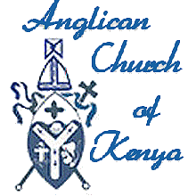Mombasa saw the arrival of Anglican missionaries in 1844, with the first Africans ordained to the priesthood in 1885. Mass conversions occurred as early as 1910. The first Kenyan Bishops were consecrated in 1955. The Church became part of the Province of East Africa, established in 1960, but by 1970 Kenya and Tanzania were divided into separate Provinces.

There are now 34 dioceses serving over 30 million people. It is claimed that 4.5 million people are Christians, a massive proportion. The Anglican Church of Kenya is politically active, opposing injustice in all its forms.

The Church Army Africa is the missional arm of the Church, working in close partnership with the wider Anglican Church to positively transform society in Africa. Much of their work lies in developing leadership skills, starting in primary schools and working through universities. They have a community programme that works with those living with HIV and AIDS and their families; helps people set up micro-enterprises and runs Agriculture, Horticulture and fish-breeding Development Programmes. Through *Christians for a Just Society*, they aim to promote  a just society that respects the rule of law; that is governed by godly moral values and practices principles of good governance'

**Sunday 8th May: The Anglican Church of Korea**

It is interesting that a country so obviously divided as Korea can be one Anglican Province, caring for the spiritual welfare of Christians in both the North and the South.

Bishop John Charles Corfe was ordained bishop on 1st November 1889 and made the first bishop of Korea, arriving at Incheon Port the following September, accompanied by a group of fellow missionaries. Work began in Seoul and spread through education, health care and social work centres across the country. From the outset, the aim was to integrate the church into Korean culture. However, Japanese colonial rule and other issues meant that the church failed to flourish for many years. In 1965, the first native Korean bishop was ordained marking a new era of closer working. Under the theme "Jesus Christ, Life of the Nation", the church continues to proclaim the message of life to the people and expediting the peaceful reunification of Korea.

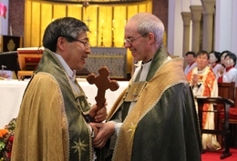In November 2013, the Archbishop of Canterbury visited Korea. Archbishop Justin said he was ‘thrilled’ to be invited by the Anglican Church of Korea and its primate, the Most Revd Paul Kim. Arriving in Busan, he said: ‘I give thanks that the Korean church continues to set before us a vision of unity and reconciliation despite the political and social challenges of this divided peninsula.’

**Sunday 15th May: The Anglican Church of Melanesia**

With evocative names such as the Diocese of the Solomon Islands and the Diocese of Vanuatu and New Caledonia, the nine dioceses that make up the Anglican Church of Melanesia are deeply committed to serving the Lord and caring for the natural world entrusted to them.

The Society of St Francis (whose mother house is in Dorset, England) is just one of four religious communities that thrive in Melanesia and the surrounding islands. Attracting men (first order) and women (second order), third order members live and work in the community while following an individual rule of life. They are joined by the Melanesian Order, the Community of the Sisters of Melanesia and the Community of the Sisters of the Church in prayer and serving the community.

The Mothers Union is a significant part of the Melanesian Church (as it is in Kenya). The Board of Mission also includes the AOA Solar Project, a Climate Change project and Mission to Seafarers. There is a theological college named after the founding bishop of the Province and a church-run university.

**Sunday 22nd May: La Iglesia Anglicana de Mexico**

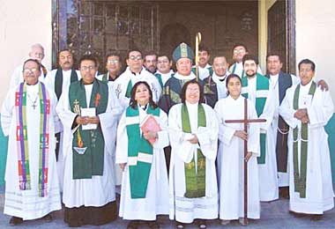A relative newcomer to the Anglican Family, the Inglesia Anglicana became a Province in its own right in 1995 though it can trace its root back to the Mexican War for Independence in 1810.

Comprising 52 parishes, 36 missions and 12 affiliated institutions, the Province is divided up into five dioceses. The Province is quite liberal in outlook, ordaining women as deacons and priests and offering support for women bishops. The Church has managed to retain its integrity as part of the Anglican Church while seamlessly integrating into the local culture.

**Sunday 29th May: The Anglican Centre in Rome**

“Promoting Christian Unity in a divided world.” Now fifty years old, the Centre brings together Anglicans and Roman Catholics at the highest level while offering hospitality to the visitor and a library facility that all may use. The Centre is a focus for greater understanding and closer cooperation between Anglicans and Roman Catholics.

**From the Registers**

**Holy Baptism:**

10th April: Chantelle Dodd

Leila Jo Moorfield

Lyle Michael Sunderland

**Funerals:**

8th April: Gordon Mundry

28th April: Kenneth Burgess

**Communicants and Collections:**

|  |  |  |  |  |
| --- | --- | --- | --- | --- |
| **2016** | **Sunday**  **Communicants** | **Midweek**  **Communicants** | **Loose**  **Collections £** | **Planned**  **Giving £** |
| 27th March | 41 | 65 | 84.05 | 198.50 |
| 3rd April | 33 | 5 | 14.50 | 344.16 |
| 10th April | 38 | 8 | 121.74 | 264.20 |
| 17th April | 38 | 9 | 6.60 | 217.50 |
| 24th April | 36 | 7 | 15.18 | 104.50 |

D

**onations**

We would like to thank everyone who has made a gift or donation to our various funds recently. Our special thanks go to:

##### General Fund

* With thanks for continued prayers from Doris Jepson
* Donation from Renee Hollingsworth
* In loving memory of my dear Joyce from Wilf (Delooze)
* With loving memories of Neil Boscoe, a wonderful son, on the anniversary of his passing with love from his Mum, Barbara
* From Bob Birbeck

Easter lilies

* From Lynne Giblin
* From Pauline Smith  
  Both omitted from last month as the list was prepared early – apologies.

*Elle and Esse*

Hair and Beauty Lodge

Unisex Hair Salon

**LYNETTE and SUE**

Lodge Lane, Bewsey

Warrington

Tel: 01925 232282

Proper Easter Eggs?

Many of Britain's best known brands have quietly dropped the name of the Christian festival, now selling Easter products labelled simply as "chocolate egg" or even "egg", it is claimed.

The allegation was highlighted by the makers of the "Real Easter Egg", a fair trade chocolate product which carries a Christian message instead of pictures of bunnies and chicks and donates its profits to charity.

David Marshall, of The Meaningful Chocolate Company, based in Manchester, said: "A lot of businesses, quite often, are not comfortable with the religious aspect of the festival."

And finally

Two elderly ladies were discussing their husbands over tea. “Id wish that my Gerald would stop biting his nails. He makes me terribly nervous.”

“My Billy used to do the same thing,” the older woman replied, “but I broke him of the habit.”

“How?” asked the first.

“Simple,” came the reply, “I hid his teeth.”

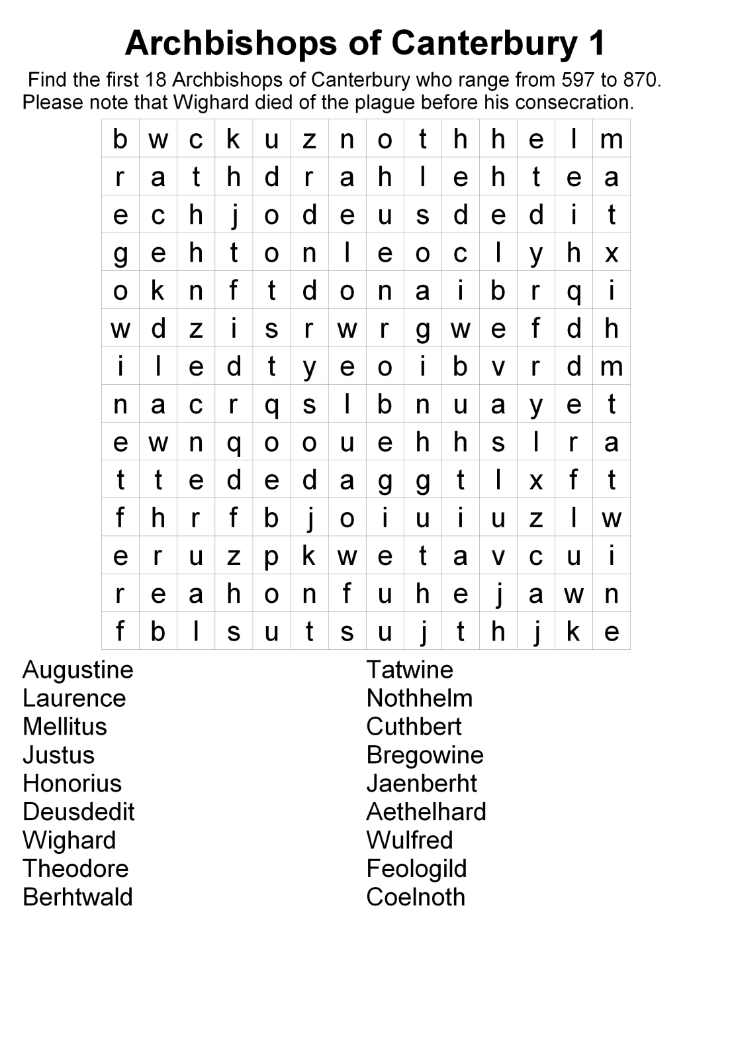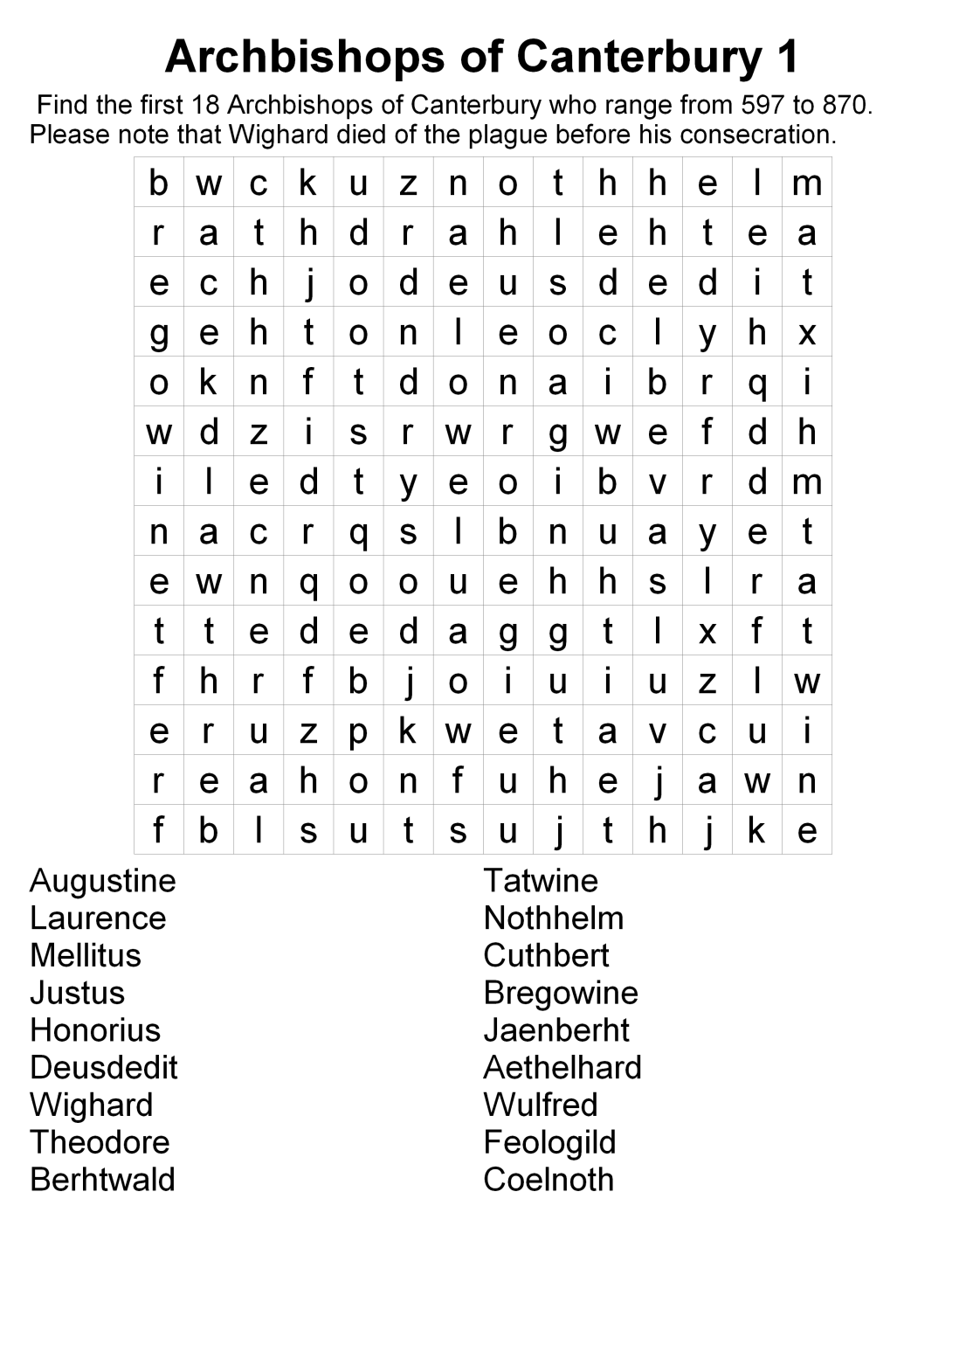

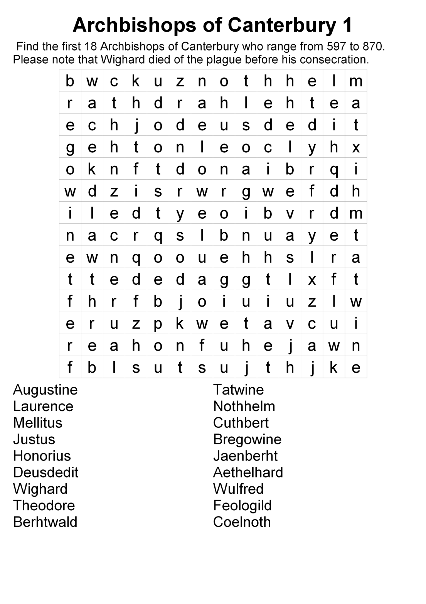

**Prayer Intentions for May**

|  |  |  |  |
| --- | --- | --- | --- |
|  |  |  |  |
| Sun | 1st | **The Sixth Sunday of Easter** | |
| Mon | 2nd | Pentland Place | Church Urban Fund projects |
| Tue | 3rd | Loweswater Close | Our Choir and Organist |
| Wed | 4th | Mill Farm Close | Warrington Hospital |
| Thu | 5th | **Ascension Day** | Those standing for election |
| Fri | 6th | Crawley Avenue | Church of the Ascension, Woolston |
| Sat | 7th | Birch Avenue | Pakistan |
|  |  |  |  |
| Sun | 8th | **The Seventh Sunday of Easter** | |
| Mon | 9th | Ullswater Avenue | Guild of Church Braillists |
| Tue | 10th | Cheviot Avenue | Nepal |
| Wed | 11th | Kendal Avenue | Residential and Nursing Homes |
| Thu | 12th | Oxenham Road | Bishop Richard |
| Fri | 13th | Long Lane | Church of the Resurrection, Cinn. Brow |
| Sat | 14th | Ennerdale Avenue | Our ecumenical partners |
|  |  |  |  |
| Sun | 15th | **The Day of Pentecost (Whit Sunday)** | |
| Mon | 16th | Toll Bar Road | Christian Aid collectors |
| Tue | 17th | Brandwood Avenue | Our School – its staff and pupils |
| Wed | 18th | Poplars Avenue | GPs and their staff |
| Thu | 19th | McKee Avenue | Chinese Christians |
| Fri | 20th | Appleby Road | St Ann, Warrington |
| Sat | 21st | Wansfell Place | Zero hour workers |
|  |  |  |  |
| Sun | 22nd | **Trinity Sunday** | |
| Mon | 23rd | Gough Avenue | Samaritans and ChildLine |
| Tue | 24th | Bentham Avenue | John, Archbishop of York |
| Wed | 25th | Locker Avenue | The Foodbank |
| Thu | 26th | Foxfield Close | Archdeacon Roger |
| Fri | 27th | Northway | St Barnabas, Warrington |
| Sat | 28th | Sandy Lane | Those living with AIDS |
|  |  |  |  |
| Sun | 29th | **The First Sunday after Trinity** | |
| Mon | 30th | Poole Crescent | United Society |
| Tue | 31st | Ajax Avenue | North and South Korea |
|  |  |  |  |