
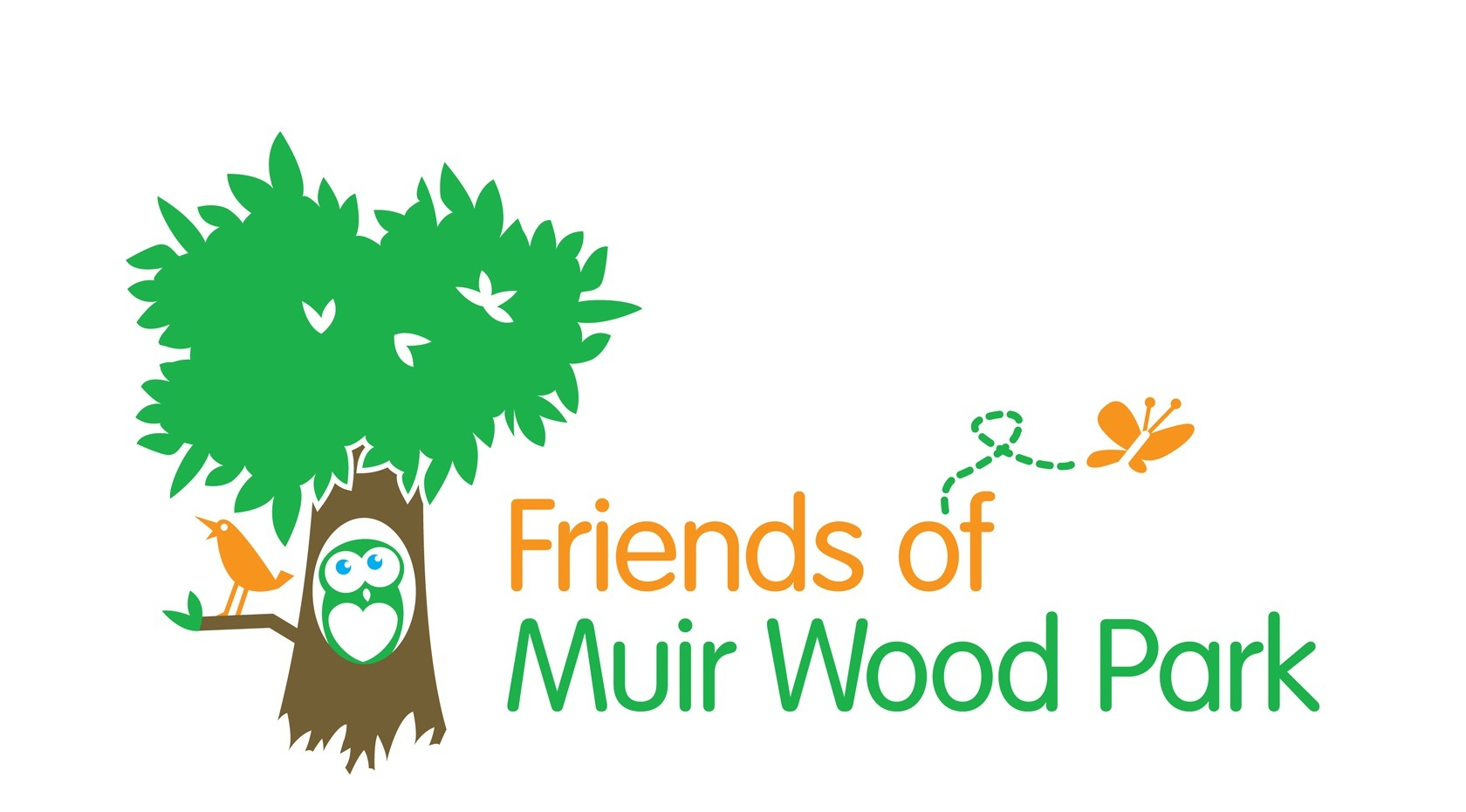

Friends of Muir Wood Park
2015 Events: Booking Form
Please tick the events you wish to book and confirm numbers

FAMILY EVENTS
30th May, 1.30-3.30pm Bio-blitz ◻ No of adults: ……… No of Children & Ages: ……..………………..
TOTAL COST (@ £1 PER PERSON):…………
28th June, 1.30-3.30pm Storytelling ◻ No of adults: ……… No of Children & Ages: ……..………………..
TOTAL COST (@ £1 PER PERSON):…………
19th July, 1.30-3.30pm Natural arts & crafts ◻ No of adults: ……… No of Children & Ages: ……..………………..
TOTAL COST (@ £1 PER PERSON):…………
6th Sept, 6.00-8.00pm Bat Walk (for all) ◻ No of adults: ……… No of Children & Ages: ……..………………..
TOTAL COST (@ £1 PER PERSON):…………
4th Oct, 12-4pm Family Bushcraft Day ◻ No of adults: ……… No of Children & Ages: ………………..
TOTAL COST (@ £5 PER PERSON):………
15th Nov, 12-4pm Minecraft Day ◻ NO ADULTS! No of Children & Ages:……………………….
TOTAL COST (@ £5 PER PERSON):………
OVER 50’S EVENTS
30th May, 10.30-12.30pm Bio-blitz ◻ No of adults: ……… NO CHILDREN!
TOTAL COST (@ £1 PER PERSON):…………
6th Sept, 10.30-12.30pm Foraging ◻ No of adults: ……… NO CHILDREN!: ……..………………..
TOTAL COST (@ £1 PER PERSON):…………

TOTAL AMOUNT DUE WITH BOOKING: £…………………………
zxczxcvzcxvzxcvzxcv

Names of attendees:

Email address for sending booking confirmation and event info:

________________________________________________________________________________

EMERGENCY CONTACT DETAILS
Name of contact:
Relationship to participants:
Emergency tel nos:

Surgery/Doctor’s name and address:

Tel no:

1. Does anyone in your group suffer from:
a. Any allergies Yes / No
If yes, give details

2. Is anyone taking medication at present or suffer from any conditions requiring medical treatment? Yes / No
If yes, give details

3. Give full details of any illness, injury or condition that might affect participation.

4. If required, do you consent to the following being administered?:
a. Paracetamol for pain relief? Yes / No
b. Suncream for protection from the sun? Any brand not permitted? Yes / No
c. Antihistamine? Any brand not permitted? Yes / No

5. Does anyone in your group have any Additional Support Needs which might affect their participation Yes / No
If yes, give details

Does anyone in your group have any special dietary requirements? Yes / No
If yes, give details

It is normal practice to take photographs / video for promotional and funding/evaluation purposes.
Please tick if photography/video is NOT permitted

PLEASE ENSURE YOU ENCLOSE YOUR PAYMENT, MADE PAYABLE TO “FRIENDS OF MUIR WOOD PARK” IN FULL WITH YOUR BOOKING FORM.
Please print and return this form with your payment to:
Jo Walton
Friends of Muir Wood Park
c/o 2 Muir Wood Grove
Edinburgh EH14 5HA

