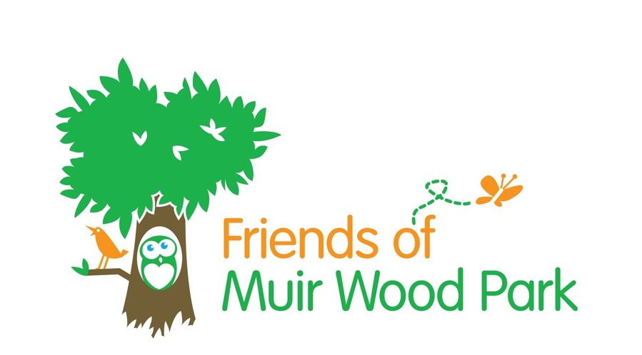

Minutes of 10th AGM on Wednesday 04th March 2015 held in
Nether Currie Primary School

Present –Neil Anderson - Jack Cairns - Jean Cairns - Barbara Chambers -
Mark Hutchison -Ann Ireland – Ian Ireland – Donald Kennedy -
Sheila Nicol .

- Apologies – Margo Arnot –Alex. Preston - Mairi Mitchell - Jo Walton.

Mark welcomed everyone to the Meeting .

- Minutes of 9th AGM on 12th March 2014 were accepted as correct. Proposed by
Mark Hutchison and seconded by Barbara Chambers.

- Matters Arising from 12th March 2014 Meeting.

- The £6,300.00 due as part payment for the new surface on the football pitch is to remain in the Friends Bank Account until the Council request it.

b) State of path – Craig has offered to have the surface scraped back and new
material laid. Craig to be asked for this to go ahead.

c) Play Park Fence - this has now been installed but due to some re-alignment
because of tree roots it is approximately two sections short. These have been
ordered by the Council workshop.
It was agreed that we should ask for “NO DOGS ALLOWED” notices to be fixed to
all the gates as soon as practical.
Sheila Nicol offered to get the children to make similar notices if there proved to
be a delay in getting them from the Council.

- Office Bearers Reports.

The Chairman reported on the completion of the Play Park fence and said that this would comply with Health and Safety requirements and give the children a much safer environment.

The Treasurer stated that just over £1,000.00 belonging to The Friends was held in our Account.

The Membership Secretary said that at present there were 106 paid up members and that this was now the time for the annual collection of the subscriptions.
These were to be returned by the end of the month (March) if possible.

The Technical Consultant gave a brief report on the state of the drains. He said that the manhole that was damaged due to repeated flooding had been repaired.

- Office Bearers.

In the absence of any nominations the existing Office Bearers agreed to remain in post.

- Issue of Membership Packs.

Ann handed out the Membership Packs to those who had agreed to collect the
subscriptions. She thanked those doing the collecting and asked for the packs to be
returned by the end of March if possible. Packs will be forwarded to any collector not
present.

- AOCB.

- Ian advised that the 10 year plan had expired and that we should be producing a plan for the next 5 year period. Craig had agreed to produce the plan but we had to provide the input.

- Information about “The Big Lunch” had been received from Currie Community Council asking if we would be interested in running this event on the first Sunday in June. After some discussion it transpired that Nether Currie School was holding its Summer Fair on that week-end and that on the Sunday it had a picnic in the school grounds to which all the parents were invited. It was agreed that it would not be practical to run this event but if the Community Council wished to hold it in Muir Wood Park on another date then we would be delighted to assist them.

- The pupils at Nether Currie Primary School were taking part in an Eco Group Competition about litter and Sheila offered us some of the posters for display in the park. This offer was gratefully accepted and we look forward to receiving the posters.

- Neil suggested that a “cattle grid” type barrier could be used at each gate entrance to the Play Park to keep the dogs out – in the event of the gate being left open. It was stated that this type of barrier was not favoured by the Council.
Neil was thanked for his suggestion.

e) Ian suggested the possibility of planting climbing plants on the Play Park fence that
ran parallel to the path. After some discussion it was agreed that it would be better
to plant some daffodils instead and it was agreed that this should be done in the
Autumn.

- Date of Next Meeting.

The next Meeting will be held in Nether Currie Primary School on
Wednesday 4th June 2015 at 6.45pm.

4. Office Bearers Reports.

The Chairman gave an update on what’s been happening in the park.

The wild flower meadow has been extended in preparation for the sowing of seeds. It is now approximately twice the original size.

Additional fruit trees have been planted in The Orchard and we now have a selection of apple, pear, plum and cherry.

Membership Secretary, Ann Ireland, said that we now have 106 members but most of them are inactive as far as the Friends Group was concerned.
She read out a letter from one of our members, Mrs. M. Farquharson of 140 Muir Wood Road, who had now moved in to a Nursing home in Colinton. She had expressed her appreciation of the work of the Friends Group and gave us a donation of £20.00.
Ann had written a letter of thanks to the lady.

Ann then handed out all the Collector’s packs as it was time for payment of the annual subscription which was maintained at £5.00 per household.

The Treasurer stated that our Bank balance was £7,018.09 of which £6,300.00 was due to Edinburgh Council as part payment towards the football pitch. The Treasurer had repeatedly offered this money to Craig Dunlop who said that we should wait until he was asked for it from the Finance Group.
Our actual balance is therefore £718.09.

In addition to this we still had 5 x £25.00 Scot-Mid vouchers. It was agreed that these should be used to purchase provisions for the Easter Egg Hunt.

We had donated £100.00 to Woodlands School in Currie towards their Sports Campaign for an All – Weather Sports Area. Ian read out a letter of thanks from Liz. Power the Chair of the Friends of Woodlands School thanking us for this donation.

The Technical Consultant, Jack, said that Calum Ross from the Drainage Department
had advised us that he hoped to carry out some work on the flooding problem in April/May.

5. Election of Office Bearers.

The following were re-elected unopposed –

Chairman Mark Hutchison
Secretary/Treasurer Ian Ireland
Membership Secretary Ann Ireland

Technical Consultant Jack Cairns

Nature Officer Mark Hutchison

6. Events in Public Parks

Mark drew our attention to the Park Management Rules regarding Events and other activities in the Park. These stated that written permission had to be obtained from the Council – the Secretary is therefore to complete the Application for the Easter Egg Hunt.

7. AOCB.

- Discussion followed on the state of the path and it was agreed that we should approach the Council with a request that it should have a tarmac surface – Secretary to write to Council.

- Mark said that the condition of the circular climbing frame was dangerous and
presented a hazard to the children . Jo to check on suitable alternatives and
contact Craig. Also the toddlers climbing frame and small chute require painting
again – Ian to contact Craig.

- Val and Jo had been in contact with Russell Leisure regarding updating the
Children’s Play area and they had suggested fencing in the Toddler’s equipment
only. It was agreed that we should continue to press for the whole Children’s area
to be fenced in. The overall cost of this project was prohibitive and Val and Jo
were thanked for their work.

- The fencing in of the Children’s Play area had now been put forward as a
Neighbourhood Environment Project. This has the support of Gordon MacDonald
MSP, Local Councillors Dominic Heslop, Ricky Henderson, Bill Henderson and Currie Community Council.

- Sheila Nicol agreed that the children of Nether Currie Primary School would
provide posters to be displayed on the park fence advertising the Easter Egg
Hunt – Ian to provide a copy of the poster he has already produced.

- Sheila advised that the School Holidays started on 4th April 2014 and
therefore the next scheduled meeting to discuss the Easter Egg Hunt was brought forward to Wednesday 2nd April at 7pm.

.
8 . Date of Next Meeting

The next Meeting will be held in Nether Currie Primary School on

Wednesday 4th June 2014 at 6.45pm
.

