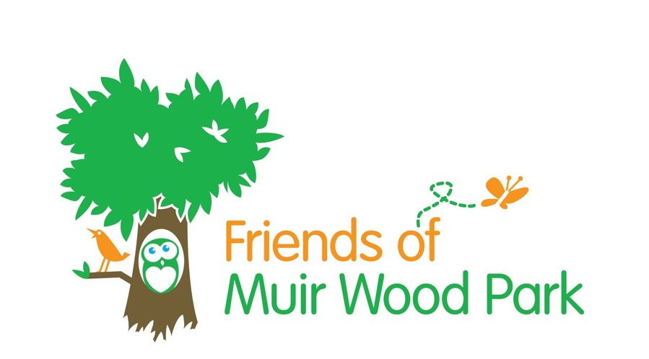
MUIR WOOD PARK: PLAY AREA SURVEY

We hope to design a new play area for Muir Wood Park. We will need to find almost all of the money for this project ourselves so it will take some time and is likely to be completed in stages. We would
welcome your feedback so that we can create a draft design for
further consultation.

Please use the links below to complete a survey. We welcome all thoughts and feedback.

If you would like a paper copy sent out, please contact events.fmwp.@gmail.com

The survey can also be accessed via our Facebook page –

(www.facebook.com/MuirwoodPark)

and website (www.fmwp.btck.co.uk)

Kids Survey https://www.surveymonkey.co.uk/r/GZYLWZR

Adults Survey www.surveymonkey.co.uk/r/QY3QFVY

