Walk from Barrington Boar to East Lambrook
8 miles circular walk to East Lambrook Manor Gardens, passing Avon Bulbs, and Barrington Court Total climb 50m
Directions start from the Barrington Boar, Barrington (Grid Ref ST 389 181)
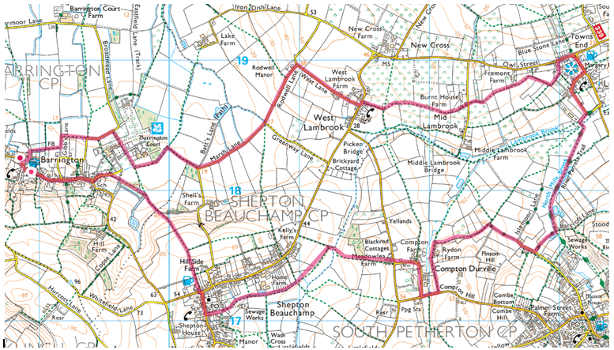
Turn left from the Barrington Boar and walk east through the village, turning left into Water Street in front of the school. At the end of Water Street walk through the gate into the cricket field opposite and follow boundary to the left and follow footpath through the small copse leading to an iron gate onto the field by the ha-ha in front of Barrington Court. Follow the path along the side of the ha-ha for approx. 50m and then veer diagonally to the right across the field towards the corner of the field to the left of the copse on the other side. Cross the stile in the corner of the field and immediately turn right onto the drove for approx. 30m. Turn left onto the lane at the end of the drove walk for 1000m and take the second lane to the right.
At the end of this lane turn left onto the Shepton to West Lambrook road and almost immediately take the footpath to the right down Cross Lane signposted East Lambrook. Follow the footpath straight ahead along the side of the orchard and continue straight ahead on the footpath follow the footpath around the left hand edge of the field to gate in the corner of the field. Walk straight ahead along the track with currant bushes on the left and an orchard on the right cross stile at end of orchard and walk across open field aiming for 5-bar gate in right hand corner of field, walk straight ahead, passing Avon Bulbs. Turn left onto the lane and immediately turn right down the track to walk through 5-bar gate, walk diagonally left across open field aiming for opening in hedge opposite approx. ¹/₃rd down from the left hand corner. Walk through the gap and walk straight ahead over two stiles and through a gate onto a drove, at end of drove turn left to walk up to the road turning right to walk along the road for 200m to the Rose and Crown at East Lambrook turning right to walk past East Lambrook Manor.
Take the first lane to the right immediately past the Manor and follow the road round to the left to pass the church on your left. Take the first lane right after the church and at the end of the lane take the footpath to the left immediately before the 5-bar gate entrance to the cottage directly ahead of you. Walk ahead on the narrow path crossing the bridge over Lambrook Brook and immediately turn right to follow the footpath alongside the ditch and orchard on your right, cross two further bridges across the ditch to walk along footpath adjacent to laurel hedge and fence on left. At the gates on left leading to Barcroft Hall turn right to walk along the lane,at the end of the lane turn and walk straight ahead, at end of track take footpath to the left signposted “Public footpath Rydon Farm”. Continue straight ahead then turn left by pond to walk past farmhouse on your left and walk along track to road ahead. Turn right and walk along road taking first right into Compton Durville. Follow road through the village crossing over T jct at end into farm yard opposite and walk straight ahead through farm to Bristol gate at end of farm yard. Continue straight ahead through gate on rhs of field; when field widens to the right continue straight ahead across field to ditch opposite bearing slightly right to cross bridge over ditch to walk straight ahead for 50m taking first left to walk along footpath on rh side of field. At end of field turn left down track, turning right through kissing gate at end of hedge on rhs. Walk straight ahead with ditch on rhs, walk through Cowleaze Meadow and continue straight ahead along Robin Lane. Turn right at T jct to walk past Church, bear left by Duke of York to walk up Ash Lane, walking straight ahead through gate, continue straight ahead on rhs of field through next gate continuing down the rhs of field, with views of Barrington Court, to exit through gate turning left on track, when track turns sharply to the left walk through field gate on rhs. Bear left to walk across field towards lh corner of field, exit through iron gate into small copse leading onto cricket ground. Walk around rhs of cricket field to exit gate in corner. Walk straight ahead into Water St and retrace your steps through the village.

