Circular walk from Barrington Boar via Puckington and Stocklinch Ottersey Church
Total distance 5.7miles. Directions start from the Barrington Boar opposite the Church (Grid Ref ST 389 181)
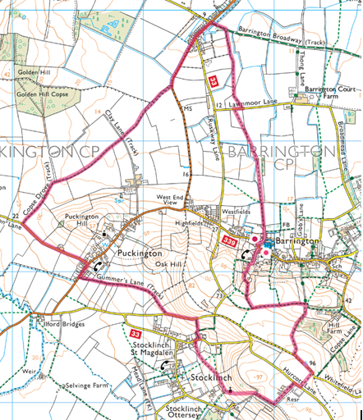
Turn right (west)from the pub and take first right down Bakers Lane, at end of tarmac continue straight ahead on track crossing stile onto open field, walk straight ahead keeping hedge on your left and cross stile at far side of field. Walk straight ahead along side of this narrow field keeping hedge on left hand side, ignore footpath across bridge to the left. Turn left through copse near end of field, pass through wooden gate at end of copse and walk diagonally left across the field aiming for a point approx 100m along the side of the field, turn left through opening in hedge to cross bridge and pass through small copse. On leaving the copse walk straight ahead to gate in middle of far side of field. Turn right onto Lawnmoor Lane for 70m turning left at first gate, walk straight ahead keeping hedge/ditch on right hand side, cross small bridge and stile at end of field immediately turning right to cross further stile in 50m. (Stile can be by-passed by walking through field gate 50m to the left). Walk ahead keeping to the left hand side of the field to gate leading onto Barrington Broadway; turn left for 120m, cross stone bridge over the Westport canal.
Turn left onto the Ilminster to Curry Rivel Road (B3168) walk for approx. ¹/₃ mile (passing Ruskway Lane), when road starts to bend to the left follow signpost to take footpath through copse on right hand side. Follow narrow track through rh side of copse to cross stile, walk straight ahead along hedge on the right to large oak tree and shortly after turn right across bridge into adjacent field and immediately turn left and walk along left hand side of field to go through steel 5-bar gate near corner of field. Turn left onto drove for 20m and turn right through 5-bar steel gate into field. Walk along left hand side of field to cross stile, continue to walk straight ahead along left hand side of field to meet track. Walk straight ahead along the track to meet Bradon Lane. Turn left and walk along Bradon Lane for ¹/₃ mile turning right onto the B3168 again for app 100m turning left through wooden 5-bar gate immediately past last house on left in Puckington.
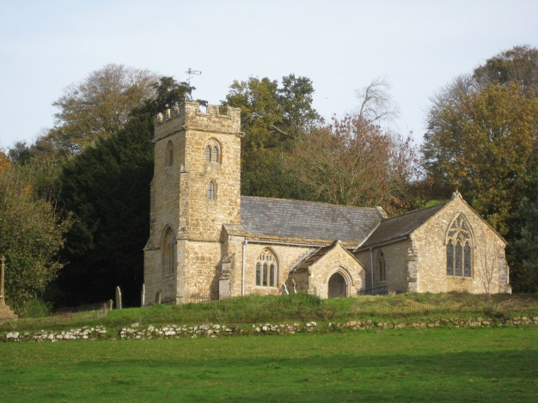
Walk straight ahead along footpath to meet unmarked lane, turn left and walk uphill for 200m turning right at first narrow footpath opening in hedge (ignore earlier field, opening). Walk down footpath turning right when you meet another footpath; turn left at the tarmac lane and walk along lane for 200m turning right onto wide track immediately past last house as the road starts to climb. Walk through kissing gate at end of track and walk slightly to the right of straight ahead aiming for the gate app 70m down from the top left hand corner of the field. Walk through the two gates and bear right and walk along right hand edge of field. When you see the church on your left hand side veer left to walk in front of the church continue with the church on your left climbing all the time to pass close to the left of the large tree in the middle of the field, continue to climb to the left across the open field to reach a wooden gate in the top corner of this field. Go through gate to join track coming in from the right, turning left onto the footpath through a copse.
When you clear the copse onto an open field turn left and walk straight ahead keeping the water tower on your right hand side, walk along the track turn right onto the lane for 40m taking the footpath to the left opposite the water tower. Walk straight across the field turning left onto a lane for 180m and climb bank to take first footpath on right. Walk straight ahead between two fields aiming to the left hand side of copse ahead, walk to end of the copse and through the gate at end of field, turning left to walk along path leading to an open field. Continue to walk straight ahead for app 400m keeping the hedge on your left hand side at the end of this field take a right turn down the depressed footpath between two hedges and descend through the glade to Copse Shute Lane, walk straight ahead on the lane turning right at the junction and the pub and church are straight ahead of you.

