  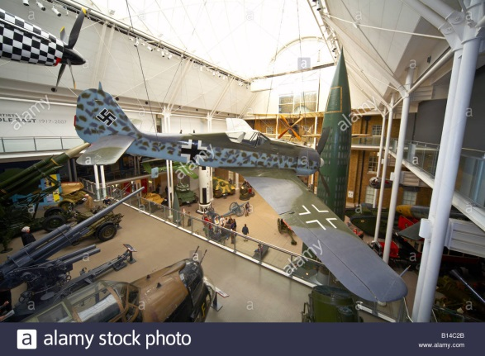

***DAYS OUT TRIPS ARE FOR ALL AGES***

DAYS OUT

Sept - Dec 2017

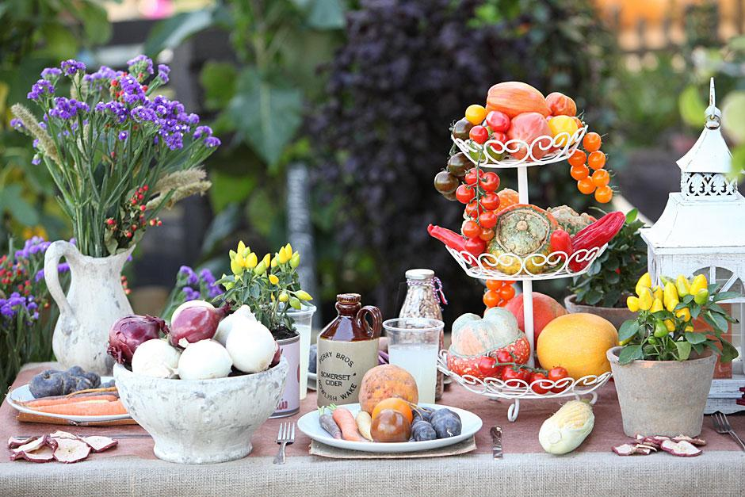  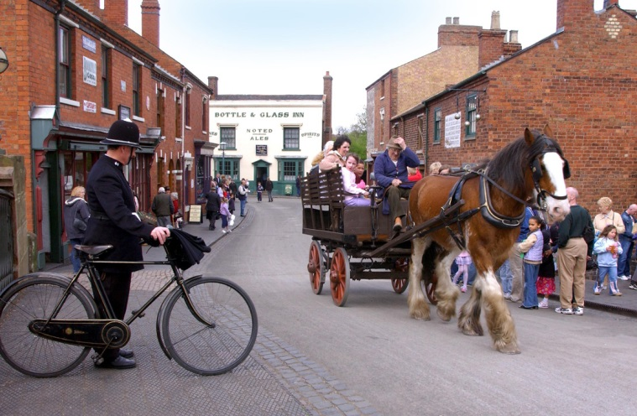

***NEW TRIPS AS WELL AS OLD FAVOURITES***

***LOOK, SOME MOUTH-WATERING TRIPS******TERING TRIPS***

***THE FUN!***

**Departure is from Daventry Bus Station unless otherwise advised**

* **Car Parking.** For **all** DACT DAYS OUT trips the first pick up is from the Old Gasworks Car Park (Brook Street). The pickup is set at 25 minutes before the scheduled trip departure time shown in the brochure. The driver will wait a maximum of 5 minutes. This allows us to get to New Street around 15 minutes before departure, giving time for the remaining passengers to arrive and board the bus. There will be a drop back to the Old Gasworks Car Park at the end of the end of the trip.
* **Litter**. The litter problem on the buses has improved – thank you for your consideration. We still have the odd occassions where a very small minority choose to leave their sweet wrappers, tissues etc on the floor of the bus and we would encourage those people to show the respect the majority of our passengers display.
* **Acessibility**: For those passengers that use wheelchairs or have mobility issues - If you have any concerns regarding accessibility we would request that you contact the venue and talk to them directly, or access their website. We can assist in providing contact numbers if necessary.
* **If you want a travel scooter for a trip you can always hire one from DACT Mobility. We do ask you to talk to the office first, to make sure we have the right type of bus available. (N.B. Some venues do provide Scooters making it unnecessary to take your own. Ask the DACT Office if you need more details)**
* **Cancellations**: These can affect a lot of people. Eg: They may result in trips being cancelled due to insufficient numbers, members losing the opportunity to get group rate entry or trips run at a loss to DACT. Please understand that to be fair to all our members we have to be consistent in applying our cancellation policy.(see back page)
* PLEASE DO NOT ASK YOUR VOLUNTEER DRIVER TO MAKE ANY DROP-OFFS TO ANY VILLAGES OUTSIDE OF DAVENTRY ON RETURN FROM THE TRIP. DRIVERS OFTEN HAVE OTHER RESPONSIBILITIES FOLLOWING RETURN FROM THE TRIP AND DACT HAVE NOT ACCOUNTED FOR ANY ADDITIONAL MILES IN THE COSTING OF THE TRIP.

**Return time is the anticipated time of departure from the venue visited unless otherwise stated**

|  |  |  |  |  |  |  |
| --- | --- | --- | --- | --- | --- | --- |
| **Sept** | **Destination** | **Type of Trip** | **Depart** | **Return** | **Cost** | **Information** |
| Mon 4th | Gloucester Quays | Shopping | 10.00 am | 3.00 pm | £15 | Situated on the waterfront Gloucester Quays is an outlet centre with over 50 stores, offering a mix of high street and designer labels at up to 70% discount off recommended retail prices. Range includes ladies and menswear, accessories, jewellery, homewear, footwear etc and includes names such as M&S, Next, Roman, Klass, Clarks, Osprey, Gap, Calvin Klein and many more.There is also a wide range of restaurants and cafes. Close by is the interesting Waterways Museum and the town centre is about a 15 minute walk away. |
| Tues 5th | Canons Ashby House | House & Gardens | 12.30 pm | 3.45 pm | £9 | Canons Ashby House is a Grade 1 listed Elizabethan manor house set in tranquil surroundings The house and gardens have survived largely unaltered since 1710 and are presented as they were during the time of Sir Henry Dryden, a Victorian passionate about the past. The house features grand rooms, stunning tapestries and Jacobean plasterwork, contrasting with the domestic detail of the servants' quarters. The gardens include terraced gardens, a formal garden and parkland. There is also historic Priory Church to visit. Refreshments are available at the Stables Tearooms. **Our National Trust special rate applies - £5.00 per person.** |
| Wed 6th | Guide Dog National Breeding Centre, Nr. Warwick | Guide Dogs | 1.00 pm | 5.00pm | £9 | An opportunity to have a 2 hour guided tour to see the National Breeding Centre going through its daily activities and to see how they use the latest technology in their breeding programmes. On specially built walkways you will see the staff and the dogs at work. There is also a Sensory Tunnel where you can get a brief insight into living with sight loss. At the end tea, coffee and cake is served and you have the chance to meet some of the dogs. The tour is free but donations are welcome should you wish to make one. |
| Thurs 7th | Loughborough | Shopping | 10.15 am | 2.45 pm | £12 | Loughborough, a vibrant town in the county of Leicestershire with excellent shopping facilities with hundreds of shops and a lively cafe, bar and restaurant culture. It also offers much in the way of culture with numerous buildings that span many centuries. The main shopping area is in the centre and includes 2 shopping centres and the market. |
| Mon 11th | Burghley House, Stamford | House & Gardens | 10.15 am | 3.30 pm | £16 | Built in the 16th century Burghley has over 115 rooms. There is also an Orangery Restaurant, giftshop, gardens and parkland walks (laid out by Capability Brown). Burghley’s Staterooms are described as breathtaking and include a large collection of fine art from around the world. The gardens are the Garden of Surprises, the Sculpture Gardens and the Deer Park. Entry: Adult £18. (There is a discount if we have 15 or more). |
| Tues 12th | BBC Tour, Birmingham | Media Interest | 10.45 am | 3.30 pm | £12 | Step inside the world of broadcasting at BBC Birmingham. An entertaining and informative guided tour explains how scripts get to the screen, how production teams work , the technology and how BBC Drama is made. The tour lasts approx 1.5hours and does involve a lot of walking and standing. Visitors can also look in at the Visitor Centre and the interactive BBC Blue Room. Cost: £9.25. Note: For this trip we can only take 15 people maximum so it is advisable to book early. |
| Wed 13th | Peak District Tour | Peak District | 9.45 am | At Dav approx 5.45 pm | £18 | Mini-tour of the Peak District with it’s beautiful scenery and picturesque small towns. |
| Fri 15th | Tamworth | Shopping | 10.15 am | 3.00 pm | £13 | Shopping in Tamworth ‘The Old Town’ offers a unique shopping experience with its quirky, independent shops, which flows into The Castle Pleasure Grounds, and in sight just across the park are Ventura Retail Parks, offering all the high street names such as M&S, John Lewis, Next and many, many more. The town centre has its Ankerside Shopping Centre and what is described as a vibrant market. |
| Mon 18th | Bletchley Park | Codebreakers Museum | 10.15 am | 3.15 pm | £10 | World famous for its code breaking activities. This is where the code breakers worked and it shows how they operated. There are a number of huts to explore, war memorabilia on display, the Victorian Mansion and much more. Free guided tours take place throughout the day. Entry Cost: Adults £17.25, Seniors £15.25. (this gives you an annual pass). Entry is free if you already have a valid annual pass. Group rate: £14.00 (Applies if we have 12 or more people). |
| Tues 19th | Mystery Tour | Mystery Tour | 10.00 am | At Dav approx 5.00 pm | £14 | Mystery tour with approx 2 or 3 stops for refreshments and browsing. At least one stop will be long enough for lunch and a look round – different route to previous mystery tours. |
| Wed 20th | The Quays / Billing Garden Centre | Pub Lunch / Garden Centre | 11.30 am | 3.15 pm | £9 | The Quays pub is at the entrance to Billing Aquadrome, overlooking the Marina. After a meal there is a short stop at Billing Garden Village, a compact but interesting place to wander around, with a small garden centre, a Ponden Mill, clothes shop and some other smaller outlets including a Smiths Farm Shop. The Quays has various meal offers. The main menu has main courses from around £5.50. There is also an over 60s menu offering 2 courses around £4.50. |
| Thurs 21st | Henley-on-Thames | River Thames Town / Shopping | 10.15 am | 3.30 pm | £15 | On the banks of the River Thames Henley is world famous for its rowing events. It is a 12th century market town with over 300 buildings designated as being of special architectural or historic interest, including St Marys Church, the Town Hall, Market Place and Henley Bridge. Thursday is market day and on this Thursday there should also be a farmers market. |
| Sat 23rd | Malvern Autumn Show | Flower Show | 9.45 am | 3.30 pm | £15 | The Malvern Autumn Show is a celebration of food, the countryside, gardening and nostalgia. A Show for food and gardening lovers, the event hosts a range of celebrity cookery demonstrations, gardening talks, vegetable displays, vintage tractors, crafts and more. Cost: Adults £15.00, Children £5 (**We have tickets so there is no need for you to book online** |
| Mon 25th | Bakewell, Derbyshire | Peak District Town / Shopping | 9.30 am | 3.00 pm | £16 | Home of the Bakewell Pudding. Bakewell is an old market town set in the heart of the Peak District and with the River Wye meandering through the centre. You can wander round the town to see the historic buildings, stroll along the river and browse the shops. Today is market day - Bakewell is described as having the only market in the Peak District National Park with around 160 stalls spread across 2 sites. |
| Tues 26th | Moreton-in-Marsh / Bourton-on-the-Water | Cotswold Towns / Shopping | 10.30 am | 3.45 pm | £13 | Visit to 2 very popular Cotswold towns. Market day in Moreton-on-Marsh attracts visitors from far & wide. Have lunch & browse the stalls before moving on to Bourton-on-the-Water. |
| Wed 27th | Black Country Museum | Historic Interest | 10.00 am | 3.30 pm | £14 | Described as a living open-air museum. The main area has ‘streets’ of over 50 factories, house and shops as they were in the early 1900s, with people in costume to tell you about what was sold and made in those days. There is so much to do and see – take a tram ride, go down a coal mine, go to school!, take a canal trip into limestone caves, watch local craftsmen at work, view historic buildings & a vehicle collection, have a beer in the spit & sawdust inn. There are a variety of food & drink outlets, including the 1930s Fish & Chip shop. Entry: Group rate: Adults £12, Seniors £10. |
| Thurs 28th | Calke Abbey | House & Gardens | 10.15 am | 3.00 pm | £14 | Historic great house in Derbyshire which has remained largely unchanged for most of the 20th century and contains some unique collections. There is also a landscaped park and walled gardens. Described as the ‘unstately home’ to let you see the effects of decline of a country house estate. A fascinating and different place to visit. Restaurant on-site. **Our National Trust special rate applies - £7.00 per person**. (NT members free). |
| **October** | **Destination** | **Type of Trip** | **Depart** | **Return** | **Cost** | **Information** |
| Sun 1st | Imperial War Museum, London | Museum | 10.00 am | 3.30 pm | £16 | IWM London has a number of diverse displays covering WW1 to more current conflicts. Displays include: Fascinating WW1 Galleries, Afghanistan, The Holocaust Exhibition, A Family In Wartime, Secret War, Witnesses To War and more. Objects on view include a Harrier Jump Jet, Spitfire, V-2 Rocket, a T-34 Tank and other vehicles. Entry is free. |
| Mon 2nd | Stratford-on-Avon | Historic Town | 10.30 am | 3.15 pm | £11 | A very popular tourist attraction on the banks of the River Avon. Visitors can enjoy the park area either side of the river, take a river cruise, wander around the shops or visit one or more of the historic attractions such as Shakespeare’s House |
| Tues 3rd | Gloucester Warwickshire Railway | Steam Railway | 10.15 am | 3.30 pm | £14 | Take a ride on a steam or diesel train through the Cotswolds. The GWR runs between Toddington (Near Tewksbury) and Cheltenham Race Course, with stops at Winchcombe and Gotherington. Various stations have tea rooms. Toddington has a small museum, a viewing area behind the loco sheds and a small display of classic vehicles. Various ticket options are available. Return ticket is £17.00 adult, £16.00 over 60s. assuming we have 10+ passengers.. |
| Thurs 5th | St. Neots | Shopping | 10.15 am | 3.00 pm | £15 | St. Neots is described as a charming Cambridgeshire riverside market town. The town centre offers a varied shopping experience, with hidden courtyards running off the High Street. Today is market day. Close to the centre is the River Ouse with it’s Riverside Park. |
| Mon 9th | Dudley Zoo | Zoo | 10.15 am | 3.15 pm | £14 | Dudley is a unique Zoo with hundreds of animals set around the ruins of an 11th century castle. It also has the the country’s only vintage chair lift!. There is a variety of animals - primates, mammals, reptiles, birds etc, including lions, giraffes and penguins. There are cafes and restaurants. Entry: Group rate - Adult £10.50 , Seniors £9.00, Child £7.50 (Assuming we have a min. of 10 people). |
| Tues 10th | Melton Mowbray | Shopping | 10.00 am | 2.45 pm | £12 | A popular destination - visit the home of the Pork Pie on Market day. Look round the, the extensive street market and the large indoor market where there is an antiques market and the auctioning of a range of livestock. |
| Wed 11th | Nuneaton | Shopping | 10.30 am | 3.00 pm | £10 | Market day in Nuneaton, with typically over 100 stores . The market town has 2 shopping centre, Ropewalk and Abbeygate plus semi-pedestrianised street shopping. Shops include Debenhams, TKMaxx, Wilkinsons, Next, Peacocks and many more. |
| Thurs 12th | Huntingdon | Historic Town | 10.15 am | 3.15 pm | £13 | Huntingdon is the county town of Huntingdonshire and birthplace of Oliver Cromwell. It has a good sized pedestrianised shopping area that also has the Cromwell Museum. A short walk away is the River Ouse with its riverside park and walks |
| Mon 16th | IWM Duxford | Aircraft Museum | 9.30 am | 3.15 pm | £16 | Duxford has a large collection of civil and military aircraft through the ages. This includes Concorde (you can walk through), Spitfires & Hurricanes, Flying Fortress, Lancaster, Vulcan. They are spread across a number of hangars, including a Battle of Britain hangar and the impressive and newly renovated American hangar. In addition the Land Warfare hangar houses one of the finest exhibitions of tanks, military vehicles and artillery in the country. For those that need it a mobility vehicle should be operating to move people around the site. Entry: Adult £12.25, Child £6.55 child. (Assuming we have a a minimum of 10 people) |
| Tues 17th | Heathcote Inn, Leamington Spa | Pub Lunch | 11.30 am | 2.30 pm Approx | £9 | A local pub in Heathcote, Leamington Spa. The pub has been recently refurbished and has new menus. The lunch time menu offers main courses from £5.00 and an all day menu offering a variety of options including traditional favourites, pizzas, fish, steaks and burgers. |
| Wed 18th | Peterborough | Shopping | 10.00 am | 3.30 pm | £15 | A vibrant East of England city with a range of shopping options including its Queensgate Centre, extensive street shopping and a market. Close to the shops is Peterborough Cathedral, described as one of the finest Norman cathedrals in England, the burial place of two queens and the scene of Civil War upheavals. Lots to explore. |
| Thurs 19th | Batsford Arboretum | Arboretum | 10.15 am | 2.30 pm | £11 | Autumn at Batsford. The Arboretum covers 56 acres, and has different things to see all year round. At this time we hope to see the Autumn colours. There is a visitor centre with its Garden Terrace Café, a Gift and Garden Shop and a Plant Centre. Entry: £6.00 |
| Mon 23rd | Kew Gardens | Gardens | 9.00 am | 3.00 pm | £19 | Autumn at the world famous Kew Gardens. Kew covers 325 acres and includes lakes, extensive walkways, themed areas and a number of greenhouses housing a wide array of temperate plants and trees, including alpines and orchids. Mobility scooters available (book in advance). There is a land train (approx £5 for the day) that stops at various points around Kew.  **With our excellent agreement with Kew we are able to offer this trip at a total cost of £19 (Bus and entry combined).** |
| Tues 24th | Severn Valley Railway | Steam Railway | 9.00 am | 3.00 pm | £15 | See Autumn colours on a steam train through some beautiful Worcestershire countryside, including a stretch alongside the River Severn. The train runs from Kidderminster to Brignorth, a jouney of just over 1 hour. In between are a number of stations providing the opportunity to get off and explore. Stop off at Highley to look round the engine house with its engines and exhibition. Fares vary up to a fully flexible ‘freedom of the line’ticket price at £19.80 adults, £18.80 over 60s and £13 children. |
| Wed 25th | Nottingham | Shopping | 10.15 am | 3.30 pm | £14 | Nottingham is described as one of the top retail centres in England. The centre has extensive shopping including the Victoria Centre (with over 120 shops), The Exchange, Cobden Chambers and Broadmarsh Shopping Centre. In addition there are museums, a city centre tram system and extensive pedestrianised streets. |
| Sun 29th | London Museums | Museums / London | 9.30 am | 4.00 pm | £19 | London’s famous museums – The Natural History Museum, The Science Museum and the Victoria & Albert Museum. The Natural History Museum is a series of zones – including the age of dinosaurs, the Darwin Centre & Cocoon and much much more. Next door is the Science Museum covering a wide range of topics such as space exploration, medicine & health, energy & flight. Across the road is the V&A Museum, claimed to be the worlds greatest museum of art & design. All museums FREE to enter – special exhibitions, simulators etc may be chargeable. This is also a good base for onward travel to Oxford Street, Harrods and other parts of London. |
| Tues 31st | Sutton Coldfield | Shopping | 10.15 am | 3.00 pm | £14 | Sutton Coldfield is a town close to Birmingham. The Gracechurch Shopping Centre has a number of shops, including M&S, House of Fraser, H&M, Next etc. Gracechurch is part of a pedestrianised shopping area in the town centre, there you can find TKMaxx, Wilkinson and more. |
| **November** | **Destination** | **Type of Trip** | **Depart** | **Return** | **Cost** | **Information** |
| Wed 1st | Dobbies Garden Centre, Atherstone | Garden Centre | 10.30 am | 2.30 pm | £10 | Popular garden centre just past Hinckley. A typical large garden centre that also Includes a clothing outlet and food hall. Also has a large restaurant. |
| Fri 3rd | The Stitching, Sewing and Hobbycrafts Show NEC | NEC Shows | 9.30 am | 3.30 pm | £14 | Stitching, Sewing and Hobbycrafts Show at the NEC. Avid knitters, stitchers, hobbyists and crafters will be in their element with endless supplies, innovations, new product launches, demonstrations and workshops designed to encourage and inspire your creativity – there’s no better place to stock up and revel in creative craft inspiration! Entry also to Simply Christmas, Art Materials Live and Cake International. Entry: Adults £12 Seniors £11. |
| Tues 7th | Boundary Mills, Grantham | Shopping | 10.30 am | 3.00 pm | £13 | Boundary Mills ,Grantham, offers a a large choice and discounted prices against leading names in [ladies](http://boundarymill.wpengine.com/department/ladieswear/) and [men’s](http://boundarymill.wpengine.com/department/menswear/) leisure, outdoor and occasion wear, [footwear](http://boundarymill.wpengine.com/department/shoes/), [lingerie](http://boundarymill.wpengine.com/department/lingerie/) etc. In the same building there is a large Downtown Department Store selling a wide range of [home, garden, electrical, fashions, toys](http://boundarymill.wpengine.com/department/home-furnishing/) and much more. Opposite there is also a Downtown Garden Centre. Boundary Mills and Downtown both have restaurants. |
| Thurs 9th | 1. Bicester Avenue 2. Bicester Village | Shopping | * 1. am | 3.00 pm | £11 | Two very different shopping experirencec in Bicester – you can choose which one you want to visit.   1. Bicester Avenue is a small avenue of shops (including Lakeland, Hobbycraft, Cotton Traders) and a large Wyevale garden centre that includes a restaurant and food hall. 2. Bicester Village is a very popular outlet for Designer brands in fashion and homeware. All leading brands are there offering goods at discounted prices that can be as high as 60%. |
| Mon 13th | Coventry | Shopping / Attractions | 10.30 am | 3.00 pm | £9 | Coventry has a number of attractions close together, all within easy walking distance. There is an extensive shopping area with most major retailers present. There is also **Coventry Cathedral** (donation requested) and the **Coventry Transport Museum** which has undergone an extensive £9 million makeover - it is a great place to visit, has a restaurant and entry is **free.** |
| Wed 15th | Brampton Halt, Chapel Brampton | Pub Lunch | 11.30 am | 2.30 pm Approx | £8 | Located in the Northampton countryside and right next to the Lamport & Northampton Steam Railway. There is an extensive menu. Meal prices vary but a number of menu items are included in a 2 main meals for £14.95 offer. |
| Mon 20th | Boundary Mills, Walsall | Shopping | 10.15 am | 3.00 pm | £13 | **Today is part of ‘Black Friday’ week so there should be some great offers.** Shopping under one roof with offers and discounted prices against leading brands in [ladies](http://boundarymill.wpengine.com/department/ladieswear/) and [men’s](http://boundarymill.wpengine.com/department/menswear/) leisure, outdoor and occasion wear, [footwear](http://boundarymill.wpengine.com/department/shoes/) and [lingerie](http://boundarymill.wpengine.com/department/lingerie/); [luggage, bags and accessories](http://boundarymill.wpengine.com/department/luggage-bags-accessories/); [home furnishings](http://boundarymill.wpengine.com/department/home-furnishing/), [cookware](http://boundarymill.wpengine.com/department/cookshop/), [china and glassware](http://boundarymill.wpengine.com/department/china-glass/); [art, crafts and gifts](http://boundarymill.wpengine.com/department/arts-crafts-gifts/) There is also a large restaurant. |
| Wed 22nd | Winchester Xmas Market | Xmas Market | 9.30 am | 3.30 pm | £17 | Winchester is a city world famous for its cathedral and other historic buildings, includng The Great Hall & King Arthur’s Round Table. In addition there are a variety of museums, shops and parks all within a reasonably compact area. Today there is a Christmas Market with wooden chalets situated in the Cathedral’s historic Inner and Outer Close, surrounding an open-air ice rink. |
| Fri 24th | Milton Keynes | Shopping | 10.15 am | 3.00 pm | £13 | Milton Keynes is a very large indoor shopping centre with major brands such as John Lewis, Debenhams, House of Fraser, Next, M&S etc. This is the time that Middleton Hall,- in front of John Lewis - has its popular Christmas themed display. |
| Mon 27th | Swindon Designer Outlet | Shopping | 9.30 am | 3.15 pm | £15 | **Now expanded to more than 100 stores, cafés and restaurants**. McArthur Glen’s Swindon Designer Outlet is one of Europe’s largest undercover centres, where you can find your favourite labels with price reductions of up to 60%, all year round. It is housed within the Grade 11 Listed building of the former Great Western Railway Works. |
| Tues 28th | Leicester | Shopping | 10.15 am | 3.15 pm | £10 | Leicester has its large modern Highcross Shopping Centre which includes major brands such as John Lewis, Debenhams and House of Fraser. Just outside of Highcross are the outdoor and indoor markets offering a wide range of foods and goods. A short walk from the shopping away is the **King Richard 111 Vistitor Centre.** |
| Thurs 30th | Worcester Xmas Fayre | Xmas Fayre | 9.45 am | 3.15 pm | £19 | Today is the start of the very popular Worcester Victorian Christmas Fayre, a Victorian- themed street market with around 200 stalls. Worcester has 2 main shopping centres plus High Street specialist shops. In addition there is the riverside to walk along the famous Cathedral. All are relatively close together. |
| **December** | **Destination** | **Type of Trip** | **Depart** | **Return** | **Cost** | **Information** |
| Thurs 7th | Birmingham Xmas German Market | Xmas Market | 10.15 am | 3.15 pm | £13 | Christmas in Birmingham. A popular shopping destination with its modern shopping centre and large indoor and outdoor markets. Shop in the glamorous Bullring Centre, stroll up New Street & other shopping streets! Take a walk to the Ashmolean Museum and the stunning new Library with its rooftop gardens and views over the City. At this time the popular German Market is spread along the length of New Street up to the Town Hall |
| Mon 11th | Solihull | Shopping | 10.15 am | 3.15 pm | £13 | Solihull has its modern Touchwood indoor shopping centre plus outside a very pleasant pedestrianised area. It has John Lewis, House of Fraser, Bhs and a host of other retail outlets. There may be a Christmas market in the square. |
| Tues 12th | Blooms Garden Centre, Dunchurch | Garden Centre | 11.00 am | 2.30 pm | £8 | Popular garden centre near to Dunchurch. Part of the Gardening Club chain, offering a wide range of goods and plants. Has a large restaurant. Outlets include Edinburgh Woollen Mill, Mountain Warehouse, Hotter Shoes & The Works |
| Thurs 14th | Red Lion, Adderbury | Pub Lunch | 11.15 am | 2.30 pm Approx | £10 | Our last pub lunch before Christmas, an opportunity to get together with friends and maybe people you have been on trips with over the year. The Red lion is part of the Old English Inns group and is an old Coaching Inn in the village green of Adderbury (near Banbury). There is an extensive menu plus a Value Menu with main courses from £4.99 and starters and desserts at £2.99. (Note: We have not booked the Christmas menu) |
| Tues 19th | Milton Keynes | Shopping | 10.15 am | 3.00 pm | £13 | Milton Keynes is a very large indoor shopping centre with major brands such as John Lewis, Debenhams, House of Fraser, Next, M&S etc. This is the time that Middleton Hall,- in front of John Lewis - has it’s popular Christmas themed display. |

**To register *FREE*  for the DACT ‘Days-Out’ Scheme, simply telephone the number below stating you wish to register as a new member. You will be asked for your full name, address and date of birth. If you have any kind of mobility difficulties which you think we should be advised of, please notify us. (e.g. you perhaps need to bring a tri-walker on a trip)**

**Points to note:**

* Booking will be on a first-come first served basis. For trips that are fully booked we will run a reserve list and contact people on that list if seats become available through cancellations.
* There are **NO** age restrictions applicable to DACT Days Out, but unfortuanately all seats are charged at the same rate. This also applies to carers of wheelchair passengers etc.
* Price quoted is for return travel only. Admission charges are not included, unless otherwise stated. Food, drink etc is excluded.
* Payment in cash should be made to the driver on the day of the trip unless stated otherwise.
* Pick-ups The bus will leave from Daventry Bus Station at the time stated in trip details. **We will wait a maximum of 5 minutes only, in fairness to other passengers.** If a number of passengers from the same area are travelling, it may be possible to arrange another pick-up point en-route.
* **Drop offs - Passengers within Daventry Town may be dropped off close to home on the return trip where practicable. This is purely a courtesy by the driver and we would ask passengers not to abuse this courtesy.**
* DACT will do their best to make sure every trip operates as advertised. However in circumstances beyond our control or minimum numbers not being met, we may have to change or cancel – we cannot run these trips at a loss to DACT.
* Trip Information is obtained from a variety of sources. We try to give a fair summary of a destination but we cannot guarantee that all the content we may use is totally accurate.
* **Trolleys**. We can carry shopping trolleys but they must be booked in advance as there is only limited storage space on our buses.
* ***CANCELLATIONS. Please be aware that if you cancel your booking late, you prevent others from travelling on the trip who would otherwise have been able to go, and also if buses then get insufficient numbers, they run the risk of being cancelled. Please only book if you definitely intend to travel. All bookings are taken on trust without a deposit and we do not want to change this procedure to avoid heavy administration. Any trip cancelled at less than 5 full working-days notice prior to the trip date (or a no-show on the trip day) will incur the full trip cost as it is unfair to other passengers to have their trip cancelled at short notice. Please pay to the DACT Office as soon as possible.***

**The Abbey,**

**Market Square,**

**Daventry.**

**Northants NN11 4XG**

**Tel: 01327 701665**

**for all bookings**

**Email: info@dact.uk.com**

**Website:** [**www.dact.btck.co.uk**](http://www.dact.btck.co.uk)

**Donating to DACT helps us to help others**

**and keep DACT’s future more secure.**



**Registered Charity No:- 1170448**

**The Abbey, Market Square,Daventry, Northants NN11 4XG Tel: 01327 701665**

**YES, I will help DACT (Keeping Charity Local). Please use my gift to help DACT provide community transport in the Daventry district.**

BANK STANDING ORDER FORM

This replaces any previous standing order to DACT

|  |  |  |  |
| --- | --- | --- | --- |
| Full Name] | From the account detailed, please deduct | Name of Account holder |  |
|  | £5 £10 £15 £20 £50 | **Name of Bank & Address** |  |
| Address] | Other £ |  |  |
|  | Every month Quarter Year |  |  |
|  | Commencing: Day /month year |  |  |
|  |  | **Post Code** |  |
|  |  | **Account No:** |  |
|  | Pay regularly until further notice | **Sort Code:** |  |
|  |  | **Signature:** |  |
| Post Code] |  | **Date:** |  |
|  |  | **FOR OFFICE USE ONLY:** | Paying Bank please use the following reference: |

**Pay to:- Daventry Area Community Transport Account No:- 10764175 Sort Code: 20 – 73 – 48**

Barclays Bank, High Street, Daventry, Northants NN11 4BQ

Please ensure any backdated payments are credited.

Or

**I cannot give regularly at the moment, but please accept the enclosed gift of £ payable to DACT**

*I am a UK taxpayer and would like to treat all donations I have made for the four years prior to this year, and all donations I make in future as Gift Aid donations. I understand that if I pay* less Income Tax and/or Capital Gains Tax in the current tax year than the amount of Gift Aid claimed on all my donations, it is my responsibility to pay any difference.

Signature: …………………………………………………….. Date……………………………

THANK YOU FOR YOUR SUPPORT  **In order to maximise your donation we will not send a receipt unless you tick this box**