**Base 25**

**Counselling delivery model**

**Young person is referred to Base 25**

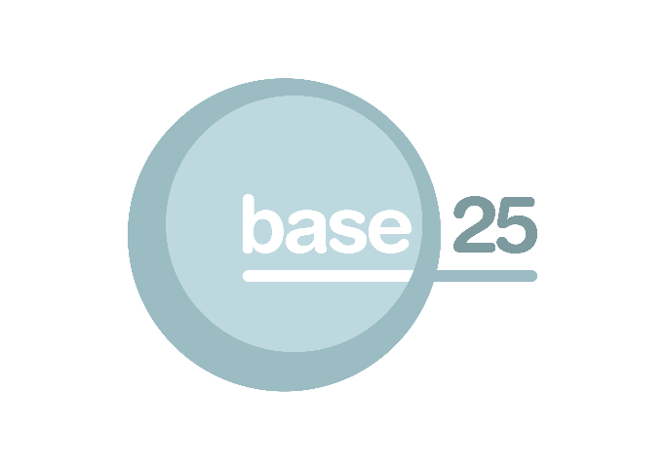

**Core Base 25 offer**

**(Key working, drop in service, group work)**

The Key worker can offer an immediate appointment with a young person and support them to access the open access drop in service; the group work opportunities, crisis counselling or be supported to access other services

**Young person presents at Base 25 in need**

**Base 25 Specialised Projects**

SAFE (DV Project)

Empower (CSE Project)

Anger Management

Gangs work

Gender based project work

**Counselling**

**Referral Assessed by multi agency duty team**

**Referral Assessed by multi agency duty team**

**Appointment offered for assessment utilising RCADS**

**Counselling appointment offered for up to 8 sessions utilising GAD7 and PHQ9**

**Review with young person/family member or carer**

**Additional sessions offered if required (up to 12)**

**Final review with young person/family member or carer**

**Step down**

When a lower threshold services can meet the individual needs of the young person

**Step up**

When safeguarding needs are identified or the young person’s needs exceed the service threshold

Referral to alternative partner organisation i.e. CAMHS