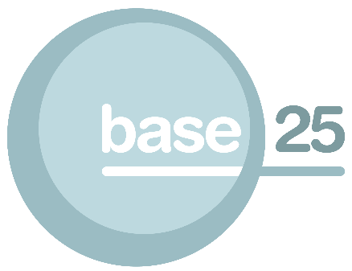

Castle House, Wheelers Fold
Wolverhampton WV1 1HN


Tel: 01902 572040



www.base25.org

Walden the Roots

Counselling and Psychotherapy Training

ABC Level 3 Certificate in Counselling Skills
Venue: Base 25, Wolverhampton, Castle House, Wheelers Fold, WV1 1ST
Course Start: October 2015
Course end: July 2016
Course Day: Thursday
Course Time: 18.00 - 21.00
Course Duration: 150 GLH
Course Fee: £1269.00

Course fee includes tuition, registration and certification fees. Course fees also include study days and weekends. Payment instalment plan available.
Maximum student capacity: 15

Entry Requirements:
Successful completion of a level 2 certificate in counselling skills or APL. Candidate suitability will be assessed through interview.

The course focuses on the theoretical concepts and skills needed as the foundation for beginning client work experience within a counselling agency setting. This is a practical course that will give you the opportunity to practise counselling skills, and to prepare for supervised work with clients.
On successful completion candidates will be eligible for interview for Diploma Level 4.
Qualification Units
- The Professional Framework of the Counsellor
- The Counselling Relationship
- Client Diversity
- The Service User-Centred Approach
- Personal Awareness in Counselling
- Counselling Concepts
- Supervision and Self-Reflection
For more information please contact Jason Dudley at Base 25 on 01902 572040 or email jason.dudley@base25.org

