I feel love – Donna Summer
Quiet
[A] Ooh It's so good, it's so good It's so good, it's so good
It's so good (2, 3, 4, 5, 6, 7, 8, 1, 2, 3, 4, 5, 6, 7, 8,)
[C] Ooh Heaven knows, heaven knows Heaven knows, heaven knows Heaven [D]knows (2, 3, 4, 5, 6, 7, 8, 1, 2, 3, 4, 5, 6, 7, 8,)
[E] OohI feel love, I feel love I feel love, I feel love
I feel love (2, 3, 4, 5, 6, 7, 8, 1, 2, 3, 4, 5, 6,)
Getting
Louder
I feel lo-[A]- [C]- [D]- [E] ve, I feel lo-[A]- [C]- [D]- [E] ve, [A]
(2, 3, 4, 5, 6, 7, 8, 1, 2, 3, 4, 5, 6, 7, 8,)

[A] Ooh Fallin' free, fallin' free Fallin' free, fallin' free
Fallin' free (2, 3, 4, 5, 6, 7, 8, 1, 2, 3, 4, 5, 6, 7, 8,)
Even
Louder
[C] Ooh You and me, you and me You and me, you and me
You and [D] me (2, 3, 4, 5, 6, 7, 8, 1, 2, 3, 4, 5, 6, 7, 8,)
[E] Ooh I feel love, I feel love I feel love, I feel love
I feel love (2, 3, 4, 5, 6, 7, 8, 1, 2, 3, 4, 5, 6,)
LOUD!
I feel lo-[A]- [C]- [D]- [E] ve, I feel lo-[A]- [C]- [D]- [E] ve, [A]
(2, 3, 4, 5, 6, 7, 8, 1, 2, 3, 4, 5, 6, 7, 8,)

[A] OohI'll get you, I'll get you I'll get you, I'll get you
Getting
Quieter
I'll get you (2, 3, 4, 5, 6, 7, 8, 1, 2, 3, 4, 5, 6, 7, 8,)
[C] Ooh What you do, what you do What you do, what you do
What you [D] do (2, 3, 4, 5, 6, 7, 8, 1, 2, 3, 4, 5, 6, 7, 8,)
[E] Ooh I feel love, I feel love I feel love, I feel love
I feel love (2, 3, 4, 5, 6, 7, 8, 1, 2, 3, 4, 5, 6,)

I feel lo-[A]- [C]- [D]- [E] ve, I feel lo-[A]- [C]- [D]- [E] ve, [A]
Quiet
(2, 3, 4, 5, 6, 7, 8, 1, 2, 3, 4, 5, 6, 7, 8,)
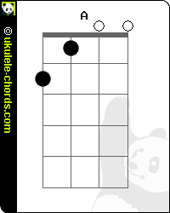 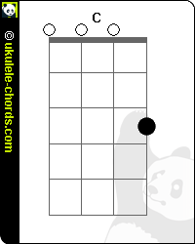 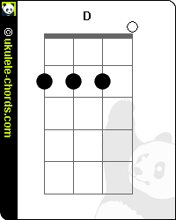 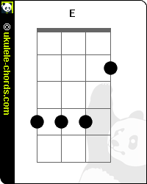 or 