Em Brain fried tonight through misuse
Monster
The Automatic
www.youtube.com/watch?v=dp0Z7otCk7Q
D6 Through misuse, through misuse
Em You can't avoid -- static abuse D6 No abuse, no abuse
Em Without these pills you're let loose
D6 You're let loose, you're let loose
Em Stand up, get out, no excuse D6 No excuse, no excuse
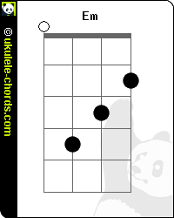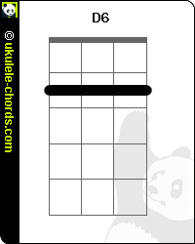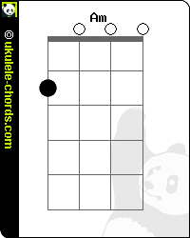

Am What's that coming Bm over the hill
Is it a Em monster? Is it a D monster?
Am What's that coming Bm over the hill
Is it a Em monster? Is it a D monster?
Am What's that coming Bm over the hill
Is it a Em monster? Is it a D monster?
Am What's that coming Bm over the hill....
Em.........
Em Confused, mind bruised, it seeps out D6 It seeps out, it seeps out
Em Face down, home town looks so grey
D6 Looks so grey, looks so grey
Em Convexed you bend, twist and shout
D6 Twist and shout, twist and shout

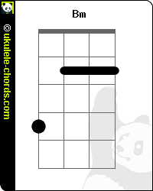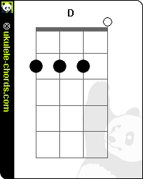
Em Stand up, brush off, get moving
D6 Get moving, get moving
Am What's that coming Bm over the hill
Is it a Em monster? Is it a D monster?
Am What's that coming Bm over the hill
Is it a Em monster? Is it a D monster?
Am What's that coming Bm over the hill
Is it a Em monster? Is it a D monster?
Am What's that coming Bm over the hill
Is it a Em monster? Is it a D monster?
X What's that coming over the hill......

