 On The Jack

This is a monthly newsletter for TCBC members with the aim of enhancing communication within the Club.
July 2016

Pentyrch B C Visit

On Saturday 4th of June we hosted Pentyrch Bowls Club. The weather was fine and everyone enjoyed the afternoon.

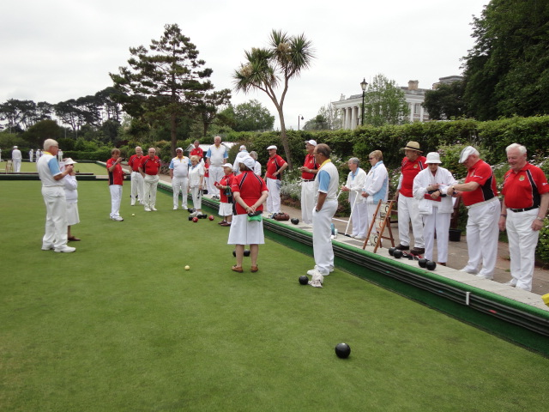

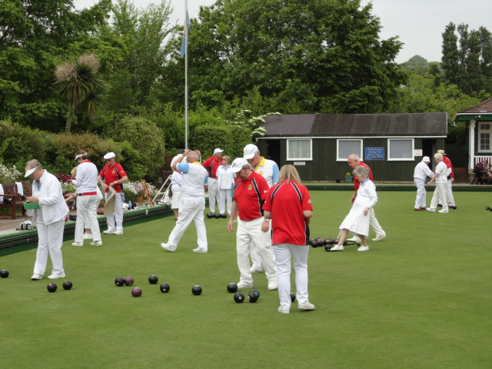

June saw us also entertain teams from Exonia B C and Woodley B C.

Unfortunately the 6 Men friendly against Isle of White Tours did not go ahead.

Thank you to all Club members for joining in these matches. Sign up in the files for forthcoming matches.

Spotlight the MDL B-Team


Above: The Lineup

Below: In Action
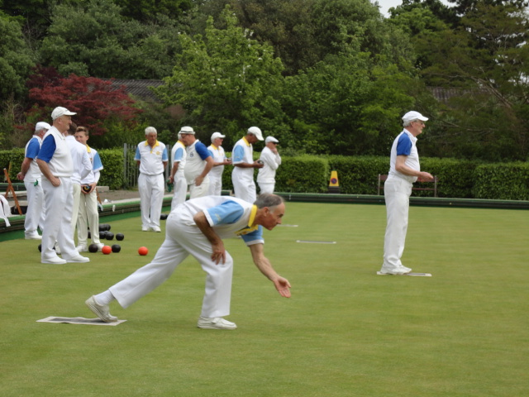
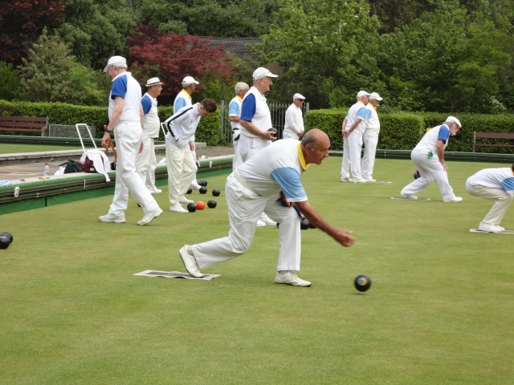
Spotlight your team. Just send in low resolution photos and they can be published On The Jack.

Around the Greens

Fortunately the A Green has been “repaired” during it’s untimely closure and is now back in action. This inconvenience has not stopped social, league and competitions from taking place. Once again, well done all those dedicated members who work behind the scenes to make our Greens playable.

Thursday Triples

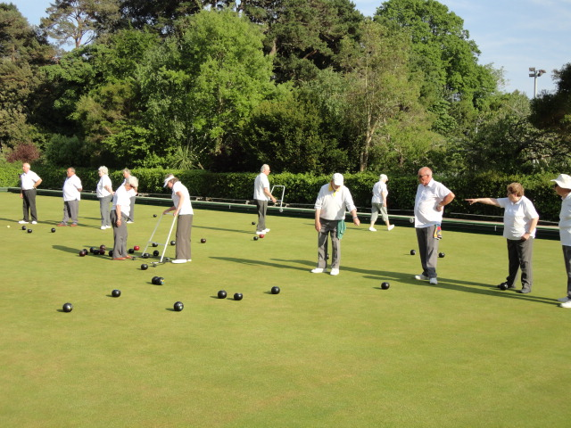

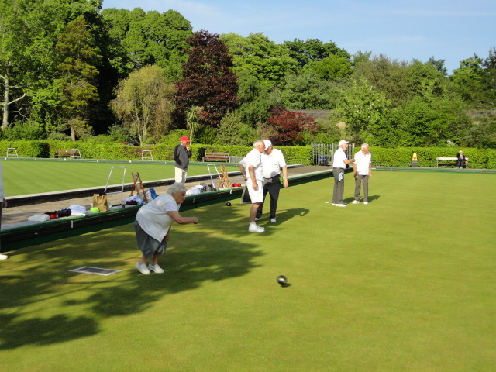

Please note

The Mens’ 2-wood pairs has been rearranged for Saturday 30th July. Check the noticeboard to see who you are playing in the first round which starts at 10am.

The Mens’ 4-wood pairs remains unaltered and is scheduled for Saturday 9th July starting also at 10am. Like the 2-woods, successful teams from the first round will play again at 2pm.

Both Greens will be booked for these days.

Competitions

Many competitions are taking place at the Club as deadlines approach. Please try to complete your matches as soon as possible.

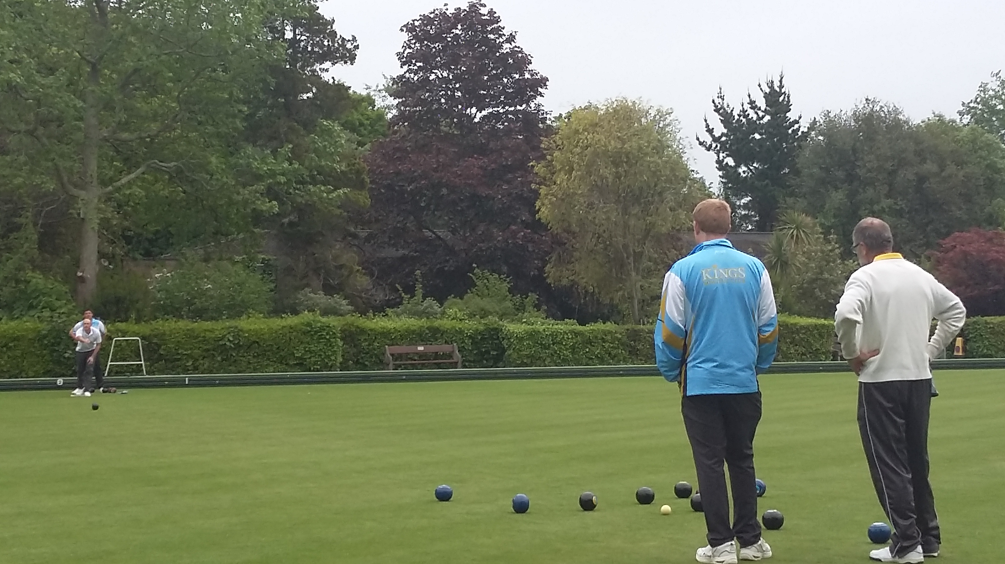

Alan Hawke and Mark Powell beating a Kings pair.

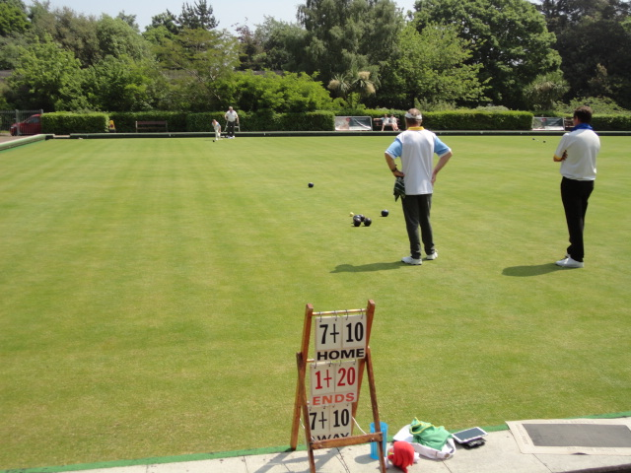
A close match between Alan and Harvey versus David and Jeff of Torquay.

Mixed Triples, Marilyn, Cyril and Bernie v. Victoria

A-Team Get Ready to Face Kings

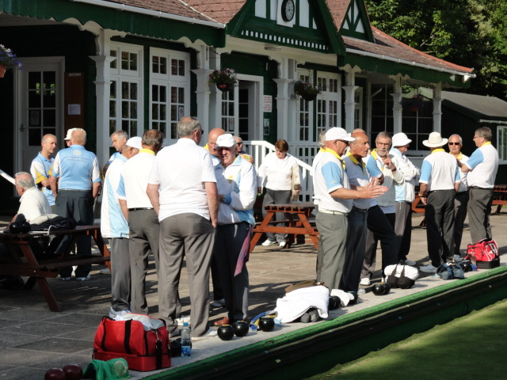

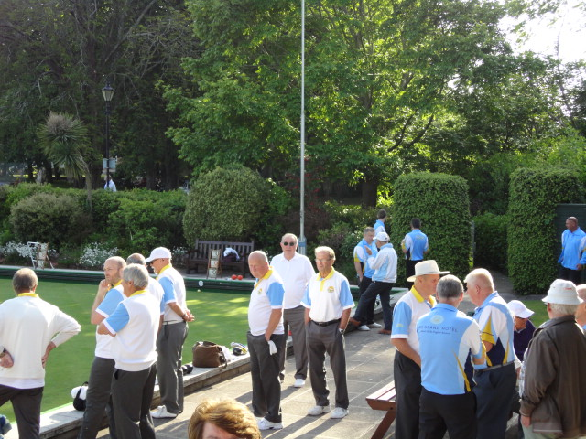

Unfortunately, top of the league Kings inflicted a comprehensive 14-0 defeat on the Club team.

Also seen on the A Green.….

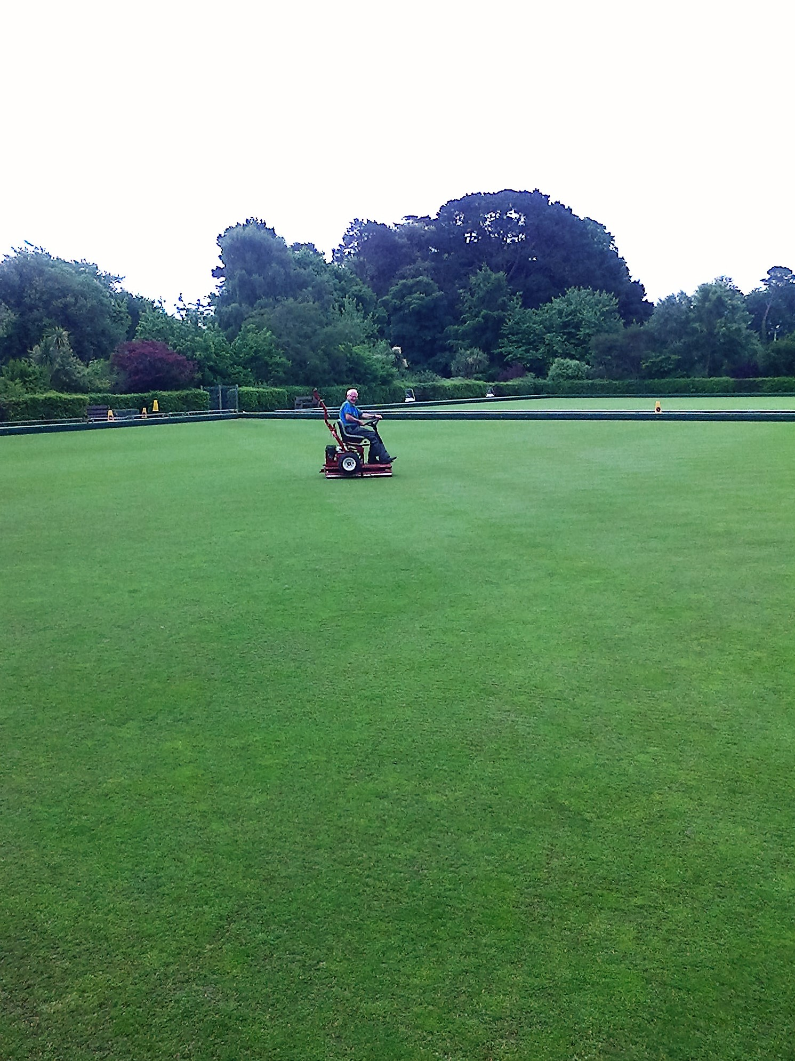
“ A boy with a toy? “

Caption Contest Result

Thank you to the numerous members who entered last month’s Caption Contest.

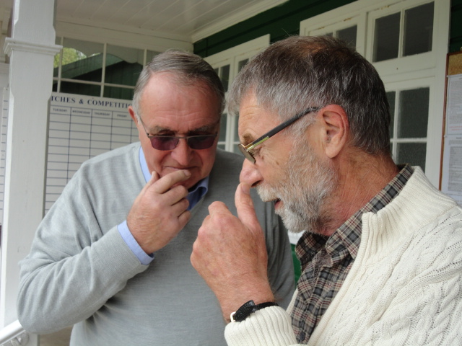

The winner is:-

“Now tell me Alan, and I promise to keep it a secret, who was the member of the A-Team who delivered a Wood on the wrong bias?”

Wit of The Month (winner), Graham Heaven.

Arrangements will be made to present Graham with a suitably inexpensive bottle of wine at the July 3rd BBQ!!

As expected some submissions were not suitable for publication, but they were funny! However, here are two that have made it.

“ I bet mine is bigger than yours”

I am assured that Rob Walker is talking about their noses.

And.….

“ I know Alan, I too find it’s hard to be modest when you’re perfect.”

That was mine.

Next Month

We hope that the weather is kind to us for the BBQ on Sunday 3rd July which is fully booked. Also there is a social on Sunday 24th so look out for details.

Latest results from the MDL A-Team

“TCBC “A” started the month of June with heavy defeats with home matches against both Kings and Newton Abbot but have responded well with three consecutive wins over Newton Abbot away, and both Kingsteignton and Torquay at home. This puts us clear fourth in the MDL Premier Division and in an excellent position to seriously challenge Newton Abbot for a third place position.
In our remaining cup competitions, we narrowly lost 2-3 away to Kingsbridge in Top Club Trophy but have successfully moved to the second round of the County Trophy with a convincing win over Brixham.”
A short report like this above can be e-mailed to tcbcnewsletter@gmail.com and it will keep Club members informed. It’s not just for the A-Team!!
Committee Notice
A notice from your Committee is also attached this month. It emphasises the need for members to sign up and take part in social matches against visiting teams. Without the revenue from this source it surely would be more difficult to balance the accounts. So, please read the notice and try to help by making yourself available.
Captains’ Day
Both Captains, Pat Phillips and Chris Ellingford, will be hosting their Bowls and refreshment day on Sunday 31st July. It starts at 1:30pm
Signing up sheets are now in the folder for you to register your intention to attend.
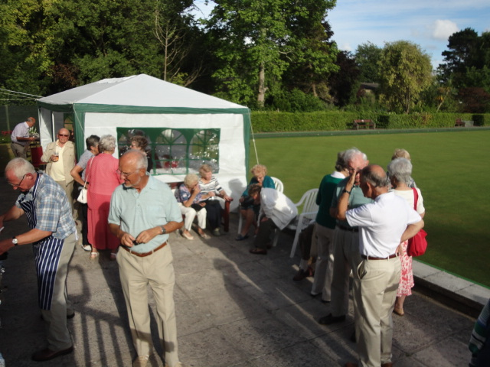
See if it was in the next issue.
This time last year. Let’s hope Sunday 3rd is sunny too.

