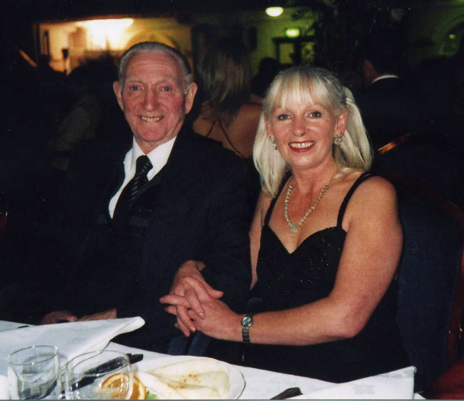

Citation. John with daughter Ann, I was in the last 3 of finalists for citizen of the year 2005 and 2 of us didn't win

Dear Sir,
I would like to propose John Lumsdon as Stoke-on-Trent citizen of year for 2005.
John came to the Potteries from the Northeast of England in 1966 and he brought with him a strong sense of community. He was one of the many men from that area who transferred into local collieries as part of the National coal Board’s plan to bring miners from closing pits, into the booming mines of North Staffordshire.
As a face worker at Florence colliery he soon settled in. He became a member of the N.U.M. committee, and was elected Workmen’s Inspector and served in that capacity for 10 years. In 1968 he became a member of the North Staffordshire Trades Council. John served with distinction in the Mines Rescue Service for which he received a Long Service Certificate, and a bronze and silver award. During the miner’s strike of 1984/85 he was the treasurer of the strike committee.
After 34 years on the coal-face John retired in 1986, since then he has continued to make a remarkable contribution to the people of Stoke-on-Trent. For 15 years he served as secretary of the Worker’s Education Association, he has been a volunteer for Age Concern since 1999. For 12 years he served as a member of the Community Health Council being its Vice Chairman in 1997/8. He was also Chairman of the now disbanded Hospital Visiting Group.
As if this wasn’t enough He also found time to research and write some of the most detailed and comprehensive accounts of many of North Staffordshire’s worst mining disasters. He has just completed listing the names of some 3,500 men killed in local mines since the early hundreds. All these papers and information are available at the click of a button on the Internet. He has also lectured on this subject for historical societies all over the area.
John is now 78 years old, he is still researching coal mining as a student of the Stoke-on-Trent College. He has visited a number of old people’s homes to teach as he calls them “the old uns” how to serf the net, E-mail and other basic computer programmes. At the present time he gives the same talks in Hanley Library on behalf of Age concern’s Mobile Information and Technology Service.
As part of the Fifty and Counting Team (FACT) he has recently visited Berryhill village and the North Stafford Hotel to give a short talk to the elderly and W.R.V.S. on how to keep fit and health in old age.
The voluntary work he does for someone of his age is amazing and he takes no account of other things that are never mentioned like answering letters and E-mails from all over the world from people inquiring after long lost relatives who may have worked in the collieries of North Staffordshire. He is still a member of the T.U.C. Pension Committee for the N.U.M.
This man leaves me breathless.
Ever since he came to Stoke-on-Trent John has worked tirelessly to support those he perceived to be less fortunate than himself. Whether serving on various committees, teaching computers, through his research, or as a member of the Mines Rescue Service he always gives his best. John is not one who seeks publicity; you will rarely find him at the front of official photographs. He just works quietly in the background doing what he thinks is his duty as a human being. On top of all this he is a smashing man, a man without malice. I have never seen him angry, but he will fight injustice in whatever form it takes. I wholeheartedly commend John to you. In my opinion more honest and decent citizen you will not find.
John Burston
Edit Save Page

