Children’s Speech, Language and Communication Development
This language pyramid below shows how speech, language and commuication skills develop (start at the bottom of the page)
Academic and social success
Writing
Reading

Language skills are crucial for learning to read and write and form firm foundations on which to base later literacy and academic achievement.
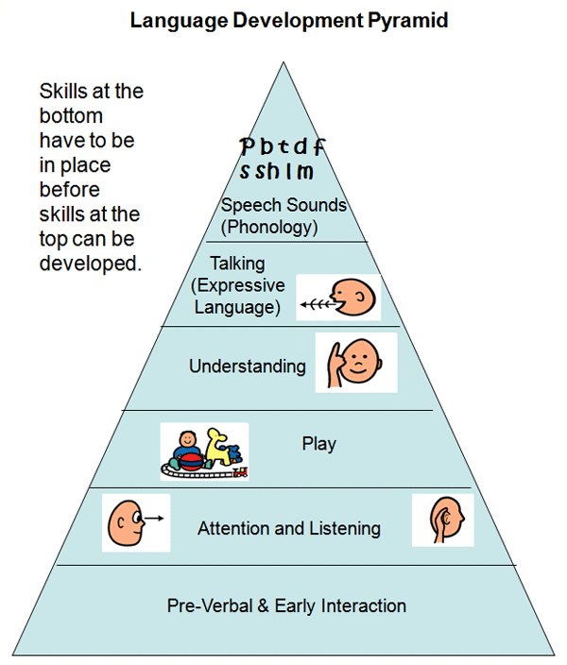
Pronunciation
Adult Child Interaction
Social Communication
Social communication and Talking
Receptive language
Communication, speech and language are essential skills for life. Almost every aspect of learning and socialising involves language. Children learn language best trhoguh talking with adults and through playing
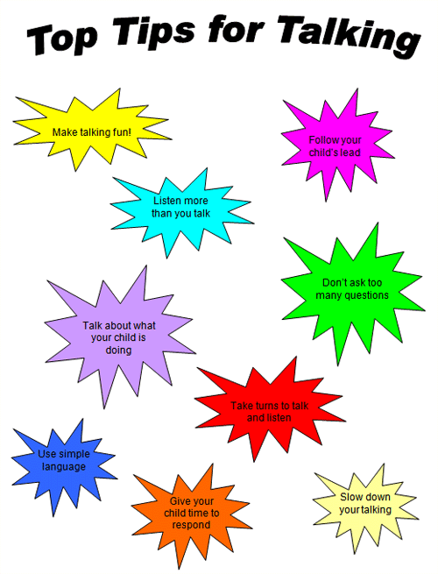
TOP TIPS FOR TALKING
Ways to support and develop communication

A Unique Child
• Follow the child’s lead.
• Join in with the child’s play or mirror their actions.
• Focus on what a child is looking at or doing.
• Wait and allow the child time to start the conversation.
• Take turns to communicate so that adults and children both get a turn
at talking.

Positive Relationships
• Build up a child’s sentences by repeating and adding words.
• Give choices to increase vocabulary, e.g. ‘Apple or Satsuma?’
• If a child says something inaccurately, acknowledge what they have
said and repeat it back in the correct way.
• Share the top tips with parents so that they can do the same at
home.

Enabling Environments
• Get down to the child’s level – it’s easier to talk if you are face to face.
• Get a child’s attention before you start to talk.
• Make sure you use lots of statements and fewer questions.
• Try to have a conversation with every child every day.

Learning and development
• Plan a variety of interesting activities so that there is plenty to talk
about.
• Use daily routines to repeat and emphasise basic language.
• Listen to sounds around you and play games that encourage listening.
• Have fun together with songs and rhymes.

Supporting children’s speech, language and communication development

Language is important because it forms the foundations for interacting with other people – for
communicating our needs, our thoughts and our experiences. From the moment of birth, babies are
ready to communicate: they listen to and look at people and things in their environment, and respond
to what they hear and see. Even the youngest babies need a stimulating environment in which those
who care for them respond sensitively to the different meanings of their cries, coos and gestures.
This early ability to communicate verbally and non-verbally is the basis on which language is
developed. A child’s ability to develop language depends on being immersed in a rich environment
of words, sounds, rhythm, and verbal and non-verbal expression from birth.

However, we know that there are still many children starting school without the extended
vocabulary and communication abilities which are so important for learning and for making friends.
Disadvantaged children are especially prone to language delay, some having only a third of the
vocabulary of other children. As children grow older, this early delay can lead to significant difficulties
later on, particularly with reading and writing.

All children’s speech, language and communication development needs to be regularly observed and their progress monitored. Individual next steps, to meet identified stages of development need to be planned to ensure maximum progress. In addition children identified as having difficulties with their speech language and communication development should be referred, with parental permission, to speech therapy. There is a Speech and Language drop-in Service for pre-school children when parents need advice or where there are mild speech and language concerns.

