28th Blackford Cubs
Winter/Spring Term Programme 2012

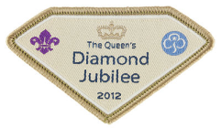

Jan 18th Hall Fitness challenge badges, Queen’s Jubilee, Camp

Jan 25th Hall Burns poetry, shortbread and Irn Bru

Feb 1st Hall Is a map useful?

Feb 4th Loanhead District Swimming Competition

Feb 8th Hall Food and nutrition at Camp

Feb 15th Half term break no Cubs

Feb 22nd Hall Clothing for camp and rucsacs, Baden Powell’s birthday
Feb 29th Hall First Aid 1

Mar 7th Hall First Aid 2

Mar 14th Hall Tents, keeping dry at camp

Mar 21st Hall Campfire, songs and activities

Mar 28th Hall What do you need at camp? and Easter

Easter Holiday

Apl 18th Visit to Bonaly

Apl 25th Hall Hygiene and Safety at camp

