MAP  DIRECTIONS  Walk - 1 mile from Central Station. Exit station and turn L on Neville St. Follow A186 and turn R on to St James Boulevard A186. Take 2nd left on to Westgate Rd A186. Pass hospital on R. The Beacon is a modern building beside a mini-roundabout.  Bus – From the Central Station: No 38, 10 or 11 west. Alight at General Hospital. Walk west along Westgate Rd, straight ahead at traffic lights. The Beacon is at Wingrove Rd/Westgate Rd mini roundabout.  Car - A1 North & South, exit at A184 Gateshead/Newcastle. Follow sign to A189. Cross Redheugh Bridge, bear R with the road but keep in L-hand lane. At traffic lights, go straight ahead. Turn L to Westgate Rd A186. Pass General Hospital on R. Immediately after the next mini roundabout, turn L into car park behind the building.  Parking – 75 parking spaces + 4 disabled parking spaces.  ENQUIRIES: Helen Simmons, Convention Chair, 07932.739734  The Convention is supported by: Cleveland, County Durham, Newcastle, Hexham, & Alnwick Beekeepers Associations, MMM Deli (www.mmm-food.co.uk) and Stamfordham Bees |  | North of England Beekeepers’  56th Annual Convention  “Breeding and the 21st Century Beekeeper”  Saturday 23rd^{st} March 2013  The Beacon, Westgate Road  Newcastle upon Tyne, NE4 9PN
   |  | 
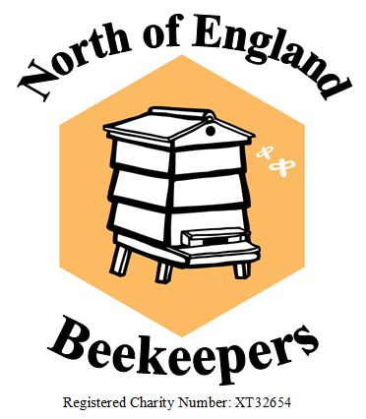

REGISTRATION: Send form to Les Cain, Convention Treasurer, 3 Ainderby Rd, Throckley, Newcastle NE159DQ or call 07760.440800
 NEBEES  @NEBEES www.nebees.org
PROGRAMME  TRADE & GENERAL INTEREST STANDS:  - Stamfordham Bees - www.stamfordham.biz 01661.886219  - Solway Bee Supplies - www.solwaybeesupplies.co.uk 01557.860400  - Bees For Development – www.beesfordevelopment.org 01600.714848  - Northern Bee Books – www.groovycard.co.uk/beebooks 01422.882751  - The Hivemaker – www.thehivemaker.co.uk 07904.003555  Please contact traders in advance to pre-order for delivery on the day. |  | We’re a modest lot at the North of England Beekeepers Convention, but we’re unashamedly proud of the 2013 programme with distinguished speakers from Denmark, Sussex, Yorkshire and Newcastle revealing the latest research and beekeeping experiences. To top it all, Britain’s most popular Radio 4 programme “Gardeners Question Time” is coming from the Convention. You are all welcome to stay for the recording session and submit questions. Assuming that beekeeping and gardening go hand in hand, we are issuing tickets to local allotment holders and keen gardeners for the GQT session. The venue is The Beacon in Newcastle, a brand new, easily accessible centre with parking and on-site catering.  So…standby for “This week, Gardeners Question Time comes from the North of England Beekeepers Convention in Newcastle.” Book early to avoid disappointment. We’re expecting record-breaking numbers to join us for the 2013 Convention with guest speakers:
  9.00 | 9.30 | Registration & Tea/Coffee
  9.30 | 9.40 | Opening Address – Brian Ripley former BBKA Chairman
  9.40 | 10.40 | Keld Brandstrup – The Truth About Buckfast Queens + Q&A
  10.40 | 11.10 | Tea/Coffee break
  11.10 | 12.00 | Michael Badger - The Busy Beekeeper  Q&A
  12.00 | 12.30 | Sally Williamson – How Pesticides Affect Bee Learning & Memory +Q&A
  12.30 | 13.30 | Lunch
  13.30 | 14.20 | Dr Karin Alton – Planting for Pollinators +Q&A
  14.20 | 14.50 | Tea/Coffee Break
  14.50 | 15.50 | Keld Brandstrup – Beekeeping in Denmark + Q&A
  15.50 | 16.50 | Ask The Panel, Chairman Eric Robson
  16.50 | 17.00 | Closing Address
  17.00 | 17.45 | Tea/Coffee, Sandwiches
  17.45 | 19.00 | Radio 4 “Gardeners Question Time” programme recorded
  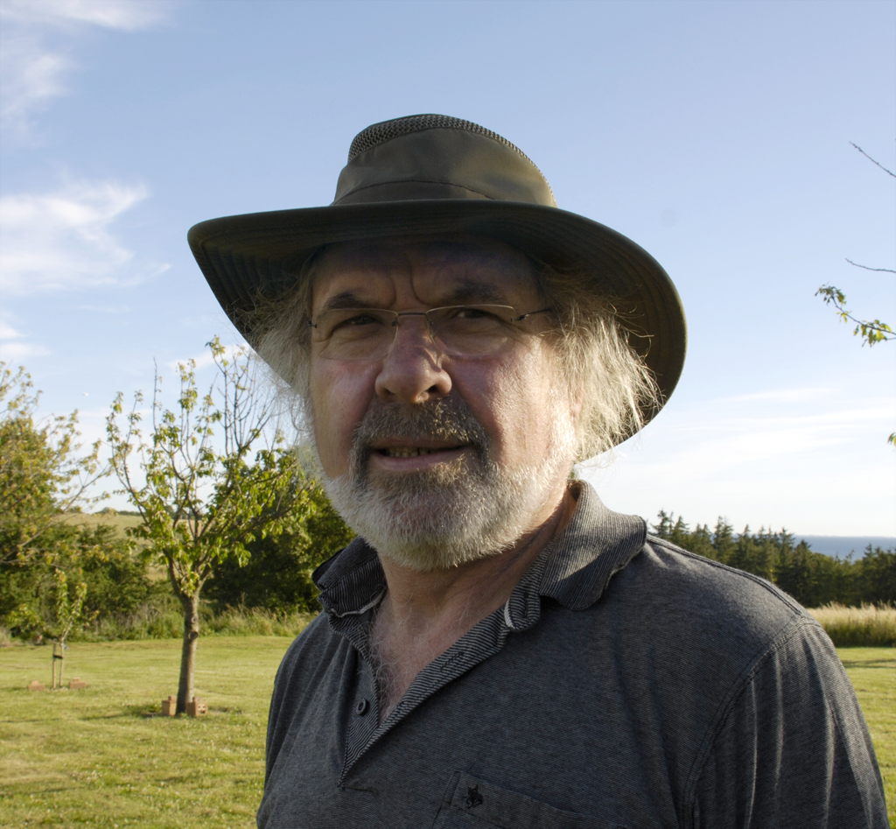 | Keld Brandstrup - Chair of the Danish Association of Commercial Beekeepers, with up to 500 colonies. International reputation for bee breeding and queen production, after close collaboration with legendary Brother Adam.
  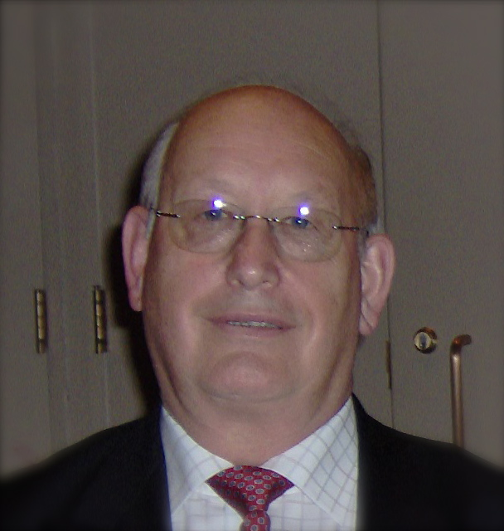 | Michael Badger MBE - Former President & Chairman of the British Beekeeper’s Association, Senior Honey Steward of the Great Yorkshire Show. A beekeeper for 50 years in various parts of Britain, he built a Grand Designs bee-house in his back garden in Leeds.
   | Dr Karin Alton - University of Sussex Bee Lab, Researching breeding behaviour and urban beekeeping in relation to hive densities and forage. Co-founder of FlowerScapes Ltd, a company that creates large scale pollinator-friendly planting schemes.
   | Dr. Sally Williamson - Research Associate, Honey Bee Lab, Newcastle University. Investigating how pesticides and mite treatments affect bee behaviour, especially bee learning and memory.

