Cambridgeshire & Peterborough Association of Local Councils

WELCOME to the CAPALC November 2013 Bulletin
CLERKS please circulate this bulletin to chairmen, councillors and members of staff in printed form or in electronic form or email the web link at www.capalc.org.uk

CAPALC BULLETIN - DIRECT TO YOU
If you are not already receiving your personal copy of the CAPALC Bulletin simply sign up on the home page of the CAPALC website at www.capalc.org.uk to receive a copy direct to your PC, tablet or phone.

RECURRING THEMES
We keep a record of queries, questions and help requests that come into the CAPALC office and we do notice some recurring issues for clerks or councils

- Managing the risk of Legionella in hot and cold water systems

Legionella bacteria are commonly found in water and the bacteria multiply where temperatures are between 20-45°C and nutrients are available.

The bacteria are dormant below 20°C and do not survive above 60°C.

Legionnaires’ disease is a potentially fatal type of pneumonia, contracted by inhaling airborne water droplets containing viable Legionella bacteria.

Such droplets can be created by: hot and cold water outlets; atomisers; wet air conditioning plant; and whirlpool or hydrotherapy baths.

Anyone can develop Legionnaires’ disease, but the elderly, smokers, alcoholics and those with cancer, diabetes or chronic respiratory or kidney disease are at more risk.

The Health and Safety Executive website provides:
- information on managing the risks of Legionnaires Disease
- frequency of cleaning and monitoring
- how to carry out a full risk assessment of the hot and cold water systems in public buildings

For more information see http://www.hse.gov.uk/legionnaires/index.htm

- Shared Clerks and Membership of CAPALC

It does not seem to be unusual for clerks to more than one council to have only one council in membership of their Local Association of Local Councils which in Cambridgeshire and Peterborough is CAPALC.

The problem is that if things go wrong for the council who is not the named member of CAPALC it ends up in a mess.

The council cannot enlist any support or advice from CAPALC and if the matter is of a legal nature they cannot get any advice from the National Association of Local Councils.

Worse still if the Matter is HR related the council may discover the clerk’s fees cover HR representation for the clerk but not the council.

It’s also quite likely the council’s insurance company will not look too kindly on them if the council is deemed to have failed to exercise good governance in respect of professional support.

The bottom line is that short term thinking can result in a traumatic situation, causing the community to loose faith in the council, councillors to resign or the clerk to leave.

The whole process end up costing lots of money that the council then needs to recoup through increases in the precept.

SOMETHING TO THINK ABOUT!
How about a Minutes Action Plan?
A simply a one page summary from each meeting attached to the minutes of a meeting that in a few columns summarises:
Date Decision Action agreed Action By whom Date completed

This can that act as a work sheet and take the focus off the minutes and on to the actions to be completed by the clerk/council.

At the next meeting the focus of the minutes will be about what has been done and what is outstanding and not an attempt to open up old issues.

The Clerk can also add in to the Action Plan important things that get done under the Clerk’s delegated powers.

Using an Action Plan is useful when writing up the council’s activities in newsletters and circulars as it keeps everyone up to date on what is being done and what is in process.

2nd Annual Peterborough Parish Conference
After the success of last year’s 1st annual parish conference which attracted in excess of 120 delegates Peterborough City Council and the Peterborough Parish Councils are pleased to announce the 2013 conference will take place as a day event in Thorney on 26th November 2013.

The list of guest speakers is currently being confirmed and the marketing and promotional material for the event will be circulated shortly.

Invitations will go out to Peterborough parish councils, community, voluntary and faith groups and to the same in districts that border the PCC area.

CAPALC Training Events
In addition to the normal councillor and clerks training events we will be hosting a pilot “Getting to grips with new media” training session on 22nd November 2013 for clerks and councillors wishing to expand their use of the web and other personal media platforms as a communication tool to better inform and engage with their community.
Price per candidate is £25.00 so call the CAPALC office on 01480 375 629 to book your place.

LOCAL COUNCILS EXPLAINED
The first copies of Local councils EXPLAINED have been dispatched. This new publication from NALC is everything you need to know about local councils.
It provides easy to read narrative about the role of the parish council, councillors and officers and how they work.
There is comprehensive and practical guidance about the legal issues that local councils are exposed to.
The Pricing Structure for Local councils EXPLAINED is:
£57.50 (including Post & Packaging) - per copy to Member councils
£67.50 (including Post & Packaging) - per copy to Non-member councils
Order via the CAPALC office 01480 375629 or accounts@capalc.org.uk

Papworth Paddling pool
There has been a children’s paddling pool in Papworth Everard for about 60 years, but the summer of 2013 was probably a one-off.
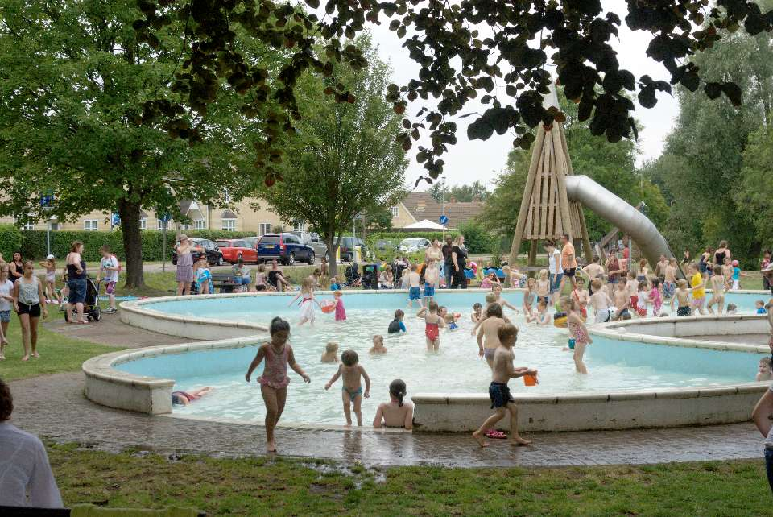
Just as it seemed that the pool might not be able to open for the summer the day was saved by local volunteers Tom and Nick.
They worked tirelessly on a rota basis, helped as necessary by two parish councillors, to ensure that children from the village and wider area could make the most of a glorious summer.
The pool was a resounding success and showed the difference a few motivated local residents can have on making your community a better place to live.

AgeUK Cambridgeshire
AgeUK Cambridgeshire is a local charity dedicated to the wellbeing of older people.

Their support and services are designed to help older people to remain independent, living a fulfilling and confident life within their own familiar communities. They provide a range of services that include:
- Information, Advice and Advocacy Service - free tailored assistance on personal rights, options and choices around the many challenging issues which frequently affect many older people’s lives and help to be heard
- Home Help Service - practical help with domestic cleaning
- Community Wardens Services – Daily contact providing reassurance which gives a sense of security and confidence. This is delivered through a staff member who gets to know someone well and can support them practically
- Volunteer Visiting Services – to help older people feel less isolated, volunteers visit lonely, housebound individuals for a weekly chat and contact
- Accident Prevention Services – to make your home safe, an holistic home assessment and practical assistance aimed at reducing the potential for slips and falls and in turn, to reduce the number of preventable injuries and hospital admissions. Installation of adaptations and small handyperson type jobs undertaken
- Social Day Clubs – a day out to enjoy companionship, a hot meal and stimulating activities and meet other friends
- Shopping Service - assistance to have shopping ordered and delivered via the internet (particularly valuable in the bad weather months)

If you think you might like to assist as a volunteer or know someone who needs support you can call Age UK on 0300 666 9860

Could you be a Trustee?
The Connections Bus Project is a small friendly charity, based in Histon (just to the north west of Cambridge), that provides youth services to communities across Cambridgeshire.

The charity delivers these activities and services using state of the art facilities on their converted double- decker bus, supported by trained and experienced youth workers and volunteers. The charity works closely with Parish Councils to identify the need for the Bus to visit their community and for funding to deliver services for their young people.
However money is not the only way to support The Connections Bus Project and it is looking for two new Trustees to join its Management Committee, which meets formally about four times a year. Matters arising between these formal meetings are dealt with by the committee using mainly email. Trustees also have the opportunity to get involved with specific issues as they arise.

The charity would, in particular, welcome interest from any Parish Councillors who have an interest in youth provision, not just from areas that the Bus currently visits.

If you would like to find out more about being a Trustee or visits from our Bus, please contact Alan Webb, Project Manager, The Connections Bus Project, P.O. Box 344, Histon, Cambridge CB24 9WZ
Tel: 01223 232978, Mobile: 07887 947748 or admin@connectionsbusproject.org.uk
www.connectionsbusproject.org.uk

FEEDBACK
If you would like to contribute articles or have any positive critical comments please let us know by clicking on accounts@capalc.org.uk and emailing us.

CONTACTING CAPALC
We are located at Unit 7, The Meadows, Meadow Lane, St Ives PE27 4LG.
Website www.capalc.org.uk Email accounts@capalc.org.uk Telephone 01480 375629

