


Volunteer application form

Please fill in this form clearly. If you are interested in a specific opportunity please tell us which one here


If you would like support to fill in this form telephone
07872 627301

Please circle your answers and use the boxes to write in to tell us more.
Yes

Mr Mrs Ms Miss Date of birth


Other (like Dr)

First name

Last name


Post code
Address


Telephone number


Mobile



Email

National insurance number (if you have one)


How did you find out about volunteering for Mencap?

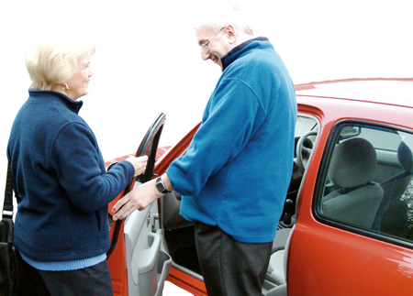
Have you done any voluntary work before?

Yes No

If your answer is yes, tell us more about what you have done.


Why do you want to volunteer with Mencap?


Have you got any experience to do with people with a learning disability?

Yes No

If yes, please tell us more


What skills do you have that you would like to use as a volunteer?


What things do you enjoy doing?


Is there anything you do not enjoy doing?

When can you volunteer? Tell us the days and times






Do you have a car that you could use when you are volunteering?

Yes No


Is there anything to do with your health that will stop you from doing some types of volunteering?

Yes No

If yes, please tell us more


We need the names and addresses of 2 people who can tell us what you would be like as a volunteer.

We will write to them and we might telephone them.

Choose people who are not in your family.

For example, you could choose your employer, a friend, your imam and so on.


Person 1

Name

Post code
Address



Telephone number


Person 2

Name

Post code
Address

Telephone number


Confidential – private

Mencap has to make sure all our volunteers are safe to work with people with a learning disability.


Have you ever been convicted of any criminal offence by a court of law?

Yes No

We will only take into account a criminal record if it could be important to the volunteering you want to do.

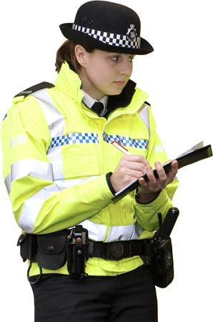
All Mencap volunteers who spend time with people with a learning disability need to have a police check through the Criminal Records Bureau before they can start.

There is another form you will be asked to fill in for the Criminal Records Bureau check if you are going to be a volunteer with Mencap.

and finally…..

You now need to sign this form.

Mencap will keep your information safe. We will use what you tell us to send you information about
- volunteering
- Mencap and what we do.


Please write your name in box 1 then sign in box 2.

All the information I have put in this form is true as far as I know.

1
Name


2

Signed

Date


Please send this form to
Bournemouth Gateway
c/o 60 Leybourne Ave
Bournemouth
BH10 6HF

Telephone - 07872627301
Email – annareeves0@hotmail.com
Website – http://bournemouthgateway.btck.co.uk

Thanks to Photosymbols for the pictures in this form.

