Contents

1. Introduction

2. The Parish

3. General Principles in dealing with development

4. Housing

5. Education

6. Traffic and Parking

7. Cycleways and Footpaths

8. Shop and Associated Services

9. Youth, Sports and Other Organisations

10. Environment

11. Flooding

12. Miscellaneous Matters

13. Action Plan

1. Introduction

Late in 2005, the Parish Council decided to investigate the possibility of producing a Parish Plan as recommended by H. M. Government. It was felt that with the intense pressures for development in the area, the people of the Parish should be given the opportunity to put forward their views on how they would like the Parish to change in the future. Through the Parish Magazine and contacts in Sowton Village, residents were asked to put forward their name if they would like to be considered for a working group to establish such a Plan. The group was set up and produced a survey which was distributed to every household in the Parish in 2005. The returns were collected by hand with a response rate of 48%. The results were collated and the findings distributed to every home.

The Plan is based on the Appraisal carried out by the Village Plan Group on behalf of the Parish Council. It gives objectives for the Council to work towards in the near and distant future and outlines aims that will be borne in mind when decisions are taken by the Council on behalf of its electorate. These aims and objectives have been set by the Parish Council based on the Appraisal.

The Plan incorporates the Parish Council’s ideas for the two areas in the future and, whilst not dealing with every street or road, considers each individual area with equal weight. The Plan has taken a lead in identifying the Parish needs. It should assist the service providers, statutory bodies and the voluntary sector to know what is required within the Parish.

Where relevant, Sowton is specifically mentioned, otherwise all comments apply to the Clyst St. Mary area.

The first edition of the Parish Plan and Design Statement was published and distributed in April 2008.

Since then, two further surveys have been carried out in the parish
- In April 2011 the parish council carried out a survey of leisure needs in the parish
- In March 2011 the Community Council of Devon carried out a housing needs survey and produced a report

The parish council has also responded to the Local Development Framework questionnaire from East Devon District Council. The information from these two surveys, the LDF response and other developments and changes in the parish have been incorporated in this first revision which was approved by the parish council in July 2012

2. The Parish

2.1 Geography

Bishop’s Clyst is situated in the East Devon District of Devon on the eastern boundary of Exeter. The parish consists of the civil parishes of Clyst St Mary and Sowton which are administered as a single body (the grouping of the two parishes occurred in 1976). Both parishes are rural parishes lying East of Exeter and the M5 Motorway, and south of the A30 trunk road. Several farms and small hamlets are scattered throughout the rest of the area in open countryside.
Sowton Village is approximately a mile to the north of Clyst St Mary as the crow flies. Sowton Village is a Conservation Area and being in a cul-de-sac, is a much quieter village than that of Clyst St Mary. Sowton Village has no shop, post office, school or pub but has a church and village hall, which was once the school. It is surrounded by farmland and several of the farm buildings are listed.
Clyst St Mary is a lively village with a shop and post office, school, village hall and pub. The other main feature of the area is the Cat & Fiddle Residential Park holding around 150 mobile homes.

In the 2001 census the population of the parish was 1229 in 550 households. The latest population figures show that there are 1260 people resident in Bishop’s Clyst. (Devon PCT 2010). In the 2001 census there were 7 second homes or holiday lets in the parish. Results from the 2011 Census have not yet been published.

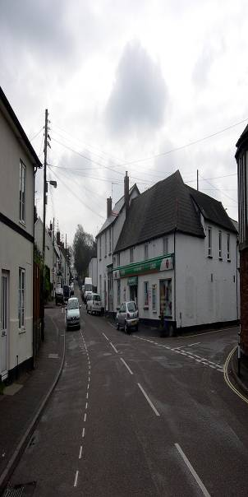

Clyst St Mary village centre

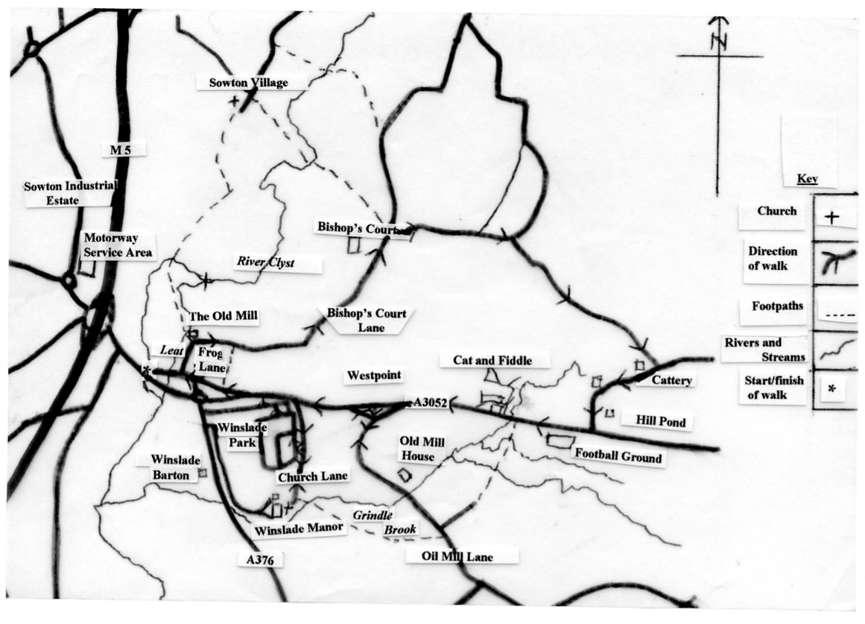

Map of the parish of Bishops Clyst

2.2 Business and Tourism

The largest businesses in the parish are Friends Life Assurance and the Regional Office of DEFRA and its Regional Payments Office. The Westpoint showground occupies a large area and has a few small office businesses on its complex as well as the Devon County Council Driving School.

Smaller business units are located at Langdon’s Business Park, opposite Westpoint, Little Bridge Business Park in Oil Mill Lane, Courtway and Bishops Court Business areas both in Bishops Court Lane. They include builders, scaffold companies, a wine merchant, kitchen equipment and design, a sign maker and a grass seed merchant, as well as several other small companies. In addition there are several bed and breakfast properties and quite a few farms in the area.

2.3 History

Even before Roman times Clyst St. Mary was the gateway to Exeter. The Rivers Clyst, Culm and Exe were all running though marsh land which was difficult to negotiate. The approach from the North East was via the Somerset marshlands - again virtually impossible without a local guide.

The road to Exeter led from Dorchester along the present Sidmouth road to the old junction with Oil Mill Lane by Longmeadow Cottages. From there, following the lay by, it would have crossed the present main road, cutting across the fields in a straight to run down the hill in Bishop’s Court Lane. A late 11th century charter refers to the boundary of the manor of Clistwicon (Clyst St Mary parish and possibly including Clyst St George) as starting at what would have been the original ford across the river just below the present Sowton path bridge. From there it ran “on tha ealdan dic" (probably by the mill leat where it ran towards the old mill), then “of stræt on sicgan mores heafod” (from the street onto Sedge Moor’s Head, probably from Bishop’s Court Lane to the high ground behind Langdon’s yard at Oil Mill Lane). In the late 12th century a bridge was built lower down the river with a causeway over the marsh. As the road was diverted to the new bridge (along the present village street), the parish boundary appears to have been moved with it.

When the church parish of Clyst St Mary was created, it was one of a small number in Devon that were parishes with a manor and church but no village. After the bridge was built, a bridge-town grew up by the bridge straddling the boundary between the parishes of Sowton and Clyst St Mary. The houses on the Sowton side were in the manor of Bishop’s Clyst with a manor house at Bishops Court, the area on the other side of the Clyst around Sowton Village being the separate manor of Clyst Fomison. The name of Bishops Clyst would have dropped out of use as the bridge settlement became known by the name of the local church as Clyst St Mary. The bridge carried traffic from much of East Devon until 1961.

The bridge was fought over several times over the centuries as it was still the only easy route into Exeter. Most notable was the battle of 1549, known as the Prayer Book Rebellion, when the King’s forces fought with rebels of the West Country. The rebels more than held their own and it took a local “traitor” to lead the forces of the crown over the old ford so that they could attack the rebels from the rear. As a result almost the whole village was burned to the ground.

Obviously the village was rebuilt and a few of the older properties date from this rebuilding.

A further claim to fame is the Bishop’s Palace now known as Bishops Court. This is situated in Sowton Parish on the lane between Clyst St. Mary and Clyst Honiton. It was used as a residence by the Bishops of Exeter between 1265 and 1546. The stables are one of only two surviving such buildings in the United Kingdom and date from the late 1400’s. An adjoining barn is probably earlier from the early 1300’s.

Another notable building is Winslade Manor at the end of Church Lane, Clyst St. Mary. There is a reference to the “Manor Clist St. Mary” in the Domesday Book but the earliest note of the present Manor House is 1734 when Theodore Taner owned the house. In recent years the property was a Catholic School until the then London and Manchester Assurance Company bought the house and surrounding site as their headquarters. They had the house painstakingly restored.

The Church stands close by, almost three quarters of a mile from the village itself. Earliest records date it back to 1217. A most unusual feature is that the altar is in the North rather the more normal East. It was extended twice in Victorian times and there was no room to go East of West so they extended North and South instead.

A fire in December 1991 severely damaged the North end and the Church Council took the opportunity to rebuild and rectify many outstanding problems with the structure to suit more modern times.

The School, which is still very well supported, was built in 1834 by the then owner of Winslade Manor, Henry Porter, who took an active interest in the school by placing himself as its manager.

A much fuller history can be read in Jeanne Axford’s book “About Clyst St. Mary”.

2.4 Geology

The red rocks of Devon, of which the red sands around Clyst St Mary form part, were laid down some 250-260 million years ago in the Permian geological period. Then, part of the earth’s crust which now underlies Great Britain was much further to the south, about 5⁰ north of the equator, forming part of a vast southern continent with a desert climate. A low range of mountains to the west was underlain by granite which is now Dartmoor. Huge fans of rock debris spread out along the edges of the mountains assisted by flash floods from tropical storms. Some of this debris forms the Heavitree Stone used for building in and around Exeter since Roman times and for Clyst St. Mary Bridge, the Church Tower, houses and cottages in Clyst St Mary. Red Lodge is a notable example.

Later, a belt of desert sand dunes developed to the east of the eroded mountains. These soft sandstone rocks are called Dawlish Sandstone after the cliffs east of Dawlish. They extend inland along the Exe estuary through Topsham and Clyst St Mary to Brampford Speke. These sands are recognised by the layering and rounding of the sand grains which can be matched with modern desert sand dunes. Dawlish sand is seen in the old sand pit at Clyst St Mary and on the corner of the upper village car park. There are gravely layers in the sand including granite fragments, which show that rain storms caused rocky debris to be washed into the area of the dunes and that the Dartmoor granite was being worn away. In Bishops Court sand pit it is possible to work out from which direction the wind was blowing. The sand is quarried as it makes very good mortar sand.

The long period of time following the Dawlish Sands is represented by the rocks forming the ‘Jurassic Coast’ from Exmouth to Weymouth and beyond. This brings us to the Pleistocene Period, the time of the ice age, up to two million years ago. The advance and retreat of the ice sheets caused major changes in sea level. During the retreat periods the climate was warmer and sea levels were higher than now. The Exe and Clyst valleys were flooded and tidal beyond Exeter and Clyst St Mary. The extent of these high levels can be seen around the village. The oldest and highest level formed the pebbly gravel layer on the corner of the sand pit nearest the village hall and covers part of the play area. A lower level forms the stiff clay layer on Winslade Park Estate and the allotments. The lowest gravely level, from about 125,000 years ago, covers the fields beside and east of the mill leat north of the old mill. Traces of gravel are in the leat banks. The lowest could indicate the possible height of sea level in the event of major global warming.

The area of much of Clyst St Mary Sand Pit is recorded as a County Geological Site because of its geological interest and educational value.

2.5 Architecture

Clyst St. Mary has a mixture of architectural styles. A large part of the Village Street has several listed buildings and cottages of the C19th many having long, narrow gardens. The School is C19th and later. There are a few C20th houses including Manor Park. By the Old Bridge is a row of late C20th houses, a barn conversion and a modern detached house. These are faced by C19th cottages and the Half Moon Inn.

Along Frog Lane is a row of late C19th cottages faced by late C20th bungalows, a C19th farmhouse, a row of farm workers cottages, more late C20th houses and the C17th Newhouse Farm building at the edge of the village. The window styles all reflect the ages of the buildings.

On the southern side of Sidmouth Road, Winslade Park is a large C20th development of detached houses and bungalows. Large, picture windows predominate and the roads all have wide grass verges.

The largest feature outside the village is the Cat and Fiddle Residential Park which consists entirely of modern mobile homes.

Sowton largely spreads along one street. The approach is dominated by listed farmhouses and their associated farm buildings. Between them and the main village is a group of modern bungalows. To the south of an apparent crossroads lies the main village which is a Conservation Area. The village consists of a large number of listed buildings, the old school - now used as the Village Hall - and the Church. A group of large, modern houses lie back from the road next to the hall. Several old cottages adjacent to the village hall were badly damaged by fire in 2011, these are now being rebuilt.
.
To the west of the crossroads is a group of late C20th bungalows.

All the properties display the window styles associated with their time of building.

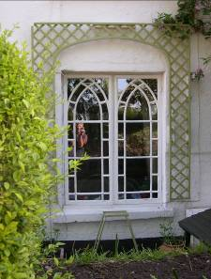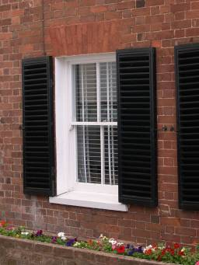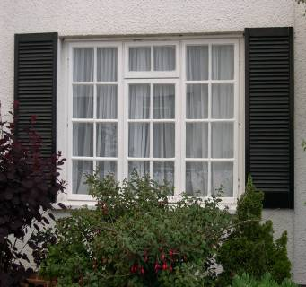

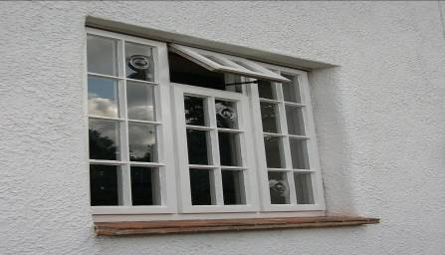

2.4 Listed Buildings in Bishops Clyst.

There are three Grade I Listed Buildings, all three being in the parish of Sowton.
The Old Bridge: an Ancient Monument, west of Clyst St. Mary Village and, until 1968, the main Dorchester to Exeter road, once the main road from London to Exeter. A causeway crosses the floodplain to the bridge over the River Clyst dating from at least 1238 and probably the oldest surviving bridge in Devon. Altered over the years, it is the site of at least two battles, in 1455 in the Wars of the Roses and in 1549 in the Prayer Book Rebellion.
Bishop’s Court: the Palace of the Bishops of Exeter from the mid C13th until 1546 when Bishop Veysey granted the estate to John Russell, 1st Earl of Bedford. Parts of the C13th and C16th alterations survive though the House was rebuilt in the 1800’s. Inside is a C13th Chapel.
In the grounds is a Tithe Barn of early C14th construction with middle cruck roofing. The Stable block is early C16th with C20th alterations.
The Church of St. Michael and All Angels, Sowton: has a C16th arcade; otherwise dates from alterations by John Hayward in 1844-5. Some of the roof bosses are probably medieval.

Grade II Listed Buildings
a) Clyst St Mary Village and surroundings
The Maltsters Arms & 1, 2 and 3 Craig’s Cottages: all of C16th construction.
28, 29 The Village and Myrtle Cottage: a row of cottages and a C19th remodelling of an earlier building.
White Lodge and Red Lodge: on the South side of Sidmouth Road, these are former lodges to Winslade Park and were built in early and mid C19th.
Grindle House: once the Rectory of Clyst St. Mary Church, its age is uncertain but thought to be mid C18th. It was carefully restored when purchased by the then London and Manchester Assurance Company..
Clyst St. Mary Church: now surrounded by the Friends Life complex. The original building dates from the late C13th with C15th and C19th extensions. Unusually the altar is at the North end. All the windows are C19th with three by Lavers, Barraud and Westlake of very high quality. In the churchyard there are three tombs of the Salter family, Edward Cotsford and a slab with a damaged inscription.
Winslade House: built by Edward Cotsford circa 1800. It had a variety of uses after the Second World War before being purchased by London and Manchester Assurance, now Friends Life, who carefully restored it to use as offices.
Terrace Walk: an early C19th ornamental walk along the North bank of Grindle Brook to the South of Winslade House.
Ivington Farmhouse: now forms part of Westpoint and is used by the Devon County Agricultural Association as offices. Built of red brick in 1846, it contains a Cider House, a Granary, a Bank Barn and a Linhay.
Coxe’s Dairy or Farmhouse: is a farmhouse of the early C17th.
Linden Lee: a detached cottage of the early C19th.
Old Kiddicott: a late C17th remodelling of an earlier house with C20th extensions.
Greendale: is early C19th and incorporates an early building.
Newhouse Farmhouse: originally a large farmhouse of C17th origin.
Bishop’s Court East Lodge: an octagonal two roomed house built in 1834, has a conical thatched roof extending beyond the lodge, supported on tree trunks to form a covered walkway.
Alder Croft & Dymond’s Farmhouse: are C17th buildings.

b) Sowton Village
Sowton Churchyard: contains four tombs, W. H. Hole 1782; Thomas Hart 1777; a set of three identical tomb chests one of which is dated to George Moore in 1821 and a tomb chest dated 1734 where the name is indecipherable.
The Lychgate: of an unusual design and is dated 1852 to the memory of Sarah Garrett.
Village Hall: once the school and possibly a barn attached to the adjacent range of cottages.
11 to 17 Sowton Lane (East side): Nos. 14 and 15 date from 1646; 11 to 13 an early C18th farmhouse; 16 and 17 are mid C19th additions.
9 and 10 Sowton Lane (East side): originally a late C17th or early C18th farmhouse.
Court Lodge, Gate Piers and Gate: a former lodge to Bishop’s Court built in 1834 . The gate posts and gate are also listed.
Bridge Railings: about 450 metres South West of the Lodge along the former drive to Bishop’s Court, is a bridge over the River Clyst. A set of cast iron railings made about 1834 with decorations are listed but only one set survives .
Clystbeare and Clystbeare Cottages: originally a farmhouse dating from 1656/7 with C19th extensions. At one time five cottages, there are now only two.
Starr’s Dairy and Farmhouse: early to mid C17th with later additions.
1, 2, 3, 4 and 5 Sowton Lane (West side): two houses and three cottages once early C17th farmhouses.
Venn’s Farmhouse and adjoining farm buildings: a C17th farmhouse with adjoining barn and range of farm buildings.
The Old Rectory: a substantial house built in 1722 on the remains of an earlier house and once the Sowton Rectory. Servants’ quarters in the attic.
Virginia Cottage: an early C17th house.
Sowton Lodge: a former lodge to Bishop’s Court and built in 1834.

. 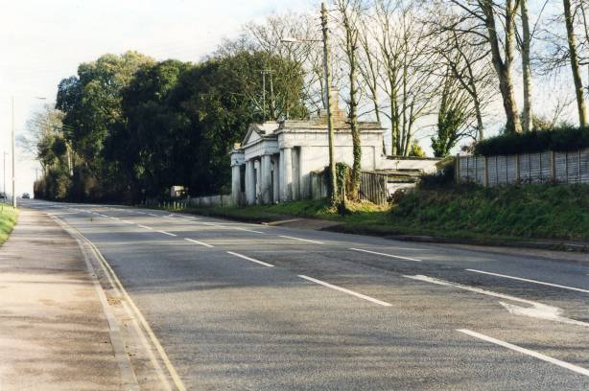

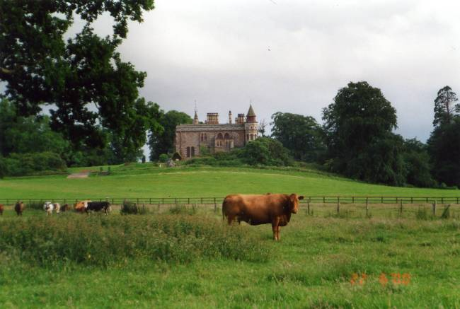

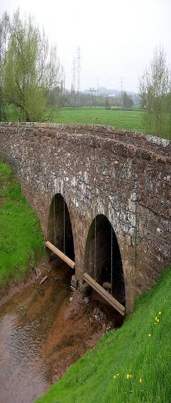

Top - White Lodge. Centre - Bishops Court. Bottom - The Old Bridge.
3. General Principles in dealing with development

3.1 General

The Parish Council will always bear in mind the preservation and enhancement of the essential character of the various areas within its boundaries.

3.2 Development

The Parish Council will continue to keep the Planning Department of East Devon District Council fully informed of the views of the Council and its electorate and ensure that the aims and objectives of the Plan are fully taken into account when any development is being considered.

The Parish Council will, in general, seek to prevent any further industrial development within the parishes and endeavour to ensure that any residential development is fitted to the needs of the people, is of an appropriate scale and will fit into the existing nature of the various surroundings. It will also seek to ensure that any such development will enhance or add to the facilities within the various areas.

3.3 Co-operation with neighbouring Parishes and Exeter

The Parish Council will endeavour to prevent any further encroachment into its area by the City of Exeter whilst seeking to maintain good relations with the City Council and all neighbouring settlements.

As a member of the Clyst Vale Group of Parish Councils the Parish Council will continue to have regular contact with our immediate neighbours.

3.4 Industrial development

It is known that an overwhelming number of residents do not want any further industrial development in the area and the Parish Council will continue to resist any applications of this nature.

4. Housing

The appraisal identified that there is a need for “affordable housing” in the Parishes. The CCD housing needs report (dated March 2011) identified the need for 11 affordable houses within 5 years. Any future development of more than four dwellings can be made to include “affordable housing”.

The Parish Council has identified land which it would not object to being developed for housing and has passed this information to EDDC. A figure of 90 dwellings is associated with this site, being an estimate based on current housing density figures and also the density achieved at Manor Park. The Parish Council would welcome advice from East Devon District Council on a figure for this site base on their knowledge of what would be realistic.

Without being prescriptive, the Parish Council would also like to have an input into the type of development that should go on the site (size of dwellings, affordable housing etc.). This could be achieved by means of a neighbourhood plan, but this would be at great cost and time for the Parish and the District Council. The preferred approach would be for a joint policy statement on the development to be included in the Local Plan as a basis for judging any planning applications for the site. We would ask that, at the appropriate stage in the process, the District Council should liaise with the Parish Council to draw up such a policy.

In general, the Parish Council is willing to approve projects of four or more properties where 40% are low cost/affordable starter or small family homes. When considering any plans for housing development the Parish Council will seek to ensure:

- Styles of new housing will, including individual properties, fit in with adjacent areas of the villages.
- A mix of housing to reflect the opinion that there must be affordable housing for local people.
- The inclusion of some Housing Association development when appropriate.
- Any application for single, large houses would add to or enhance the character of the area.

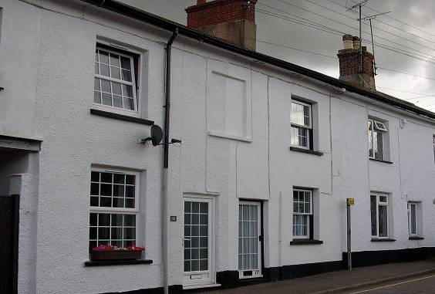

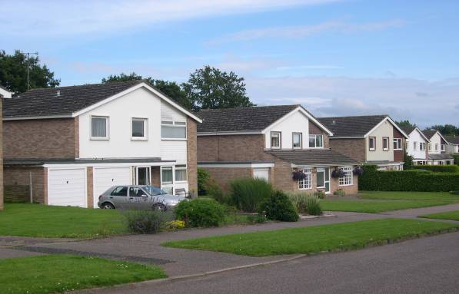

Top - The Village Street. Bottom - Winslade Park.

5. Education

5.1 Primary Education

Clyst St Mary Primary School is a thriving village school which was graded as “Good” in the last OFSTED inspection. The school was recently extended with a new resources room. The Pre-school is housed on the school site in a new building (in 2011) and the site also provides accommodation for the Area Children’s Services. The planned admission level was recently raised from 20 to 25 which should go some way towards avoiding difficulties which have arisen in the past when local residents have been unable to obtain places for their children. There are plans to add a further classroom in 2014 to cope with increased numbers.
The Parish Council has and will always have the aim of supporting Clyst St. Mary Primary School in any way it can. The Parish Council will support local parents in preference to those from other areas in obtaining places for their children on occasions when demand for such places is high.

5.2. Secondary Education

The vast majority of our children go on to Clyst Vale Community College and, being outside the Council’s area, it does not have much opportunity to liase on a regular basis. However, whenever support has been needed, the Parish Council has provided it and will continue to do so, probably through the Clyst Vale Group of Parish Councils.

The Parish Council has made representations to the Education Authority about apparent neglect at Clyst Vale Community College pending the move to a new site at Cranbrook. As the Cranbrook development has been delayed, this problem is likely to persist and the Parish Council will do all that it can to support Clyst Vale.

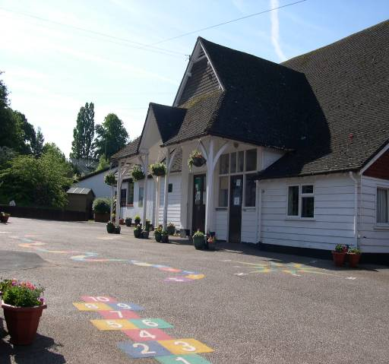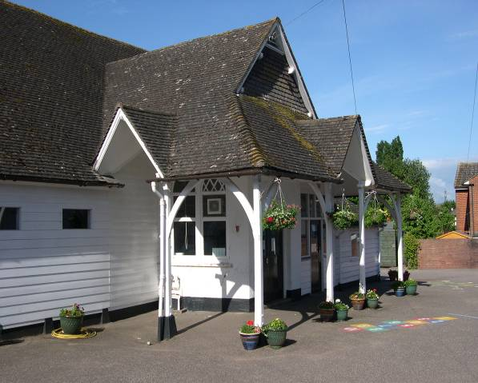

Clyst St Mary Primary School

6. Traffic and Parking

6.1 Community Transport Plan

In May 2004, the Parish Council undertook, in conjunction with the Highways Department, a Community Transport Plan when villagers were given the opportunity to voice their concerns and give their opinions on all aspects of transport in the area.

6.2 Parking in the Village of Clyst St. Mary

The parish Council owns and operates two public car parks, one in Frog Lane and one at the top of the village. There have been problems with long term parking from outside the area but these have been largely solved with waiting restrictions and a permit system for locals.

On-street parking is a problem especially around the village shop where casual callers often park indiscriminately and dangerously. Revision of parking regulations has taken place. The Parish Council will monitor the situation and maintain pressure on EDDC to penalise illegal parking both near the shop and outside the school.

There are ongoing problems with parking on Church Lane in Winslade Park and in Manor Park. The police have regularly dealt with vehicles parked dangerously in Church Lane. The problems in Manor Park are difficult to address due to the restricted nature of the parking in this area.

6.3 Parking in Sowton Village

This is not a major problem although there is limited space for village hall functions.

6.4 Egress from the Villages:

There are 3 problem areas in Clyst St. Mary:

- A376/A3052 Roundabout - The traffic lights at Friends Life exit appear to be working well, although there are some evening rush hour tailbacks. There is now a 40 m.p.h. speed limit on the A 376 from Sandygate roundabout to those lights.

- Church Lane - the Community Transport Plan identifies a “No Right Turn” out of the lane.

- Cat and Fiddle: The residents would like traffic lights but Highways do not think there is sufficient traffic to make this a viable option. The situation will continue to be monitored.

Egress from Sowton Village has not been a problem in the past. Work is currently in hand to provide a new junction on the A30 to serve the Skypark development. This will require different access and egress routes for Sowton village. Villagers and the Parish Council have lobbied Devon County Council to keep the existing slip road open but it will be closed off and used only for emergency purposes. The parish council will monitor the situation when the new arrangements are in place and raise any concerns with Devon County Council.

6.5 Traffic Speed

The 20 m.p.h. limit in Clyst St. Mary needs enforcement This is a matter for the police. The Parish Council will continue to talk to the police on this matter.

The following methods of speed reduction have been investigated:

a: Speed humps: Most residents do not want them but the Highways Authority state that
such measures do work.
b: A Peninsula: Lower down the Village Street with authorised parking and a directional priority between them.
c: A One Way System: Village residents are themselves divided over this.

An “uphill system” would force the Village Street residents up to the Sidmouth Road where they would have to turn right into already congested traffic to access either the Exeter or Exmouth directions, which is obviously not desirable.

A “downhill system” would only encourage the existing “rat run” and probably increase speeds. One suggestion is to have a “No Right Turn” from the Sidmouth Road into the top of the Village opposite “White Lodge.” This would mean that people coming from the Sidmouth direction and Eastern parts of the area wishing to access the Village Hall, Rydon Motors or the village itself would have to go round the roundabout. However, following a site meeting in Spring 2009 DCC could not find a reason for a no right turn from A3052 into the village.

d: A Toucan Crossing: A Toucan crossing has been installed on the A3052 adjacent to White Lodge. This now makes road crossing much safer and easier for pedestrians especially the elderly and parents with young children.

e: Cat and Fiddle: Our County Councillor is actively promoting a scheme to extend the 40 mph speed limit to beyond the Cat & Fiddle Residential Park. Devon County Council are currently considering this option.

f: Sowton: Residents have not made a direct request to the Council for a 20 m.p.h. speed limit and as the village is a virtual cul de sac it is unlikely that Highways or the Police would back such a request should it be made.

6.6 Bus Services:

There is an adequate service to Exeter and Sidmouth with alternate services to Sidmouth extended to Honiton and Seaton. Additionally service X58 from Exmouth to Exeter can be accessed at Sandygate roundabout and the Council has asked via the Community Transport Plan that stops be made close to Clyst St. Mary roundabout.

X53 - The Jurassic Coast Service, operates between Bournemouth and Exeter and can be used from the Clyst St. Mary Bus stops.

A few residents asked for services to Topsham and Pinhoe through the Community Transport Plan. Both Devon County Council and the bus company have been approached but have both rejected the proposals as being economically unviable.

There are three Park and Ride Services operating from the Exeter Side of Sandygate roundabout, at Honiton Road, Sowton amd Digby.

7. Cycleways and Footpaths

7.1 Cycle Paths

The Parish Council’s request in the Community Transport Plan to link Oil Mill Cross to existing paths into Exeter has been actioned. A requirement for a cycle path from Clyst St Mary to Topsham has been identified by residents and is actively supported by the Parish Council.

7.2 Footpaths

The unpaved footpaths in the area are regularly inspected by Councillors who arrange for any deficiencies to be attended to either by the landowner or Highways. There have never been any real problems with this arrangement. The Parish Council will continue to monitor the paths

The Parish Council has made formal approaches to landowners about additional footpaths and discussions continue.

Paved footpaths are also regularly checked and deficiencies noted to Highways. Potholes are usually dealt with quite quickly but other maintenance is a matter of funding and it is often several months before such work is undertaken. The Parish Council will continue its regular monitoring of verges and hedges and press the relevant authorities for action when necessary.
8. Shop and Associated Services

8.1 Clyst St. Mary Village Shop

We recognise that we are very fortunate to have a thriving Village Shop incorporating a well used Post Office, as this is an essential part of the survival of the community spirit within a village. It is the sole provider of many services that are essential to residents, especially those without transport. The shop incorporates a bakery, sells all newspapers and magazines, fresh milk and other dairy products, a selection of fresh meat from a local butcher, a well stocked off-licence and a very wide range of grocery items.

The Post Office handles licence applications, foreign currency, savings accounts and a banking service in addition to all the usual Post Office business.

The Parish Council has long realised what a valuable asset this is to the community and will continue to do all it can to support and in the long term, retain it in the village.

Sowton does not have a shop.

8.2 Public Houses

There are two public houses in the parish. The “Half Moon” stands on the corner of the village street and Frog Lane. Just over a mile east along the Sidmouth Road is the “Cat and Fiddle.”

9. Youth, Sports and Other Organisations

9.1 Play Area and Parish Council field

The Parish Council owns land adjacent to the village hall in Clyst St Mary. Over the past few years a voluntary and very active Recreation Committee has raised funds and, with Parish Council support, provided a very well equipped and maintained Play Area. This Committee also provided a multi-discipline hard surfaced sports area at the top of the large Parish Council field behind the Village Hall. The Parish Council adopted these facilities and assumed responsibility for annual insurance and maintenance costs. The Parish Council will continue to support these facilities. The field and play area has been designated as a Queen Elizabeth II Field, safeguarding it as a public open space. The results from the 2011 Open Space survey showed a priority to improve the play area/field boundaries and to see capital expenditure for additional equipment/upgrading in the play area.

9.2 Youth Club

There is now a thriving Youth Club running in the village hall at Clyst St Mary. The Parish Council will continue to support it in any way that is practicable.

9.3 Over 60’s Club

The survey shows that people would like such a club. Local residents or a dedicated agency could set this up. Should such a facility come into being then the Parish Council will do all it can to facilitate such a venture. The Cat and Fiddle does have a Residents Club.

9.4 Village Hall

Both Clyst St. Mary and Sowton have Village Halls managed by Village Hall Committees..

Clyst St. Mary has a modern hall with full kitchen facilities and other amenities. There is a large car park and the hall is regularly used with very little available letting times. The Village Hall Committee has produced plans for an extension to provide an additional meeting room. The Leisure Survey indicated a number of additional activities which could use an additional room. This would increase the availability for lettings and is strongly supported by the Parish Council.

Sowton’s hall is in the old school, is thatched and a listed building. It does not have the same facilities as Clyst St. Mary and is not used as much. It also suffers from lack of parking space.

The Parish Council will continue to support the halls as need arises.

9.5 Football Club

Clyst Valley AFC is a thriving Football Club which was formed in 1889 making it one of the oldest clubs in the Devon & Exeter League. Their ground is located at the southern end of Winslade park Avenue and currently they run four teams in local leagues.

They need to upgrade their existing facilities which are also used by our local school and which would include increasing the size of the pitch, the building of new changing rooms etc., provision of disabled facilities and access and possibly the construction of a clubhouse that could be used by the village as a whole. A five year development plan has previously been submitted to the Parish Council. The results from the 2011 Open Space Survey revealed a priority to see the Football Clubs facilities improve.

The Parish Council will support the Club as well as it can when the need arises.

9.6 Other activities

Other possible activities identified in the leisure survey and by subsequent comments were a cricket club (possibly linked to the football club), a tennis court and a skate park.

10. Environment

10.1 Recreation

Both villages are surrounded by open countryside and the Valley of the River Clyst is designated as a County Wildlife Site. There are also three designated Recreation Areas: One is the Parish Field and play park by the village hall; second is the area to the east of Clyst St. Mary School; third is the large area south of Winslade Park Avenue containing Clyst Valley F. C. ground, the field around it and Friends Life Playing Fields. Only the Parish play park is a public area. The Council will seek to preserve these sites as recreational areas and prevent any development on them.

10.2 Grass cutting

Grass cutting and road verge maintenance are the responsibility of the Devon County Highways. The reduction in the frequency of grass cutting often leads to an unacceptable situation with the verges on Winslade Park. There are also regular problems with vegetation encroaching onto the footway on the Sidmouth Road. The Parish Council will continue to monitor these problems and bring pressure to bear as appropriate.

10.3 Street Cleaning

This is the responsibility of East Devon District Council who will not increase present levels of attention. Litter is collected and bins emptied twice weekly. Despite frequent requests, East Devon will not increase the frequency of these operations. A group of local residents, calling themselves the “Wombles” voluntarily carry out regular collection of litter around Clyst St Mary. The Parish Council supports this group, which has received community grants from Cooperative Group and Friends Life to buy equipment.

10.4 Dog Bins

East Devon District Council are responsible for these. They have informed us that they will not put in any more and are even considering removing some existing bins. The Parish Council will continue to pressurise East Devon to keep these bins emptied on a regular basis.

10.5 Public Toilets

Such a facility would have to be funded and managed by the Parish Council as the District Council will not consider these facilities in the villages. Such a provision by the Parish Council would have far reaching financial implications for the local precept both in capital and maintenance costs.

10.6 Policing

This is a matter for the Police Authority. Our local officers are accessible and only too willing to assist whenever they can. They regularly attend Parish Council meetings and hold occasional “clinics” in the village. We will continue to work closely with our local officers.

10.7 Neighbourhood Watch Schemes

These are in operation in some areas. One new scheme has been implemented and an existing scheme extended. New schemes could be set up in conjunction with the Police but they need local residents to run them. The Parish Council will assist in bringing interested people in contact with the relevant police department.

10.8 Household refuse and recycling collection

The Parish Council sees recycling as a very important issue and will continue to lobby the District Council to extend the amount of recycling.
Residents are issued with three bins, one for household refuse which is collected fortnightly, one for recyclable materials and the other for food waste which are collected weekly. At present not all recyclable materials are included, but there are plans to add cardboard and possibly garden waste as the scheme develops.
After some initial problems the scheme appears to be working well. There is an issue with obstruction of the narrow part of the village street on collection days, but the operator is making efforts to collect in this area as early as possible.

10.9 Sowton street lighting

The Parish Council has not had a request for this. The Council would have to fund any such scheme which would certainly cost several thousands of pounds and there would certainly be problems, given that the Village is a Conservation Area, and special types of lamps and standards would be required if such a scheme were even to be permitted. The Parish Council will continue to monitor the situation.

10.10 Exeter Airport

The Parish Council is represented on the Airport Consultative Group. The Council has requested a ban on night flying from the airport and will continue to monitor this situation now that the airport is under new ownership. The new Airport Master Plan has been approved by the Parish Council.

11. Flooding

11.1 Flood Area

There are 51 properties identified to be at risk of being affected by flooding in Clyst St Mary. These are mainly in the centre of the village and include the shop and the Half Moon public house. The flood defence scheme has been upgraded to a limited extent in recent years, but is still below recommended protection standards.

The Parish Council has set up a Flood Group which has produced a formal Flood Plan showing the actions to be taken before, during and after a flood. This is supported by a coordinator and a network of flood wardens. The group is in regular contact with the Environment Agency and other service providers and monitors the drainage system and flood defence scheme for the village. The Flood Plan was formally adopted by the Parish Council in November 2011.

11.2 Cranbrook New Community

Cranbrook is being closely monitored as this will undoubtedly affect Clyst St. Mary although assurances have been given that measures will be put in place to stop additional flood waters flowing down the River Clyst.

11.3 Wetlands

As part of the Lower Clyst Project, the Environment Agency is abandoning maintenance of the tidal banks and the area between Fisher’s Mill, Topsham and the weir above Clyst St. Mary will return to its original wetland status. We are assured that residential properties will continue to have the flood defences maintained to protect them. The Parish Council is closely involved as a consultee in this work.
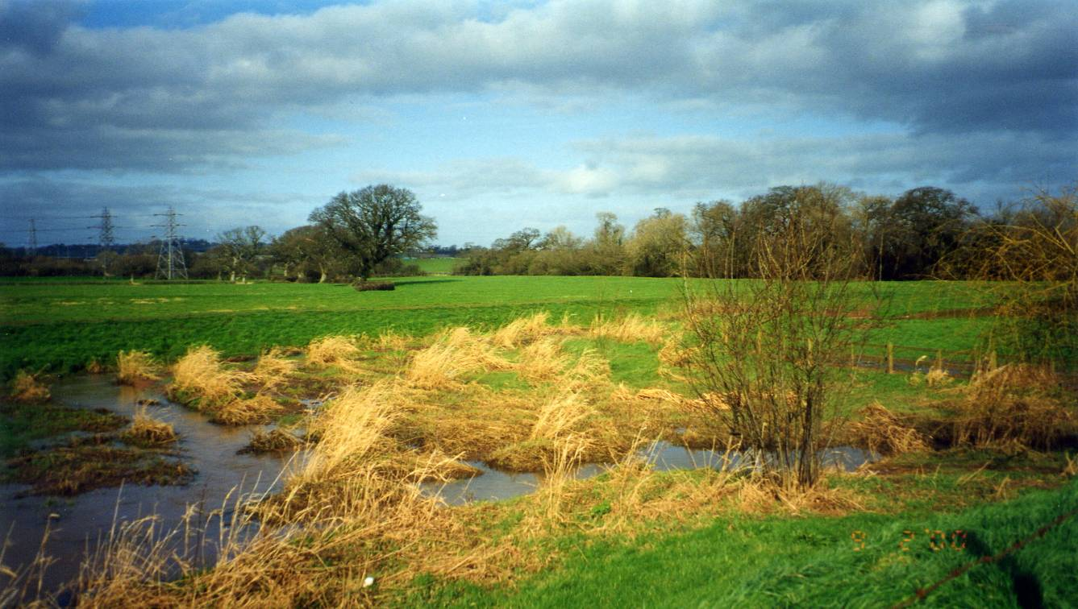

12. Miscellaneous Matters

12.1 Doctor’s surgery

This was closed because only an average of 1.8 residents used it per week. The Parish Council was consulted but had reluctantly to agree that it was not viable to continue.

Prescriptions issued by Pinhoe Surgery can be delivered to Clyst St. Mary Post Office.

12.2 Dentist:

Given the current situation in the N.H.S. it is most unlikely that a practice would set up in either village.

12.3 Disabled Access

Clyst St Mary Church, Village Hall, Shop and Half Moon Pub are all readily accessible.

Access to Sowton Village Hall is a little difficult as is Sowton Church but these are matters for Sowton Village Hall Committee and Sowton Parochial Church Council as they are responsible for conforming to current legislation.

12.4 Website

A website – www.bishopsclyst.btck.co.uk is now up and running. Details of council members, minutes of meetings and other documents, including this Plan, can be accessed on the website.

12.5 Notice Boards

Currently, there are three Parish Council notice boards in Clyst St Mary, one in Sowton Village and one at the Cat and Fiddle Residential Park. However, the notice board at the top car park will shortly be resited to replace the existing unsatisfactory board at the Cat & Fiddle. The Parish Notice Board near the shop could, perhaps, be better sited. The notice board on Winslade Park is in poor condition and has recently been repaired but needs replacement in the future.

12.6 Publications

The Clyst St. Mary Parish Church group Magazine, “The Clyst Valley News” is a monthly newsletter and the easiest and most viable option as the main vehicle of communication but it does need a dedicated Council Correspondent. It is not distributed in Sowton as it is not a part of the Church grouping.
The only other possible way is a Council newsletter and that involves production expenses as well as delivery problems and further implications to the Parish Precept. At the moment, “The Clyst Valley News” is a much more useful way of communicating

12.7 Churches

Ecclesiastical matters are the responsibility of the individual Church of England Parochial Church Councils or the Diocese and not the Parish Council. Clyst St. Mary is grouped with Aylesbeare, Clyst St. George, Exton, Farringdon, Woodbury and Woodbury Salterton Churches into the White Cross Mission Community. The Rector with part-time assistance covers all 7 parishes. Sowton is grouped with Pinhoe and Broadclyst.

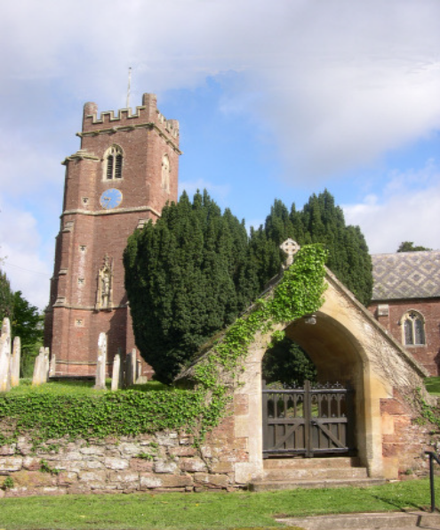

Sowton Church

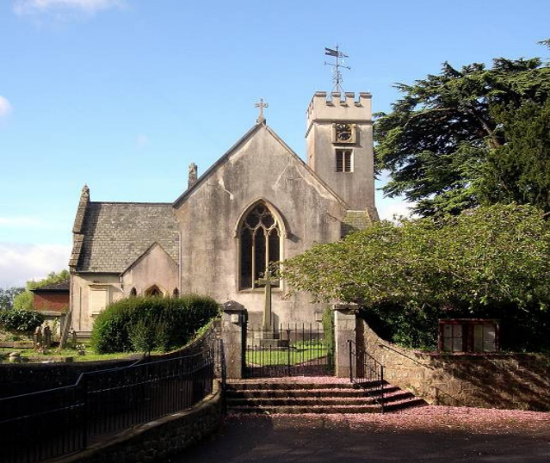

Clyst St Mary Church

13. Action Plan

Action | Current status | Further action proposed | Comments
Identify suitable land for future housing development (4) | Complete – land identified to EDDC | Support any moves to develop land identified
Implement revised parking regulations in Clyst St Mary village (6.2) | In process of implementation
Seek solution to “rat run” through CSM village via a one way system (6.5c) | Traffic survey carried out but at inappropriate time | Further discussions with highways
Seek further footpaths in the area (7.2) | Negotiations with landowners in progress
Resite parish council noticeboard near the shop (12.5)
Extension of 40mph speed limit on Sidmouth Road to Cat and Fiddle (6.5e) | With County Councillor for action
Cycle path to Topsham (7.1) | Awaiting development of Clyst Valley River Park
Resolve parking problems in Church Lane (6.2)
Resolve parking problems in Manor Park (6.2)
Improve verge maintenance on Winslade Park (10.2)
Improve equipment and fencing to play area (9.1) | Awaiting S106 money, plans in hand

