Tips for using Universal Job Match site

This is not a full guide to Universal Job Match, but a companion to assist users who are new to the site, compiled from experience helping new users. Please follow this guide as you go on to the Job match site.

Entering Your Account
1/ Government Gateway twelve digit ID and password. It is important that this information is kept safe, as losing it or forgetting the password will mean a new account needs to be opened- either save in documents,one drive, phone, or even email to yourself.

2/ Once you have entered your ID and password, press ‘enter’. Be aware that, due to unexpected technical errors, you may not always be allowed in. DO NOT immediately assume you typed in your ID or password incorrectly, and start typing in variations, but calmly try again.

3/ On gaining entry to ‘your’ Jobmatch page (you should see your name in the top right hand corner), take a moment to study the menu items across the top of the screen (home,profile,CV etc). Click on each one to view the contents. Also be aware of the three AAA’s on the top right hand corner of your screen, pressing each one may make the use of the site more comfortable for you.

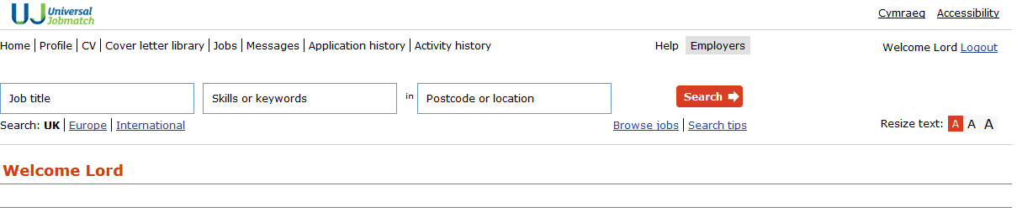

Search Menu

Home: Your Homepage with all your latest information and Job Matches

Profile: Use this button to change/alter your profile information including adding new keywords.If this is your first time using Jobmatch, please check this section is correct - right contact details etc

CV: Use this button to add or view your CV. You can create a CV within the site, or ‘upload ‘ a CV that has been created for you.

Cover Letter Library: Use this to create and edit up to 5 cover letters that will go with your online application. There is a cover letter within this section that you can amend for your own use.

Messages: This will show you any messages that have been sent to you from within the Jobsmatch site

Application History: Show all the online applications you have made using the site

Activity History: Display all your recent activity. This screen should be your first point of call when entering the site, as it is a record of your jobsearch activities. Use the box on the right hand side to date and note each seperate activity eg 3/1/15 Attended Job Club, 3/1/15 Telephoned A.N.Employer. You are creating a diary of your jobsearch activities to show the Jobcentre. It is common for people to spend a lot of time looking through the site and then forget to complete the activities box - therefore update first, then look at the rest of the site, then return to update what you have done.

4/ CV

You are expected to have a CV in order to get the best use of the site, and there are 3 options available to you.

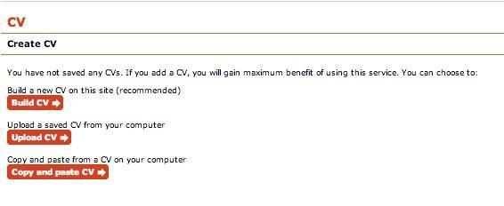

Regardless of the way in which you want to create your CV (build it in the site or upload it )there are some options that need to be considered:
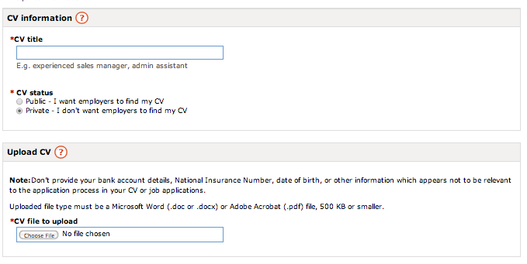
CV Status: By choosing to make your CV public it means that employers who match your keywords can see your CV and are therefore more likely to contact you direct if you meet their criteria and invite you to apply for a specific vacancy.

Upload CV: Be aware that if you are uploading a preprepared digital CV it can be in .doc/.docx or .pdf format (and less than 500KB file size). Using .pdf documents here will ensure that your CV is ‘locked’ and cannot be edited/altered.

Security: The site advises- ‘Don’t provide your bank account details, National Insurance Number, date of birth, or other information which appears not to be relevant to the application process in your CV or job applications.’ It is also important to read the information given when you click on the ‘?’ (question mark) symbol next to CV Information – the notes here advise you how the site protects your personal details.

5/ Covering Letter
Use the cover letter library button to create up to 5 cover letters that will help you introduce yourself to prospective employers

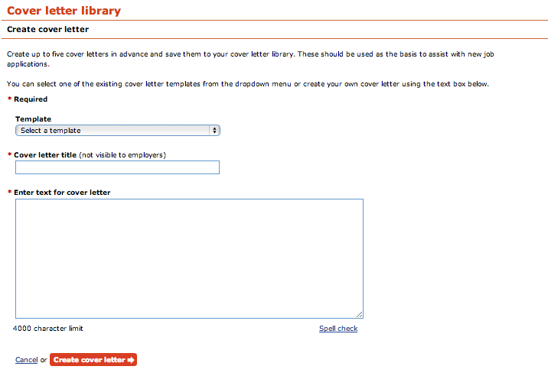

6/ Basic Job Searching

Once you have a CV and a covering letter set up, you are now fully equipped to start using the jobsearch boxes, which offers you three boxes to narrow down your search-

-any job title- You can be specific here, but bear in mind that a search for ‘forklift driver’ will miss out on the ideal job of ‘pallet distributor’ as the title is different. This box is best suited for specific searches.
-any skills,keywords or job ID- This would be a better place to use the skill ‘forklift driver’
-city, county or postcode - Bear in mind that this means the travel to work area of your local jobcentre, which means that entering Caernarfon will also show up vacancies in Caernarfon , Pwllheli and other local areas.

7/ Finally

When you have finished your jobsearch activity, ensure you have again updated your activity record, and make sure you logout of your Universal Jobsearch account if you are using a shared device to go online, otherwise the next user will be able to see your account.

