

Lincoln Cursillo
IMP SHEET
Issue #79
July 2014

Lay Director's Report

I was rather thrown this week to receive David McCormick’s resignation as our Diocesan Spiritual Director. David has become a dear friend, and I have enjoyed “sitting at his feet” for various training sessions and more informal gatherings during his two and a half years as SD. A highlight will remain the Retreat he led for us last autumn! He brought us encouragement, inspiration, affirmation, and great fun!

I was actually relieved, though, that David had reached the point of recognising that it is time to cut back on his voluntary roles to save himself from unbearable stress. We all know that David is not able to give any less than 100% of himself to everything he commits to, and we have all benefited from that energy and passion. However, his two half-time posts in ministry were almost bound to exhaust such a person, without adding all the other forms of service he so desired to offer. I know he feels wretched about having to relinquish the post of SD mid-term, but I hope I have reassured him that we understand, and that he shouldn’t let any feeling of guilt add to his sense of pressure. We love you, David, and wish you well!

Whenever David and I met up for discussion about Cursillo matters it became a precious meeting of minds and souls. David is a good listener, and I am grateful for his wise advice, as well as tea and tissues on occasion! I’m sure many individual Cursillistas have particular remembrances of David, both staffing on weekends and at Ultreyas, etc.

This is beginning to sound like a eulogy – sorry! No – David is very much still around, and will continue to support Cursillo locally and within the diocese. Ultreya David! We salute the work you are doing both in your parish and at the Hospice, and will continue to pray for you.

The Secretariat has not yet had time to think and pray sufficiently about David’s successor as Diocesan Spiritual Director. Many of our Cursillista priests are now retired, and others, having responded to God’s call to ordination, have still not had experience of being on the Team for a Cursillo Weekend. I would ask that you all add your prayers to ours for wisdom and discernment from God. Of course our Diocesan Bishop also will be part of the process. I hope to meet with him soon.

I feel I should add to this article my own realisation that the role of Diocesan Lay Rector is huge! I know it is only as big as any individual chooses to make it, but I, too, am feeling the pressure of combining too many housekeeping issues within the diocese together with new ideas I feel I would like to develop. No, I am not resigning (!) but I have realised that there is a need to set up temporary “task-groups” to look at key issues alongside me. I hope some of you will feel able to respond to one or other of these as these materialise. I am very grateful for all the great people around me on Secretariat, and for my loyal friends in Alford Reunion Group who offer support. I don’t think God created us to be alone! Relationship is basic to our Gospel message, and we do well to remember this and to be a good example of sharing together and supporting each other, different though we all are!

With my best love in Christ,

Liz
All the thirsty people John 4:6-10 (njb)

Jesus, tired by the journey, sat down by the well. It was about the sixth hour. When a Samaritan woman came to draw water, Jesus said to her, 'Give me something to drink.' His disciples had gone into the town to buy food. The Samaritan woman said to him, 'You are a Jew. How is it that you ask me, a Samaritan, for something to drink?'—-Jews, of course, do not associate with Samaritans. Jesus replied to her: 'If you only knew what God is offering and who it is that is saying to you, "Give me something to drink," you would have been the one to ask, and he would have given you living water.'

Nowadays we hear quite a lot about groups of Christians marching around the edge of a town or part of a city 'claiming it for the Lord’. One hopes that they get involved with the centre of such areas as well. A friend of mine was asked to run a house for homeless men in the East End of London when he was still very young. Each night he set off in the dark to seek out places where these men (many of them alcoholics) settled for the night. Sometimes he was so frightened that he turned round and ran home again. He was only a part-time coward, though. He persisted, and the project thrived. He took Jesus to people who might not have met him otherwise.

Here we see Jesus taking himself into an area that Jews normally avoided like the plague. He did not walk round it; he walked into it.

Having dispatched the disciples (why did it take twelve men to collect the groceries?), he then defied convention even further by not only speaking to a Samaritan woman, but actually asking her for a drink. Like the homeless men that my friend visited on their own ground, she was curious about the motivation for this unusual behaviour. The answer in both cases was the same—Jesus had come, bringing the water of life.

It is not easy to go into places that are unfamiliar or threatening in some way, but if we want to follow Jesus, that is what will happen. It may be the people next door, it may be the pub down the road, it may be deepest Borneo, but if he calls us, we either go—or disobey.

A prayer
Lord, am I avoiding anyone or anywhere that you want me to visit?
I need courage.
Please give it to me when I need it, so that I can take you to those who need living water.

From ‘When You Walk’ by Adrian Plass

Website

The Lincoln Cursillo website: http://lincolncursillo.btck.co.uk/ includes most of the contents of the Imp Sheet as well as useful information such as links to related websites and a Download page that has publicity posters and pamphlets, secretariat job descriptions and weekend application forms.
Lincoln Cursillo #30
2 – 5 May 2014
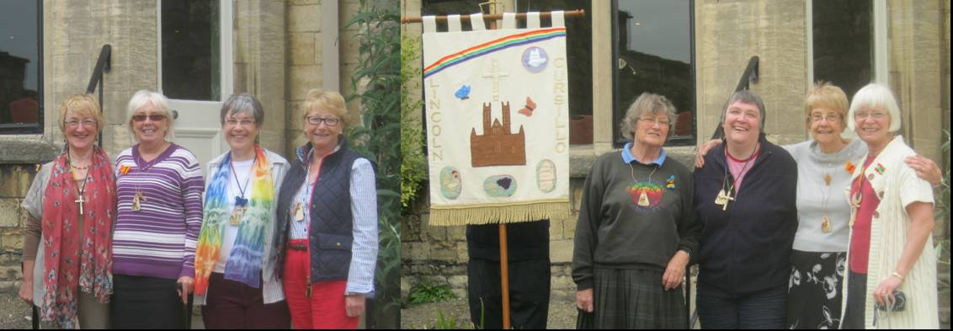
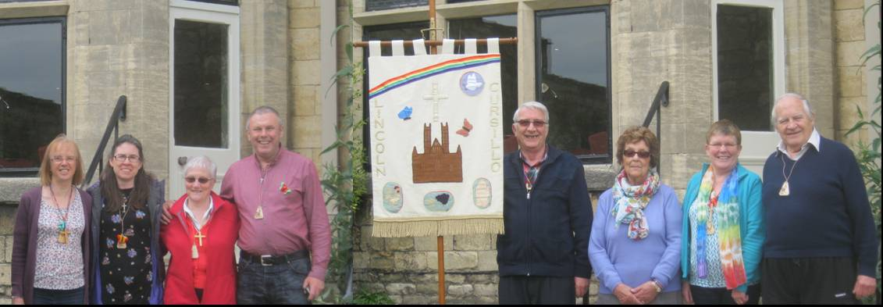
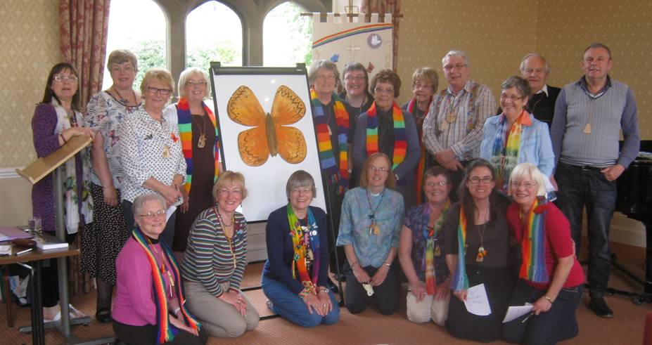
Dedicated to St Christopher
Blown away, having been in the doldrums. Kick-start to where I ought/want to be
Saw Holy Spirit at work. Feel more determined and aware of own capability, with His help
Tranquillity. Allowed to concentrate on thoughts between God and self. Love God & love others
Loved it. Experienced the feeling of being a disciple of Jesus
Do I look different, because I feel it!
Made me look at my lifestyle & behaviour as a Christian
Another stone of growth on the foundation.
Privilege & benefit to be with other committed Christians
Introduced to a range of experiences I wouldn't have touched, yet not unpleasant!
Wonderful to absorb love & guidance. What I needed
St Thomas
St Stephen
St Matthew
St Benedict
Study

Life is made for learning
From a very early age
Stories from our parents
Help us to engage.

Life continues learning
We never know it all
And if we really think we do
We’re heading for a fall.

Life’s not just books and study
We meet it on the street
In people in adversity
And everyone we meet.

Life is in the sacraments
And life is in the park
It’s in the song of skylarks
And the silence of the dark.

If we turn to Jesus
And meet him where we are
By our daily studies
He will help us to go far.

St Thomas Decuria. Lincoln Cursillo #30

Cursillo Weekends.

The following Weekends have been sent a Palanca Poster from Lincoln Cursillo.
Please support them with Palanca prayer.

Date | Cursillo
21 -24 August | Scotland #63
11 – 14 September | St. Davids #17
2 – 5 October | Clifton Diocese
9 – 12 October | St Edmundsbury and Ipswich #35
16 – 19 October | Peterborough #8
23 – 26 October | Blackburn #60, Bradford #25, Chester #49  Durham #22, Ely #28,
30 Oct – 2 Nov | Derby #17, Canterbury #52, Chichester #25,  London #28, Oxford #15
20- 23 November | Chelmsford #29, York #22
27 – 30 November | St Albans #5

Contemplative, Creative And Intercessory Prayer

I recently had an opportunity to spend a day at a Hidden House of Prayer gathering. This is a national gathering of people drawn to the practice of contemplative, creative and intercessory prayer in their own homes.

I especially picked up on 3 suggestions.

1, When you donate to a food bank pray that God may be able to intervene in the recipients situation.

2, Night Prayer - There is no longer enough nuns/monks for this practice to continue. There are also a lot of people who can't sleep through the night and and if you are one of these can you use this opportunity for pray for others as well as yourself?

We were told of a time when a gentleman spent the night as a guest in a house. The next morning the host enquired if the guest had slept well? The guest had slept well and enquired if the host had also had a good night? The host however had not had a good night and very really did but because he knew that somewhere there was someone praying it prevented him from doing anything stupid (i.e. suicide).
3, A lady was knitting a scarf for a friend who had cancer and singing the Lord's Prayer in Arabic has she knitted. She found she was able to put her friends name into the prayer (instead of 'give us our daily bread' she would sing 'give Jane her daily bread'). If you knit for needy people can you pray for the recipient as you knit?

You may already be practising these but if not how about giving it a go?

Susanne Wills

If you want to know more about Hidden House of Prayer go to http://hiddenhousesofprayer.wordpress.com/

Cursillo Leaders Workshops

10 - 12th October 2014 at Wistaston Hall, Crewe, Cheshire
17 - 19th April 2015 at Shallowford House, Stone, Nr. Stafford
24 – 26th July 2015 at Shepherds Dene, Riding Mill, Northumberland

If you are interested in attending a Cursillo Leaders Workshops, please contact the BACC Rep Gillian Padley (see below) and she will make the necessary arrangements – please don't contact the venue direct.
Planned Giving

Do you want to ensure that everyone who wants to experience Cursillo and that very special weekend, can do so?

Think back to the time you made your Cursillo.
Remember the love you received, and how your heart was full of joy.
How this changed your life, and the benefits which you continue to get from that weekend. How we all thank God that we were led to Cursillo.

Cursillo continues to give benefits to more and more people.
It flourishes by the love of God, but like a plant, needs feeding in order to continue to grow. Cursillo needs continual feeding! Like every organization it needs money!

Have you ever wondered how it is funded?
It is only after making your Cursillo that you realize there is no subscription, and only donations which are freely given from time to time help to fund it. The fact is that Cursillo manages to continue to change people’s lives by virtue of what we ourselves donate and the grace of God. Its survival depends on us.
The cost of holding a weekend at Edward King House is been around £6000.
The payments received towards the cost of the weekend – approx. £3000.
This leaves a shortfall of at least £3,000 per weekend!

Costs will escalate from now on, as Edward King House (Palace Hotel) is operated as a hotel and we will need to investigate alternative venues. Even by increasing the charges to Pilgrims there is still a huge shortfall. A significant increase to participants is not really an option if we want the weekend to be available to all.

We are pleased with the wide variety of donations at our events and Ultreyas. But we need to draw everyone’s attention to the necessity for regular giving, possibly by bankers order. This will enable us to build up a positive financial framework, so that we can then concentrate on serving God, and to give more people that love and joy which we received from Cursillo.

How can each one of us help?
By making regular (monthly/quarterly/or annually) donations through banker’s order.
By sending a donation by cheque to David Simcox (Treasurer) at 16, Tothby Meadows, Alford, LN130EH.

By gift aiding any of the above if you are a taxpayer. For every pound that is given by a standard rate taxpayer, a further 25p can be claimed by us from the Inland Revenue.

What price do we put on faith?
Think carefully about what you may be able to afford to give, and remember that all donations are appreciated – remember the story of the Widows Mite.
Do please give the matter your careful and prayerful consideration.

If you decide to make a regular donation via bankers order, please contact our treasurer David Simcox – see above, and he will help you fill in the necessary forms.

We are sure that all Cursillistas will respond and make a difference, so that our finances are on a firm, sound footing, as is our love for God and for one another.
To watch people blossom at a Cursillo Weekend is a real privilege, and to observe how pilgrims continue to grow in their enthusiasm to spread God’s message of love wherever they find themselves is truly wonderful.
Please help to ensure that Cursillo can be there for others, so that they can all receive the benefits and become the people God wants them to be. Remember what it has done for you.

Yours in Christ

Lincoln Diocesan Cursillo Secretariat

SUMMER EVENT
21st of June
12.00
Holland Fen
All Saint’s Church
Village Hall
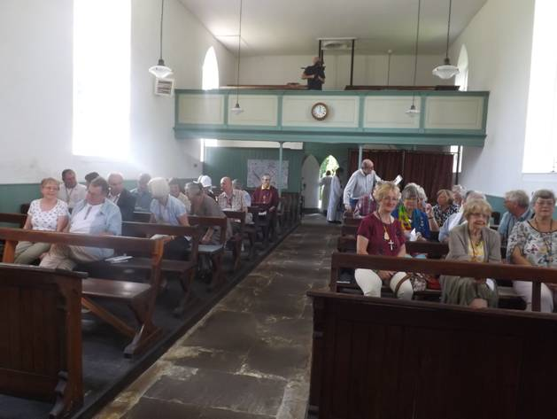
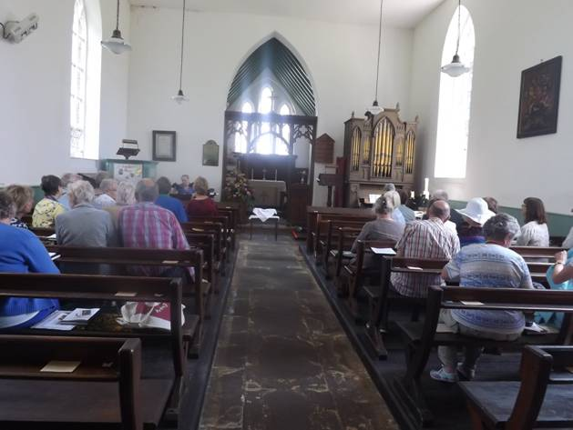
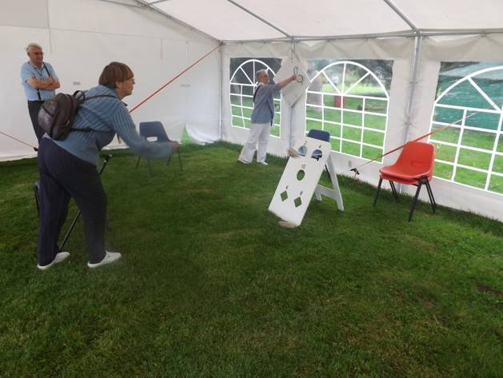
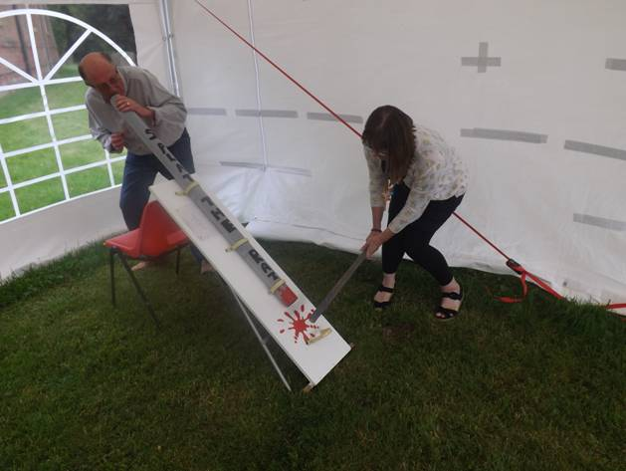
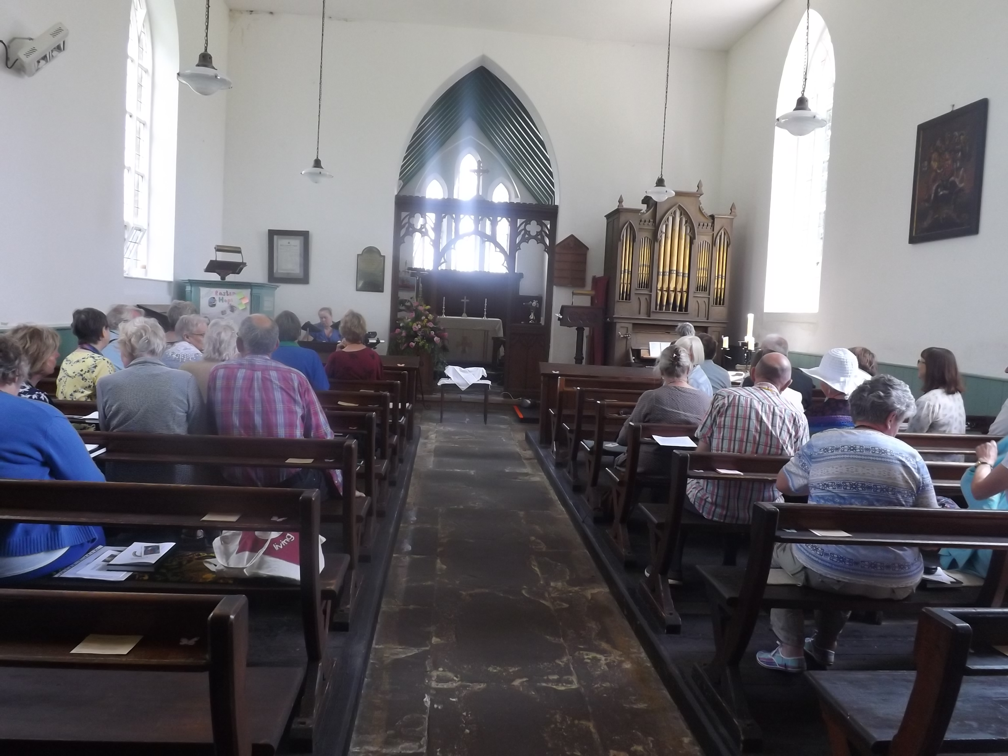

Facebook

A Facebook group CursilloLincs has been set up. This will allow members in the group to share thoughts, offers of lifts, friendship and prayer requests etc. In order to keep the information confidential this has been set up as a private ('secret') group. Membership will be by invitation by email. This will unfortunately take time to set up as names and addresses need to be collected and emails sent out.

BACC AGM Catch the Vision Weekend 30th May to 1st June.

As Lay Director and BACC rep, Liz and I attended the weekend accompanied by Mary Dixie.

We all met at Mary’s house and Liz drove us down to High Leigh a Christian Conference Centre in Hertfordshire stopping on the way for lunch.

We arrived early afternoon with over 80 more Cursillestas from all over the country.

That afternoon after meeting friends old and new Liz and I enjoyed a walk in the beautiful grounds of the centre.

Following dinner everyone met for our first study session where we compared two Bible passages, Acts 16.25-34 and Psalm 45.8-47.1 then we had Evening Prayer and off to bed.

Morning Prayer on Saturday at 7.45 a.m. followed by breakfast and our next Study session on Disciples as Pastors where we compared Acts 3.1-15 and Isaiah 55.1-56.1 followed by Acts 10.34-43 and Deuteronomy 1.17-26, this was followed by lunch and the AGM took place at 2.00 pm. New members of the Standing Committee were elected and it was time for Lyn Radcliffe to stand down and Sally Henniker-Major to take her place. The cost of the CLW is to go up to £175 from 2015. The National Ultreya is taking place on 30 August and several more items were addressed.

A very moving Eucharist took place when members of the Committee we De-commissioned and Commissioned. After dinner there was Compline and then a social gathering where we had a quiz (and a fire alarm went off and we had to evacuate for a short time). Later in the evening some people watched a film.

Sunday Morning Prayer at 8.45 then followed a further study ‘The Living Stone and a Chosen People’ where we compared 1 Peter 2.4-10 and Isaiah 61.1-10. Eucharist was held just before lunch when thereafter it was time to depart.

Gillian Padley
B.A.C.C.Rep.

BACC Pages

This is available from http://www.anglicancursillo.co.uk/bacc-pages.php.
The Winter 2014 edition is available and can be downloaded directly from http://www.anglicancursillo.co.uk/BACC%20Pages/bacc-pages-winter-2014.pdf 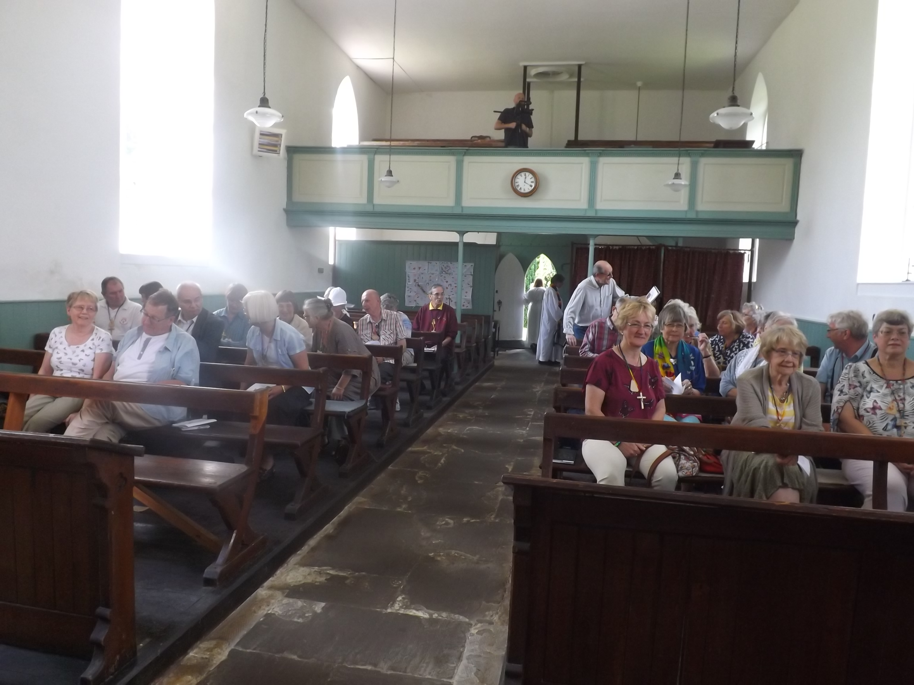

Lincoln Cursillo Dates

2014
30 August | National Ultreya |  | Canterbury
22 - 29 September | PILGRIMAGE to SANTIAGO DE COMPOSTELA
4 October | equip |  | Lincolnshire Showground
9 October | 6.45 for 7.00 – 9.00 | Secretariat | Bailgate Methodist Church
10 – 12 October | CLW weekend |  | Crewe
8 November | 9.30 for 10.00 – 12.00 | Reunion Conveners | TBA
8 November | 12.00 for 12.30 | Eucharist | TBA
8 November | 1.30 – 4.00 | Bring & Share Lunch  & Ultreya | TBA
22 November | 9.00 for 9.30 - 4.30 | MBTI Event 3 – Prayer | The Old Palace
2015
17 – 19 April | CLW weekend |  | Stone, Staffs
23 May | 9.00 for 9.30 - 4.30 | MBTI Event 4 – Conflict | The Old Palace
24 - 26 July | CLW weekend |  | Riding Mill, Northumberland
Conveners for Reunion Groups
Alford | Angela Simcox | 01507 466824
Caythorpe &  Claypole | Susanne Wills | 01400 272777
East Wolds | John Pollard | 01205 822958
Grimsby | Kathy Whitlam | 01472 871669
Lawres | Paul Mabbott | 01522 688737
N. Hykeham | Hetty Naylor | 01522 681984
Scunthorpe | Stuart Duff | 01652 652120
W. Norfolk | Bridget Everitt | 01553 840527

Your Servant Community
Lay Director | Liz Lilley | 01507 440039
Spiritual Dir | Vacant
Secretary | Judith Scott | 01400 272974
Treasurer | David Simcox | 01507 466824
Pre-weekend | Barclay & Janice Brader | 01724 348595
Weekend Rep | Lesley & Stuart Duff | 01652 652120
4th Day Rep | Angela Simcox | 01507 466824
B.A.C.C. Rep | Gillian Padley | 01636 626510
Publicity | Vacant
Palanca. Imp & Web Editor | John Pollard | 01205 822958

Editor John Pollard, Top Floor Flat, Station Road, Swineshead, Boston, PE20 3LP
Tel 01502 822958. E-Mail: jjfp240@btinternet.com

