How did you spend your last holiday?
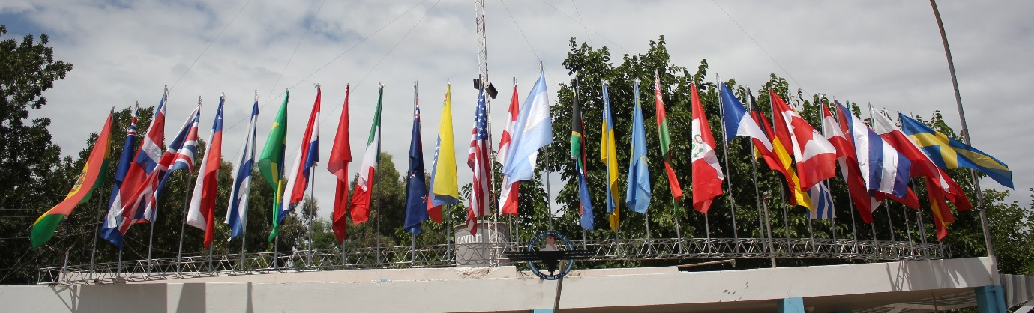
(Roof of the Drop Zone (DZ) manifest flying the flags for the competing contraries)
I have been skydiving on and off since I was 16 yrs old (periods of non-jumping included: serving in the RAF, when my daughter was young, and after an injury caused by parachuting). During this time I have managed to be awarded British Intermediate National Champion in Style (individual set of turn and loops on heading in the fastest time) and Accuracy (landing as closest to a 2cm disc, lowest score wins) for two years as well as winning a number of team medals for 4 way formation skydiving (FS) (four skydivers linking together to make a number of predefined formations, you get a point for each correct move within a given time period).
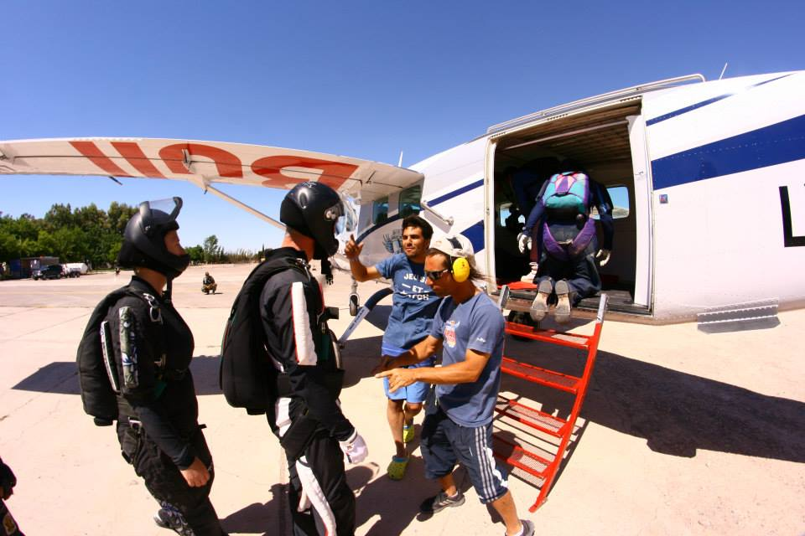
(Polly and Nigel getting checked before getting on the aircraft by Simon Donnelly)
This year I was invited to represent Great Britain in the 12th Parachutes Over Phorty POPS World Championship which was held this year in Argentina. The competition included both classic and sports accuracy, national 4-way FS, 4-way FS scrambles (mixed nation teams, drawn at random) and 6-way FS speed star (mixed Nation teams, drawn at random) and the Hit and Rock event (Fun individual event requiring precision landing and running skills). The POPs events encourage competitors to get involved in as many events as they can. It gives jumpers a great opportunity to share knowledge, expertise and approaches with other jumpers as a number of these events mix jumpers from different nations. Countries in attendance included: Argentina, Bolivia, Brazil, Holland, USA, Denmark, Australia, New Zealand, Switzerland, Canada, Germany, Russia, Israel, Italy and ,of course, Team Great Britain. The numbers were down on the previous years and that was put down mainly on the cost of travelling out to Argentina. This year the British contingent consisted of 9 competitors, we were able to field two 4-way teams as well as competing in all the other events. The teams were: Bodyflight SkyVandals (Anthony Green, Ben Samuel, Jo Whiting and Mike Dawson with Nigel Rowlan on camera) and Aeronauts (Jeff Chandler, Nicola Bagwell, Polly Chandler and Neils Hansen with Simon Donnelly on camera).
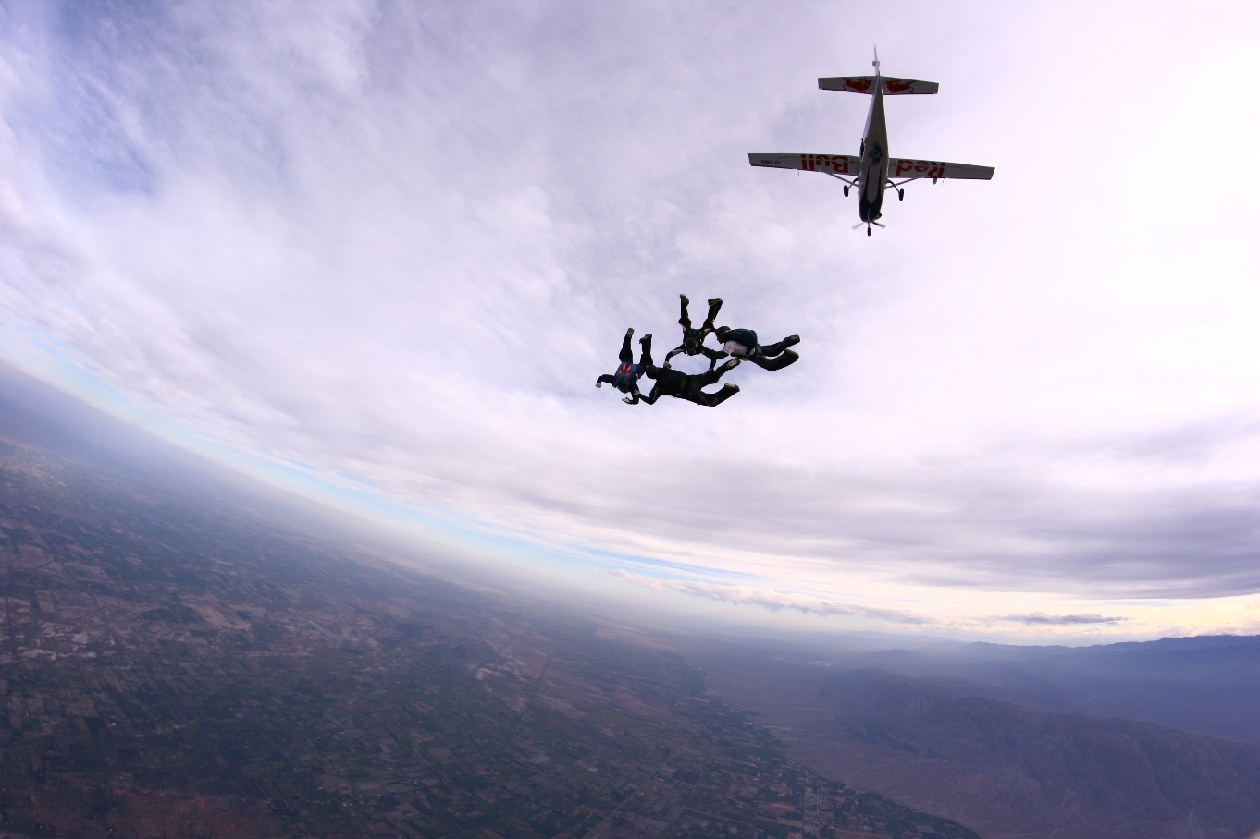
(Aeronauts jumping out of the otter with a stunning view of the Andes by Matias Gutierrez)
When we arrived at the Drop Zone (DZ) ‘Centro De Aviacion Civil’, San Juan, they were still busy putting the finishing touches in preparation for the event. All of the DZ team were very friendly and made us all very welcome. After initial registration and administration the opening ceremony was held at the San Juan football stadium hosted by the San Juan province Governor and was well attended, by both competitors and local community; after which we were transported (under police escort!) to the Orquesta Sinfonica de San Juan, where they had arranged a classical music concert for the competitors and local dignitaries.
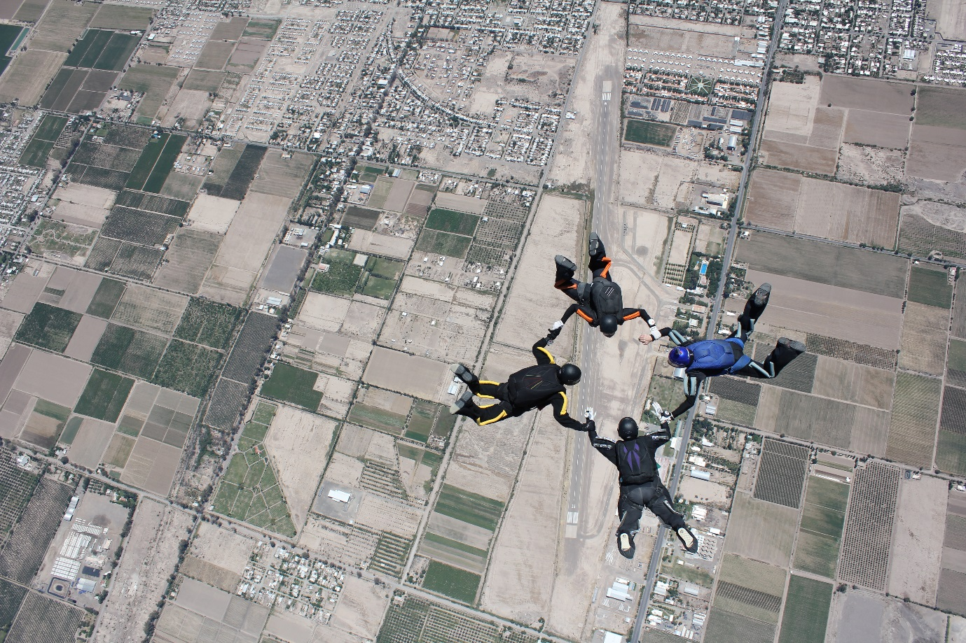
(Polly Chandler (in purple and black) scrambles team chilli peppers over the DZ by Simon Donnelly)
The competition commenced with the 4-way scrambles which was a great way to mix up the different nationalities and allow everyone to become familiar to the DZ. It was a great start to the week with a GB competitor in the top 3 teams (Polly – Gold, Mike – Silver and Ben – Bronze). Team Bodyflight Sky Vandals won the 4-way Nationals and Aeronauts finished 3rd , narrowly missing out on 2nd place by just 1 point. The 6-way Speed Star also had a GB competitor in the top 3 teams (Ben – Gold, Jo – Silver and Mike - Bronze).
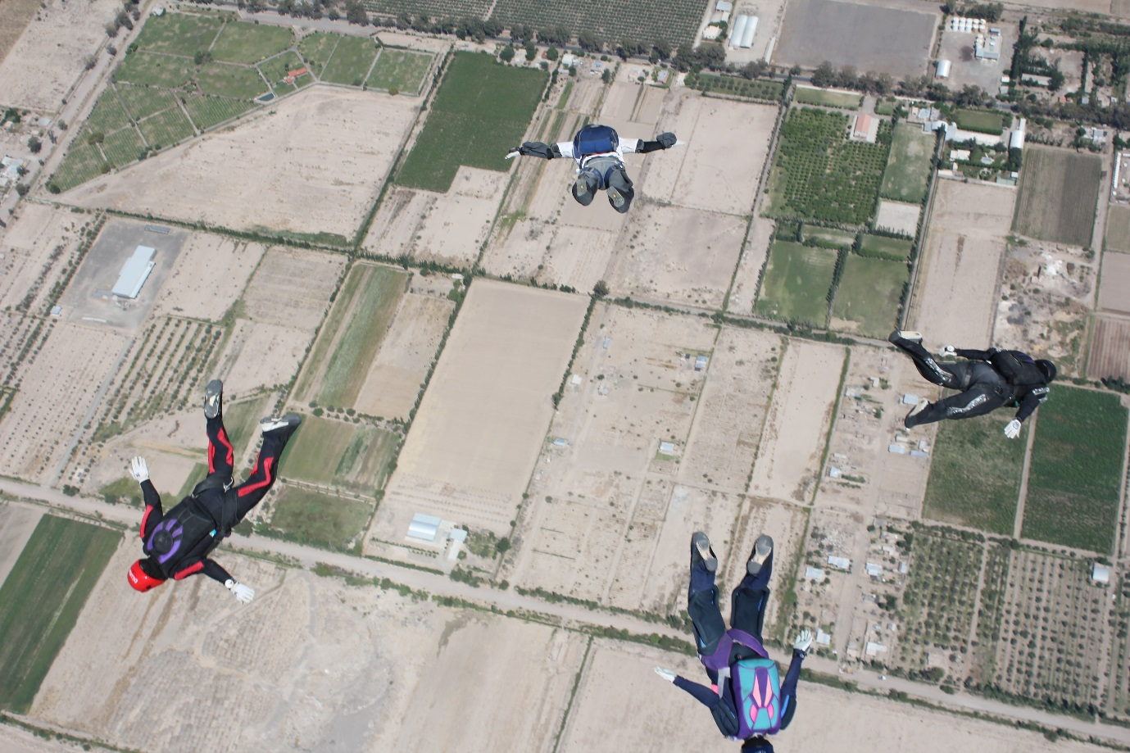
(Aeronauts tracking off at the end of one of their jumps by Simon Donnelly)
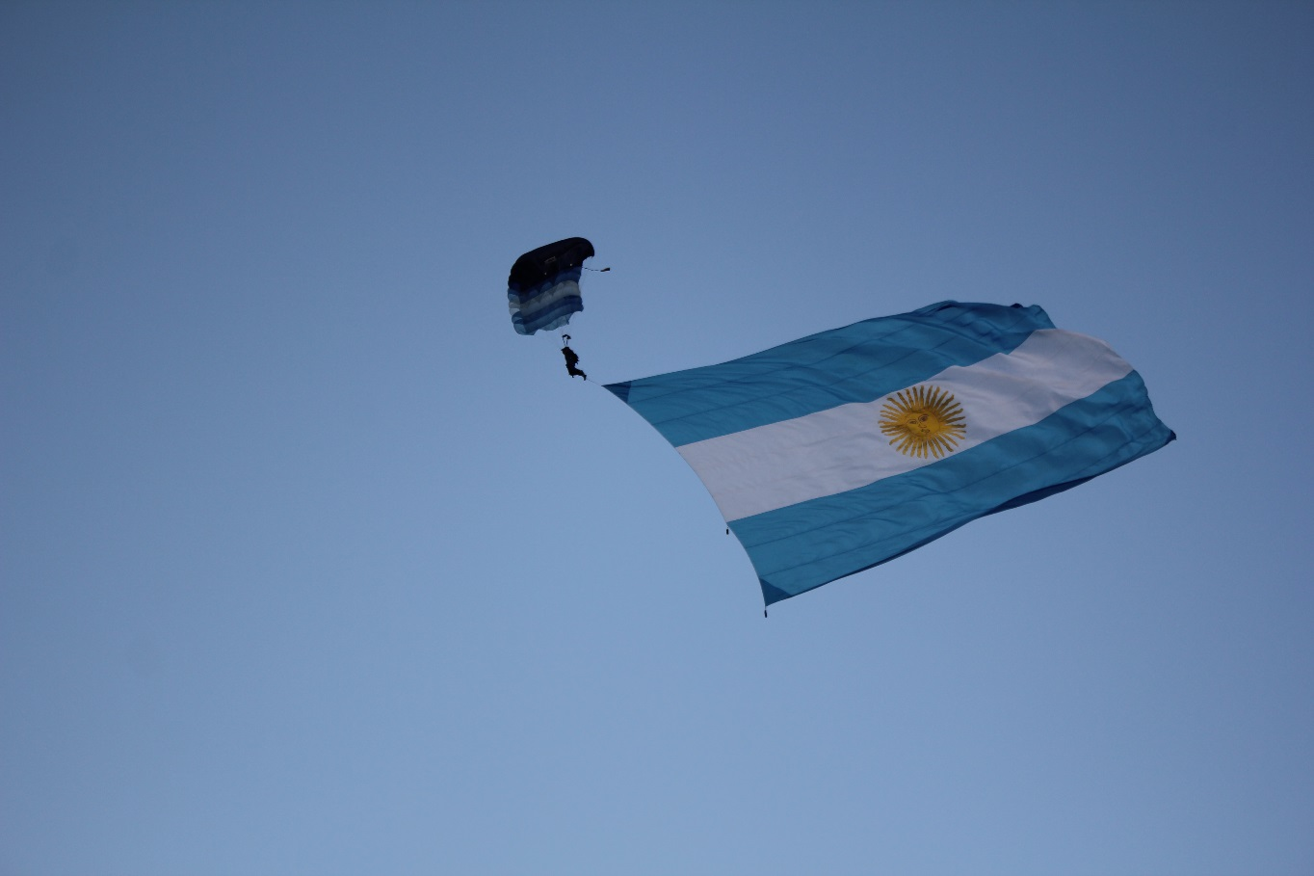
(Opening ceremony by Simon Donnelly)
The weather conditions were challenging with high altitude fast landings and unpredictable winds, including dust-devils. The whole championship was completed without major incident though (notwithstanding a few bruises, bumps and chipped bones), the scenery was outstanding, and the staff were all helpful and went out of their way to ensure that everyone was happy. There were some random breakouts of dancing outside the manifest and tango dancing lessons, as well as trips arranged to local vineyards. A really lovely atmosphere and interesting people.

(Nigel, Jeff, Polly and Nicola by Simon Donnelly)
Representing Great Britain in the POPS Championships was a privilege and an amazing experience.
This year will see my weekends taken up with further team training and more National Competitions and hopefully I will be invited to compete in the 13th POPs World Championship which takes place closer to home in Germany in 2016.
If you are interested in skydiving, or maybe you have recently taken up skydiving and have some questions about competing, then either way please feel free to drop me a line.
Polly Chandler
Defence Fire and Rescue Project

