THE ISLA PARISHES

PARISH PROFILE

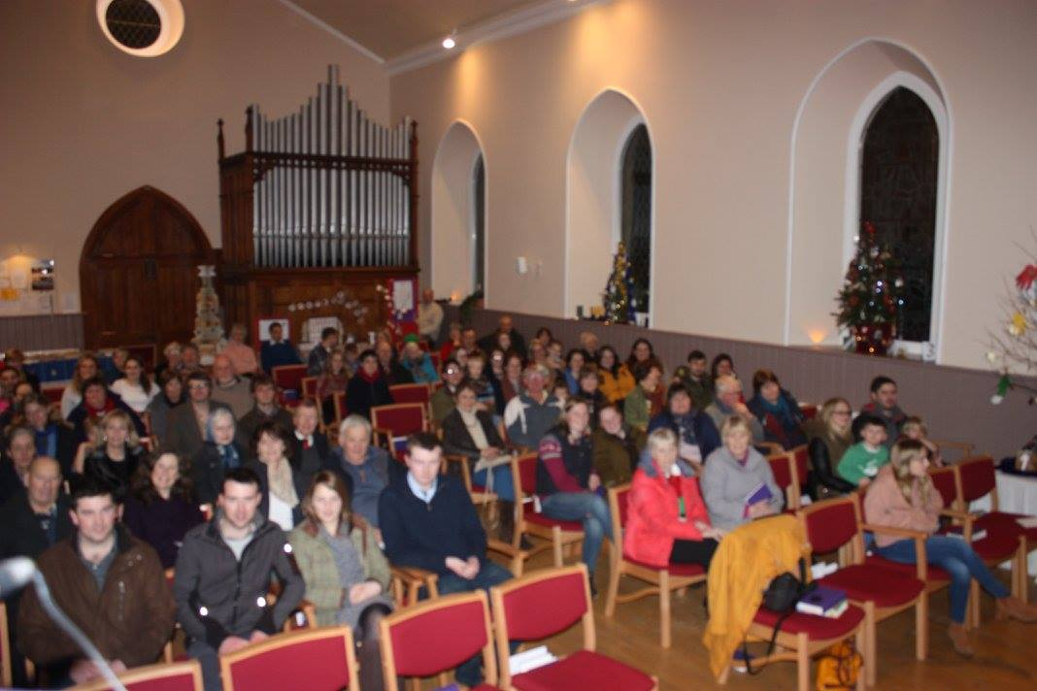

The Isla Parishes – (SC031461) 2016 – PRESBYTERY OF ANGUS
THE ISLA PARISHES – part of the WEST ANGUS AREA MINISTRY (WAAM) – was formed in 2005 by the Union of the United churches of Airlie, Ruthven and Kingoldrum, and the United churches of Glenisla, Kilry and Lintrathen. Since Union the Isla Parishes congregation has, guided by faith, prayer and love, worked hard in so many ways to achieve our present state of “one-ness” within the congregation. We rejoice that we, following Christ’s injunction to love one another, have helped create a single congregation from many, historically disparate and geographically scattered, parts, and forged a solid link in the Christian chain that binds us to our Lord Jesus.

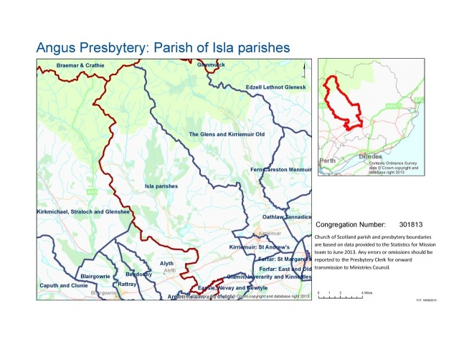
Kilry

WHO ARE WE?

As a result of inspired leadership during the last decade we have grown into a warm, welcoming and vibrant church community. It has been an exciting journey with numbers worshipping in the Isla Parishes Church growing year on year.

As in every corner of rural Scotland, farm mechanisation and the absorption of small holdings into larger units, has had a dramatic effect on the number of people living and working on farms. However, given our proximity to major centres of employment many have chosen to make their home in this countryside and then been drawn into church and community activities and church life.

Our congregation is drawn from many walks of life and all age groups. We strive with God’s blessing to be good neighbours in a caring and unselfish way.

OUR FAITH JOURNEY ONWARD

We look forward to continuing our journey of faith; growing with prayer, in mission, service and love, with encouragement and spiritual growth led by our Minister. Whoever is called to The Isla Parishes is assured of our whole-hearted support as we get to know each other.

Young people are actively involved in our worship and they participate in fundraising and other activities. This is an area we would like to develop. The WAAM Area Team Minister has already built up good, positive links with our young people.

We are, therefore, seeking to call a Minister who would be our pastor and friend, who would lead us forward, striking a balance between all that is strong and comforting in our traditional way of life and worship, and with the imagination and creativity necessary in a 21st century ministry.

Woman or man, newly qualified or experienced – this is immaterial to us. Much more important is that we attract someone who can harness our strengths and help us to develop and grow in purpose and faith, who wants to be at the heart of our community, and who will be happy to live and work in the peace, safety and beauty of the Isla Parishes and as part of the WAAM team.

OUR WORSHIP SERVICES

We gather on Sunday at 10am for morning worship in the Isla Parishes Church. Worship is normally followed by fellowship over tea or coffee which often lasts as long as the service itself. Living as we do in a scattered community this is an important part of our spiritual and social bonding.

Easter
We celebrate Holy Communion on the last Sunday in May and November and home Communion is given to the housebound and the sick.
In Holy Week in recent years, seated round a table, we have held a Communion Service on the evening of Maundy Thursday. On Good Friday we hold a vigil in the church from 12 noon until 3pm. Then on Easter Sunday the energetic of all ages climb a nearby hill (weather permitting) to greet this special day, returning to enjoy bacon rolls before proceeding to morning worship which is usually followed by an Easter egg hunt in the church and manse grounds.

Christmas
During Advent we hold a Christingle service, a Gift Service and, on Christmas Eve, at 6.30pm a service of Lessons and Carols sometimes led by elders and members of the congregation. On Christmas Morning we hold a family service at 10am in the Isla Parishes Church. (A Community-led Watchnight Service has been held for the past few years in the former Glenisla Parish Church.)

All the offerings made at the Christmas Eve and Christmas Day services are donated to charities – local, national and international. The gifts brought to the Gift Service are given to Family Support Teams in Angus.

Harvest Thanksgiving
Our Harvest Thanksgiving Service, which is also sometimes conducted by elders and members of the congregation, is usually held on the third Sunday in October. The non-perishable food is now donated to a local Food Bank and the fruit, vegetables and flowers are distributed throughout the parish and surrounding area to the housebound or unwell.

Armistice Sunday
Again this is a service which elders and members of the congregation have occasionally led. The worship service ends with the two minute silence and the congregation then travels to Lintrathen war memorial and on to the memorial at Craigton of Airlie to lay wreaths and remember our many dead. In Glenisla a service of commemoration takes place at the war memorial at the eleventh hour of the eleventh day.

Music
A feature of our worship, regularly commented on by visitors and visiting clergy, and of which we are rather proud, is our joyful and enthusiastic singing and our love of music in general. We are fortunate in having the great benefit of an excellent and supportive organist who makes the most of our wonderful pipe organ.

OUR PLACE OF WORSHIP

The former Kilry Church, built in 1877, was selected as our sole place of worship in 2006 and it is here that we gather for Sunday morning worship. In 2014 and early 2015 the building was entirely renovated inside and out. Various articles from each of the five closed churches were incorporated in the refurbishment including the very fine Victorian pipe organ originally sited in Airlie church. Pews were replaced with comfortable seating, flexible lighting installed as well as secondary glazing, a new heating system, a new audio-visual system and fresh décor. All in all we now have a warm, welcoming, versatile church which is admired by visitors.

THE MANSE

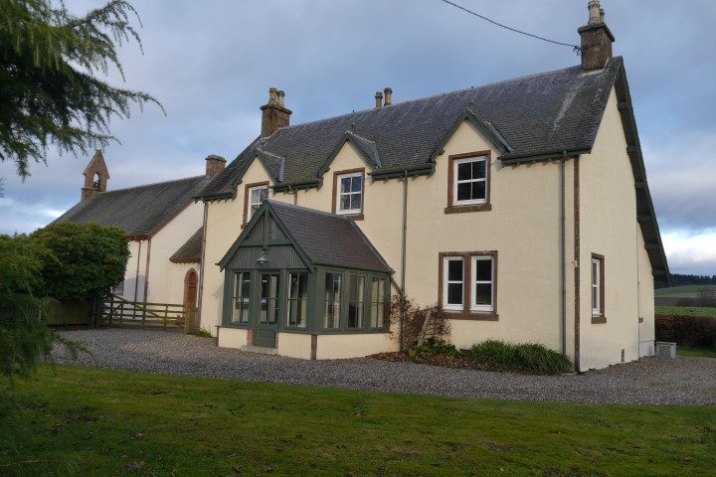

The Isla Parishes Manse, Balduff House, is a 19th century house standing adjacent to the church building. This fine, south-facing stone building is in first class condition. It has efficient oil-fired central heating, a wood burning stove and is double-glazed throughout. The interior was completely re-decorated in February 2017.

The front entrance is via a recently added sunroom. There is a modern and convenient kitchen with adjacent utility room and walk-in larder. The ground floor also comprises a drawing room, dining room, minister’s study and cloakroom with toilet. On the upper floor are four bedrooms - the master bedroom with an en-suite bathroom. One of the other three bedrooms has a wash-hand basin. There is also a family bathroom with shower.
External renovation was completed within the last two years and the outside of the house painted. A pleasant garden area is easily maintained. Garden ground, a garage for 2 cars and outhouses are to the south and east of the house.

OFFICE-BEARERS, FINANCE, FABRIC AND OUTREACH

The Kirk Session

The Isla Parishes has a Unitary Constitution. The Kirk Session is made up of 19 elders – 9 men and 10 women. Most of the elders have a “district”, visiting their members at least twice a year before the May and November Communion services, and delivering the biannual parish newsletter to members. The Kirk Session meets regularly to hear reports from the Finance, Fabric, Social and Fundraising Group Convenors, and from the Safeguarding Officer and Sunday School leader.

Finance

The principal source of income is the weekly offerings given variously through open plate, direct debit, or freewill offering with an increasing number of the congregation in recent years choosing to give by direct debit. In addition there are one-off donations and occasional bequests. Gift Aid also enhances our income considerably.

In 2016 the very active Social and Fund-raising Group raised a total of £3210.30.

We are not a wealthy congregation, but our financial management is prudent, and all our central commitments are met each year. Income from the sale of the various properties went to central funds and it was from these that the money spent on the interior and exterior of both the church and the manse were drawn

Fabric

This group has the responsibility of care for all properties and ground owned by the Isla Parishes. This includes the ground around the Isla Parishes Church which has no graveyard and therefore is not in the care of Angus County Council. Apart from the church and manse the Isla Parishes also owns the Manse Cottage at Airlie which is occupied by the Church Officer and his wife who cleans the Isla Parishes Church.

The modernisation of the church building and the upgrading of the manse in recent years, not to mention the disposal of properties, meant a great deal of work principally for the convenor of this group and the group secretary.

Social and Fundraising Group

This is a very active group who engage both the congregation and the whole community in their endeavours, making people aware of the need to raise money to meet some of our financial commitments. The group is very successful in attracting the wider community to events supporting the church.

Among their regular fund-raising ploys there is a highly successful annual Plant Sale and Coffee Morning held in Airlie Hall in the spring. Between times there are very popular quiz nights and paper quizzes, ceilidh, sponsored walk, a decorated Christmas tree exhibition, silent auction, beetle drive and a strawberry tea. From time to time tubes of Smarties are handed out to be returned minus the sweets but full of coins. In recent times, in October 2016, the Group raised over £1000 with a coffee morning held in the nearby town of Alyth, and about £400 with a trolley raffle at the Blairgowrie branch of Tesco and a similar amount at a Quiz Night. These endeavours make a remarkable difference to our finances. The congregation have always taken part in the Blythswood Shoe Box Appeal and this year we were able to fill 60 shoe boxes.

Outwith the group, ladies from the congregation often undertake kitchen duties and catering for Church events as well as refreshments and bites on other occasions. In addition, a much appreciated part of community outreach is the monthly Skein Tryst gathering when usually about forty people come together for coffee, a speaker and lunch – people who are on their own, are new to the area, have retired, may now be living further afield but like to keep in touch – the first Wednesday of the month is busy and noisy in Kilry Hall!
(Skein is a flight of wild geese, symbolic of the strength that comes from flying together rather than separately and the symbol of the West Angus Area Ministry)

Safeguarding and our Young Folk
We were thrilled that our Sunday School was reinstated in 2009 led by several members of our congregation. For a number of years the Sunday School was very active and a much enjoyed part of the children’s time at church. As these children have grown into active young people they have become more involved in the Sunday Worship Services and participating and assisting at the various events held by the church. At present the Sunday School may be dormant but we are proud that our young people consider themselves to be an integrated part of our church community and hope to re-introduce an active Sunday School in the not too distant future.
As a congregation we are conscious of our duties of care and our Safeguarding Coordinator ensures that our PVG records are up to date, that applications are submitted in a timely fashion and that training is obtained when necessary.
Knitivity

A number of the congregation knit, sew or crochet to provide gifts that can be given to anyone within the community who may be in need of comfort or support. Knitivity very quickly became synonymous with caring and love and each gift carries the label– Handmade with love from the Isla Parishes. The Special Care Baby Unit in Ninewells Hospital, Dundee and overseas aid also benefit.

THE WEST ANGUS AREA MINISTRY

The Isla Parishes are an integral part of the West Angus Area Ministry [WAAM]

WAAM is a Parish Grouping and was formed by the Congregations in the Kirriemuir Cluster of the Angus Presbytery Plan. There are four ministries posts allocated to the Kirriemuir Cluster. Currently WAAM comprises the Congregations of …

- The Isla Parishes 1 post in a 60/40 basis
- Eassie Nevay Newtyle 1 post
- Glamis Inverarity Kinnettles Under Presbytery Guardianship
- Kirriemuir St Andrews linked with Oathlaw Tannadice 1 post
- The Glens and Kirriemuir Old 1 post

In addition WAAM has had the services of a Team Minister since 2005 but this funding stops in September 2017.

In recent years WAAM has evolved along the following lines …

[1] The Ministers of the team meet on a weekly basis to discuss ideas, share views and support each other. They also provide pastoral cover for each other, for instance, during holidays, in the event of illness and vacancies. Session Clerks join the Ministers once a month.

[2] Congregations work together where it makes sense to do so and alone where appropriate. To date, examples of working together have included Bible Study, joint newsletters, joint membership classes, administrative support, cover during holidays and illness, pulpit rotation, a web site and various special services.

[3] The Team Minister’s role evolves on an ongoing basis and she has identified and visited young families in WAAM. She supports primary school chaplaincy in WAAM, makes pastoral visits in WAAM and leads worship. She is also Chaplain to Webster’s High School S1 in Kirriemuir and she is involved in Primary / Secondary transfer.

[4] We are now part of the national Path of Renewal Project.
The Call to the Isla Parishes

The Call to the Isla Parishes is on the basis of a 60 [Isla Parishes] / 40 [WAAM] split.

In general terms this is interpreted as follows …

- commitment to work as part of a team with colleagues who are a support and a strength
- flexibility in outlook to Parish Ministry and its development
- willingness to contribute personal areas of strength to WAAM
- recognition that team work in the Church of Scotland is in its infancy and a willingness to share in this exciting development
- willingness to share in general ministry activities across WAAM
- willingness to undertake specific projects across WAAM

In specific terms this is interpreted as follows …
- · 3+ days a week [or equivalent] working in the Isla Parishes
- · 2 days a week [or equivalent] working in the other WAAM Parishes​
- · Leading Worship in other WAAM sanctuaries on a regular basis in addition to leading Worship in the Isla Parishes
- · attending the weekly WAAM Team Meeting
- · sharing in the leadership of WAAM

In a nutshell our hope is that with God’s guidance and blessing a team player will respond to the Call and will rise to the opportunities and challenges offered by the Isla Parishes in particular and the West Angus Area Ministry in general.

WAAM Ministers
Rev Carleen Robertson CRobertson@churchofscotland.org.uk
Rev Malcolm Rooney MRooney@churchofscotland.org.uk
Rev John Orr JOrr@churchofscotland.org.uk
Rev Linda Stevens LStevens@churchofscotland.org.uk

OUT AND ABOUT…

We have two Primary Schools within the Isla Parishes – a recently opened newly built school, the Isla Primary, two miles from Balduff House, and Airlie Primary School near the southern end of the parish. These are feeder schools for Webster’s High School in Kirriemuir.

There are many attractive tourist facilities within a short distance including fishing, golfing, ski-ing, walking etc.

We are fortunate in having excellent modern Community Halls through the parish. These halls are in frequent use for a wide range of activities throughout the year – for SWI meetings, dance clubs, indoor sports clubs, mother and toddler groups, church fund-raisers, concerts, ceilidhs, quiz nights, etc. Kilry Hall, with its access for the disabled, toilets, and excellent kitchen facilities is situated only a few yards away from the Isla Parishes Church and is available to the congregation for all sorts of activities.

The nearest shopping centre to Balduff House is the small town of Alyth – 5 miles away – where most everyday requirements are available. Blairgowrie, Kirriemuir, Forfar, Dundee and Perth are all just over half an hour’s drive from Kilry.

There are excellent Health centres in Alyth and Kirriemuir. The nearest major hospitals in the area are Ninewells, Dundee; Stracathro and Perth Royal Infirmary. In addition we are fortunate to have Blairgowrie Cottage Hospital close by with its GP unit, physiotherapy, podiatry and other services.

OUR COMMUNITY

The Isla Parishes lie on the border of the county of Angus with Perthshire. The entirely rural population is a scattered one with clusters of houses in each of the former small parishes which still retain a very strong sense of community. There are modest settlements, lowland and upland farms, gentle valleys and heather hills

At its southern edge the parish lies in the fertile valley of Strathmore. At its most northerly point it rises into the foothills of the Grampians touching the Cairngorm National Park.

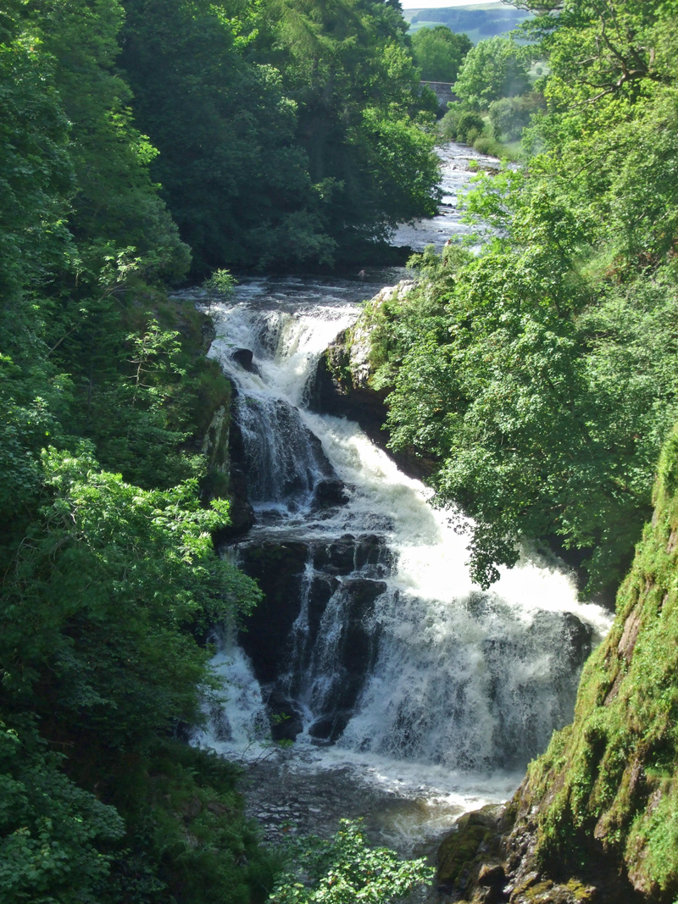The River Isla rises in the northernmost part of the parish as a mountain stream, flows down through Glen Isla catching feeder water from each of our original six parishes before rushing over the spectacular Reekie Linn and wooded dens and gently meandering towards the River Tay – hence The Isla Parishes.

The River Isla at Reekie Linn

The intention of this Parish Profile is to give an overview of who we are, where we are, where we have come from and where we would like to go in our witness to God’s love and purpose.

It is our hope that its content will be an aid to God’s call to someone who would guide us as our pastor and friend in our continuing mission of witness, sharing love and Christian compassion within our community and beyond.

