

**Integrate would like to invite you to a Brass Band & Choral Concert in aid of the Mayor of Preston’s charity fundraising;**

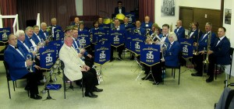**C:\Users\collumc\AppData\Local\Microsoft\Windows\Temporary Internet Files\Content.IE5\ZCQ2EWX1\MC900039430[1].wmfC:\Users\collumc\AppData\Local\Microsoft\Windows\Temporary Internet Files\Content.IE5\ZCQ2EWX1\MC900039430[1].wmf**

**STACKSTEADS BRASS BAND**

**&**

**7th DAY ADVENTIST CHURCH GOSPEL CHOIR**

**Brass Band & Choral Concert**

**& Last Night of the Proms**

**Saturday 13th October 7.30pm at St Walburge’s Church Hall**

**Tickets**

**Adults: £7.50**

**Children under 12: £5.00**

**This includes hot pot supper**

**Ring 01772 333805 and ask for Joan Durkin or 07917041251 and ask for Jim Leaver regarding tickets**