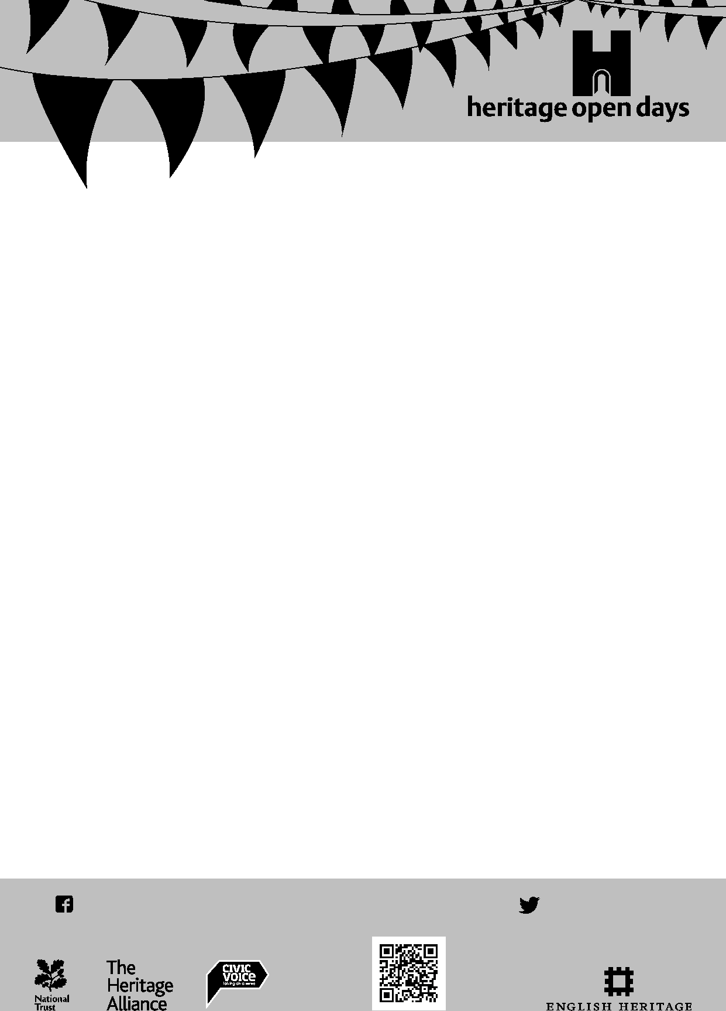

**HERITAGE WALKS AND TALKS SERIES No 9**

**Produced by Judy Langhorn, Friends of Pittville, for Heritage Open Days**

**Thursday 12th – Sunday 15th September 2013**

**One of two walks in THE PITTVILLE ESTATE**

**1. TO THE BOATING LAKE via The Pittville Estate Squares**

The Pittville Estate was established in 1824 by Joseph Pitt and contains many of the town’s finest Regency houses. Pitt had invested in land north of the town and planned an estate of 600 houses, an impressive spa building, pleasure grounds and six miles of walks and rides. Unfortunately the estate was not completed owing to the general economic difficulties of the period**.**

**Begin the walk** (1 to 1½ hours) at the museum by turning towards the ancient Minster Church of St. Mary. Passing to the left of the church and along a passage enter the High Street. Cross the High Street into Bennington Street, beside Tesco, and at the end of that street cross the main inner by-pass road and turn left, then immediately right into Monson Avenue, walk to the end.

**Turn right and enter the first of the Pittville Estate Squares** named after The Duke and Duchess of Clarence. Here the houses date from 1832 to 1842 except Nos 15 to 19 on the south western edge, which were built to the original design, but not until 1848. Number 19 is where the British explorer of Australia, Charles Sturt, died in 1869 (see plaque on the house).

**Cross** to the square’s western side (with central park on your right). Numbers 20-30, although in the Gothic revival style, were built by 1842.

Along the northern side side of the square note the period heart and honesuckle style ironwork canopy and balcony at number 36 and the “Wellington style” door knocker at number 37.

**Leave this square** at its northern end by St. Martin’s Terrace - a Regency “homage” (2007) to the classical houses on that side. Enter Wellington Square, which was named as a tribute to the first Duke of Wellington who, it is said, considered Cheltenham his favourite spa.

.



**As you pass between the two squares** **and cross** Clarington Mews **look left** to glimpse the cupola tower of St Paul’s church, designed by John Forbes, designer of the Pittville Pump Room.

As in Clarence Square the enclosed central garden was once the exclusive amenity for residents.

To appreciate the diversity of architectural styles and periods of build **turn left** into the square and walk the three sides. Avondale c1834 and other Regency and Victorian properties sit with early and late twentieth century homes. Numbers 18 and 19 (1836) have fine canopies and verandas. Note the more unusual wave motif.

The land in front of Clive Lodge and Wellington Lodge was once a nursery and botanic garden with conservatories, hothouse and greenhouses.

The twelve fine Gothic revival houses on the western side (1845-59) are probably the most impressive in the area. The decorated stone façade was built as a free standing structure and the building plots behind were gradually sold and built over the years.

Number 6 was the home of Shakespearian actor William Macready, see plaque and statue. It is said his friend Charles Dickens stayed with him there.

After passing the latest additions to the square you will find the oldest properties in Pittville (1826-27) Laurel and Percy Houses and the fine Glenmore Lodge on the corner, the earliest (1826).

Opposite Glenmore is a red brick Victorian Gothic house, The Old Rectory, designed by acclaimed architect John Middleton (1870).

**Leave the square and continue along West Drive** passing Dunalley School on the left, and go straight ahead to a side entrance of the west section of Pittville Park. **At the path T junction turn** **right** beside the boating lake, until you reach the information board and wooden signpost. Here the layout of this section of Pittville Park and its history can be appreciated.

Head towards the boathouse (open for refreshments 10.00-18.00, seasonal) and **cross the lake** at the community bridge (2011). The art work represents the local school children’s interpretation of the park. **To extend the walk** turn right after the bridge and go around the west end of the lake back to the bridge.

**To return to town** **turn left** and exit through the tunnel behind the heritage notice board and enter the east side of Pittville Park (*see Heritage Walk Number 10 Pittville Gates to Pittville Park.*)

**From this point the town centre is to your right as you leave the tunnel**. It is approximately 15 minutes walk back to the High Street.

A frequent bus service passes into town along the Evesham Road, the stop is 100yds to the north.

To see which 31 buildings are open free of charge (some are opened only for this event), eight free walks and two free talks for Heritage Open Days visit [www.cheltenhamcivicsociety.org.uk/chods](http://www.cheltenhamcivicsociety.org.uk/chods) or [www.visitcheltenham.com](http://www.visitcheltenham.com) or for places to visit in the the county of Gloucestershire [www.heritageopendays.org.uk/directory/county/Gloucestershire](http://www.heritageopendays.org.uk/directory/county/Gloucestershire)

These information sheets are free of charge during Heritage Open Days, sponsored by Cheltenham Local History Society but a printing charge of 10p per sheet is made by the Tourist Information Office for printing after this time

For further details on **Cheltenham Local History Society** please see

[www.cheltlocalhist.btik.com](http://www.cheltlocalhist.btik.com)

Series Compilation © 2013, Cheltenham Local History Society. Text © 2013, Judy Langhorn on behalf of Friends of Pittville

For details of **Friends of Pittville** or further information see [www.friendsofpittville.org](http://www.friendsofpittville.org)

25th August 2013