 | AUTUMN SUPPLEMENT 2013  Your  Peterborough  Pilgrim | 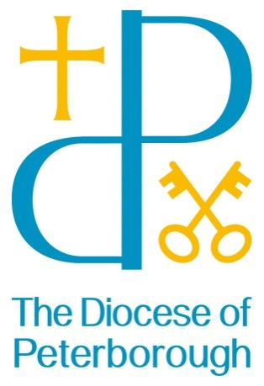
The Summer Ultreya!
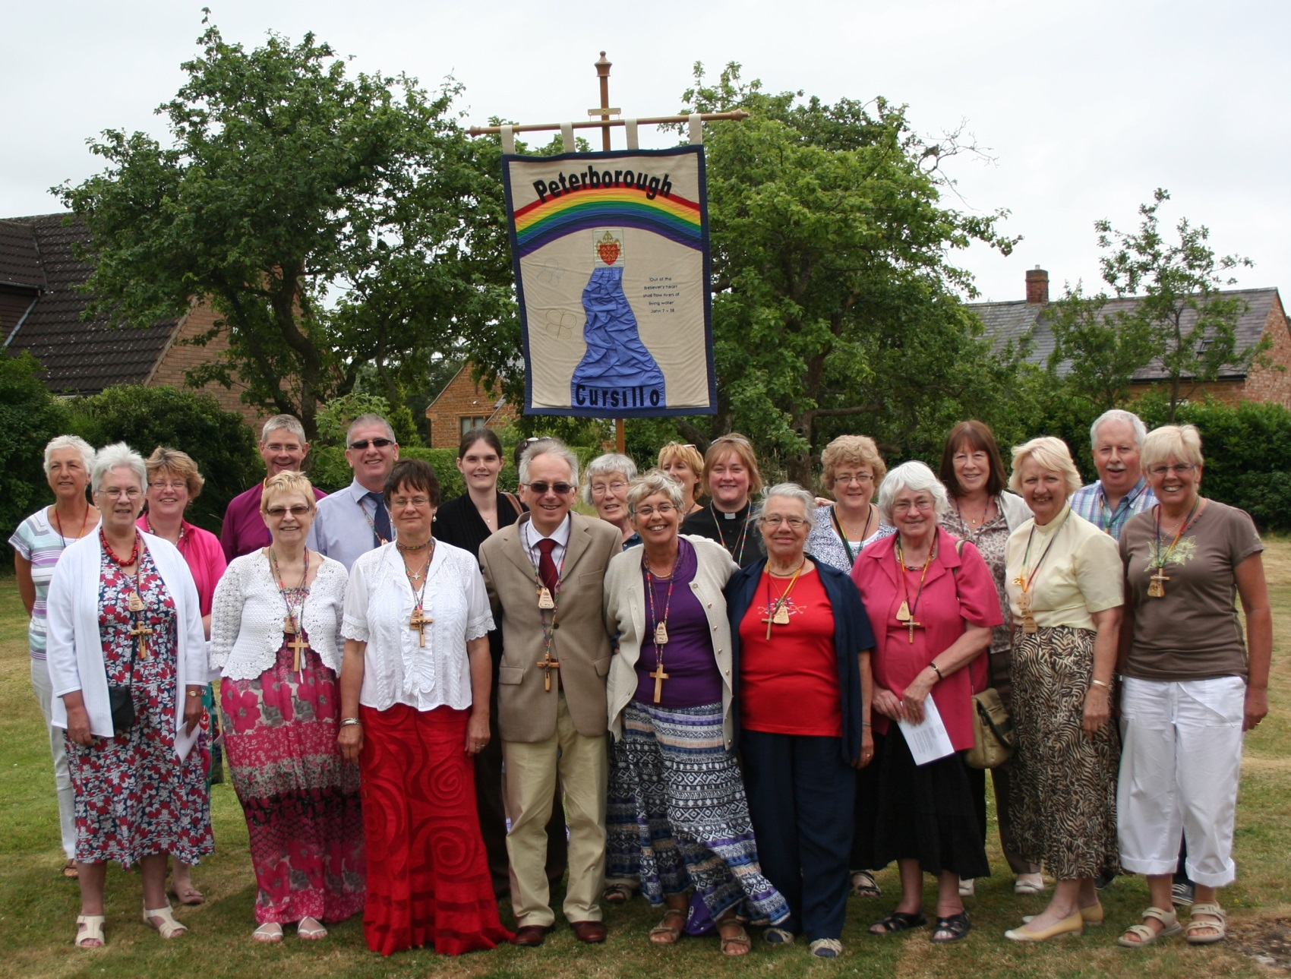
Saturday July 20th
Was Held at the home of Bishop John and Mrs Elizabeth Holbrook
In the village of Mears Ashby and at Mears Ashby Church…
and a Good Time was had by all…
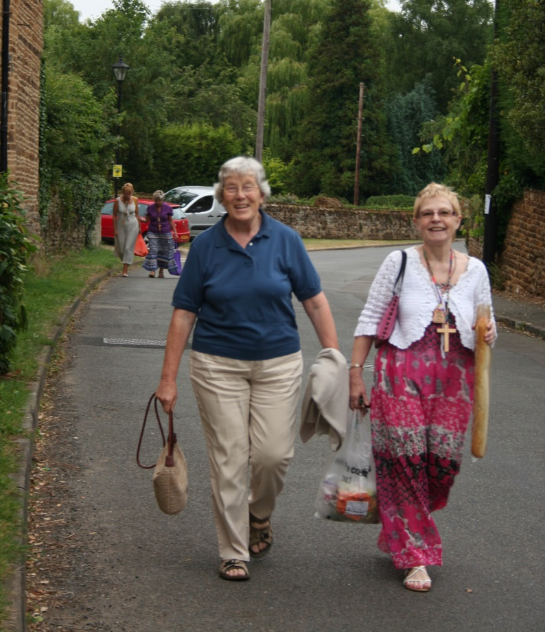  Many Cursillistas arrived early… | 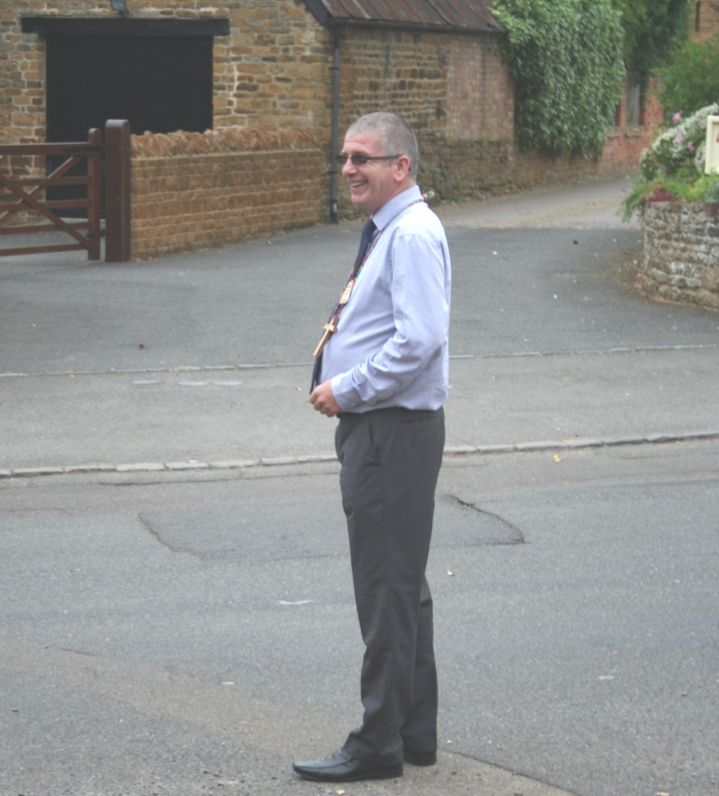  Dave advised on the parking…

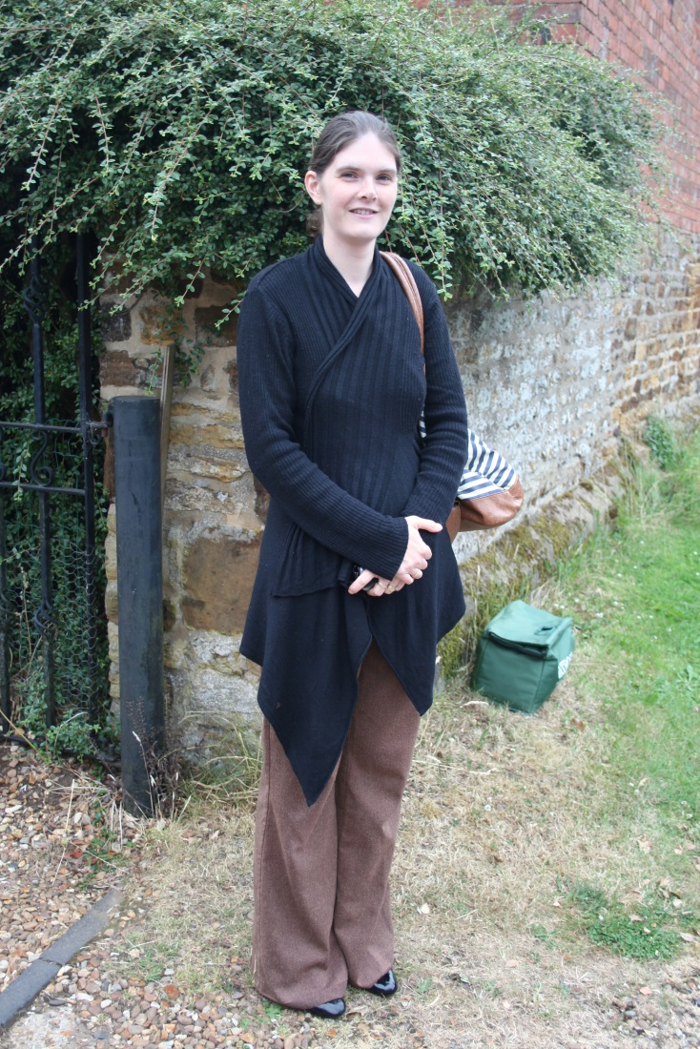  Danielle greeted us at the gate | 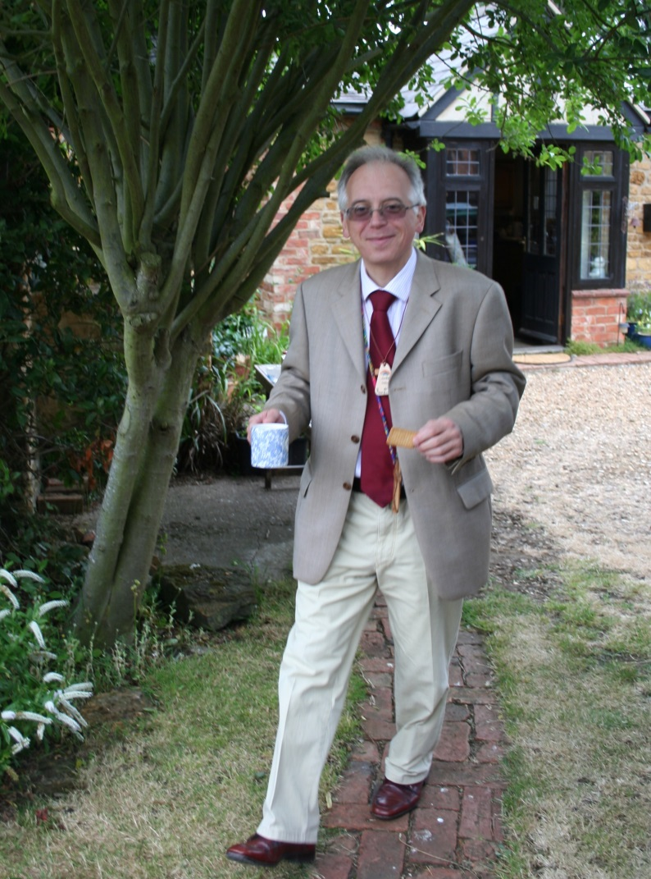  Mark was geared up to give a brilliant witness…
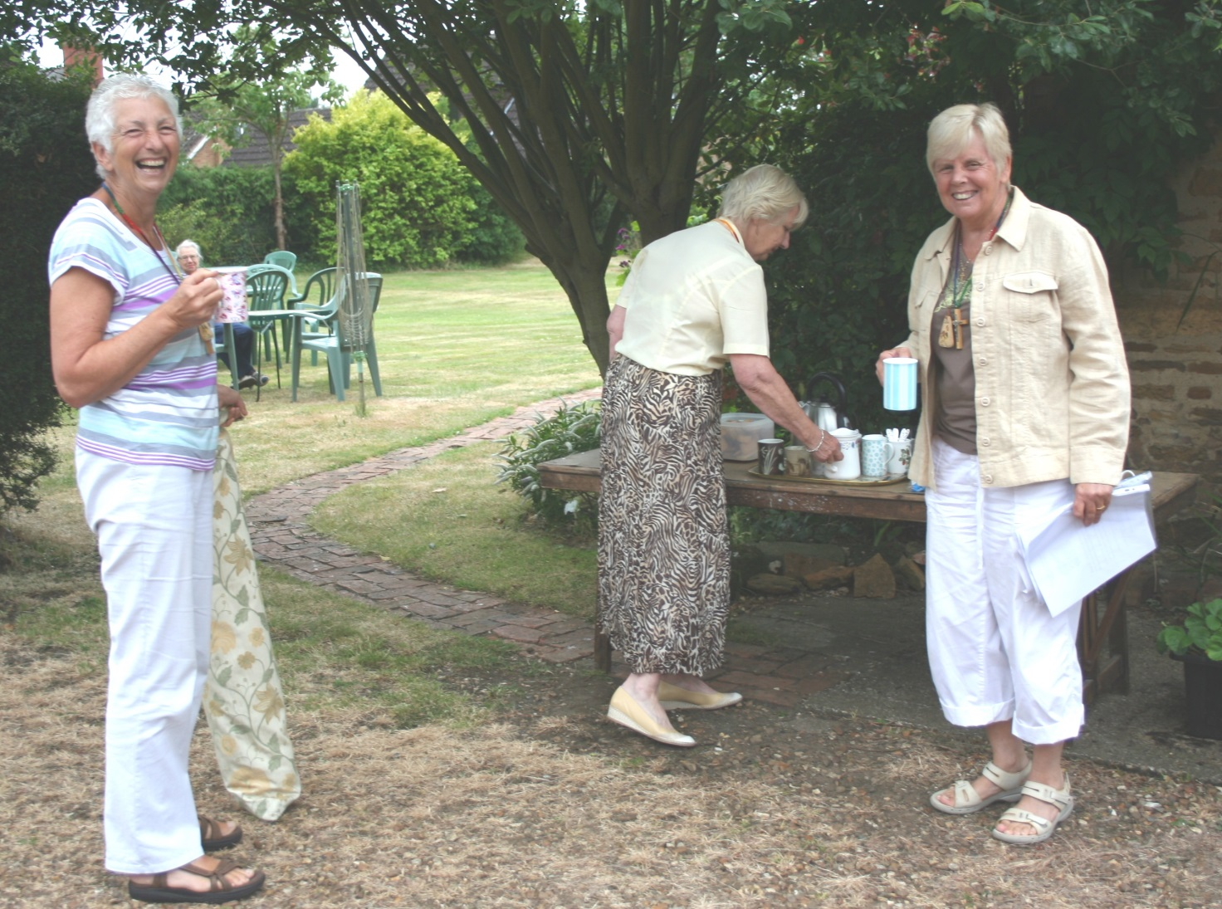
Who was handing out that coffee? – Liz, Karen and Eddie, of course…

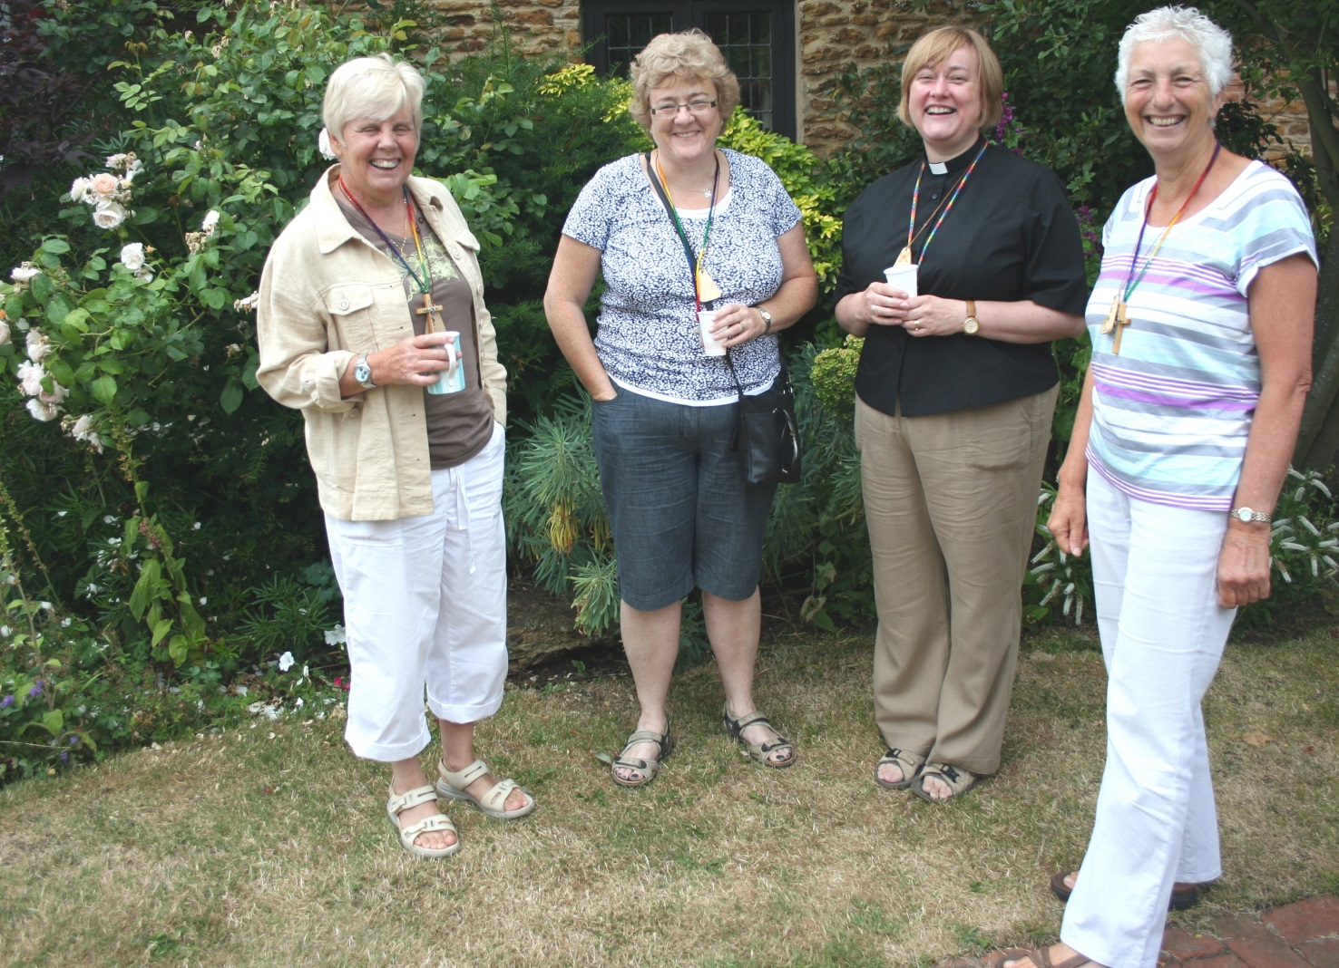
That special cursillo smile…
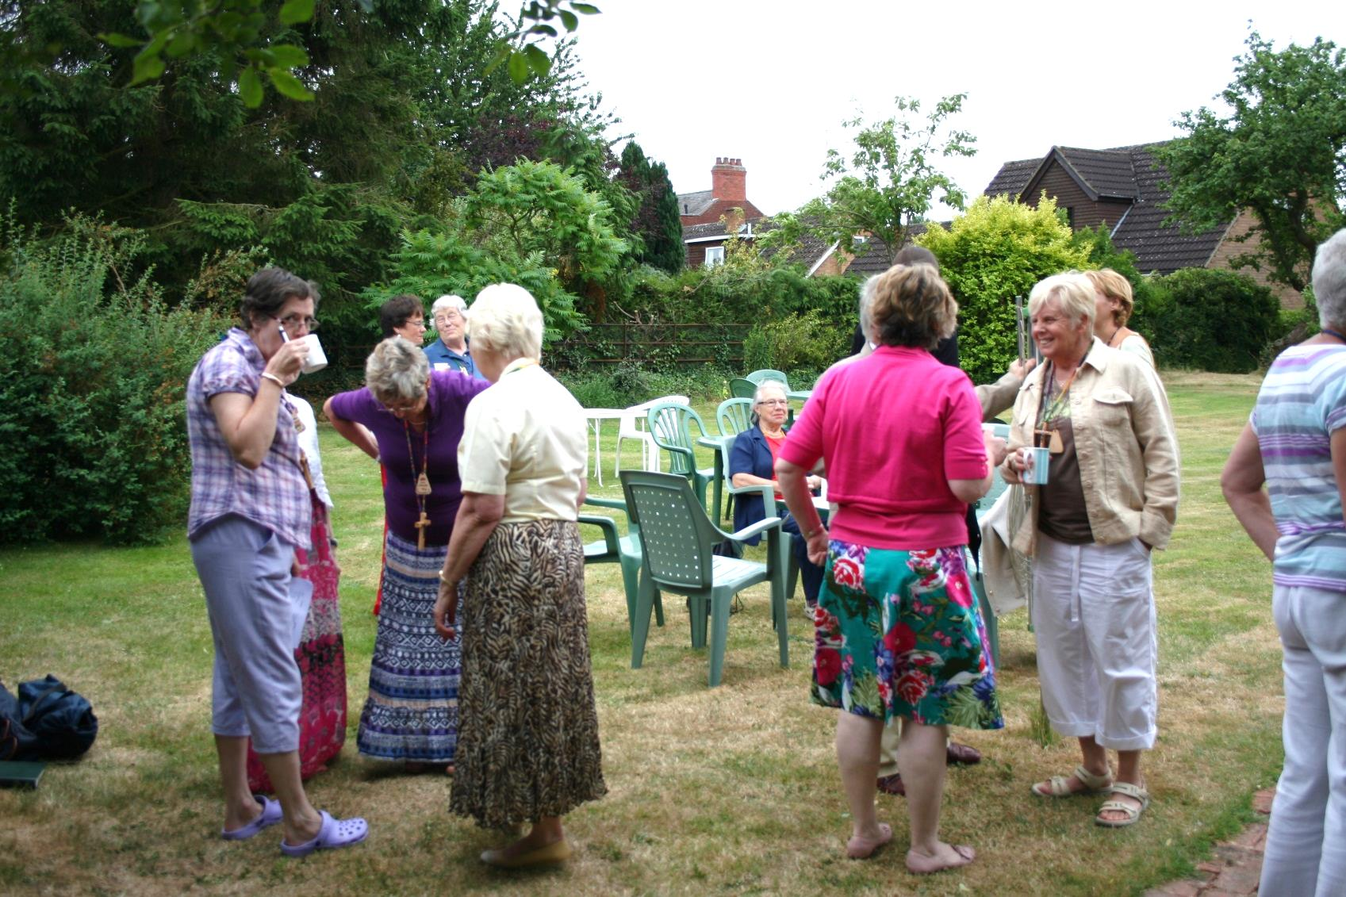
More folk arrived…
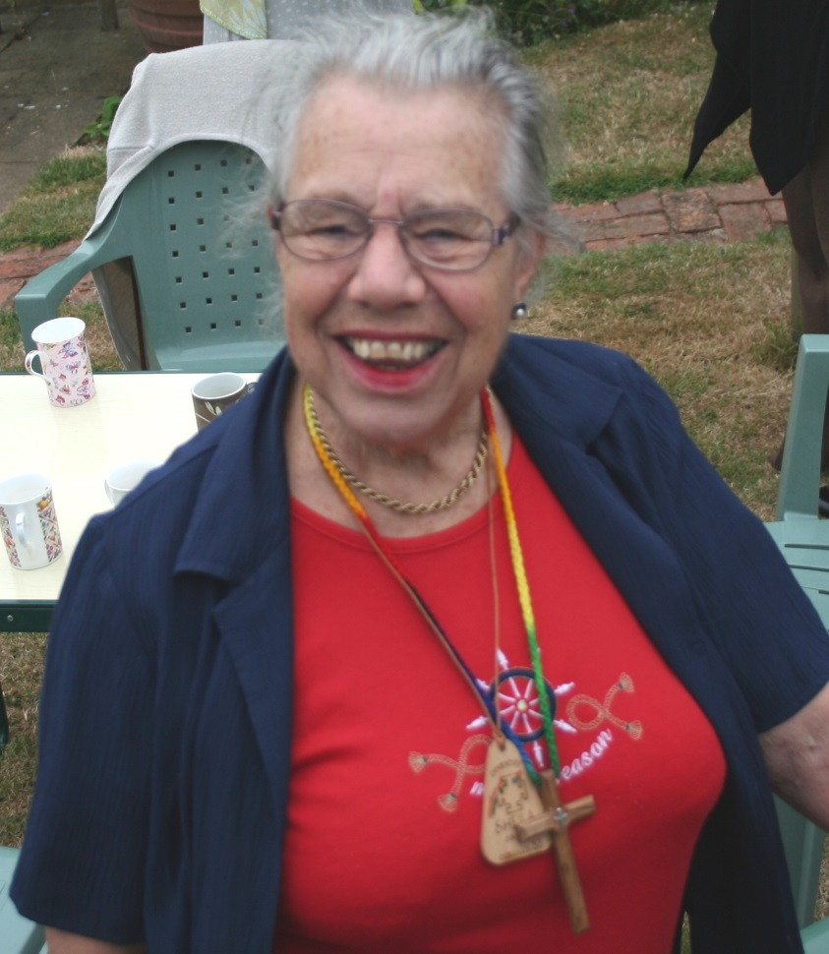 | 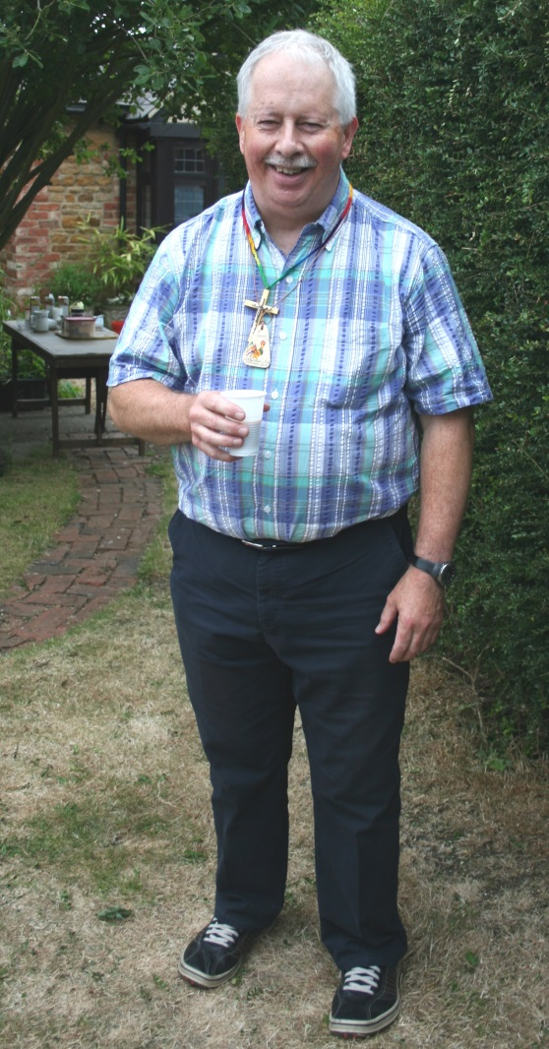
I’m Having a Great Time! Me too!

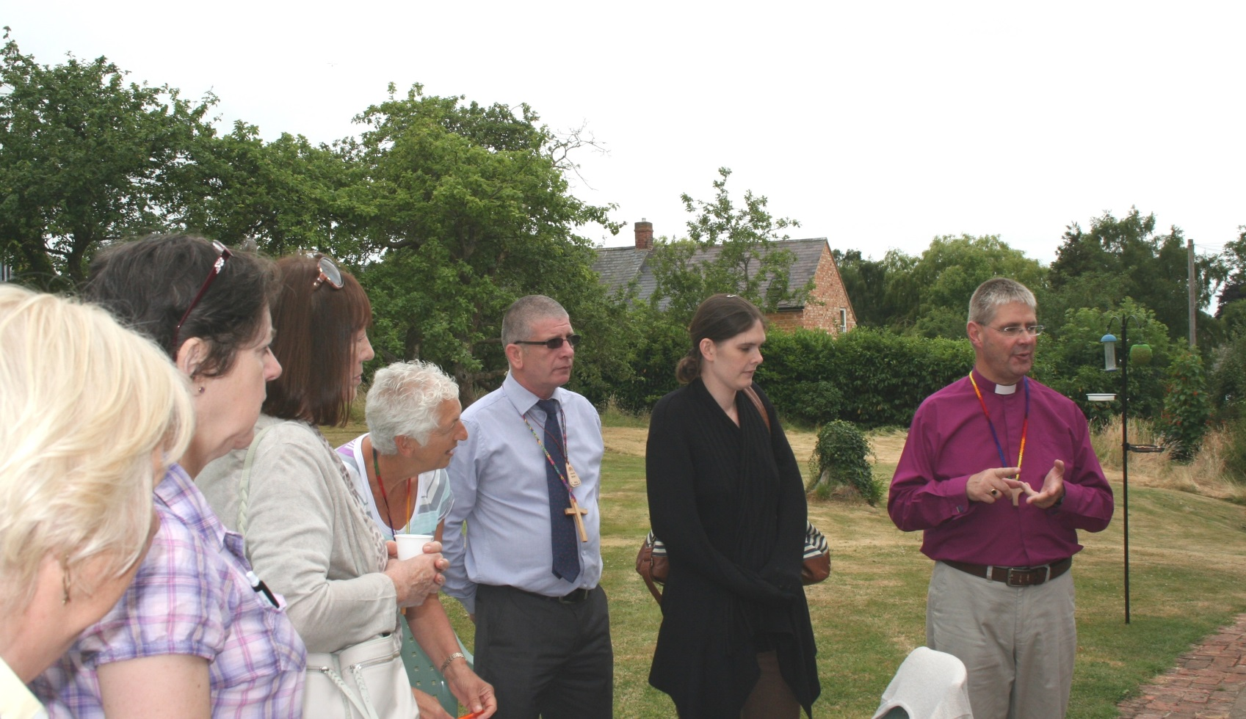
Bishop John showed everybody around the garden…

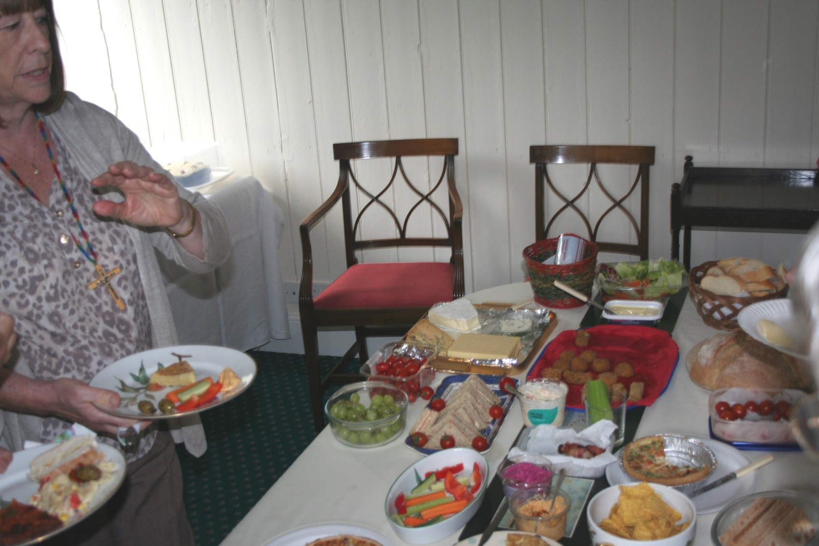
Our shared lunch was magnificent!

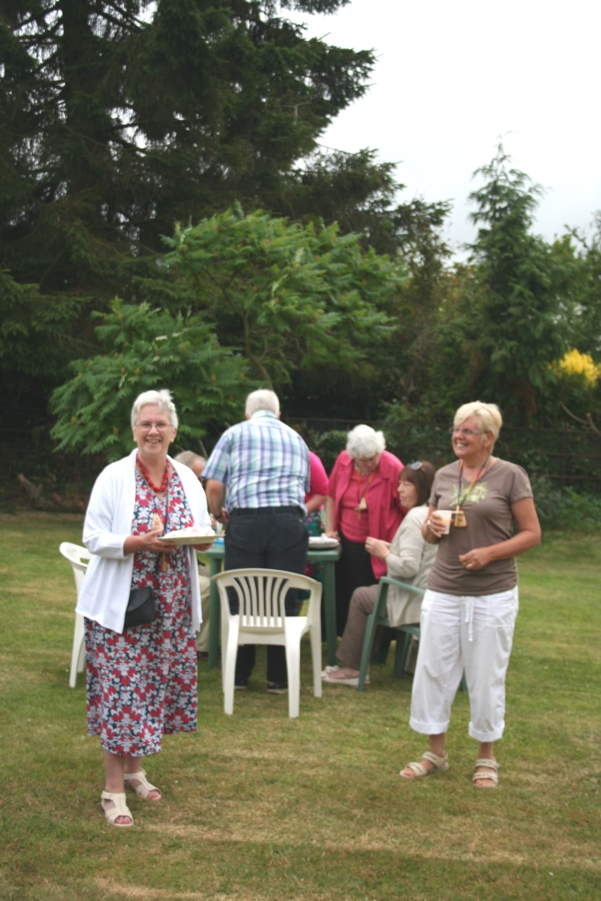 | 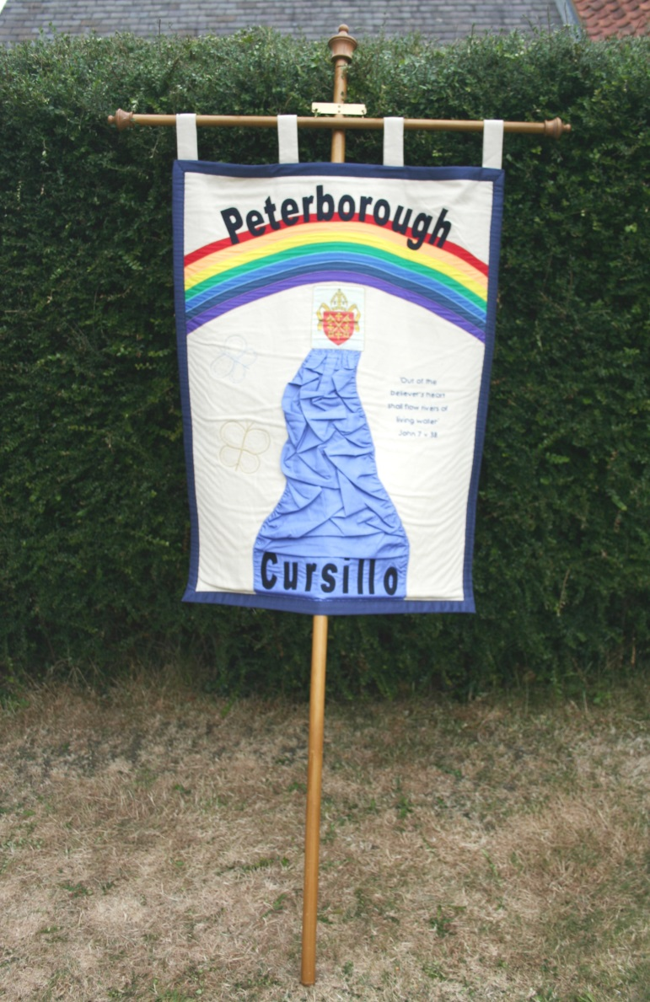
What A LOVELY Day! Our Banner on display…

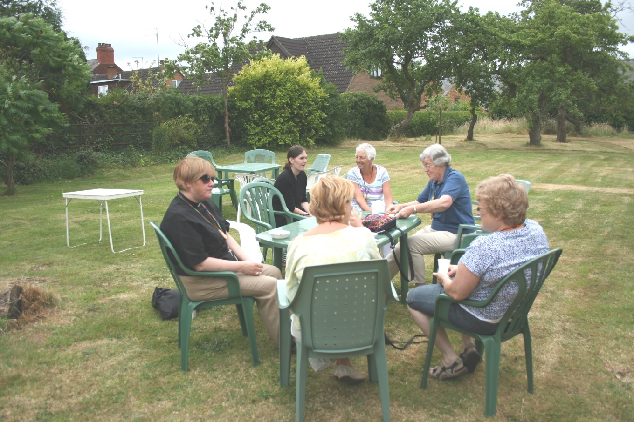
Relax, chat, and eat that delicious food!
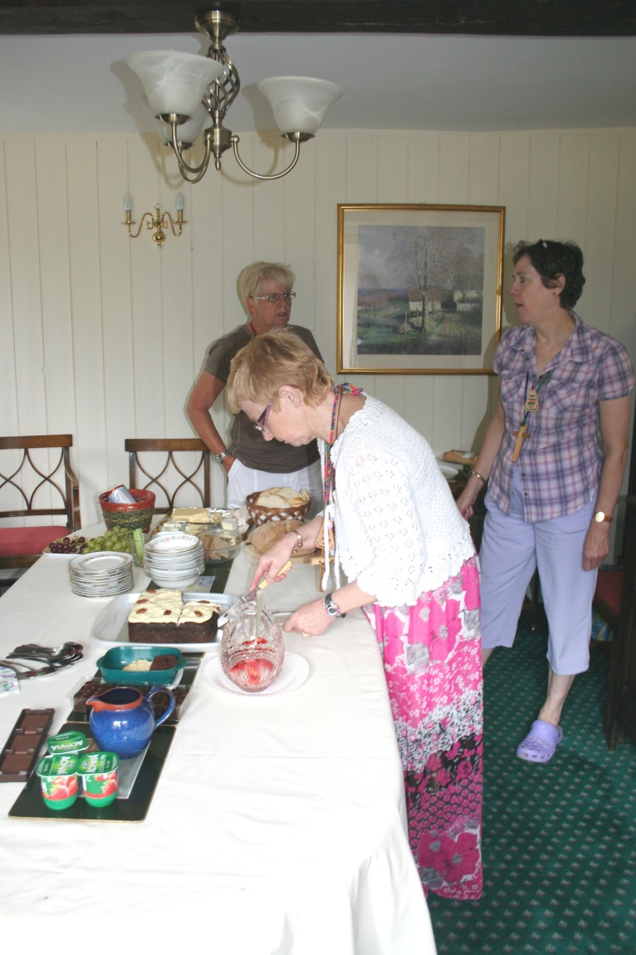 | 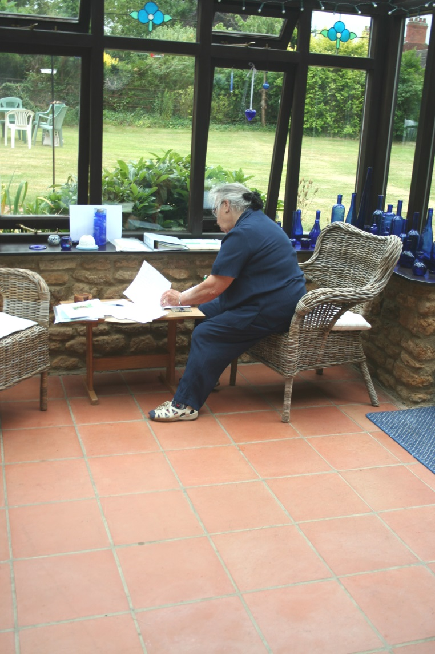
Time for delicious dessert…and time to sign palanca
Meanwhile, in the kitchen…
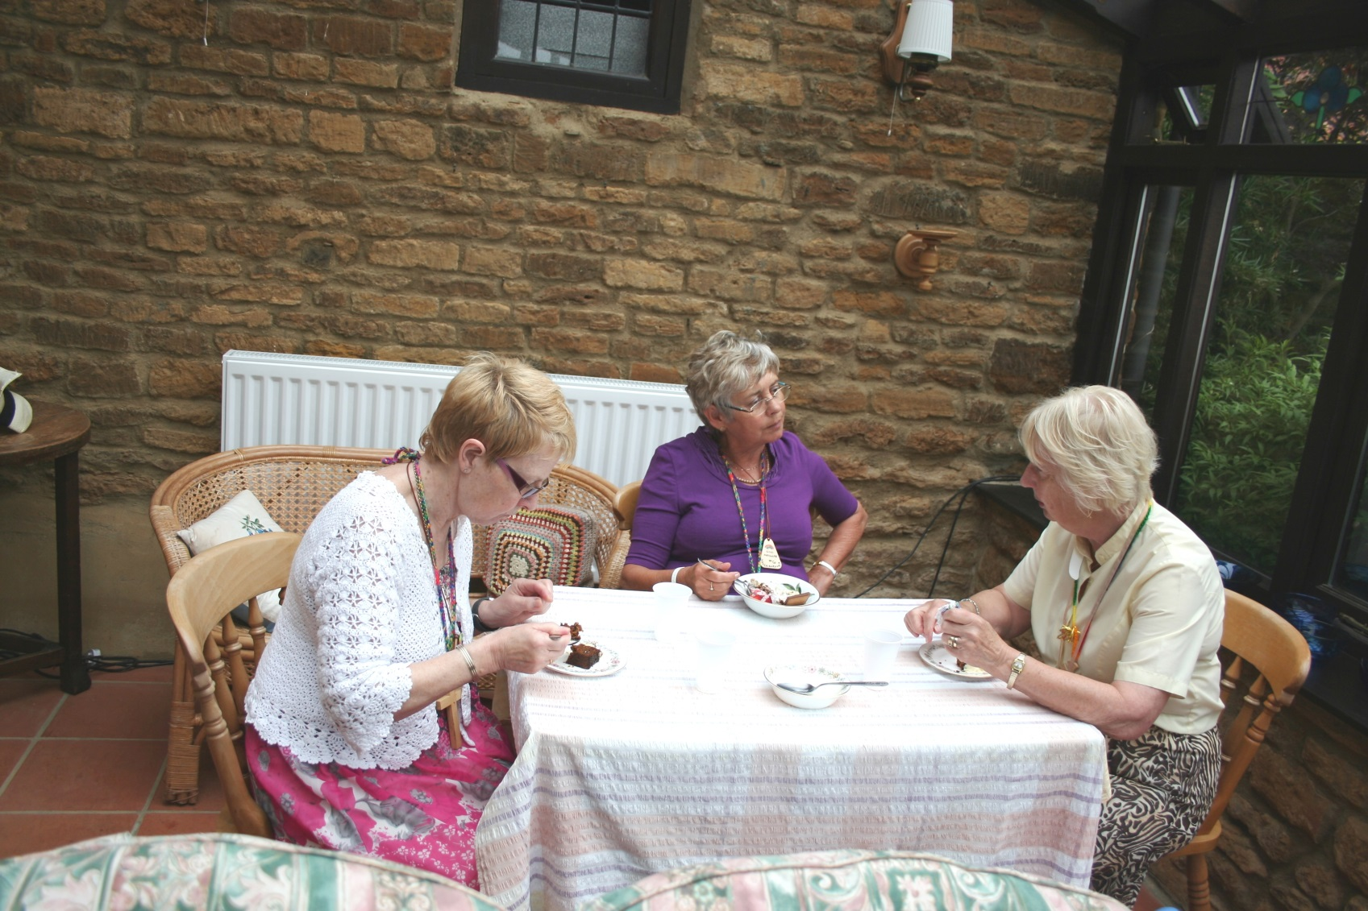
Time for a chat…
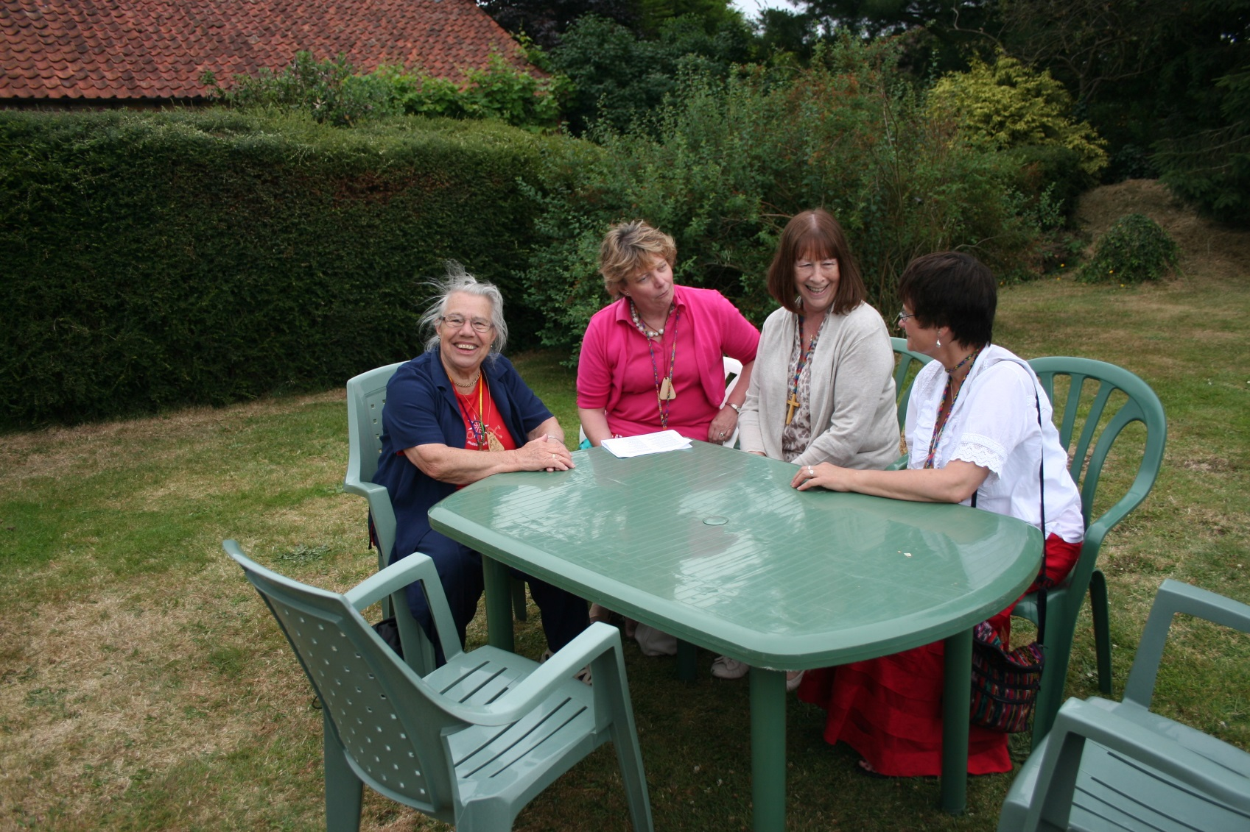
Then we broke into Reunions…
After the Reunions, Eddie proudly displayed the new Hymns and Worship Songs Book, produced by
Pat Hope- Jones, Reader at St Botolphs
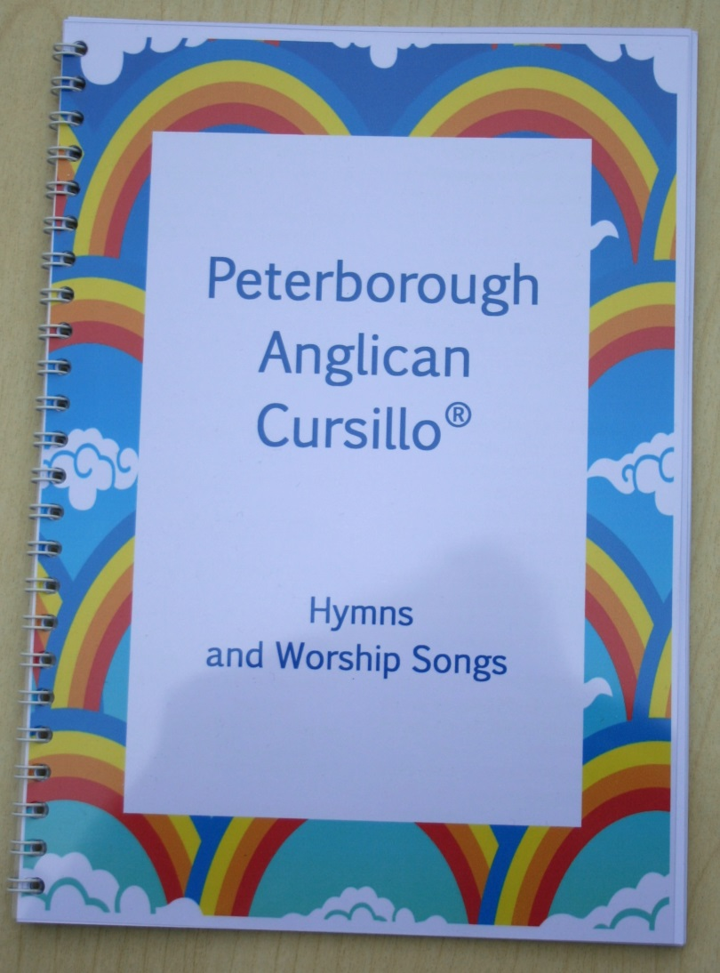 | 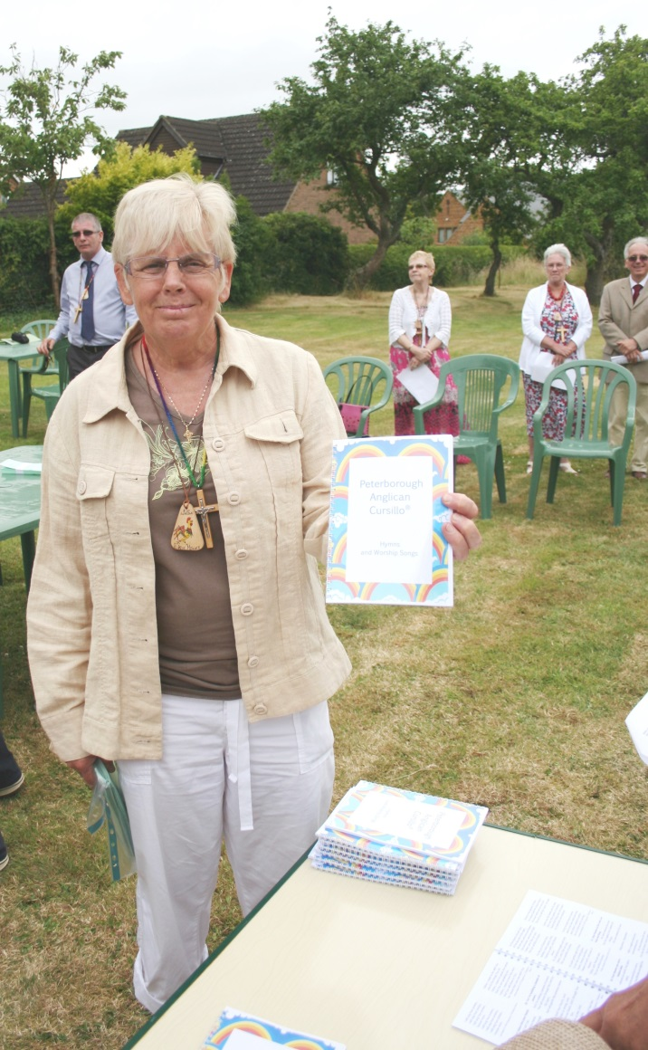

On behalf of all the cursillistas, your Secretariat would like to thank Bishop John and Mrs Elizabeth Holbrook for the courtesy of holding our Summer Ultreya at their home.

Thank you, we all had a wonderful time!
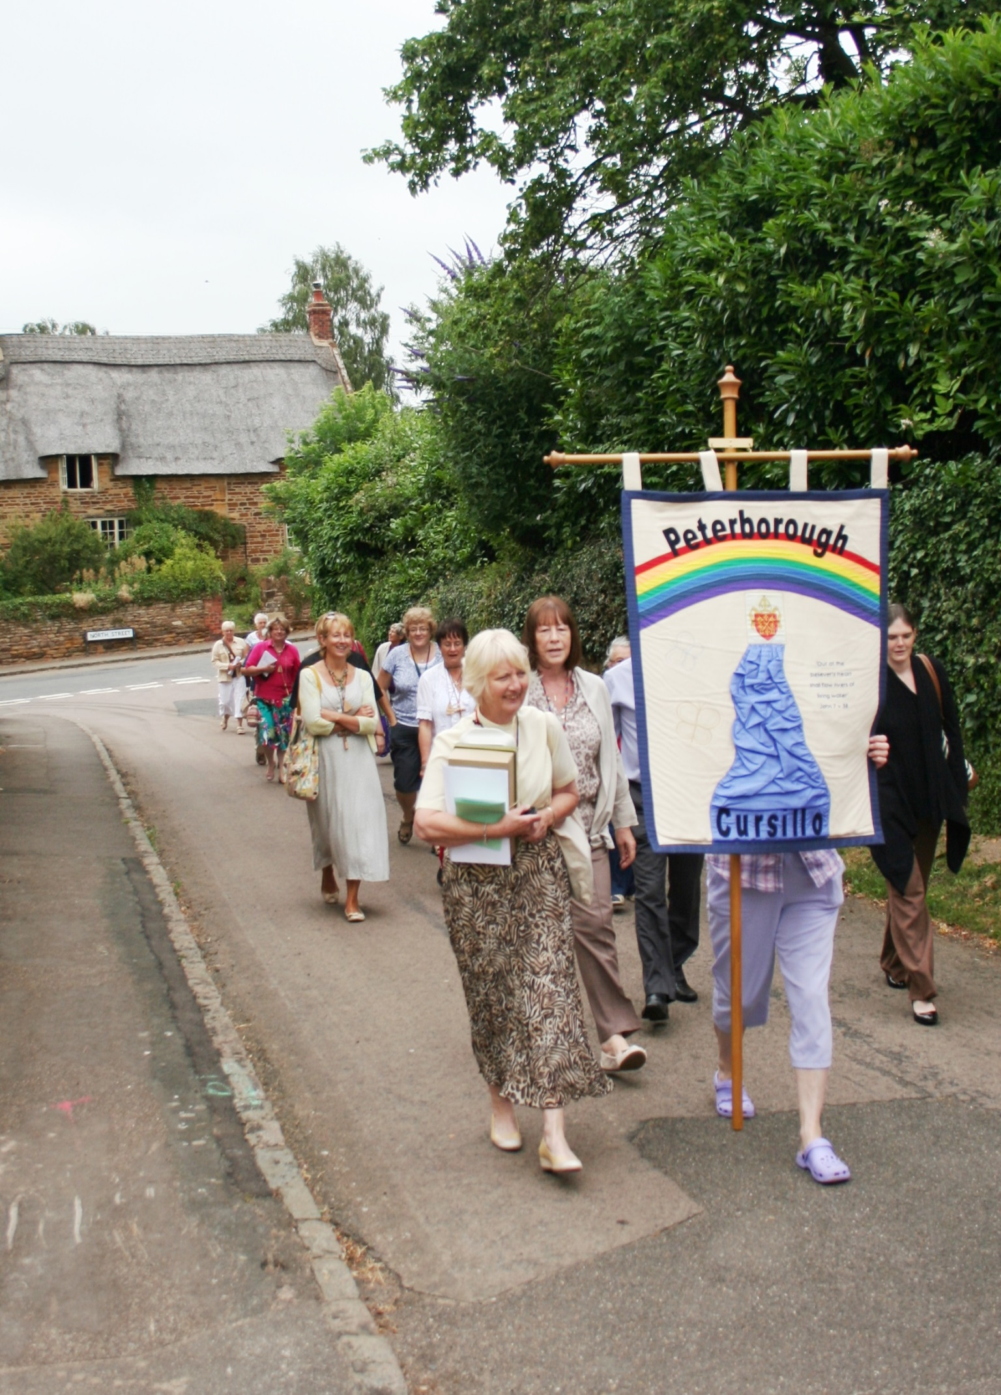
Then we all processed behind the banner to the parish church for the summer eucharist…

(Pictures are copyright free and may be downloaded to your PC for use as Screensavers)

