|  |  |  |
| --- | --- | --- |
|  | **EASTER ISSUE 2013**  **Your**  **Peterborough**  **Pilgrim** | Description: Description: http://www.peterborough-diocese.org.uk/logo/rgb_vertical_main.jpg |

[](http://www.google.co.uk/url?sa=i&rct=j&q=&esrc=s&frm=1&source=images&cd=&cad=rja&docid=J3NOhhZBEDNuhM&tbnid=tHcvPkQ0s25tEM:&ved=0CAUQjRw&url=http://www.fredcrystal.com/clipart.htm&ei=9ohMUc6bO6Ob0AWH1YDgAw&bvm=bv.44158598,d.d2k&psig=AFQjCNHTbjaM2FVdAuwYmuyDmZpmPjY75A&ust=1364056659885757)

**Dear Peterborough Cursillistas…**

Resurrection is the theme of this edition of the Peterborough Pilgrim and the plan is that by reading page by page from the beginning to the end we can **re**view (**re**surrect) our **re**lationship with God as we do in witnessing to each other in Group **re**union.

Before you start you may like to list some of the words which begin with the letters **RE.**

The Comm Squad over a lunch at Bella Italia came up with **re**fresh, **re**new, revisit and **re**store!

You may also take time out to **re**visit your own Cursillo weekend and what it meant and means to you in your 4th Day.

At the end is a challenge to you to share this experience with others who may grow in faith by attending one of our weekends.

**Gilly Beardmore**

Lay Rector Peterborough #7

(On behalf of the Secretariat)

**RE-**flecting God's Presence in a Moment.

Imagine a two year old at the altar rail awaiting a blessing with a member of the children's team. After the adult raises their hands into the sunlight for the bread Phoebe imitates what she has just seen.

She raises her chubby toddler hand and explores the word biscuit with a plea that is heard as “Be quick.”



Unsuccessful she nevertheless merrily toddles (taking the long in- and- out -of -the -pews -way! ) back to the carpeted toddler praise area mumbling “be quick ,be quick”.

She eventually reaches her Mum, breast feeding her younger brother. The adult who witnessed her pleas “sneaks “ a couple of dry biscuits from the coffee area finds herself breaking them and sharing them with Phoebe and all the other toddlers. Another Mum who has watched their eager response remarks “That's what we did at our previous church. The children received broken biscuits in their worship area too”.

**ACTION**: a colourful plate, children's biscuits, toddler non drip mugs and red juice to be brought next week. Such is the result of Phoebe's imitation of God's love.

**Remember this Year’s Cursillo Summer Event!**

**This year’s Summer Event will be hosted by Bishop John at his home and at Mears Ashby Church on 20th July 2013. There is a number limit of 25, so please make a note in your diaries and let us know if you can make it. We will remind you again later in the year.**

**RE**invigorating Christians @ Barclaycard

A small group of BarclayCard colleagues meet weekly for fellowship, Bible Study and prayer.

The highlight of the year is the annual Carol Service held in Barclaycard House. This takes weeks of preparation.

We are fortunate to have the support of the CEO, Sports and Social who fund the event and a local primary school which sings for us each year. Colleagues love to see children in the office and that is a big draw.

Last year about 150 Colleagues attended. We have tried several formats for our weekly meetings including sharing about charities, prayer and Bible study.

We pray for individual Colleagues in need, for groups affected by a situation and for the BarclayCard leadership.

Occasionally we are visited by a colleague who leads the wider Christians at Barclays fellowship.

I believe it is worthwhile to encourage whole life discipleship. We are called to let Jesus be Lord of all our lives not just our home and church lives. For me work is a major part of my life ad I want to understand what the Bible says about work and enjoy fellowship with other Christians working for the same organisation.

**Sally Patmore Peterborough #3**

**Thank You!**

*David Best writes:*

I would like to thank everybody who attended the AGM on Wednesday and made my witness talk a lot easier than it could have been.

Besides having faith in our Lord Jesus Christ, we need to have faith in our fellow Christians.

I have felt tremendous support from all at Cursillo and would like to express my deep felt love for all of you.

Thank you very much Judy, for a heart felt response! All of your comments make me so much more aware that friendship in Christ, is the only and true way in which we should live our lives, so thank you to you all for your encouragement, and may God be with you all, love

**David Best Peterborough #6.**

**BACC NEWS – Retiring and Renewing…**

|  |  |
| --- | --- |
| http://btckstorage.blob.core.windows.net/site7771/LIZ.JPG  ***Liz Medlock*** | **Pilgrimage Places Still Available**  There are still some places available for the UK Pilgrimage taking place at Durham in August. Please visit the British Anglican Cursillo Council national website at [**www.anglicancursillo.co.uk**](http://www.anglicancursillo.co.uk) for more information.  **A Job for Sister Anna?**  An opportunity to carry the Peterborough Cursillo banner at the National Ultreya!  Come and join us and meet up with your fellow Cursillistas from afar, at the National Ultreya in Wakefield on Saturday September 7 2013. It is a great day with the privilege of carrying our banner, an opportunity not to be missed! |

**Goodbye and Hello!**

On May 11 2013 at the BACC AGM in Ardsley we say thank you and farewell to our National Spiritual Director Bishop Idris and welcome our new N.S.D. The Rev'd Hugh Burgess from St Asaph.

More details from Lynne Radcliffe…

|  |
| --- |
| **A Message from the BACC President…**  Lynn and Bishop  ***Lynn Radcliffe with Bishop Idris***  Dear Friends,  As you are all aware, Bishop Idris is stepping away from the role of National Spiritual Director of BACC at our AGM in May.  It is with great pleasure that I tell you that Rev'd Hugh Burgess, SD of St. Asaph; will be Bishop Idris' successor. Hugh will be taking over as from the A.G.M. in 2013.  Please pray for Bishop Idris in his very busy new role and for Alison as she supports him.  Also pray for Hugh as he prepares to shoulder the responsibilities of the British Anglican Cursillo NSD and those who will support him.  With love and prayers to all,  **Lyn Radcliffe BACC President** |

**And A Warm Welcome to**

**Rev. Hugh Burgess…**

|  |  |
| --- | --- |
| Hugh attended a Cursillo weekend in 1998 and subsequently trained as a Reader in the Diocese before later offering for ordination.  He was ordained in 2006 and is currently Priest in Charge of The Mountain Parishes of Halkyn, | [http://www.churchinwales.org.uk/asaph/life/renewal/cursillo/images/clip_image002.jpg](http://www.google.co.uk/url?sa=i&rct=j&q=&esrc=s&frm=1&source=images&cd=&cad=rja&docid=ifsoOy0hj1kCuM&tbnid=3R_H1U776ke_dM:&ved=0CAUQjRw&url=http://www.churchinwales.org.uk/asaph/life/renewal/cursillo/&ei=TGxQUYuYCcyr0AXgk4D4Cw&bvm=bv.44158598,d.d2k&psig=AFQjCNGMyd0hCNzVP4-ghiTB95mONAEcig&ust=1364311492011698) |

Caerfallwch (Rhosesmor) and Rhesycae.

He has been on the weekend team for Cursillo as both a lay and ordained person in the Dioceses of

St Asaph and St David's. He has also staffed on the Cursillo Leaders' Workshop. Hugh became Spiritual Director in 2010.

He also has a job in the IT industry where he works for a major international consultancy firm.

**BACC Pages**

Want to know more about your national body for Cursillo in the Anglican Church? It’s all in the latest issue of **The BACC Pages** which is now available on the internet.

For all Cursillistas, whether newly made or long experienced, reading The BACC PAGES was always a useful way to keep up the latest events, and now the national magazine is available to download directly to your computer or mobile device!

Go to: [**www.anglicancursillo.co.uk**](http://www.anglicancursillo.co.uk)

Click on **“Information for Dioceses”** on the navigation bar, then on **BACC Pages** link.

Or better still, visit our own website and follow the link to the BACC website from there.

Well, that’s me signing off and signing out as your BACC Representative, it’s been great fun and I would not have missed it for the world.

Ultreya!

**Liz Medlock**

*(Good bye Liz, it’s been fantastic having you on the Secretariat and we welcome Judith who will be shadowing you prior to taking over the post shortly. – Ed).*

|  |  |
| --- | --- |
| **Judy’s Jottings**  **From Your Spiritual Director**  **Dear Friends…** | MC900435246[1] |

As we come into the season of Easter, of spring, of celebrating new life, in many ways I am struck at what a contrast this is to the last few months.

It seems to have been a long hard winter, not only with the cold, the wet, short days and long dark evenings, but also so many people struggling in the difficult financial climate, with increasing expectations and stress at work for those in work and anxiety for those without a stable income.

C:\Users\Colin\AppData\Local\Microsoft\Windows\Temporary Internet Files\Content.IE5\0CKJ7Q3Q\MC900071389[1].wmf

In my work as a GP we are facing increasing demands, decreasing resources, rising expectations, what seem like endless changes that keep being demanded of us and generally low morale all around us.

I know I am not alone, and many people in all sorts of fields report similar issues. Some days I have wanted to run away and hide, something I am not prone to.

Where, I find myself asking, are the signs of hope, of new life, of resurrection and renewal?  
What has happened for me is a need to go back to the root of my calling and my faith; to re-discover my calling under God and a sense of really having to trust God each day to carry on.

The danger is that we come to rely too much on our own strength, particularly when we are busy and stressed, finding it difficult to find time to have real space to sit with God.

What I am learning again, and sometimes I wonder if God gets a bit tired of my needing to re-learn the basics so often, is that it is only in God’s power we can fulfil our calling.

The sense of not having to carry it all on my own, of trusting that God will give me strength each day, is a wonderful re-discovery and has brought a huge sense of relief.

This renewed faith and trust in God hasn’t taken all the problems away, but has brought a sense of perspective, of hope and a feeling that I can stay with it all a while longer.

[](http://www.google.co.uk/url?sa=i&rct=j&q=&esrc=s&frm=1&source=images&cd=&cad=rja&docid=3y_Y8lenCqxb1M&tbnid=Q9kDe-cPC7atGM:&ved=0CAUQjRw&url=http://www.freechristianresources.org/2007-11/lots-of-free-images-from-christians-unite&ei=2olMUfW_A-iZ0QXAm4HgBg&bvm=bv.44158598,d.d2k&psig=AFQjCNFFknsOfys0JXe5WZHEj5T8cwsZ8A&ust=1364056884619079)

As we celebrate the resurrection of our Lord, as we remember that death does not have the last word, perhaps we can learn to look out for signs of that new life and hope in our day to day lives, even when they are troubled.

This can come in so many different ways as gift from God. In the last few days I have experienced this in a thank you from someone, a sense of being in the right place to help someone in trouble, catching a glimpse of sunlight on water whilst driving, the joy of shared laughter, all of which have helped me to keep hold of hope even when it all seems too much.

My prayer is that each one of us, even when the going gets tough, may have a renewed sense of resurrection in our journey and that we will learn afresh to notice all the signs around of us of that resurrection power at work in our lives.  
With best wishes.

**Judy Craig Peck**

[](http://www.google.co.uk/url?sa=i&rct=j&q=&esrc=s&frm=1&source=images&cd=&cad=rja&docid=JJxtG9b5LVyzIM&tbnid=FAlaQMsDG3SfPM:&ved=0CAUQjRw&url=http://www.chadbournph.org/SPECIALEVENTS&ei=iotMUcfuLIGV0QXq84GoBw&bvm=bv.44158598,d.d2k&psig=AFQjCNH9EYuBTLk2QkmpHLWECVHDoiHSRg&ust=1364057260017427)

|  |  |
| --- | --- |
| http://btckstorage.blob.core.windows.net/site7771/EDWINA.JPG  **Edwina Miller** | **Lay Director’s News Letter Easter 2013**  Many of you know that I like to carve pieces of wood. I had a large piece of walnut standing in the porch for many years. I decided it was time to cut the bark from it, and, once I had seen its shape and form decide what it was to become. Imagine my dismay to find it riddled with woodworm, and discoloured by the weather!  However my teacher encouraged me to ‘keep calm and carry on’ as the saying goes.  Over the last six weeks I have chiselled away at this large walnut log, cutting the outer  layer away, including the rot and worm. |

While I work I can pray that God will guide my hand and, I will then reach the heart of this wood where its true self will be revealed.

|  |  |
| --- | --- |
| As I cut away the wormed outer part of the log I started to reach the inner heart that revealed a wonderful patina and grain. It made me think of our human condition, weak and fallible, bowed down by the external elements that take up our energy and attention.  By now I have a decided its shape lends itself to being an owl. I have used the woodworm to guide where I cut, just as with God’s Grace He can transform our failings. Like my own infallible weak self, when I can strip away the external concerns, I will be better able to find the heart of my being when I will know myself even as I am known.  Like my log was once rooted in the ground and nourished by the soil we can trust our God to be the source of our lives, which reminds me…  Last summer we had the theme:  “**Bloom where you are Planted**”  we are now urged by our communication team (“The Comm Squad”), to have a look at:  “**Being rooted in the right ground**”  “Abide in me like branches of a vine”, says Jesus (John 15: 4-5)  Cursillo gives us a method in our tripod of prayer, study and action. This spring is a good time to take stock, replenish, renew and re energize our | MP900406587[1] |

faith. We need to keep close to the teachings of Jesus – Stephen Cottrell in his writings in New Daylight tells us: “The Bible itself is a stream of living water”. Luke Ch 10 – 12.

Like trees planted in streams of water, we will bear fruit for God.

My prayer for you all is that you persevere in maintaining your group reunions and in forming new ones, so that all are supported and new Pilgrims welcomed.

Love and prayers,

Ultreya!

**Edwina**

|  |  |  |  |
| --- | --- | --- | --- |
| **Happy Retirement!**  *Eddie writes*: Longstanding Cursillistas Phillip and Hilary Nixon retired to Oxford and we wished them well and a card was sent from all in Peterborough Cursillo, this was their reply:  Dear Ed Many thanks for your card and kind words. We have already had an invitation from Oxford Cursillo, (but not on a date we can manage) and we hope to see them soon. We are finding plenty to do in Oxford, and our new little house is snug.   |  |  | | --- | --- | | We went to Chester last Sunday to see our  granddaughter Niamh baptised. We have happy memories of Peterborough Cursillo, and wish you all well. Ultreya! **Phillip** | Description: Description: C:\Users\Colin\Downloads\SDC11259.JPG | | **OUR CURSILLO WEEKEND**  **Peterborough #7**  **Date: October 17 2013**  **To October 20**  **Start Time 6.00 pm**  **End Time 4.00 pm**  **Takes place at Launde Abbey**  **LE7 9XB**  **SPONSORSHIP FORMS ARE NOW AVAILABLE please contact us at:** [**pbcursillo@gmail.com**](mailto:pbcursillo@gmail.com)  **For application forms and guidelines for becoming a sponsor.**  ***Can You Sponsor A Pilgrim Today?*** |

***We are all inspired in some way to celebrate Our Lord, sometimes in song,***

***sometimes in dance, and sometimes in verse…***

**When…**

My heart sings with thanksgiving as I recall

Moments of encounter with Mother Creator

When I felt the sea and my whole being responded

When I swam with the ocean creatures

When Sister Moon led me safely on snake ridden paths

When the storm revealed her cruciform light

When I stood amidst the spray from crashing waterfalls

When I sat by a still pond watching the toads

When the sunrise beckoned me out over breakfast

When the sun was setting over holy hills

When I cycled the lanes with a barn owl for company

When I stood arm outstretched for raptors to perch

When I waited and watched for the great ocean giants

When I held my breath as they came and went

When I walked the lanes through an autumn carpet

When I saw the wind rustling the fresh spring leaves

When I wept for my friend whilst watching the horses

When I stood in the quiet of the snow clad earth

When rainbow colours brought neighbours in shared wonder

When I sat watching the dancing dying fire

Drawn by each moment in connection and longing

Rooted and nourished by beauty and wonder

All my life a journey discovering

A deep rooted love revealed in creation

**Judy Craig Peck**

***Emmaus House 5.12.12***



***From ‘No…’ to ‘Yes!’***

“Come on a Cursillo Weekend” my sponsor said with glee

She seemed absolutely certain that Jesus had chosen me

“No, I’m just too busy; I don’t have the time to spare”

But the seed had been planted and suddenly I was there

“You must be joking Lord – you’ve got to be

having a laugh!

You can’t seriously think I’m good enough to staff?”

But I felt the glance of Christ – His amazing grace

So as a Table Leader, I proudly took my place

“What more responsibility – No I cannot do that!”

But the glance was there again and I’m on Secretariat

Now whenever Jesus calls me I wonder if you can guess

My *NO* has disappeared and the only answer is *YES!*

***Sandra Harrison***

***Bradford 15***

|  |  |  |
| --- | --- | --- |
| **“My C of E” – The App!**  iPhone Screenshot 2  Like to know the latest news about your faith while on the move?  Want to know more about events and activities within your national church or your diocese?  Then download the My C of E App – directly to your smartphone!  Available from the iTunes store it is free, it’s fun  *and* it keeps you up-to-date.  At present it has twenty-seven dioceses contributing their news and the number is still growing.  Your own diocese, Peterborough, is up there with the best of them. For a quick peek over coffee, or on the way home on the train, this is definitely   |  |  | | --- | --- | | the App to use for iPhone, iPad or other mobile devices.  (And we thought we were getting up-to-date by having a Facebook Page!)  Help Spread The Word…  *Copyright ©2013* [*Chapel Studios Communications Ltd*](http://www.chapel-studios.co.uk)and produced in partnership with the [Diocese of Guildford](http://www.cofeguildford.org.uk) | [http://images.apple.com/uk/iphone/design/images/hero_front.jpg](http://www.google.co.uk/url?sa=i&rct=j&q=&esrc=s&frm=1&source=images&cd=&cad=rja&docid=urHkXkz2j5WcjM&tbnid=ILAU7jVqdWF1VM:&ved=0CAUQjRw&url=http://www.apple.com/uk/iphone/design/&ei=4dBSUeqyHcOr0QWdkIHIDw&bvm=bv.44342787,d.d2k&psig=AFQjCNFx0T-Z8iPjOurtqXSGfap_WOfNoA&ust=1364468287671935) | |

**Peterborough Cursillo AGM - 20 March 2013**

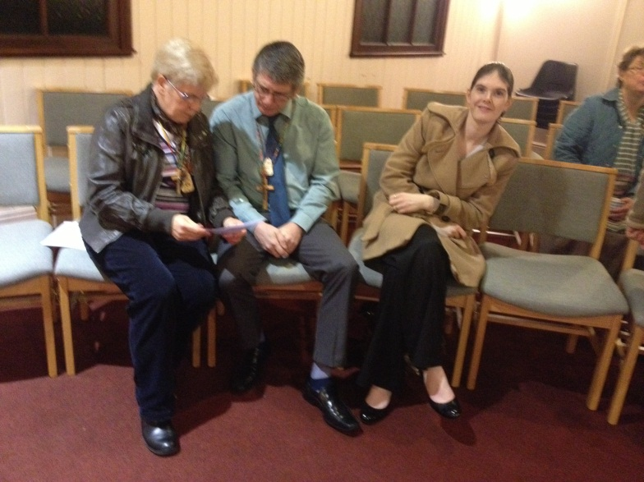

***Eddie checks a few points with David…***

*Lay Director, Eddie Miller writes*: Since I spoke to you at the last AGM your secretariat have enjoyed a year of hard work. I personally had the added responsibility of being the Lay Rector of Peterborough #6.

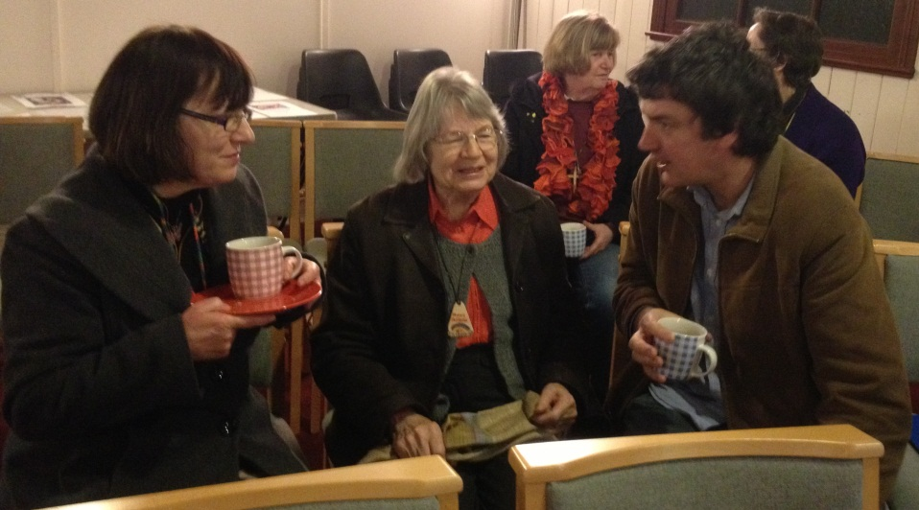

***A quick coffee before we start…***

The year was particularly difficult for your secretariat as two of the key post holders resigned three months into their three year contract. This was a great blow, but we doubled up on jobs and managed. Our aim was to create strong leadership team in the secretariat and to improve the communication to the Cursillo community and encourage group reunions.

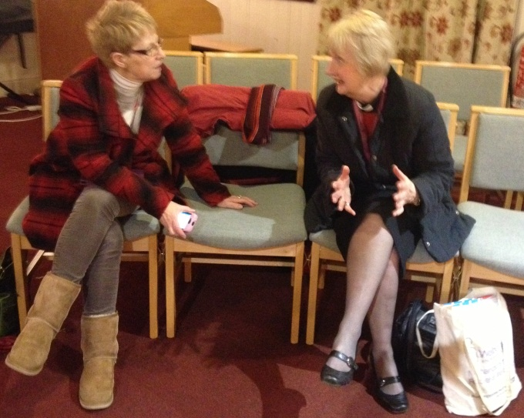

***Sue and Karen discuss some details…***

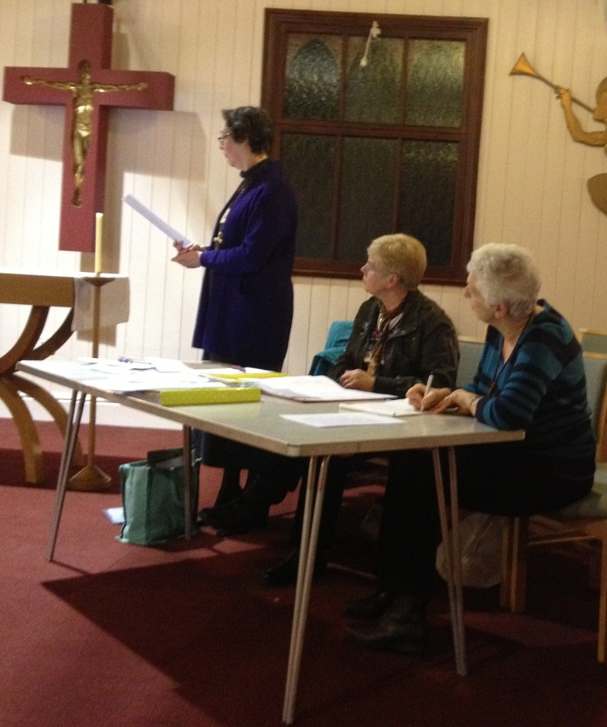

***As Cheryl gives the Financial Report, Eddie and Liz pay close attention…***

**How have we done?**

I am grateful for those who have come forward to fill some of the vacancies on the Secretariat. Without them I could not provide good leadership.

Secretariat members are encouraged to go on a CLW and this gives new contacts ideas from across the whole Cursillo movement. We have had two of the secretariat attend the Cursillo leaders workshop, and a further three persons will attend this year.

Membership of the secretariat is for three years. At the end of this time I hope you agree it is good to be able to hand the baton on. There are many on the secretariat who are due to stand down, so I ask you to consider the vacancies of Lay Director, Secretary, BACC rep, and weekend reps, there can be a period of shadowing to allow people to take over when they are familiar with the role.

**Communication**

We have been working hard to provide you with leaflets that are published to a high standard befitting our Cursillo and we have asked you to respond to various communications. We have an excellent website and Peterborough Pilgrim Newsletter, I would ask you to support our communication team. I have been disappointed at the poor response to our survey. Please send us your comments

As we prepare for Peterborough #7 to be led by Gilly Beardmore, we are in the process of putting together a team; we need at least thirteen

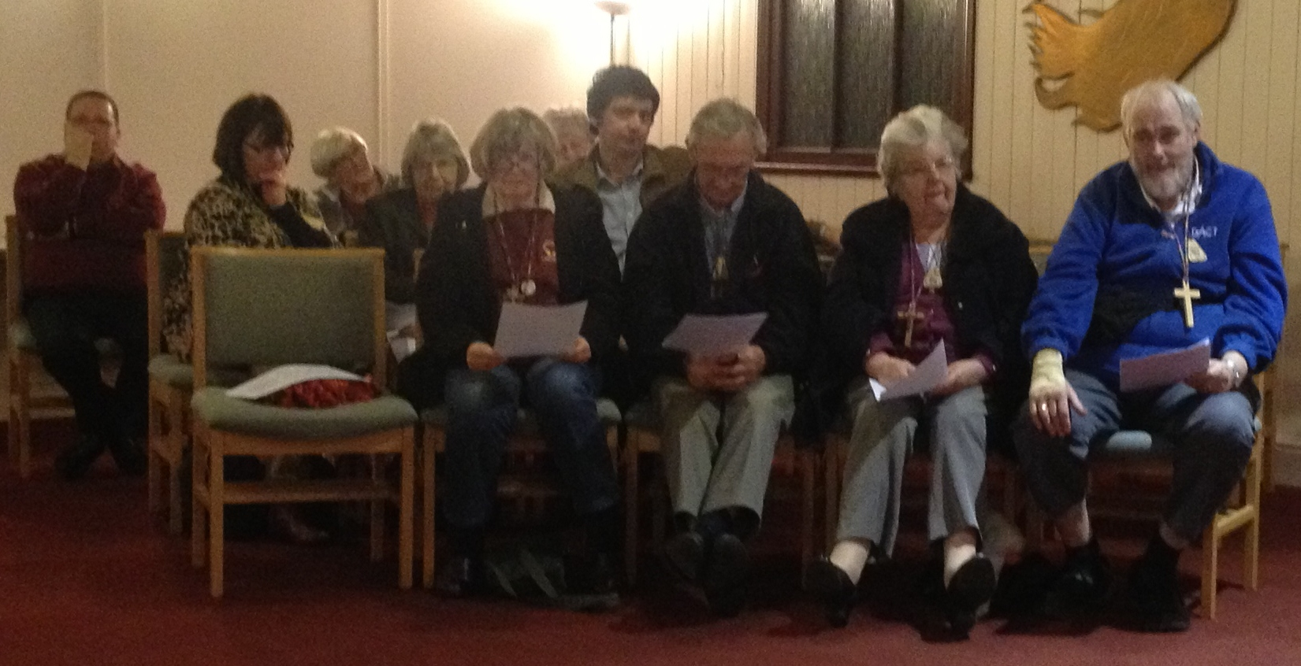

members who will attend two training days before staffing on the weekend. I must tell you that to staff is a wonderful opportunity to guide new pilgrims on their 4th day, and is the ministry of every Cursillistas. We are a new Cursillo still and the pool of Cursillistas to ask to staff is small, therefore many are staffing for a 3/4th time. Everyone has something unique to offer, so please do not feel you are too new or too old.

I am pleased to report that we have at least five Pilgrims signed up so far!

**A Word About Sponsorship…**

Sponsorship is extremely important as is group reunion and I ask all sponsors to ensure that they know which group reunion that they will invite the Pilgrim into following their weekend.

That the Pilgrim knows the cost of the weekend, or if unable to meet this that support can be obtained.

The sponsor should come to wake up and to the Clausura and should give the Pilgrim the date of the welcome back to keep free. This will be Wednesday 6th November 2013 at St Michaels Church, Kettering NN15 8BU.

**On a Positive Note, More News…**

The Clergy Taster Day hosted by Ely Cursillo was attended by six of our diocesan clergy. Cursillo is very much a lay/clergy partnership and we are pleased that recently we have had several Cursillistas ordained as priests and licensed as lay readers.

At least two of our clergy staff on each weekend as spiritual advisors and, like lay staff we need to increase the numbers who have experience staffing on our weekends.

This year we have Cursillistas doing their Lay Pastoral Ministry training. There are also many who are in the process of offering themselves for LPM and Lay Reader, Lay Evangelist Training, please hold them in your prayers.

**Chalice and Patten**

It has been requested that we have our own chalice and pattern for use on our weekends, I ask you to let us have your views or ideas on this.

In the Pilgrim Newsletter last year our theme was: “Bloom Where You Are Planted”, this year we must acknowledge that the soil in which we are planted must be nourished and replenished.

The way we can achieve this is through our actions and responses being rooted in Jesus as described in scripture and revealed to us through prayer. I am always humbled and inspired by the prayer life of Cursillo. This spring we are taking the theme of renewal, refreshment and resurrection as our aim.

**Let’s Get Physical!**

Let’s get physical, we need to energize Cursillo, we ask “What do you Cursillistas want from us your secretariat?” send us an email!

The Summer Event will be hosted by Bishop John at his home and at Mears Ashby Church on 20th July 2013, there is a number limit of 25, so please make a note in your diaries and let us know if you can make it. A further note will be emailed out later in the year.

I would like to see Peterborough Cursillo forge greater links with other Cursillo groups and diocese.

To join with other diocese is to further share our faith and encourage our fourth day.

To this end we are going to join with Ely Cursillo for a Regional Ultreya. The proposal made by the Lay Director of Ely Julie Robinson-Judd, is to invite surrounding diocesan Cursillo this end of the country and to also approach Kairos, Tres Dias, Walk to Emmaus etc. in East Anglia to invite them to join in with this regional Ultreya.

I am very excited about joining in with this proposal and hope that you will all give Cursillo your renewed energy and commitment in this coming year.

My plan for the future is also to retire as your LD following the October weekend, so please pray that the Holy Spirit will guide us in choosing the next **Lay Director, Edwina**

***Ultreya!***

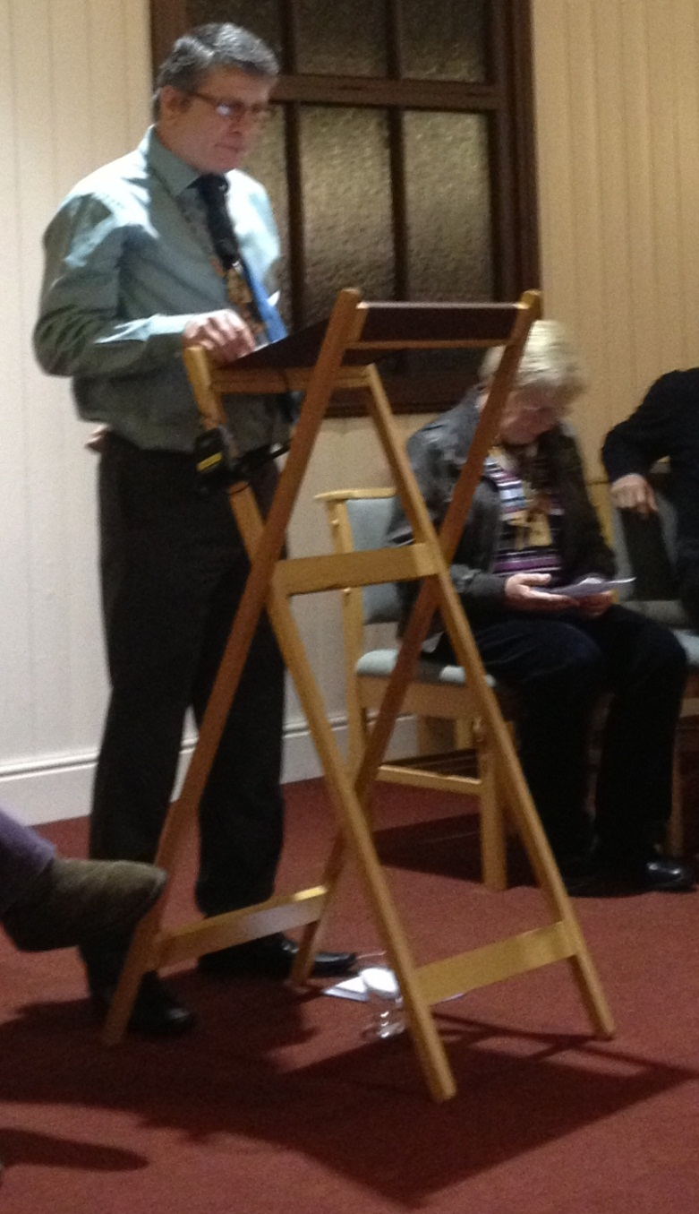

***Following the AGM, we received a most powerful witness from David Best…***

The AGM and the Cursillo Reunion was well attended with over twenty people present and some eleven who gave their apologies for being unable to attend.

Following the results of the Survey conducted by the Comm Squad, although the size of the Peterborough Anglican Cursillo membership numbers around 140, in actual fact an active group of around forty to fifty is a more realistic figure. This does not mean that those who are not active in their Reunions or Ultreyas will not be encouraged to take part through communications via The Peterborough Pilgrim, the website, Facebook, or email.

|  |
| --- |
| **General Information**  **If you wish to submit articles or items to**  **The Peterborough Pilgrim and would like to see what the finished results look like this may help you…**  The Peterborough Pilgrim is published quarterly and is set using Trebuchet MS font at font size 11 for general use.  Page margins are at 0.7 cms all round.  We prefer colour wherever possible for the benefit of those who read the magazine on their computers, smartphones or iPads.  A Black & White issue is always available for printing in order to help keep your costs down, particularly if you are printing and passing on the magazine to others, which we would encourage you to do.  Please also print one for your church if you can.  Providing that they are your own copyright, we love to receive your articles, pictures, prayers, ideas, comments, cartoons or anything else you’d care to send us which would improve this magazine and bring our Cursillistas together to praise God and to thank Heaven.  The Lord has not commanded us to set our ideas in stone; we are flexible, almost to the point of being double-jointed.  Images printed in the magazine are copyright free unless otherwise stated and articles are copyright the individual writers.  Any infringement of copyright is unintentional and we request such infringement is brought to our attention immediately.  Articles are submitted at the writers own risk and may be altered to meet the needs of time, space and good taste.  Please contact us through:  [**pbcursillo@gmail.com**](mailto:pbcursillo@gmail.com)  we prefer email but you can also leave answerphone messages at: **Colin’s phone number**  All rights reserved. E&OE  All items **©** Peterborough Cursillo Secretariat.  **The decisions of the Editors are final.**  **Particularly when they are wrong.** |

[](http://www.google.co.uk/url?sa=i&rct=j&q=&esrc=s&frm=1&source=images&cd=&cad=rja&docid=9xLfWMbRSeSmfM&tbnid=MpGpuTykj1Ip3M:&ved=0CAUQjRw&url=http://www.foylesearchandrescue.org/&ei=cPxSUdPOKceO0AXL6YHADQ&bvm=bv.44342787,d.d2k&psig=AFQjCNG7NDL9jjZj77GdQ3Hnq72VvOYWWQ&ust=1364479464194122)

From your own Facebook page, go to the top left hand corner and click the three horizontal lines. This takes you to the Search menu. Click on Find Friends, type ‘Peterborough Anglican Cursillo’ and ask them to ‘friend’ you. There is a short delay until you are verified as a Cursillista before you can join. The reason that the page is secure and requires verification is that we sometimes pray for individuals and we respect their privacy.

***Continuing our theme of “RE” for this issue…***

**The Results of the Cursillo Research…**

***117*** *questionnaires were sent out and we received* ***38*** *responses (****39*** *if you include the carefully stamped envelope returned to us which was empty). The survey was included in a copy of The Peterborough Pilgrim mailed out to each address on the Cursillista Address List (some addressees were cohabitees and received one copy jointly). This is a response rate of nearly one third. Most expected response levels for a “Cold Survey” (that is, to people who do not know about you) are around 3% so this could be seen as a good result, however, given that it was mailed to all those who have made their Cursillo, it was rather disappointing.*

*Colin continues*: We received some very nice comments written on the questionnaires from various well-wishers, plus a Christmas card for the “Comm Squad” and a book of 6 second class stamps! We also received some responses from those who wished to withdraw from the movement as they were now elderly and no longer wished to continue their membership. There were also a few responses tidying up personal information.

Where figures do not tally arithmetically, the cause is due to respondents not checking all the statements, or occasionally, checking more than one.

**Overall we have learned the following:**

**Computer Access:**

**10** had no access to a computer, **28** had access

**6** printed off The Peterborough Pilgrim (PP) and read it as hard copy

**3** printed off PP for another Cursillista

**1** would be happy to print a copy off for another Cursillista, if asked.

**3** read PP printed by another Cursillista

**28** read the PP on the computer screen

|  |  |
| --- | --- |
| **Internet Access:**  Only **1** respondent claimed not to have internet access.  **Website** | *C:\Users\Colin\AppData\Local\Microsoft\Windows\Temporary Internet Files\Content.IE5\SWED41V1\MP900409652[1].jpg* |

Nobody visited the website every day.

**4** Never visited the website

**28** visited the website either every week or occasionally

**Facebook**

**16** Never use the Facebook Page

**7** Occasionally used Facebook

|  |  |
| --- | --- |
| **2** Used it every Week.  **3** Used it every day. | *C:\Users\Colin\AppData\Local\Microsoft\Windows\Temporary Internet Files\Content.IE5\UT6Q0YE1\MP900448528[1].jpg* |

**Reunion Group Attendance**

**9** Attended every time one is held

**4** Whenever they could

**2** Occasionally

**1** Never

**Ultreya Attendance**

**3** Every time

**13** Whenever they could

**7** Occasionally

**Being a member of the Peterborough Anglican Cursillo movement**

**19** regarded this as very important

**9** saw it as “useful to me”

**1** regarded it as not important

**Mailed Copy of The Peterborough Pilgrim**

**3** wished to continue to receive mailed hard copies of PP

**3** wished to stop receiving copies and to resign from Cursillo for personal reasons

**1** failed to complete anything on the form, but simply made the remark that they had been ignored for 3 to 4 years, so “*why contact me now?”*

|  |
| --- |
| **The Peterborough Pilgrim**  **Christmas 2012**  http://clipart.christiansunite.com/1350297661/Christmas_Clipart/Nativity_Scenes_Clipart/Nativity_Scenes019.jpg |

**Research Analysis**

**Response Rate**

We must admit to being a little disappointed by the response rate. We included self-addressed envelopes so that all everyone had to do was place a second class stamp on the envelope.

**Printing for Others**

The response to this was heart-warming. We need to encourage more Cursillistas to print off copies of The Peterborough Pilgrim for those without PCs. As colour printing can be costly, the Comm Squad has already developed Black & White versions with the emails for Cursillistas to print off and give out. Perhaps we could encourage the printing of extra copies for your parish church, too.

**The Website**

Most of the respondents with PCs visit the website once a week, so we need to have something worthwhile or new to be viewed there at least every week.

The Comm Squad has already begun to respond to this by having an uplifting video placed on the site on a weekly basis, as well as placing more news there regularly.

The problem with offering a video is the need to ascertain ownership of each film and to get copyright waivers from the owners; we have found copyright a very murky area and have learned to navigate it cautiously. We have found that this generally means having to use American (and often Roman Catholic) websites which we have found to be most generous and helpful.

**Facebook**

Under one third used the Peterborough Anglican Cursillo Facebook page. It would be interesting to see how this figure changes - and hopefully grows - with time and the arrival of younger Cursillistas. Facebook is still seen by those not used to it as something strange or fearful.

Silly news-paper stories have not helped here either.

We envisage that more people will be using the Facebook page over the next year or so...

**Reunion Group and Ultreya Attendance**

This is only a gut feeling and we readily admit that there is no real hard evidence here, but we have the impression that there is still confusion between Ultreyas and Reunions, their value and purpose. The plaintive cry on one survey form: *“After 3 to 4 yeas…why contact me now?”* shows that the role of the Sponsor is (or was) not clear to some of our members.

**Being a Member of the Peterborough Anglican Cursillo Movement**

Although 28 respondents rated being a member as either “very important” or “useful”, we have no explanation as to why others failed to check this statement. It may well be bad design on Colin’s part (*and “Tut!” he used to teach this area*). Perhaps the idea that being a Cursillista has some earthly value or importance is not in keeping with the ethos of the movement…

**Hard Copies of The Peterborough Pilgrim.**

We must admit amazement that only three people have responded with a request for a hard copy of the magazine to be mailed to them, but if that is all that is required, we can fund these quite easily.

**Overview**

The survey as an exercise was valuable. It gave us information about the Cursillo Movement in the Peterborough Diocese which we can act upon. From the figures taken from the membership list we used to assume a membership of around 140 active people. Even allowing for joint responses from married/cohabiting couples, the true figure for active Cursillistas is closer to 40 or 50, which is closer in number to those who actually attend (or send apologies for absence) at Ultreyas, Reunions, the AGM and other events.

Our communications also need to be reconsidered. We now know that many of our members do not make use of a PC or, for one reason or another, do not read The Peterborough Pilgrim. Although we believe that we must press on with the new technology available to us, we must also be inclusive in our communication. One possibility would be to arrange for a copy of the magazine to be placed in each church within the diocese which has at least one Cursillista.

We are striving for a balance here. Nobody wants to find their inbox stuffed with Cursillo emails, nor can we afford to mailshot everyone on the membership list. Word-of-mouth is still the most effective method of encouraging new members and to bring existing Cursillistas together.

If anyone reading this article has any ideas that would help them in their own situation, we would be happy to learn from them.

**Colin Suter, on behalf of**

**The Comm Squad**

**DATES FOR YOUR DIARY**

**These are taken directly from the Peterborough Anglican Cursillo Website at:**

**peterborough-cursillo.btck.co.uk (or simply type “Peterborough Anglican Cursillo” into your search engine). At the Home Page, enjoy the video by clicking on the arrow in the centre of your screen, then go to the navigation bar on the extreme left of the page and click on “Calendar” which is the fifth item up from the bottom. The calendar page lists all the events in the Cursillo Year. Any further questions please email us at:** [**pbcursillo@gmail.com**](mailto:pbcursillo@gmail.com)**. We are here to help.**

Cursillo Leaders' Workshop

**Date:** 26 Apr 2013  
**To:** 28 Apr 2013

**Start time:** 05:00 PM  
**End time:** 04:00 PM

At the Gillis Centre, Edinburgh Please contact Jan Watts, via the email on this website

BACC AGM

**Date:** 11 May 2013 (all day)

More details to follow...

Cursillo Leaders' Workshop

**Date:** 05 Jul 2013  
**To:** 07 Jul 2013

**Start time:** 05:00 PM  
**End time:** 04:00 PM

At Wistaston Hall, Crewe For further details please contact Jan Watts through the email on this website

BACC Pilgrimage at St John's College, Durham

**Date:** 20 Aug 2013  
**To:** 24 Aug 2013

**Start time:** 12:00 AM  
**End time:** 12:00 AM

Costing £250, the BACC pilgrimage at St John's, Durham will be led by Rev. John McManners. More information is available at the BACC website: http://www.anglicancursillo.co.uk/

National Ultreya

**Date:** 07 Sep 2013 (all day)

Wakefield Cathedral More details to follow...

CURSILLO WEEKEND - Peterborough #7

**Date:** 17 Oct 2013  
**To:** 20 Oct 2013

**Start time:** 06:00 PM  
**End time:** 04:00 PM

Takes place at Launde Abbey LE7 9XB Please arrive at 6.00 pm on the Thursday evening and be prepared to depart around 4.00 pm on the Sunday

Cursillo Leaders' Workshop

**Date:** 18 Oct 2013  
**To:** 21 Oct 2013

**Start time:** 12:00 AM  
**End time:** 12:00 AM

Running parallel with our own Cursillo Weekend at Launde Abbey, there is also a national Cursillo Leaders' Workshop at Shallowford House, Stone. For more details contact Jan Watts through the email on this website.

Peterborough #8

**Date:** 16 Oct 2014  
**To:** 20 Oct 2014

**Start time:** 12:00 AM  
**End time:** 12:00 AM

Takes place at Launde Abbey, further details will be available later in the year