|  |  |  |
| --- | --- | --- |
|  | **AUTUMN 2014**  **Your**  **Peterborough**  **Pilgrim** | Description: Description: http://www.peterborough-diocese.org.uk/logo/rgb_vertical_main.jpg |

[](http://www.google.co.uk/url?sa=i&rct=j&q=&esrc=s&source=images&cd=&cad=rja&uact=8&docid=qO4jC49wspe3AM&tbnid=WPjB7m1BOgDPVM:&ved=0CAcQjRw&url=http://www.whatiscursillo.com/&ei=-jYYVM7hLsvkaOfxgJgP&bvm=bv.75097201,d.ZGU&psig=AFQjCNEcdpU76YMfwFIABU92M22096JJKA&ust=1410959451416422)

**Cursillo,**

**No Secrets**

* **Only Surprises**
* **Dear Peterborough Cursillistas…**

***“I told some colleagues that I was attending a Cursillo Clergy Taster Day. They all stared at me in horror and one of them said to me ‘Good Luck!’***

***“I came away from the Cursillo Weekend absolutely invigorated, but must admit that when I went there to start with, I was really terrified. Silly wasn’t it?”***

***“Nearly packed my bags to go home on the first night…”***

***“I thought it was going to be all Masonic Style handshakes and blood curdling oaths. Seriously!”***

**These are just a few statements from some of those who have attended our Cursillo Weekends or Taster Days in recent years.**

**Rather concerning isn’t it?**

**One person whom I interviewed, told me that she had been worried about ‘attending a Cursillo’ because she noticed that ‘those who came back from such events seemed to be more bubbling over with Christianity - I thought that they had been brain-washed!’**

**She went on to explain that in each case the attendees had seemed to have become refreshed in their faith and were more involved with different aspects of the working of their parish.**

**Well, that was good news, at least.**

**But it is this image of a ‘Secret Society’ with ways of identifying other cursillistas, the emblems of rainbows, butterflies and the ‘strange Spanish words’ that really needs to be dealt with (I am not suggesting we do away with them, by the way…).**

**What I also find amusing is that on the one hand some who know nothing of us describe our movement as “too Catholic” – presumably because we always explain that although we are an Anglican organisation, the roots of Cursillo were planted in the Roman church in Spain. Come to that so were the roots of the Church of England…**

**On the other hand, I was told that it was “Too Happy Clappy!” by someone who had not the faintest idea what we were about but had heard from ‘a friend of a friend’ about us…**

**I like to think that if we are being misunderstood from both sides of our very broad church, we must be doing something right…**

**I guess the answer is to explain and explain and explain again. I like Judy Craig’s point to me when I became a cursillista:**

**‘We are not a secret organisation. There are no secrets. There *are* a number of surprises. A bit like a Birthday Party. We’ll tell you what they are if you want to know, but that rather spoils the idea of the surprise…’**

**One way that some have tried to get the message across is to invite non-cursillistas to a Reunion.**

**When the Grendon Reunion group became too large, we split off and established the Earls Barton Reunion. This meets every month (we originally started meeting every six weeks but found that short monthly meetings were easier to diarise).**

**There are only four of us and, as with the Grendon group, we like to meet at 8.00 am on a Saturday for a breakfast at someone’s house (we all take turns). We can eat, chat, journey through our Piety, Study and Action and still get away for the rest of the Saturday morning by nine o’clock.**

**With one of our members shortly moving away from the village, we would be down to just three, so we are inviting non-cursillistas to come and join us, with the idea of introducing them to Cursillo and to get some idea of the Fourth Day, without any commitment on either side, and of course, with agreement from the incumbent of their parish.**

**Have you found a way of bringing Cursillo into the conversation?**

**Our shirts and sweatshirts have proved to be a good conversation starter for some people.**

**I will be investing in another colour cursillo shirt this winter in order to ring the changes.**

**Whatever method you choose, can you pool your knowledge and experiences with us through The Peterborough Pilgrim?**

**We would be very interested in learning from your experience.**

**By the way, I personally have no problems with philanthropic societies doing good in the community... ULTREYA!**

**Colin Suter**

|  |  |
| --- | --- |
| **Judy’s Jottings**  **From Your Spiritual Director**  **Dear Friends…** | MC900435246[1] |

|  |  |  |
| --- | --- | --- |
| **C:\Users\Colin\AppData\Local\Microsoft\Windows\Temporary Internet Files\Content.IE5\3F19MZHM\MC900056115[1].wmf** | **As the autumn beckons Peterborough Cursillo are planning Peterborough #8 (get those sponsor forms in now!). In everyday life September is often a time for new start as we enter a new school year; it’s also the period when clubs and courses all begin again, a time to decide what to take up or drop.**  **Shall I continue singing in that choir, or might I take up a new hobby, perhaps consider an evening class in something I’ve never done before.**  **After the break of the summer it may be that we decide to continue with our normal routine, but it can be an opportunity to think afresh and maybe do differently. This can be a challenge that is life giving, but will also make us feel a bit uncomfortable, at least to start with.** | |
| **When we are facing change first of all we might find ourselves inhabiting an ‘in between’ time. Perhaps we have stopped one thing and not yet started the new one. Maybe we find ourselves in limbo for reasons beyond our control. Waiting for results of tests, looking for new work after redundancy, wondering what to do now we are retired. No doubt things will eventually evolve and God will make his plans clear.  In the meantime we might find ourselves in an ‘in between’ place, a waiting time. I recently had a Quiet Day and was reflecting on waiting times. I discovered I had a mixed bag of thoughts and feelings, and wrote a poem exploring how we might inhabit this waiting time in creative and positive ways.**  **I pray that you might find some creative space for God in any waiting times you may be facing.**  **Best wishes**  **Judy Craig Peck** | | **C:\Users\Colin\AppData\Local\Microsoft\Windows\Temporary Internet Files\Content.IE5\EZ8G6HV7\MC900056152[1].wmf** |

|  |  |
| --- | --- |
| **Waiting Times**  **In this Waiting time we long to discover**  **Trust amidst all our anxieties**  **Patience through our impatient haste**  **This ‘waste of time’ can become creative space**  **Stuck in the Waiting place perhaps we can**  **Discover a sense of being when we feel lost**  **Find open-mindedness when we are demotivated**  **Be more relaxed when we get on edge**  **Living in the Waiting space we hope God will**  **Conquer our fears with confidence in Him**  **Let love flow out of our disconnectedness**  **Embracing this Waiting as gift we trust that**  **God’s longing will inform our heart’s desire**  **Our restlessness will be transformed**  **So we can enjoy God in this present moment.** | C:\Users\Colin\AppData\Local\Microsoft\Windows\Temporary Internet Files\Content.IE5\W5HB1KWM\MP900384909[1].jpg |

**Ramblings from Rahab…**

**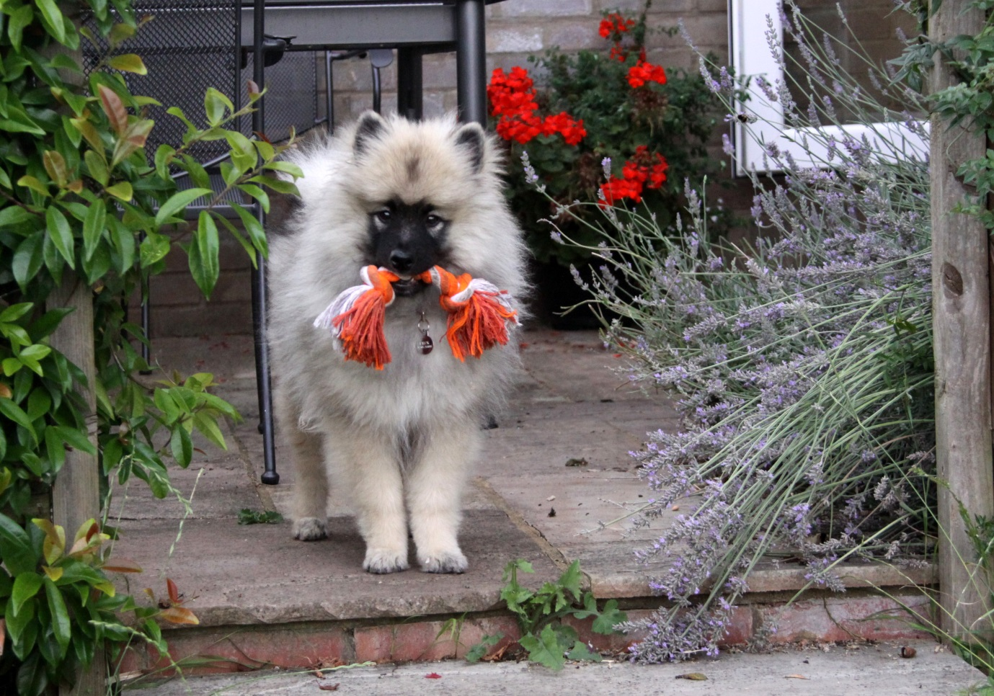**

**Hello; I’m four and a half months old and I belong to Chris and Judy.**

**Well, that’s what they think. Actually they live in the house that I’m busily making mine! However, it’s not all sweetness and light. They don’t seem to get that I am a PUPPY.**

**Sometimes I just get this burst of energy and run wild, I’ve got new teeth coming through and I need to bite everything that I can, I don’t always remember to go outside when I should, and sometimes it’s just more fun to run off and hide somewhere away than it is to come when I’m called.**

**And that’s just who I am at the moment. But they seem to think I should be different, and sometimes they get cross with me (even though all those puppy books they keep reading tell them never to be cross with their puppy!).**

**I sometimes think: wouldn’t it be wonderful to have a master or mistress who always accepted you as you are, who was always patient with you, who always had time for you, who forgave you if you did naughty things, who never shouted at you, who understood you through and through and went on loving you however much you upset them by the things you do. I wonder if they have someone like that to talk to - they certainly seem calmer when they’ve spend time sitting in those chairs with their books and mumbling away…**

**Perhaps if they spent more time doing that they wouldn’t get so cross with me!**

**NEWS FROM**

**OFFA HOUSE…**

[NEWS FROM OFFA HOUSE received from Brenda Reeves Coventry cursillo Dear All

Some time has elapsed since the last update of progress since  Offa House re-opened.

The House has been open for prayer at 7.30am, 12.30 ( Eucharist) and 5pm, every week, Monday to Thursday  from 7th July. This Rhythm of Prayer has been a wonderful opportunity to pray in the peace and quiet that exists there.

From 6th October, in addition to these formal prayer times, the House will be open throughout the day for private prayer. The grounds are always open. Shortly we hope to offer 'Quiet days' of extra activity, be it in led retreat form or creative expression. 

For those of you who have already been part of this, thank you for your support  while we search for God's will in its future. 

Several people have asked if, in addition to their prayers, whether they could support this activity financially.

The answer is yes - please!!

Although only a part of the House is open, there are still costs to be covered - insurance, Caretaker, lighting and heating. 

Standing orders are welcome, but  cheques, made out to Coventry DBF, can be sent to Mrs Jill Benn, Diocese of Coventry, 1 Hill Top Coventry CV1 5AB.  Please inform Jill that  it is for Offa House.  Gift aid forms are available at Offa House.

One of the ways to build on our achievements so far is to spread the word to as many as we can. Prayer support, either at Offa House or outside is vital if we are to grow a vision for the future. If you are able to put information on your Church notice board, it will act as a constant reminder to come and join us. All are welcome, and the lower chapel is available for those who find the stairs difficult.
In Christ, and for the future of Offa House

Roger and Rosa](https://www.facebook.com/photo.php?fbid=10204703457736765&set=gm.817046731659483&type=1)

*(received from Brenda Reeves of Coventry cursillo and downloaded from Facebook)*

**Some time has elapsed since the last update of progress since Offa House re-opened.**

**The House has been open for prayer at 7.30am, 12.30 (Eucharist) and 5.00pm, every week, Monday to Thursday from 7th July. This Rhythm of Prayer has been a wonderful opportunity to pray in the peace and quiet that exists there.**

**From 6th October, in addition to these formal prayer times, the House will be open throughout the day for private prayer.**

**The grounds are always open.**

**Shortly we hope to offer 'Quiet days' of extra activity, be it in led retreat form or creative expression.**

**For those of you who have already been part of this, thank you for your support while we search for God's will in its future.**

**Several people have asked if, in addition to their prayers, whether they could support this activity financially.**

**The answer is yes - please!!**

**Although only a part of the House is open, there are still costs to be covered**

**- insurance, Caretaker, lighting and heating.**

**Standing orders are welcome, but cheques, made out to Coventry DBF, can be sent to:**

**Mrs Jill Benn, Diocese of Coventry, 1 Hill Top Coventry CV1 5AB.**

**Please inform Jill that it is for Offa House. Gift aid forms are available at Offa House.**

**One of the ways to build on our achievements so far is to spread the word to as many as we can. Prayer support, either at Offa House or outside is vital if we are to grow a vision for the future.**

**If you are able to put information on your Church notice board, it will act as a constant reminder to come and join us.**

***(You are free to download this item, print it out and use it).***

**All are welcome, and the lower chapel is available for those who find the stairs difficult.  
In Christ, and for the future of Offa House**

**Roger and Rosa**

**URGENT PRAYER REQUEST FOR REVD CANON ANDREW WHITE**

*(received from Revd. Liz Cowley on Facebook)*

**The Reverend Canon Andrew White is vicar of St George's Church, Baghdad, the only Anglican Church in Iraq.**

**He has thus been dubbed the "Vicar of Baghdad".**

**At the age of 33 years he was diagnosed with multiple sclerosis, a condition which for many years affected his mobility and his speech. He has been undergoing a new stem cell treatment for MS at a clinic in Baghdad that utilizes his body's own stem cells and he has said "It had completely transformed my life”**

****

**Andrew had the stem cell replacement last week unfortunately it appears he received contaminated blood. [We have heard that it was his own blood but that the machinery was unclean, this is unconfirmed].  
He now has Hepatitis B and has been flown home to the UK. Please pray for God's care and compassion on this lovely man.**

**Prayers also very much needed for those treating him as well as for the situation in Iraq.**

**Rev. Simon from Seoul…**

[Liz & David , They are here  with  me.
We  had a good  time....after  lunch took a photo at Cathedral....](https://www.facebook.com/photo.php?fbid=501009413369976&set=a.170798053057782.42247.100003827659448&type=1)

**Lovely to see Liz and Dave Cowley with Rev Simon from Seoul Diocese. Simon came and worked with the Daventry Team some years ago for a two year period.**

**Lay Ministry Training Quiet Day**

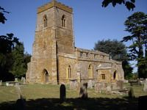

*All Saints, Flore*

**As well as the site for our Summer Ultreya, All Saints was the venue for a Quiet Day held on September 13 by the Lay Ministers in Training who are to be licensed by the Bishop on September 20. There were some cursillistas within the group, plus a few who were continuing their Christian Journey through to next year.**

**The Prayer Vigil**

**for Peterborough 8**

**By now you may have received the Prayer Vigil as an email. This is just a reminder and may already be slightly out of date, but you can contact John Mullins on:**

**member@mullins28.freeserve.co.uk**

**and offer to cover a particular time.**

**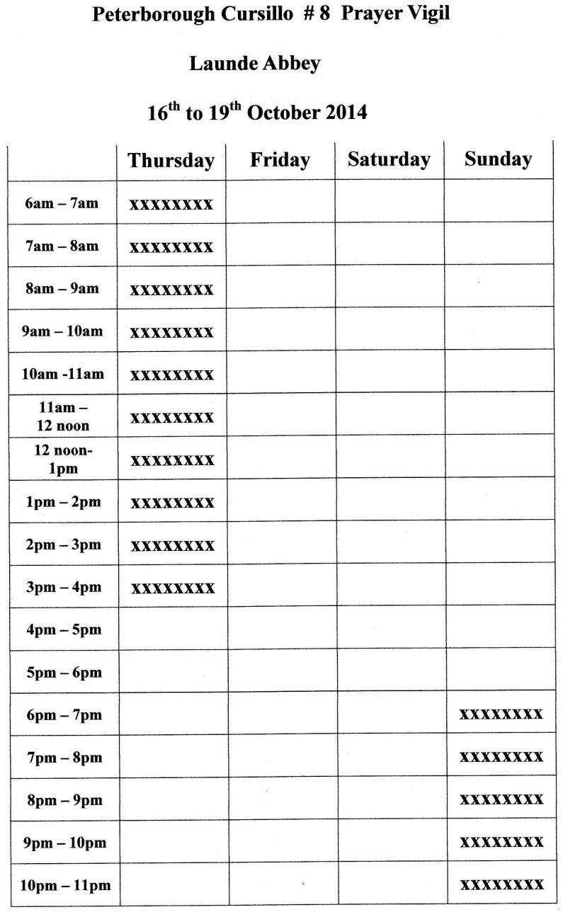**

[](http://www.google.co.uk/url?sa=i&rct=j&q=&esrc=s&source=images&cd=&cad=rja&uact=8&docid=YCGuwMadfeR0mM&tbnid=vkiAKVVp9qecrM:&ved=0CAcQjRw&url=http://www.canterburycursillo.org/what-is-cursillo&ei=ticcVKDwArCJsQTD_YDQCg&bvm=bv.75774317,d.ZGU&psig=AFQjCNGcpX0xt5yqZ2rsDq0L6ewXa19OLg&ust=1411217673278295)

**Shadowing The Secretariat - Treasurer**

|  |  |
| --- | --- |
| **C:\Users\Colin\Pictures\Sllepout and Cheryl\IMG_4986.JPG**  *Cheryl Goddard* | **Cheryl Goddard Secretariat Treasurer Writes:**  **I would be pleased to hear from anyone who is interested in shadowing me as Treasurer with a view to taking on the role in the future.**  **It is not a demanding role. There are infrequent transactions throughout the year but more activity before and after a Cursillo weekend.**  **I record all the transactions on a couple of Excel spreadsheets. If you are not familiar with spreadsheets, they are just like using a very large table in Word, but in Excel, figures can be easily calculated. Do please get in touch with me if you are interested in exploring this further –** [**cheryl.cfgbusiness@gmail.com**](mailto:cheryl.cfgbusiness@gmail.com)  **Cheryl**  **Treasurer Job Description**  **The Treasurer is a member of the Secretariat and gives a verbal report on the financial state of affairs at each meeting. The task of the Treasurer is to deal with all the financial affairs of Peterborough Cursillo, as follows:** |

**Take charge of all money received (cash and cheques) and pay it into the bank account as soon as possible. Money comes to Peterborough Cursillo from various sources:   
- banker’s orders from Cursillistas  
- income relating to Cursillo weekends  
- donations  
- fund raising activities  
- other miscellaneous sources  
- tax relief on gift aided donations  
Funds are deposited with Barclays Bank.**

**2. Maintain a book-keeping system to record all receipts and payments. Cheques should only be drawn against presented invoices or expenses claims supported by receipts. There are four signatories on the account, all four being members of Secretariat and all Trustees. Any two signatures are required to sign a cheque. A signatory should not sign a cheque payable to themselves against an expenses claim. All payments to be made within 28 days.**

**3. Encourage Cursillistas to donate regularly to Peterborough Cursillo, ideally by Standing Order, and to ensure where possible the contributions are gift-aided. This may be done verbally at Ultreyas and other meetings, and in writing through the Newsletter.**

**4. The Treasurer to sign the HMRC ‘Model declaration for fit and proper persons’, to be held by the Secretary of Secretariat. The Treasurer to register as the responsible person for dealing with gift aid claims. Gift aid to be claimed annually.**

**5. Annual accounts to be produced by the Treasurer as soon as possible after the financial year end on 31 December. The accounts should be independently examined and presented to the Annual General Meeting.**

**6.To be responsible for completing the Annual Return on the Charities Commission website, and keeping the registration of Trustees updated.**

**Accounts records and annual accounts to be kept for six years, as per Charity Commission guidelines.**

**National Cursillo Canterbury**

**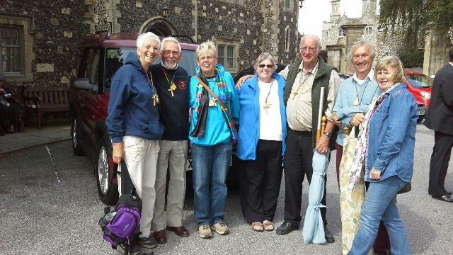**

***Hail! Hail! The Gang’s all here!***

|  |  |
| --- | --- |
| **C:\Users\Colin\AppData\Local\Microsoft\Windows\Temporary Internet Files\Content.IE5\6VRVZ74T\20140830_100533_resized.jpg** | ***Eddie and Liz write:***  **It was a Wonderful Ultreya.**  **We met many old friends!**  **(We reckon that they made a number of new ones, too!)**  **C:\Users\Colin\AppData\Local\Microsoft\Windows\Temporary Internet Files\Content.IE5\3F19MZHM\20140830_122219_resized.jpg** |

**Alaskan Journey…**

**Gilly shares her experience with husband, Keith on a journey which brings home to us all the God’s handiwork can be seen in nature…**

**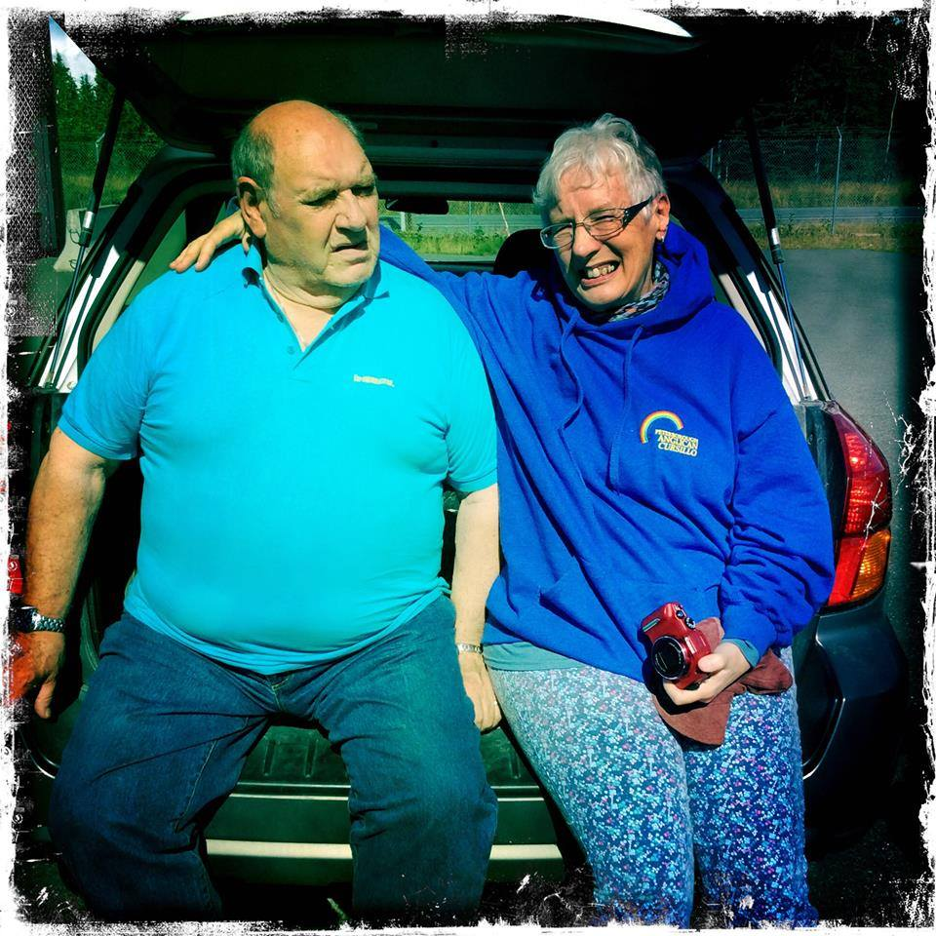**

**Before the trip in a 4-seater plane across the Cook Inlet to the landscape of the wilderness with Gregg and Amanda…**

**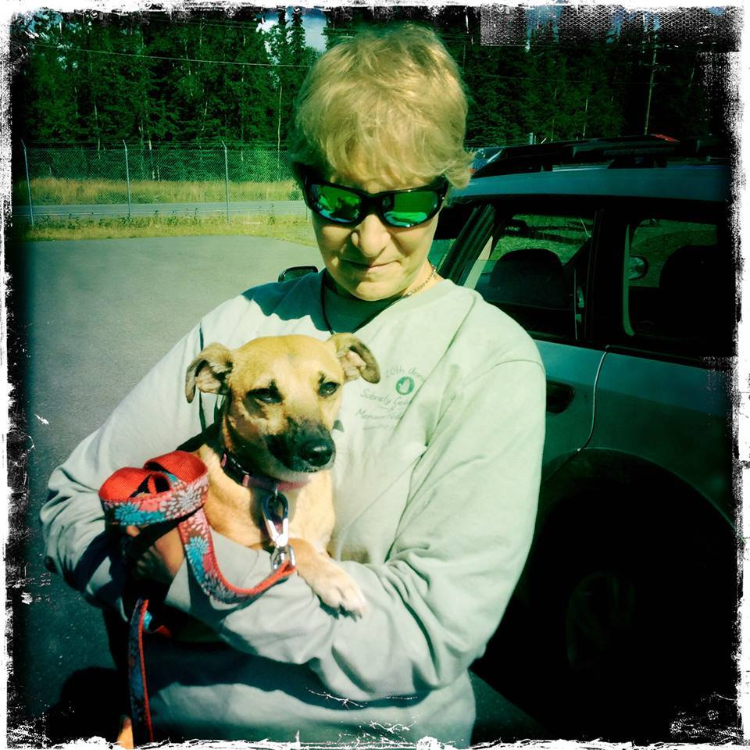**

**Jan who with Stan planned the elements of our stay and taught us all about their wonderful capacity for hospitality and friendship.**

**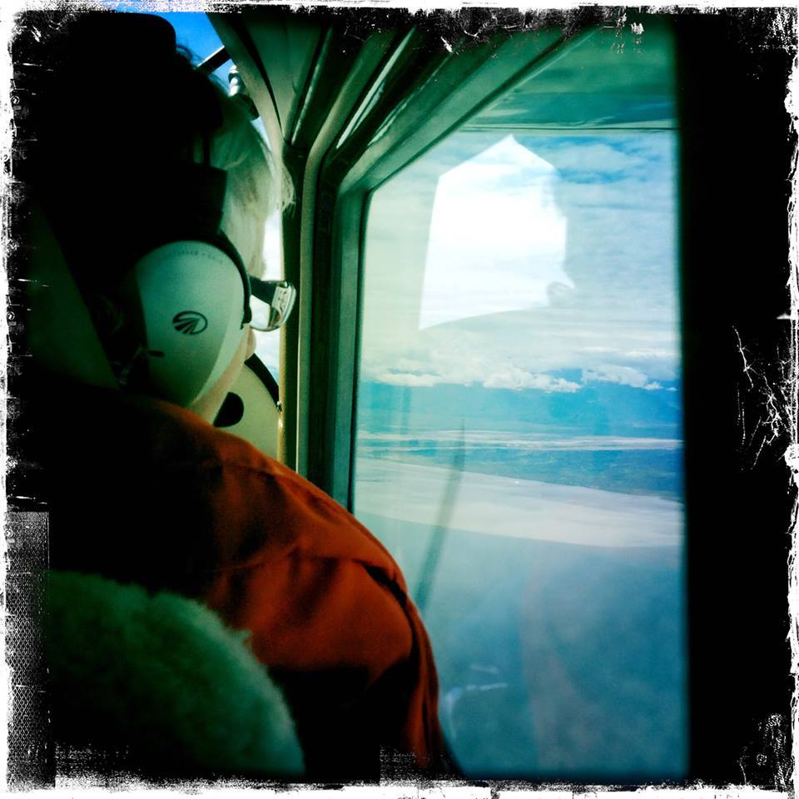**

**Gilly in the 4-seater plane renewing a sense of the wonder of creation…**

**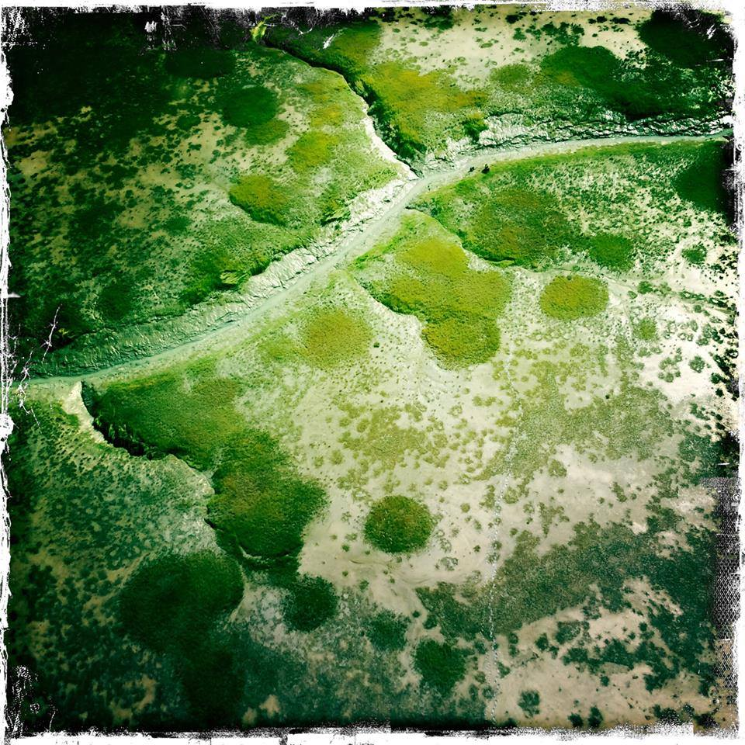**

**Bear hunting the sedge grass at the river delta grounds…**

**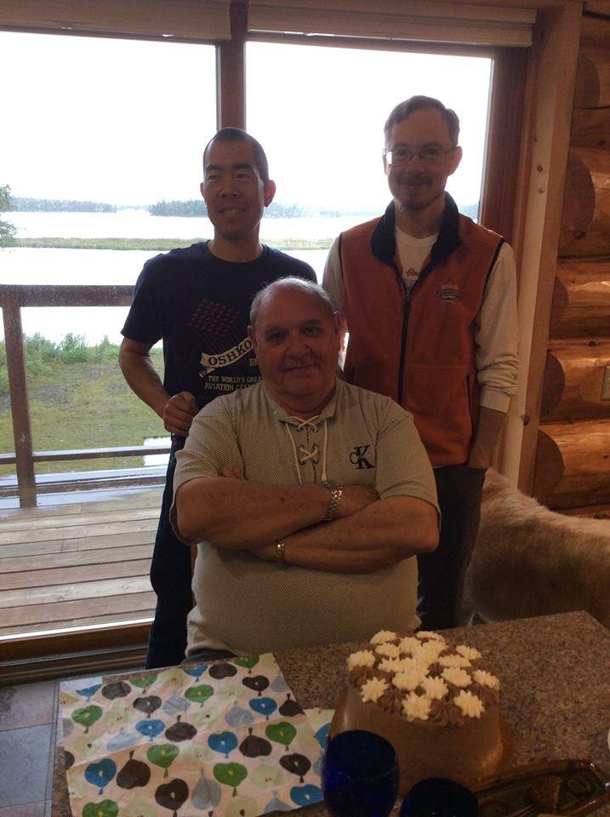**

**The boys - Stan who with Jan created our Alaskan rainbow experience, Gregg, the pilot, and Keith my wonderful travelling companion through this time of our lives…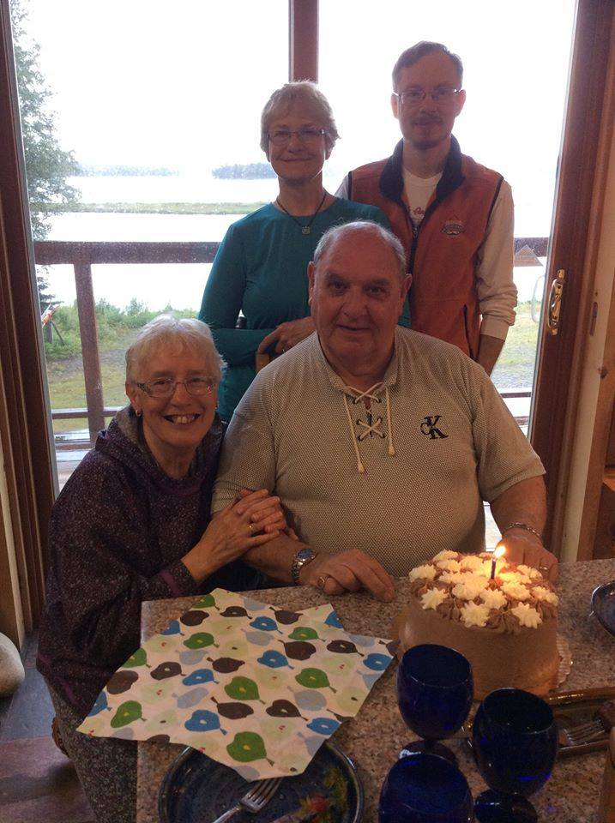**

**BIRTHDAY Breakfast at Ellen and Duane’s Ellen's delicious sourdough pancakes and the gift of a piece of driftwood on which Ellen had carved “Nature is art of God”.**

|  |
| --- |
| **Bouquets and Brickbats**  **The Peterborough Pilgrim is an online magazine which is published at least four times a year and on occasion, more frequently as and when the material builds up.**  **It is produced for The Secretariat by**  **The Comm Squad:**  **Colin, Ann, Mark, and introducing - Paul…**  **All Errors and Omissions are the fault of Colin; all Bouquets are for the rest of the team who do so much.**  **Colin is shortly retiring and we are always looking for new cursillistas to expand the scope of our magazine. If you would like to consider shadowing by joining in with us with no commitment on either side, you would be most welcome. Contact us by email, please.**  **E & OE.**  **© The Secretariat of the Peterborough Anglican Cursillo**  **Website**  [**www.peterborough-cursillo.btck.co.uk**](http://www.peterborough-cursillo.btck.co.uk)  **email:** [**pbcursillo@gmail.com**](mailto:pbcursillo@gmail.com)  **All Rights Reserved**  [https://encrypted-tbn2.gstatic.com/images?q=tbn:ANd9GcQiYfeRl5eB6ZcdJ_WGL1nP_929_PXRFiqHK4eb4JmGYwYjx0Ld](http://www.google.co.uk/url?sa=i&rct=j&q=&esrc=s&source=images&cd=&cad=rja&uact=8&docid=i8f0zP4TbS_tNM&tbnid=NwOqLgHb-nlnjM:&ved=0CAcQjRw&url=http://www.pictures88.com/comments/butterfly/page/3/&ei=STAcVP-5E6nlsASwvYC4DQ&bvm=bv.75774317,d.ZGU&psig=AFQjCNGkeXC8f_QU3owm9W8OiCL79vkw-g&ust=1411219900923545) |