|  |  |  |
| --- | --- | --- |
|  | **SUMMER ISSUE 2013**  Your  Peterborough  Pilgrim | Description: Description: http://www.peterborough-diocese.org.uk/logo/rgb_vertical_main.jpg |



**Is It Ever Easy?**

**Renewing Christian Faith**

**Dear Peterborough Cursillistas…**

The theme for this Summer Issue is Renewal. That is how my cursillo weekend was first introduced to me – a chance to reaffirm and renew my faith in Jesus Christ.

I wonder how many of us had any idea what to expect when we decided to attend that weekend?

I know that, despite a great deal of help and support from my sponsor, Chris, I was completely overwhelmed.

So much, that it took me ages to find that little green card headed MY RULE OF LIFE that they handed to me on the Sunday.

Do you remember that? For me, it was over two years ago when I received it. It was full of ideas to renew and re- commit to Christ, though at the time I felt that I was really unworthy of his love.

But then, let’s be honest, are any of us truly worthy of God’s love? The Creator of a universe that is 13.7 billion light years across (and, if Quantum Mechanics is correct, of an infinite number of similar such universes) actually knows you, cares for you and loves *you*. As an individual. A person. He knows everything about you. And still loves you.

That for me is the wonder of our faith.

|  |  |
| --- | --- |
| Recently, Sue and I visited the British Museum to see the Pompeii Exhibition. It was well worth going to see.  The pictures, the artefacts, the computer - generated images, were all of ordinary people, just like you and me, going about their daily business. Their gods, from Jupiter down to the Lares et Penates, lived a separate, parallel life, needing propitiation and sacrifices in order to pay any attention to their worshippers. | C:\Users\Colin\Pictures\IMG_1488.JPG  ***Photo © Stargazy enterprises*** |

Cursillo brought home to me just how personal God is in my life.

The Reunions, The Ultreyas, the opportunities to share the ways that we can nourish our union with Christ, through Piety, Study and Apostolic Action, these are all ways to renew our faith on a daily basis.

Time to get my green card out and look at it again…

**Colin**

**1**

**The Meaning of Cursillo…**

**Cursillistas taking part in the Peterborough Cursillo # 7 Weekend in October, have been asked to introduce themselves in this issue of the Peterborough Pilgrim by writing about what making their cursillo meant to them.**

**Look out for their articles on different pages throughout this issue, they are surrounded by a red square.**

**Here’s the first, from Christine:**

|  |
| --- |
| **What Cursillo Means To Me**  https://lh4.googleusercontent.com/xwDTy9XPvIL3Y_fmBjdWzVlgXDfR7F5dkkwK6lfLYgrrqaYAHuFYXDucag9e669t-CZJizkgxHF3mBf9b7Bq9P3GaHmDGcn9E63sUVETg0DvYwOPRP2qIjaSXIpQAQxS4w  I made my Cursillo on Peterborough #3 at Offa House. I didn’t have any idea of what to expect, but was soon made comfortable by the warm, friendly reception I received.  For me, the weekend was a mix of learning, exploring, emotions (a lot of!!), fellowship and a few surprises!   I left feeling exhilarated but exhausted.  Cursillo gave me a new perspective on my faith, and my own journey with God, which has continued to grow, and been helped along by the meetings and fellowship of other local Cursillistas.  **Christine Hawkins**  **Staff Member Peterborough #7** |

**Cursillo Crosses and Toggles**

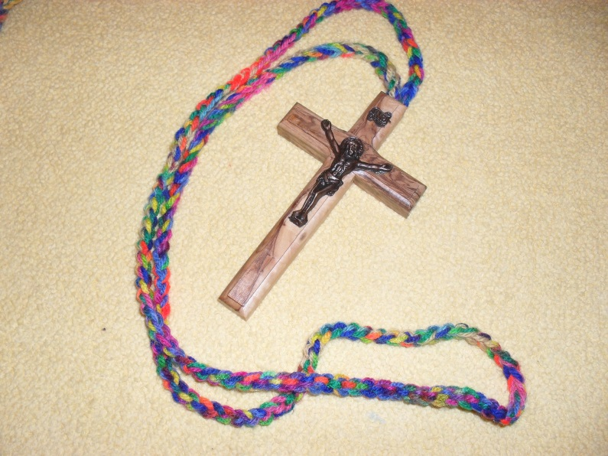

One of the continuing surprises of a Cursillo Weekend is the presentation of name toggles and of course the Cross, blessed by the Bishop at the Clausura.

A continuing surprise of course because we carry them both as a token of our shared experience and membership of a world wide body of Christians who are committed to a life of piety, study and action in the name of our Lord Jesus Christ.

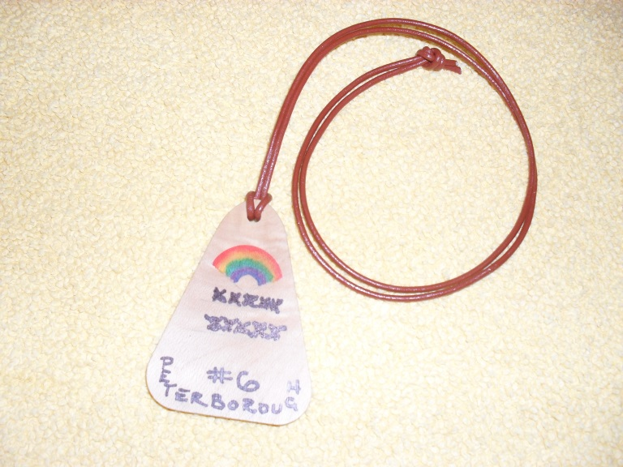

Toggles and crosses are a form of Palanca just as much as the cards and messages we send during the weekend and the support we give to Pilgrims both before and afterwards.



Crosses and Toggles are an affirmation of our individuality whilst recognising that we are part of the Cursillo Community.



They signify that “Christ is counting on us and we on Him” to use the words of the Commissioning during the Clausura. They are a continuing reminder of our journey with Our Lord and that we journey together with each other.

|  |
| --- |
| *An opportunity has arisen for a willing member (or indeed members) of our community to contribute significantly to the provision of toggles and crosses.*  *YES! You can do it!*  *It’s not rocket science by any means. All the materials are readily available, we have a stock which will last quite some time and we can provide training if you need it. If you can use a felt tip pen and learn to crotchet (you may already be able to do so) this is the job for you.*  *If you feel called to this satisfying ministry, please let any of the Secretariat know.*  *We would love to make use of your talents and for you to help our Cursillo grow.*  **Bill & Pat Rout**  **pbcursillo@gmail.com** |

**2**

|  |
| --- |
| **What Cursillo Means To Me**  I made my Cursillo at Lincoln #20 after being told by my niece that she recommended it for me.  By way of deviation, my niece has since become The Rev. Sally Turnbull and serving in the Lincoln Diocese.  I cannot think how many times I have thanked the Lord for telling Sally to tell me.  What a difference a weekend makes to your life…    Joy, happiness, lasting friendship with our Lord and fellow Cursillistas. I learnt to look to Him for guidance in my life and to the Cursillistas for human love, laughter and support.  **Ann Gowen**  **Staff Member Peterborough #7** |

**Equinox**

|  |  |
| --- | --- |
| **An in between time, light and dark, converging in equal measure**  **The cycle of life moving effortlessly onwards**  **The darkness of restless fear and tired uncertainty,**  **Greeting the possibility of connection and hope**  **Surely the light will bring encounter with Love**  **A new sense of life giving joy of the heart**  **Yet each day is the time to notice God at work in everyone**  **Each place holding potential for encounter on Holy Ground**  **Each person offering an opportunity to find and give love**  **Every moment made sacred through our connecting** |  |

**As spring beckons perhaps buds of trust will peep out from amidst the chaos**

**Faith and Love become the bed where the call to follow can flourish**

**Longing to grow into all that is possible, the beauty the creator yearns for**

**In the depth of my being assured that every moment is gift from the divine to be made Holy.**

**Emmaus House 20th March 2013**

**Judy Craig Peck**

**3**

|  |  |
| --- | --- |
| **Judy’s Jottings**  **From Your Spiritual Director**  **Dear Friends…** | MC900435246[1] |

I am writing this after packing the car in preparation for setting off after church tomorrow to camp in Dorset. Looking out of the window I am a little puzzled as to why we are doing this, as it is teeming with rain. However I remind myself that we always try and go in June to catch the long days, so we have natural light to enjoy the camping as much as possible, without having to use torches etc. to get around.

C:\Users\Colin\AppData\Local\Microsoft\Windows\Temporary Internet Files\Content.IE5\W1T2R7SK\MC900295659[1].wmf

Light is so important for our well-being; think of how much more cheerful people are on a sunny day, and how many of us get a bit low in the winter when there are such short days.

|  |  |
| --- | --- |
|  | This is true not only for the natural physical light from the sun, but also for the spiritual light from God.  Sometimes when I am particularly aware of God’s presence it is almost as if I am bathed in love, rather like someone opening the curtains to let the daylight in; everything seems clearer, more vibrant, and looks better. |

This morning the sun was shining in my eyes at breakfast time so we pulled the blind down, then the clouds came over and suddenly it was dark and dreary. Opening the blinds meant suddenly the room was full of light, and I think that is sometimes what happens in our spiritual lives.

 Perhaps we are reticent about facing up to our sinfulness, or are carrying some resentment around, or maybe hanging onto our annoyance with someone, or hardening our hearts so we refuse to forgive someone, or even to ask God to help us forgive them; all these things can be like a cloud or a blind shutting out the light of God’s love for us.

We can choose to pull the blind up again, confess our sins, pray for those who have annoyed us, forgive someone, or at least pray that God will help us to want to forgive them. Sometimes however even if we pull up the blinds in our spiritual lives, the clouds may still be there making it feel dark and dreary, almost as if the sun isn’t’ there at all.

This may be for all sorts of reasons, a bad patch at work, illness or bereavement, concern for others, and at such times we need to hang in there trusting that the light really is there behind the clouds and that the sun will shine again. It is at these times that we rely on those we share our lives with to uphold us and encourage us.

C:\Users\Colin\AppData\Local\Microsoft\Windows\Temporary Internet Files\Content.IE5\2G7UE1GG\MC900089522[1].wmf

Our group reunions are a particularly good place to experience this support, a safe place to speak of our ups and downs about our prayer, our study and our action.  As we share together we are in some ways holders of the light for one another, a true gift of friendship and companionship. I encourage you to try and make attending a group reunion a priority in your life, it is one of the most special gifts that Cursillo brings to us, the opportunity to share our journeys of faith and grow in discipleship.

My prayer is that through this summer you may enjoy not only the light of summer, but become more aware of the light of God travelling and leading you on your journey.

Yours in Christ

**Judy Craig Peck**

**(Peterborough Cursillo Diocesan Spiritual Director)**

**4**

|  |  |
| --- | --- |
| C:\Users\Colin\Pictures\2013-06-25\042.JPG | **What Cursillo Means To Me…**  **Surprised by God’s Love**  I journeyed without much expectation, in fact rather warily, as pilgrim on Peterborough 6, but God had surprises for me in store!   A joyful and lasting life enhancing experience.  I   encountered an almost overwhelming revelation of God’s love for me personally, at a time when I was still struggling to adapt to the loss of my husband and subsequent major life changes.  It was a deeply spiritual experience, but also fun!  For me the Group reunions are a great encouragement to discipline; working towards increased spirituality in daily life with trusted companions, sharing our struggles and joys.  I look forward to the privilege of being part of the staff, able to show God’s love in action, and to be a small part in this community of love and service.  **Gill Metcalfe**  **Staff Member Peterborough #7** |

|  |  |
| --- | --- |
| **Bishop John at Welton Fete!**  OV7C6449  **For more images, please go to:**  **http://www.stmartinswelton.org.uk/photos/welton-fete-2013/** | OV7C6436  OV7C6465 |

**Bishop John has kindly allowed Peterborough Anglican Cursillo to quote him on our new leaflets…**

***“I loved my Cursillo weekend which was a time of great spiritual refreshment. It was a source of real joy to watch people growing in the course of just a few days. I was also thrilled by the partnership of clergy and laity working together. As a way to deepen understanding, strengthen faith and renew our passion for God it was inspiring. Having seen God use it to change lives, I’m pleased to commend Cursillo to the diocese.”***

***And you can meet Bishop John at The Summer Event Ultreya…***

***5***

**Peterborough Anglican Cursillo**

***Come Along and Join Us at Your***

Summer Event Ultreya

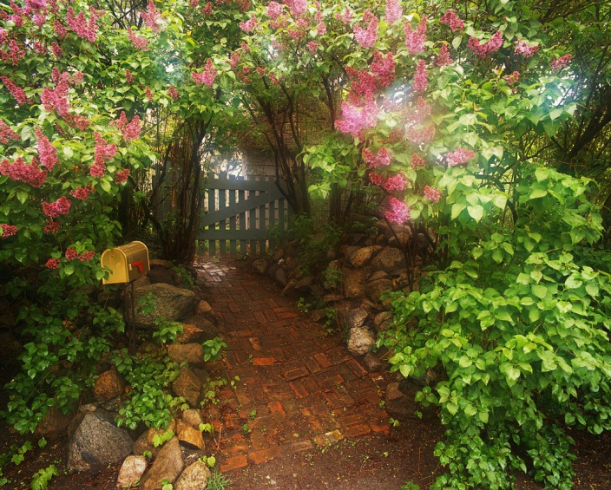

**Saturday July 20th 11.30am – 4pm**

At the home of Bishop John and Mrs Elizabeth Holbrook

**Orchard Acre 11 North St Mears Ashby NN6 0DW**

and in Mears Ashby Church

(*Parking is in the lane between the church and North St on* ***one*** *side of the road)*

**Please bring your cross and toggles**

|  |  |
| --- | --- |
| **11.30 – 12 noon**  **12 noon-1pm**  **1.30 - 2pm**  **2.30 -3pm** | **Welcome - Tea and Coffee**  **Bring and Share Lunch in house or garden (subject to weather!)**  **Group Reunion**  **Short walk up the lane to Mears Ashby Church for Witness Talk and Response**  **Eucharist with Bishop John Holbrook as celebrant** |

**Please RSVP to Cheryl Goddard, whether you can come or not**

**email:** [**cheryl.cfgbusiness@googlemail.com**](mailto:cheryl.cfgbusiness@googlemail.com)

**phone: 01933 392696 by July 13th**

6

|  |  |
| --- | --- |
| http://btckstorage.blob.core.windows.net/site7771/EDWINA.JPG  **Edwina Miller** | **Lay Director’s News Letter Easter 2013**  **Dear Cursillistas**  Carrying on our theme of light, I am sitting in the conservatory whilst working on the laptop, my main computer has become so slow that it takes forever to do anything! But this is a treat as it is so nice to have the summer warmth and light at last.  This past weekend has been full of the Holy Spirit. I so much enjoyed meeting our fellow Cursillistas at the Regional Ultreya held by Ely Cursillo. |

|  |  |
| --- | --- |
| Following a sharing and lunch there were about eighty of us who joined Bishop Stephen in the Lady Chapel for a wonderful uplifting Eucharist. In his address, Bishop Stephen reminded us that we were there by God’s grace through his son Jesus Christ, the light to the world.  He also said that as friends of Jesus we join the unending stream of Christians working towards God’s purpose. The Bishop said that we can be “drips for God”.  On Sunday our church of St Botolph, Longthorpe, celebrated 750 years of worship and praise on the site of our church. Bishop Donald reminded us that although history was very important, and celebrations of this kind were biblical (in Israel multiples of 7 years were important as 7x7made 49 and the 50th year would be one of celebration, when all slaves and bonded were freed) Christians should remember the past but live in the now and look to the future. The Christian faith he said is a lifelong journey.  In Cursillo we are ever changing and moving, in our faith and discipleship. Your secretariat has changed its membership this year as we say thank you to Liz for her role as BACC rep, and welcome to Judith Willis who takes up this post. Ian stands down as Post weekend and Ultreya organiser and David Best steps into the breach, thank you both. I too am overdue in standing down as your Lay Director and pray that another will come forward along with a secretary. | ***Liz Medlock displays our Peterborough Cursillo Banner with pride…*** |

Bill and Pat Rout longstanding Cursillistas and founder members are planning to move to Norwich and will be sadly missed. They have been Weekend rep, Palanca rep and the ones who produce the cross and toggles for the pilgrims for each weekend. They have kept in these roles for much longer than the stipulated three years, and I thank them for the invaluable contribution they have made to Peterborough Cursillo. These roles will need to be filled, so if you have some spare moments to give to Cursillo please do get in touch with me via our communication team or by phone 01733 222539. It is only right that we should move forward and change. If we really do believe in Christ light of the world, then we need to examine our own beliefs which in turn allows new thoughts, expressions and talents to influence our Cursillo leadership, only then can we continue to grow both individually and as a movement, and bring others further on in their faith.

As we start to bask in the light of summer I look forward to seeing as many of you as can make it to our summer event. In the meantime may the force be with you

Ultreya!

Love and prayers **Edwina**

|  |  |  |
| --- | --- | --- |
| **What Cursillo Means To Me…**   |  |  | | --- | --- | | crop-at-mums | Cursillo has given me the opportunity to make good Christian friends I would not otherwise have met, both in my own Diocese and more widely. The mix of Churches and churchmanship has been a delight, allowing me to dip my toes into waters I may not otherwise have experienced. How amazing that each weekend, with the same list of basic ingredients, produces something so different every time. I have been very blessed in the ways I have been invited to serve Cursillo since I was a guest on Coventry #1 in 1991.  This is my first time as Lay Rector’s Gopher, and I feel very privileged to have been asked to support Gilly.  **Brenda Reeves**  **Staff Member Peterborough #7** | |

**7 If you did not manage to get the following poster up in your own church, there’s still time…**

|  |  |  |
| --- | --- | --- |
| http://btckstorage.blob.core.windows.net/site7771/Header/CURSILLO.jpg | **Peterborough Anglican** | Description: http://www.peterborough-diocese.org.uk/images/common/diocrest.gif |

Cursillo **empowers Christian growth**

through

**prayer, study and action**

and enables us to

**share God’s love**

with everyone…

**Annual Weekend Retreats are held. A Cursillo member can invite a Pilgrim to attend.**

**PETERBOROUGH #7**

*Thursday 17 October – Sunday 20* October 2013

at

Launde Abbey Diocesan Retreat House

Thursday 16 October 2014 – Sunday 19 October 2014 at Launde Abbey

For more information please go to:

[**www.peterborough-cursillo.btck.co.uk**](http://www.peterborough-cursillo.btck.co.uk)

Or email:

[**pbcursillo@gmail.com**](mailto:pbcursillo@gmail.com)

|  |  |
| --- | --- |
| Your Local Contact: | Your National Contact:  [**www.anglicancursillo.co.uk**](http://www.anglicancursillo.co.uk) |

**Registered Charity No: 1119601**

**You can highlight this page, click on it, and then print it out for use in your parish church 8**

|  |  |
| --- | --- |
| g.jpg | **What Cursillo Means To Me**  I made my Cursillo when I attended Peterborough #3 at Offa House with Cheryl Goddard our treasurer on the Secretariat and OLR (Peterborough #8).  We have since become firm friends. Cursillo is a very important “Joy”. Its discipline has encouraged me to keep a balance between times with spent with God, trying to serve Him practically and exploring Faith in study.  It has brought such fun and fellowship both through regular group reunion and at various Ultreyas. Since Peterborough #6 last year when I received the Lay Rector’s Cross from Bishop John, I find myself enjoying the role of Lay Rector immensely. My job is to coordinate our staff team of some thirteen Cursillistas for Peterborough #7 together with three, yes three, experienced and supportive SA’s.  It is a real privilege. Please support us by using the monthly prayer for Peterborough #7 which can be now be found our Peterborough Cursillo website.  **Gilly Beardmore**  **Lay Rector Peterborough #7** |

**NEWS**

(For the latest news from the [The British Anglican Cursillo Council](http://www.google.co.uk/url?sa=t&rct=j&q=bacc%20cursillo&source=web&cd=1&cad=rja&sqi=2&ved=0CC4QFjAA&url=http%3A%2F%2Fwww.anglicancursillo.co.uk%2F&ei=i1_MUY2rL-iw7Abdv4DgBA&usg=AFQjCNHT4ukHJtf1yjtXoDQktqXl4oF_aQ&bvm=bv.48340889,d.d2k) please go to their website at: **www.anglicancursillo.co.uk)**

***There are still some places*** available for the “UK Pilgrimage” taking place at Durham in August. Please visit the Cursillo National website for more information.

***An opportunity to carry the Peterborough Cursillo banner*** at the National Ultreya!

Come and join us and meet up with your fellow Cursillistas from afar, at the National Ultreya in Wakefield on Saturday September 7th 2013. It is a great day with the privilege of carrying our banner, an opportunity not to be missed!

**Cursillo #7**

Numbers are beginning to grow for Cursillo #7 weekend, but we still have places available.

There is information online at the website if you require it or if you need any help or advice on sponsoring someone please email us here at [**pbcursillo@gmail.com**](mailto:pbcursillo@gmail.com) and we can send you leaflets by return.

|  |  |  |
| --- | --- | --- |
| |  |  | | --- | --- | | [Sue Morris](https://www.facebook.com/sue.morris.90038) | **What Cursillo Means To Me**  I think that Cursillo speaks to me of family, of support and of love. This has been a journey for me from bemusement at being invited on a "Cursillo Weekend" to something that is now an integral part of my life. Church is great and I couldn't do without that either but Cursillo has more of the flavour of a band of pilgrims on a lifelong, life giving journey.  Practically, there is always instant prayer support via the closed Facebook page but it is as much, if not more, about giving support as well. Local reunions help with this too. Cursillo is also very balanced with an emphasis on study, piety (spirituality) and action. |   This helps to keep me grounded and helps me to take steps to make sure that my life reflects my faith. My picture shows my granddaughter Aphra. She is a total answer to prayer. We have seen many prayers miraculously answered in Cursillo and we have seen our trust in God grow through this and in the prayers that he has chosen to answer differently than we might have hoped. So, if someone asks you to go on a Cursillo weekend I highly recommend it. It is a highly life affirming experience.  **Sue Morris**  **Staff Member Peterborough #7** |

|  |
| --- |
| **9**  ***The BACC have developed this response to the “RULE of LIFE” cards that are handed out at the end of each Cursillo. It can be downloaded from our website:*** [**www.peterborough-cursillo.btck.co.uk**](http://www.peterborough-cursillo.btck.co.uk)  ***If you require a new green card, they are available from the BACC website, or contact us at*** [**pbcursillo@gmail.com**](mailto:pbcursillo@gmail.com) ***and we can arrange it for you.***  **SUGGESTIONS ON DEVELOPING AND USING ‘A RULE OF LIFE’**  **Why have a personal Rule of Life?** • To give you something to aim at and measure yourself against. • To help you achieve a balanced Christian life of piety, study and apostolic action. • To help you be realistic about what you can and should be doing as a disciple of Christ.  • To help you be specific about living out your Christian discipleship. • To help you avoid complacency and to grow in Christian life in grace.  **What are the ingredients of a Rule of Life?** • A series of realistic, but challenging, specific commitments, freely entered into after proper consideration.  • At least one specific commitment under each of the headings Piety, Study and Apostolic Action. • Something which reflects your need to attend to your own health and well-being, and to nourishing your close relationships. • Each commitment should be as specific as possible: e.g. "Morning Prayer: twenty minutes every day before leaving for work" rather than "Morning Prayer" "An Annual Retreat" rather than "Retreat". "Use Daily Light Bible reading notes each day" rather than `Bible reading".  **How Do I use the "My Rule of Life" Card?** • To give you ideas of the kinds of things you might want to include in the various categories.  • Make a brief note of your commitments by writing in the spaces provided for each section. • Write your name and the date you filled in the card as a reminder that this is your personal Rule of Life entered into at a particular point in your life. • Obtain a new card when you feel it is time to change your Rule of Life in a significant way.  **How do I begin to develop a Rule of Life?** • Look through the "MY RULE OF LIFE" card to see the kind of commitments suggested. • Consider what you are already doing, and reflect thoughtfully and prayerfully on whether you should consider: adding some further commitments, or whether you should cut back in some area. • As you develop a set of specific commitments, consider whether they are realistic and appropriate for you and: whether they are challenging you to further growth. • Consult others, such as Christian friends, your Parish Priest or Spiritual Director. • Decide on a set of specific commitments to begin with, and fill in the card as indicated above.  **How do I use my Rule of Life?** • Ask God to help you in keeping the Rule of Life you have entered into. • Look through your Rule of Life regularly, as a way of reminding yourself of your commitments and helping you to assess how far you are living Christian life in grace. • Include your failure to keep some part of your Rule of Life in your prayers of penitence to God.  **How do I continue to develop my Rule of Life?** • From time to time, perhaps once a year, you should reflect with your Spiritual Director on how far your Rule of Life is still appropriate to your way of life and stage of Christian discipleship. • Make a fresh commitment and fill in and date a new "MY RULE OF LIFE" card if appropriate'. |

***(Copyright British Anglican Cursillo| Charity Number: 1119601 ®***

***Council 2003 Cursillo ® Registered at the U.S. Patent Office)***

**10**

|  |
| --- |
| **What Cursillo Means To Me**  **http://btckstorage.blob.core.windows.net/site7771/IMG_4026.JPG**Mentally, and emotionally, making my Cursillo was like being whacked over the head with a sock full of grit wielded by God. And that’s an understatement.  Originally my wife and I were to be together on Peterborough # 5, but our eldest daughter was taken ill with MCAS in the States and Sue had to drop everything and fly out to Seattle; so I was on my own…  I made a lot of good friends at Ely and came away just so effervescent and excited that I could not sleep. I distrust making decisions on an emotional high, so waited a number of days before speaking with my parish priest who pointed me towards an “All Are Called” day being held a few weeks later.  There I met someone who said to me: “When I go into a church, I ask the vicar to point out the irritating members of their congregation – the ones who ask awkward questions and ruffle feathers. I know that those are my potential Lay Evangelists.” I thought: “I’ve come home!”  I applied for Lay Ministry Training and with the strong support of my priest, my Lay Evangelist Warden, and my cursillo sponsor; I am now half way through my Lay Training programme. What does Cursillo mean to me?  It changed my life…  **Colin Suter**  **Staff Member Peterborough #7** |

|  |  |
| --- | --- |
| E147_Logo.jpg | **PRAYER FOR PETERBOROUGH #7 CURSILLO WEEKEND**  Father we thank you for the prayer that has already surrounded the preparation for Peterborough #7. You have sent us ten pilgrims to date and we know that YOU have others to bring to us through the watchful eyes of other Cursillistas.  We now have thirteen staff confirmed. Please pray for those preparing for the first training day in July and their work together over May and June. Please Father bless all those who have come forward to serve the Pilgrims as part of the Peterborough #7 staff team. Give them strength through your Spirit. May it may guide them in fellowship and faith.  Show them Your vision and purpose for Peterborough Cursillo in this changing and needy world.  **Isaiah 6:8**  ***Then I heard the voice of the Lord saying, "Whom shall I send? And who will go for us?" And I said, "Here am I. Send me!"*** |

|  |  |  |
| --- | --- | --- |
| |  |  | | --- | --- | | C:\Users\Colin\Pictures\CHERYL.jpg | **What Cursillo Means To Me** Cursillo has been part of a much bigger journey for me.  In 2005 I was diagnosed with breast cancer, from which I have made a full recovery. This wake-up call put me on a pathway of sorting out outstanding relationship issues, and on sharing this with a college friend she mentioned I should go on Cursillo in 2006.  I looked around but couldn’t find anything on this.  Time went on.  I completed a physical pilgrimage walking 200 miles to Santiago de Compostella in 2007, then attended the Ecumenical SpiDir course in 2009. |   It was during the SpiDir course that my priest suggested I went on Cursillo and my spontaneous answer was yes. I now have a rule for life which gives me a focus for every new day. Have I spent time with God today? Have I shared my faith through action? Have I managed to spiritually feed myself this week? I have a reminder of how short I fall of being God’s disciple…  **Cheryl Goddard**  **Staff Member Peterborough #7** |

**11**

|  |  |  |  |  |  |  |
| --- | --- | --- | --- | --- | --- | --- |
| **Four South Korean Visitors…**  **…and Five Cursillistas!**   |  |  |  | | --- | --- | --- | | On a pleasant June afternoon at the vicarage in Staverton four clergy guests from South Korea and five cursillistas discussed the partnership between the clergy and the laity in this part of the Peterborough Diocese.  The clergy were the Revds. An, Wong, Bang and Yoo together with **John and Sylvia Henley** (who are helping out **Pat Rout** for Peterborough #7).  **Revd. Liz Cowley (Spiritual Advisor Peterborough #7**) and her husband **Dave (our Peterborough # 7 Palanca Gofor)** are part of a group hosting this 2013 exchange with South Korea. Revd. Liz has responsibilities for this. | **C:\Users\Colin\AppData\Local\Microsoft\Windows\Temporary Internet Files\Content.IE5\2G7UE1GG\Korean Visitors 012.JPG** | | | C:\Users\Colin\AppData\Local\Microsoft\Windows\Temporary Internet Files\Content.IE5\8TOQJTHQ\Korean Visitors 010 (1).JPG | | link and together with Dave and a party which included Bishop John had visited Seoul themselves in the spring John and Sylvia Henley are part of a local team who take communion to those at a local hospital, a dementia unit, a care home and to the homes of the housebound. John is currently training to be a Street Pastor. Both will be assisting Pat Rout and her Party team during Peterborough #7. Gilly Beardmore is a member of an Ecumenical Schools Team in Daventry and completing her first year of training as a Licenced Lay Evangelist. She was the fifth cursillsta present.  For two hours and in the capable hands of a very skilled and patient South Korean clergy translator we shared and compared faith in action in two very different parts of the globe. |   You will be pleased to hear that the word “Cursillo” came into our conversation and thanks to Revd. Liz  and Dave it appeared that our guests and already received  colourful Cursillo Leaflets.  ***PLEASE HOLD THIS LINK WITH SOUTH KOREA FIRMLY IN YOUR PRAYERS***  ***Thank you Gilly Beardmore on behalf of the “Five Cursillistas”!*** |

**We can feel that *Adrenalin Rush…***

…as we start to get ready for Peterborough #7. In addition to those who have shared their thoughts, feelings and ideas of *“What Cursillo Meant to Them…”* we must also mention:

**Linda Atkinson**, our Music Gofor, **Pat Rout**, **Mark Ingham,** Table Leader, and Spiritual Advisors: **Canon Karen Jongman,** and **Canon Tony Lynett.**

Please pray for all those who are already (and have been for quite a while) making preparations for the Cursillo Weekend on October 17 through to October 20.

God Bless You.

And Have a Great Summer!

**12**

**STOP PRESS!**

**This issue had just gone to bed when photographs arrived of Rev. Paula York becoming ordained at Peterborough Cathedral.**

**Paula is special to us as she helped to found (with Jane Burns) the Peterborough Cursillo Facebook Page, as well as working with Jane on Peterborough # 5.**

***If you have any pictures of a cursillista who has made news, please do not hesitate to contact us and we can load them up onto your website***

|  |  |
| --- | --- |
| **C:\Users\Colin\Pictures\PAULA\IMG_1496.JPG** | **C:\Users\Colin\Pictures\PAULA\IMG_1503.JPG** |

**Taken straight after her ordination, the picture on the right shows Paula with five of the All Saints, Earls Barton Lay Pastoral Ministers, who are part of her team…**

**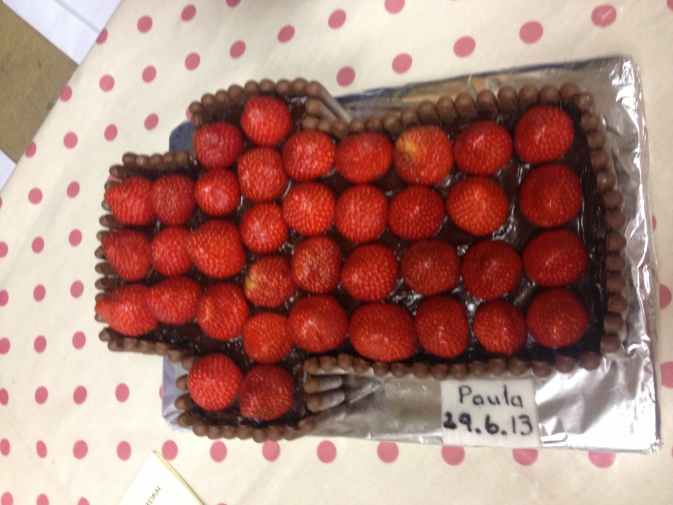**

**…and a Cross-shaped Strawberry Chocolate Cake baked in her honour after her first Eucharist.**