|  |  |  |
| --- | --- | --- |
|  | **SPRING ISSUE 2014**  **Your**  **Peterborough Pilgrim** |  |

***Featuring…***

**The New Peterborough**

**Anglican Cursillo Logo!**

****

**PLUS!**

**News of the AGM…Hello Jane!**

**Thank You and Farewell Eddie…**

|  |  |  |
| --- | --- | --- |
|  | **New Group Reunion Card**  **New Clothing…** | Description: Description: http://www.peterborough-diocese.org.uk/logo/rgb_vertical_main.jpg |

**For Every Season, Turn! Turn! Turn!**

**Ah me! You are all probably far too young to remember the hit “Turn! Turn! Turn! It is a song that was written by** [**Pete Seeger**](http://en.wikipedia.org/wiki/Pete_Seeger) **in the late 1950s and became a major hit in the 1960s for The Byrds.**

**The lyrics, except for the title which is repeated throughout the song, and the final verse of the song, are adapted word-for-word from Chapter 3 of the** [**Book of Ecclesiastes**](http://en.wikipedia.org/wiki/Ecclesiastes)**.**

**If you want to hear it now, paste this into your internet search box:**

[**http://youtu.be/v9ZAEXoXNTQ**](http://youtu.be/v9ZAEXoXNTQ)**.**

***To Everything (Turn, Turn, Turn)  
There is a season (Turn, Turn, Turn)  
And a time to every purpose, under Heaven…***

**It is a time to say “Goodbye!” to old friends Eddie (and Liz!) who have done so much in steering the Peterborough Anglican Cursillo and keeping it on course.**

**The past few years have been tremendous in firming up our foundations, training up new people, and developing plans for the future.**

**And now it is time to welcome the newly elected Jane Burns as our Lay Director.**

**I have a soft spot for Jane as she was the one who ran the weekend on which I made my cursillo (and who can ever forget their Cursillo Weekend?).**

**In fact, as the gloom and misery of our winter departs, I personally feel an uplifting excitement for the future of The Peterborough Anglican Cursillo. We have some new folk on the Secretariat. We have some new ideas for supporting the weekends. We even have a new logo to place on our letter headings and our clothing!**

**Later in this online magazine, we have details of how to order the new tops. There are hoodies and sweatshirts for the cold and cooler weather and some very smartly cut polo shirts (Men’s and Lady’s) to wear when it’s warmer.**

**Watch out for us at the Summer Ultreya!**

**There is a wide range of colours and sizes and the quality is good too - manufactured for us by Fruit of the Loom.**

**The logo is a great conversation piece. Wearing it at a church event only the other day, I was asked “Oh, Cursillo? What is it?”**

**‘Funny you should ask me that…’ I replied, and there I was talking about it freely and easily.**

**Also in this issue is a copy of the new Group Reunion Card from the BACC.**

****

**You can download our copy from this magazine, it will shortly be on our website, or you can visit the British Anglican Cursillo Council at:** [**www.anglicancursillo.co.uk**](http://www.anglicancursillo.co.uk)

**and download it from there.**

**I recently visited their website and ordered a hundred Anglican Cursillo A5 sized posters for display in churches. You can see a copy of it on page 13.**

**If you’d like one for your church, please contact us and we’ll get one to you:** [**pbcursillo@gmail.com**](mailto:pbcursillo@gmail.com)**.**

**In addition, we have the new Sponsorship forms available. These will be sent to you separately in a few days.**

**Hey! It’s all happening!**

**Yes! I really think that from those solid foundations we are going to start growing and growing…**

**We all feel that there is something in the air – a confidence… a certainty…**

**As the man said in the first Talkie:**

**“You Ain’t Seen Nuthin’ Yet!**

***TURN! TURN! TURN!***

**The Comm Squad**

**1**

**Jane Writes…**

**Dear Friends**

****

**It’s a real privilege to follow in Eddie’s footsteps as your Lay Director and, as Colin mentions elsewhere, there are indeed firm foundations to build on.**

**Peterborough Cursillo is still relatively new in this diocese and I am only the third Lay Director.**

**I am conscious of the responsibility that comes with such a role and I am acutely aware that we are better as the sum of our parts rather than as individuals. Whatever we are able to achieve over the next few years will be because of what we do together as well as what we may do individually and I am really looking forward to working with the secretariat and with any of you who may feel called to be more involved.**

**After only 24 hours in post I was able to attend a Deanery Chapter and talk to the Clergy there about Cursillo from a lay perspective and I was heartened by the fact that it was warmly received. This highlighted for me some of the challenges that we have in engaging and educating people, particularly clergy, about the value of Cursillo and how it can be a real catalyst for individuals, church communities and all of us collectively as the Body of Christ.**

**It’s easy to become side tracked into thinking the Weekend is the most important part of what we do when, in fact, it’s what follows that really matters.**

**I would ask that you hold the Clergy Taster Day on the 20th May in your prayers. There is considerable interest in attending from Clergy around the diocese and it’s the first such event that we will have held.**

**I am conscious that I know some of you but by no means all. I would welcome the opportunity to get to know more people in our Cursillo community either individually or collectively so please do feel that you can get in touch.**

|  |  |
| --- | --- |
| **With love and prayers** | **Jane**  **2** |

|  |  |
| --- | --- |
| **Judy’s Jottings**  **Dear Friends** | MC900435246[1] |

**As I write this there are a lot of signs of new life around and about, the gardens and trees are coming alive, blossom and buds abound; we went for a walk this afternoon before supper and there were so many birds singing, it was like a choir proclaiming the wonder of God’s creation.**

**Each season has its own special beauty, and as each one comes along I enjoy nature’s display, yet this year I am reminded that spring has so much promise and hope about it.**

****

**As we travel through Lent, looking towards Passiontide, Holy Week and Easter, I realise again how spring, with the promise of new life emerging from the depth of winter, resonates with the Christian belief that out of death new life will burst out.**

**This is true at so many levels, the bulbs and buds changing daily, the celebration of Jesus’ resurrection after the horror of crucifixion, and the promise that this belief gives us of the possibility of new life emerging out of our troubles. This is God’s promise to us that out of our grief, our struggles, our pain at all sorts of levels, new and life giving possibilities will emerge.**

**Sometimes we can know this in our heads, but actually believing it in our hearts can be more difficult. When we leave a familiar job or situation, and God seems to plunge us into a strange environment that’s unfamiliar and strange, we can be anxious and fearful.**

**When we lose someone we love and rely on, and we are all at sea, it is hard to really believe that things will be good again. Yet that is the message of hope that Easter offers us. It isn’t a quick fix, or a magic pill, we have to live through the winter of loss and hurt, but we can hold onto the Easter hope, trusting that in time the winter will pass and the spring will come.**

**In our Cursillo community we have faced loss in recent months. Long standing and faithful Cursillistas have gone from our Peterborough Cursillo community. The deaths of Deanna Long, Margaret Wren and Jane Simpson have left many sad and grieving.**

|  |  |
| --- | --- |
| **We do, of course, live in the Christian hope that this is not the end for them, though we miss them dearly. We have also said goodbye to Bill and Pat Rout as they move nearer family in Norfolk, and although they are.** | **C:\Users\Colin\AppData\Local\Microsoft\Windows\Temporary Internet Files\Content.IE5\8TOQJTHQ\MC900048041[1].wmf** |

**sorely missed we know they have another Cursillo community to be part of We said goodbye to Eddie and Liz from the secretariat, after many years of faithful and dedicated service. They will continue to be part of our number and I think are already finding God is calling them both onto new horizons.**

**At the same time I think we are in a spring time in Peterborough Cursillo.**

**We welcome Jane Burns as our new Lay Director, and we hope other new folk will step forward to serve. The Clergy Taster Day planned for May will hopefully inspire some of our parish clergy to encourage new pilgrims to make their Cursillo, and to have the opportunity to deepen their faith so that they can bear fruit in their communities. Perhaps you can spend some time praying this Easter about who you might sponsor and support as pilgrims for October at Launde.**

**I pray that as we enjoy the new spring life all around us our faith may be renewed, the Easter experience may empower us and give us hope whatever we are facing.**

***Ultreya!***

**Judy Craig Peck**

**3**

|  |  |
| --- | --- |
| http://btckstorage.blob.core.windows.net/site7771/EDWINA.JPG | **Lay Director’s Report**  **AGM 19th March 2014** |

**Dear Cursillistas**

**This is my fourth Lay Directors report, you may say thank goodness for that! I say what a journey.**

**I was recently on a skiing holiday (with Liz) in the French Alps and we stayed in a catered chalet with fifteen other people - all strangers.**

**On Shrove Tuesday we spoke about pancakes and the next day being Lent, and the significance to us of fasting. It gave others an opportunity to say anything in an easy way. One guy said he was a Scottish Presbyterian; they sat in the dark and grumbled!**

**We all laughed but it did make me think how many times over the last four years that I have done just that in relation to the challenge God had set me in leading your Cursillo.**

**For example: the times of difficulty when putting together the team for the next weekend…**

**Asking folks if they will staff for three years on the secretariat…**

**Urging people to go to the National Ultreya…**

**Doing two jobs instead of one…**

**Each time God has transformed my measly efforts into His success in His way. And sent me those Cursillistas to help and prod me on. Not least of all my partner Liz.**

**Since our last AGM I have started an LPM course, only to find at least four other Cursillistas doing the same. Who says Cursillo does not make a difference!**

**Since our last AGM we have Cheryl Goddard as our very able treasurer. She will be presenting our accounts and asking for your support on the Secretariat’s recommendation, to gift half of the cost of the weekend for staff and pilgrims. It is by no means a small achievement to be able to do this. It is through the generosity of those who regularly give a small amount per month and of generous donations together with the careful stewardship that we your secretariat employs.**

**Our last weekend Peterborough # 7, led by Gilly, welcomed twelve new Pilgrims to Launde Abbey, who are all now in group reunion. As we prepare for Peterborough #8 to be led by Lay Rector Cheryl Goddard, we are in the process of putting together a team of fifteen. The team will attend two training days on Saturday 2nd August 2014 and Saturday 27th September 2014 and of course the weekend is 16th – 19th October 2014 at Launde Abbey. Please keep the dates free in your diary. If you feel now is the time for you to staff for the first time or to staff again after some time please see Cheryl or Jane.**

**A word about sponsorship, do please speak to our Pre-weekend Rep Revd Karen Jongman who will guide you through the forms for both Pilgrim and Sponsor parts.**

**Or send an email to** [**pbcursillo@gmail.com**](mailto:pbcursillo@gmail.com)

**and forms will be sent to you.**

**It is important that sponsors speak to the incumbent of the church where the pilgrim worships before sponsoring and that you are prepared to attend the Clausura and that you invite the pilgrim into group reunion. This can be prior to the weekend also.**

**I am pleased to have on the secretariat Judith Willis who is our BACC rep and will be telling us a bit about the CLW that four of our Cursillistas attended last weekend. David Best is our Ultreya organiser helped in a massive way (cake!) by Danni, his wife.**

**I urge you to take every effort to elect a secretary and weekend representative to this secretariat. It is essential that these roles are shared.**

**Our progress this year has been marked by the compiling and printing of our own song book, and our chalice and pattern donated by Rev Dominic Barrington. Both of these items will be used at our Clergy Taster Day and on weekends and Ultreya.**

**Forging links with other Cursillo dioceses has taken place and Liz and I attended the Regional Ultreya in Ely.**

**The National Ultreya in Wakefield was attended by Liz, June and Judy and the Banner processed on both occasions. 4**

**We have enjoyed the presence of Cursillistas from other diocese serving on our last weekend, whose experience added much to the team.**

**I thank Linda Atkinson, music gofer and Brenda Reeve, LR Gofer.**

**The Ultreya of the year was our summer event hosted by Bishop John and his wife Elizabeth and much enjoyed by over twenty of us.**

**This was shown in photos published in Peterborough Pilgrim. It’s good to look at back copies of our Peterborough Pilgrim to remind us of how much we have to be thanking God for.**

**On a sad note, three Cursillistas have died over this past few months. We have said goodbye to Deanna Long, Margaret Wrenn, and Jane Simpson.**

**Some members have moved away. Pat and Bill Rout (who have been welcomed as part of Norwich Cursillo). They are all missed as their supporting role came from a huge heart for Peterborough Cursillo.**

**Finally may I say that I will be very happy to stand down (in an Eeyore sort of way) and relinquish the reins to the next LD Jane Burns, who will do it her way.**

**It has been a privilege to serve you all, and I thank you all for your prayers and your support.**

**Ultreya**

**Edwina**

|  |
| --- |
| **At the AGM…**  C:\Users\Colin\Pictures\CURSILLOAGMMAR\IMG_2492.JPG  ***…you can always look forwards to cakes made by Danni…***  **C:\Users\Colin\AppData\Local\Microsoft\Windows\Temporary Internet Files\Content.IE5\2G7UE1GG\20140323_114523.jpg**  ***Eddie was presented with a beautiful icon and also with a hand painting of a butterfly*** |

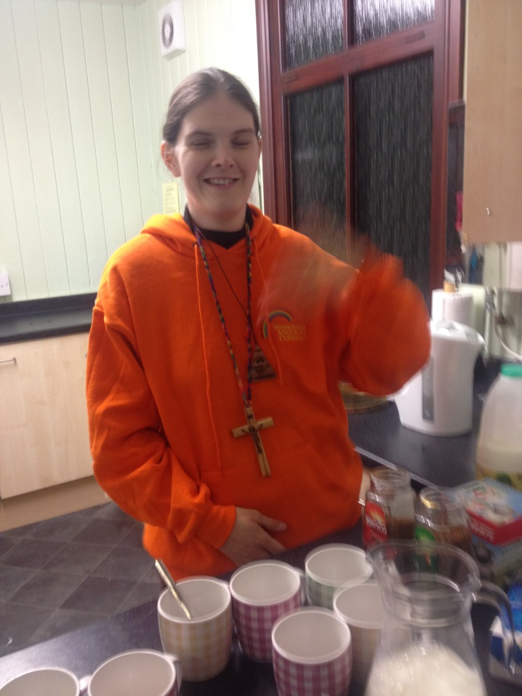

**Danni as ever, in the kitchen… 5**

**The Annual General Meeting**

**APPROVAL OF THE MINUTES OF THE ANNUAL GENERAL MEETING HELD 20TH MARCH 2013**

**The minutes were approved, proposed by E Medlock, seconded by Cheryl Goddard and duly signed as a correct record of the last meeting by Edwina Miller, Lay Director of Peterborough Anglican Cursillo.**

**LAY RECTORS REPORT**

**The Lay Rectors report had already been circulated.**

**Referring to the detail in her report Edwina Miller drew particular attention to:**

* **The arrival of our new treasurer Cheryl Goddard onto the secretariat.**
* **Staffing for the forthcoming Peterborough #8 in October at Launde Abbey.**
* **The proposal to be able to gift half of the cost for both pilgrims and staff.**
* **The role of the sponsor, and to support pilgrims into group reunion.**
* **The new song book, and a chalice and pattern donated by Rev Dominic Barrington.**
* **The vacancies of a secretary and weekend rep on the secretariat.**
* **The summer event hosted by Bishop John and his wife Elizabeth.**
* **The importance of forging links with other diocese.**
* **The sad loss of those cursillistas who have died, Deanna Long, Margaret Wren, Jane Simpson.**
* **Bill and Pat Rout who have moved to Norfolk, and attending Norwich Cursillo, and the thanks we owe them.**

**Treasurers Report**

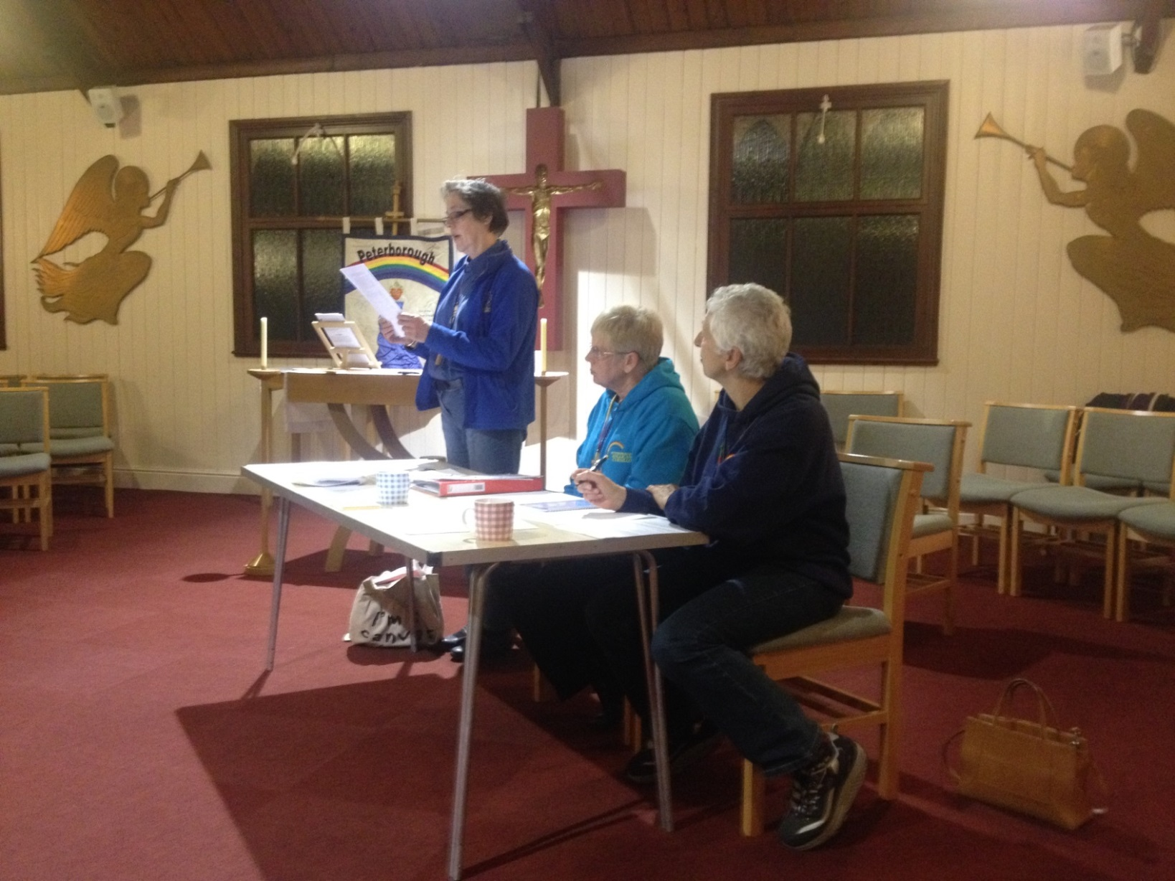

***Cheryl, assiduously listened to by Eddie and Liz***

**Cheryl Goddard provided the Annual Accounts for the year ended 31st December 2013, and thanked Michael Hermann for examining them.**

**The opening balance at the beginning of the year was £6,424.93, closing at £8,087.93.This showed a surplus of £1663, 00, and thanks were given to the regular donors who make this possible. Gift aid had been claimed back from 2009 to 2012, and a total of £1379.22, was received from HMRC in January. 6**

**The annual accounts for the year 1 January 2013 to 31st December 2013 were accepted, approved and signed by the retiring Diocesan Lay Director Edwina Miller.**

**The proposal to gift half the cost for each pilgrim and member of staff on a Cursillo weekend was put forward, also to reduce the deposit from £75 to £50. The pilgrims and staff contribution would be £125.**

**Both of these proposals were passed unanimously by the floor.**

**Fund raising was encouraged to cover the cost of the planned Clergy Taster Day on May 20th 2014.**

**Cheryl thanked all who donate regularly or who hold fund raising events.**

**Covenanting forms and gift aid envelopes were available.**

**Cheryl announced that she would be standing down as Treasurer at the next AGM and asked for someone to come forward to shadow her until then.**

**A vote of thanks was given to Cheryl for her work as treasurer.**

**Communication Rep Report**

**In Colin Suter’s report he highlighted the following points;**

**Thanks were given to Gilly Beardmore and Ann Gowen for their loyal support to ‘The Comm Squad’.**

**There were a number of problems with the website throughout 2013 and Colin would welcome help from anyone with better IT knowledge than himself to develop the website.**

**Face book continues, and thanks given to ‘the Gate Keeper’ Paula York.**

**There are three planned Peterborough Pilgrim issues a year These are to be post AGM, a summer issue and one post the weekend / welcome back Ultreya.**

**A new Peterborough Cursillo logo for paperwork was on display for people’s opinions.**

**Cursillo clothing sporting the new logo was on display and open for orders.**

**Colin encouraged people to write an article for the Pilgrim and to sign up to face book.**

**This is the final year for Colin as Communication Rep, and will be standing down at the next AGM.**

**Spiritual Directors Report**

|  |  |  |
| --- | --- | --- |
| **C:\Users\Colin\Pictures\CURSILLOAGMMAR\IMG_2517.JPG**  ***Judy reports both as Spiritual Director and for the BACC*** | | **Revd Dr Judy Craig Peck spoke of how she had been encouraged by the growth of Cursillo over the past year. She spoke of how more priests are becoming aware of Cursillo in the Peterborough Diocese, of the forthcoming Clergy Taster Day in May, and a Presentation of Cursillo in June at a synod meeting.**  **Revd Judy spoke of the successful peaceful atmosphere at Peterborough #7 and the commitment to fourth day activities.**  **Retiring Lay Rector Edwina Miller and Liz Medlock were thanked by Judy for their dedication and service to Peterborough Cursillo secretariat.**  **BACC REPORT**  **Revd Judy Craig Peck delivered this report as our BACC rep Judith Willis had been unable to attend any of the BACC meetings this year.**  **The following points were highlighted: The BACC AGM in May, the National Ultreya and the BACC council meeting in November had all been represented by Peterborough Cursillo. 7** |
| **C:\Users\Colin\Pictures\CURSILLOAGMMAR\IMG_2522.JPG**  ***Karen Jongman*** | **BACC continued**  **The Cursillo Leaders Workshops which are run by BACC are now led by Paul Thacker since Jan Watts retirement.**  **Sally Henniker-Major is taking over from Lyn Radcliffe as National**  **President at the AGM in May 2014.**  **Pre Weekend Report**  **Karen Jongman stressed the importance of the sponsor’s role, of prayer and of inviting the pilgrim to a group reunion pre the weekend.**  **At this time there are not any pilgrims signed up for Peterborough #8 for October 2014, however there had been interest expressed by a number of Clergy.**  **Secretariat Vacancies and Election of New Officers**  **Jane Burns was elected as Lay Director; proposed by Cheryl Goddard and seconded by Colin Suter.**  **The posts of Secretary and Weekend Rep remain vacant.**  **Any Other Business**  **Danni Best spoke of her experience at a recent Cursillo Leaders Workshop and encouraged sponsors to fulfil their duties of arranging group reunion for their pilgrims.** | |
|  |  | |

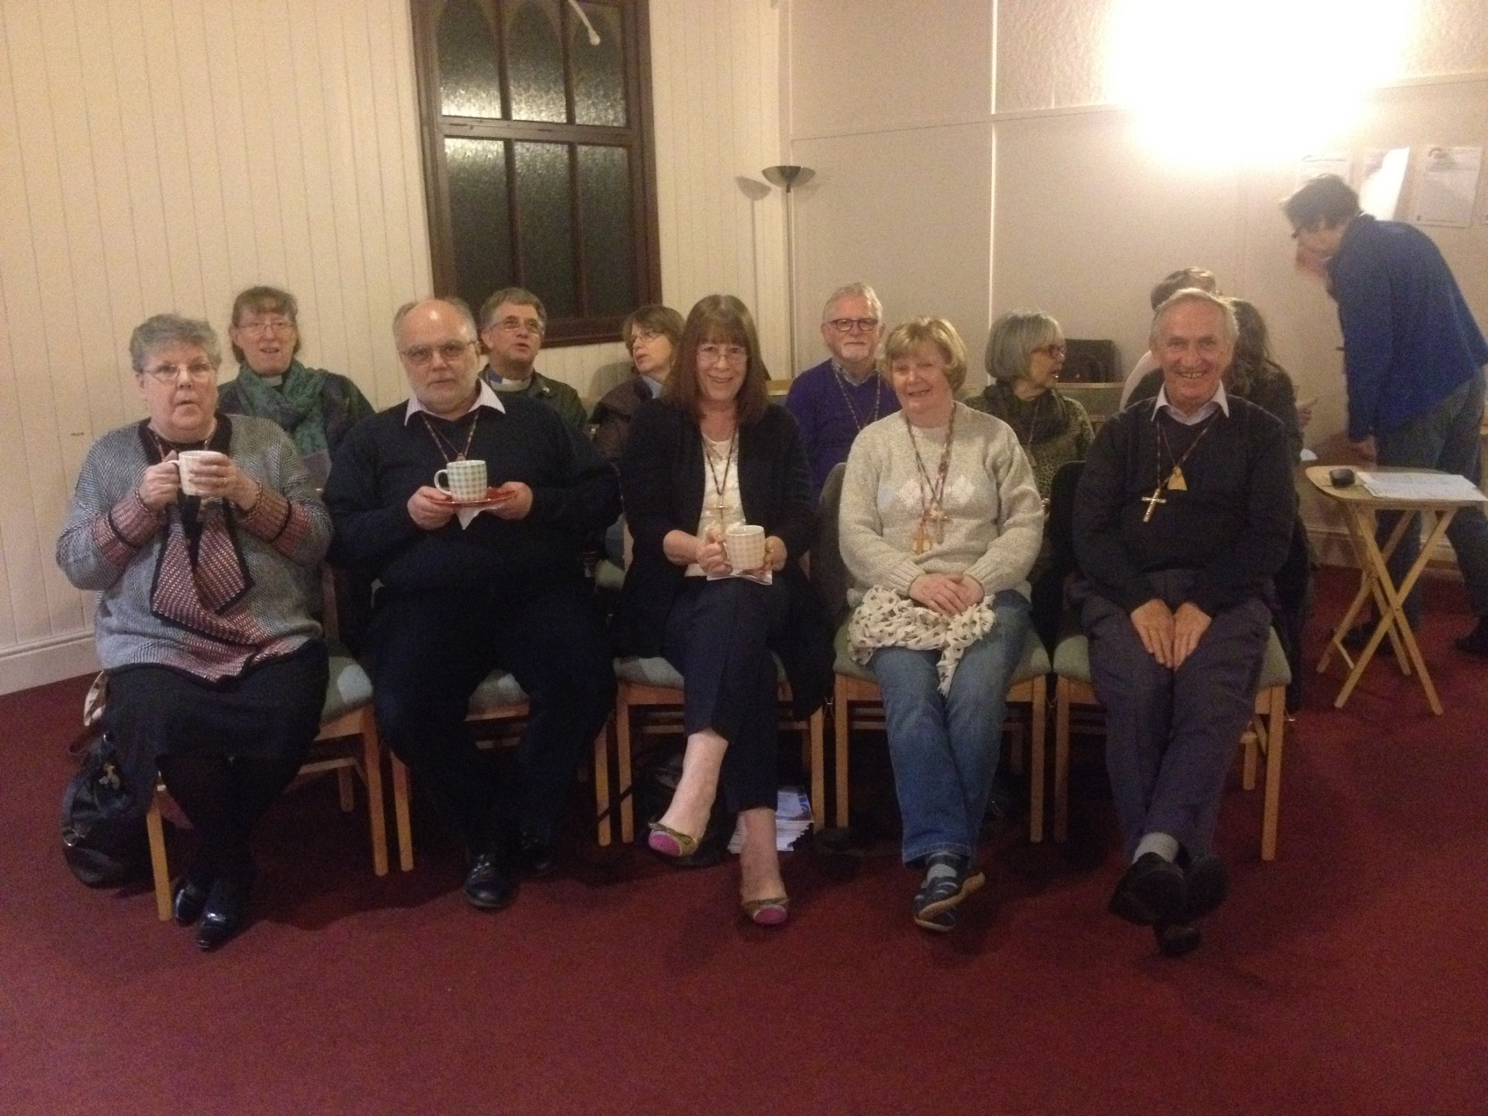

**Always a nice cup of something before we start…**

**8**

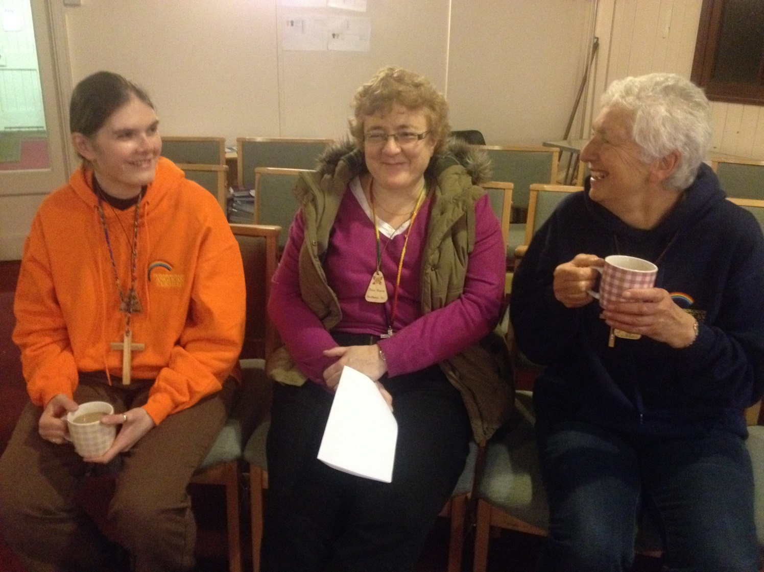

**Danni, Jane and Liz share a smile …**

|  |  |
| --- | --- |
| **Sue, Gill, and Karen, up to something mischevious…**  C:\Users\Colin\Pictures\CURSILLOAGMMAR\IMG_2510.JPG | C:\Users\Colin\Pictures\CURSILLOAGMMAR\IMG_2514.JPG  **I’m just taking a rest before we start to sing…** |

**9**