|  |  |
| --- | --- |
| **Thanks and gifts of flowers, a cheque, an icon and a water colour of a butterfly by Gill Metcalfe were given to retiring Lay Director Edwina Miller and to Liz Medlock for all their work on the secretariat of Peterborough Cursillo…**  ***Judy begins the presentation*…** | C:\Users\Colin\Pictures\CURSILLOAGMMAR\IMG_2535.JPG |

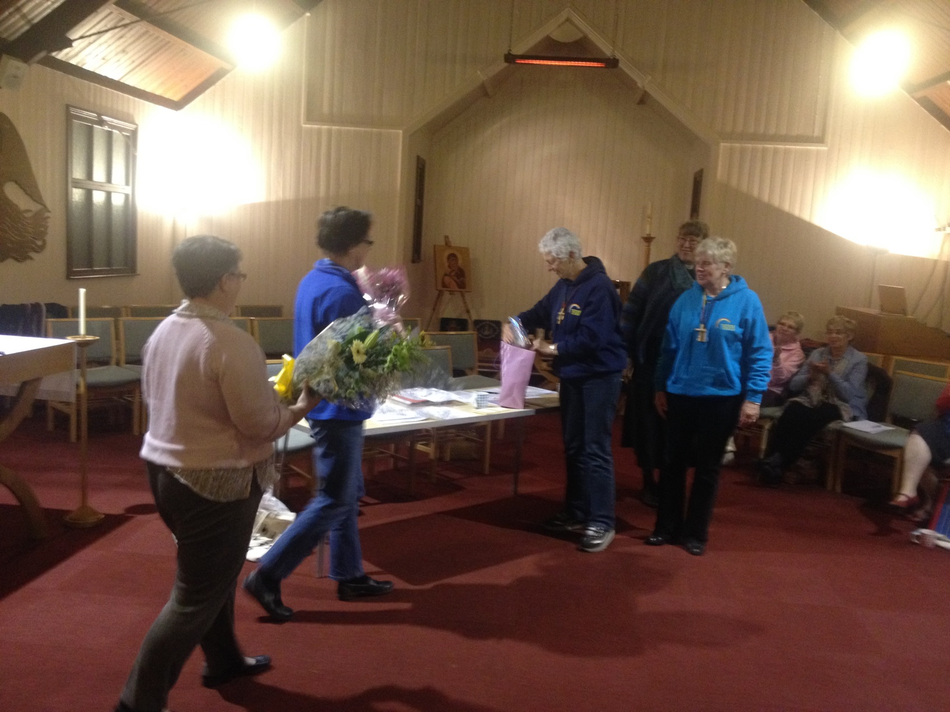

***Flowers arrive as Liz and Eddie wonder what’s in the packaging…***

**10**

|  |  |
| --- | --- |
| C:\Users\Colin\Pictures\CURSILLOAGMMAR\IMG_2558.JPG  ***Overcome with emotion, Eddie says***  ***“Thank you, so much!”*** | C:\Users\Colin\Pictures\CURSILLOAGMMAR\IMG_2573.JPG  ***Liz displays the icon to everyone*** |

|  |  |
| --- | --- |
| C:\Users\Colin\Pictures\CURSILLOAGMMAR\IMG_2580.JPG | C:\Users\Colin\Pictures\CURSILLOAGMMAR\IMG_2581.JPG  ***Left: The Icon on display***  ***Right: The hand-painted Butterfly***… |

**11**

***After the presentations, everyone enjoyed the Ultreya…***

|  |  |
| --- | --- |
| C:\Users\Colin\Pictures\CURSILLOAGMMAR\IMG_2587.JPG  **With music and singing led by the one and only Jonathan Cramer and an excellent Witness Talk from Helen…**  ***The AGM is more than a ‘dry as dust’ committee meeting as some might think.***  ***It is a great opportunity to meet up with other cursillistas and to enjoy and sing praise to God in an Ultreya.***  ***If you have difficulty getting there then please email us, we are sure that we can arrange a lift for you!*** | C:\Users\Colin\Pictures\CURSILLOAGMMAR\IMG_2588.JPG |

***And In Other News Around the Diocese…***

|  |  |
| --- | --- |
| **Group Reunion in Daventry Deanery…**  ***Ann Writes:* Three Cursillistas from Bugbooke, one from Nether Heyford and one from Daventry meet monthly in turn in our houses. We find the regular meetings so refreshing and uplifting and they encourage us in our daily and Christian living.**  **Coming from different churches brings extra meaning to our worship and gives us fresh ideas to enable our Christianity to grow and flourish.** | **Bishop's Bible Day**  **This was a wonderful opportunity to learn more about our faith, all the different activities and an occasion for celebrating our Lord's life and love and meeting fellow Christians.**  **Besides increasing our knowledge and love of Jesus and his people, fun was had by some of us in learning how to play bongo drums, and how we all enjoyed hearing them in the last worship time!**  **The Bishop is proposing to have two if possible in 2015. Please try to make one of the Bible Days next year.** |

**12**

**New A5 Poster from the BACC!**



***We have a number of these A5 posters on glossy paper and in colour for you to display in your church. If you would like one please contact us at:*** [***pbcursillo@gmail.com***](mailto:pbcursillo@gmail.com) ***or write to the same address for the clothing shown at the end of this issue. We can send as many as you’d like to you free!***

**13**

|  |  |
| --- | --- |
| **The BACC NEWSLETTER**  **Dear Friends in Christ,**  **Your BAC Standing Committee met at St. Giles Church in Durham City on 15th February, 2014. Both our CLW Convenor Jan Watts and Secretary Jim Webster were absent due to health problems, and I would be very grateful if you would add these two good people to your prayers for healing.** |  |

**We were joined by Sally Henniker-Major (President Elect) and the five future Area Representatives who will join the Standing Committee after the AGM at High Leigh in May.**

**They are Margaret Tate (N.W. England), Jacqui Johnson (upper Midlands), Alison Askew (Lower Midlands) and Libby Bradshaw (Metropolis). Unfortunately, Roberta Smith (Far South West) was unable to join us.**

**These future members of the BAC Committee came as observers so that they have a clear concept of how BAC operates and the contents of meetings. Please pray for all of those mentioned as they prepare to take up the task of helping Sally and Rev’d Hugh to steer BAC after May 31st.**

**Our programme was very full and after Rev’d Hugh led us in prayer and Floating Group Reunion using the new Group Reunion sheet (which is now available on the National Website), we then followed our Agenda which included:**

**Approving the Minutes of previous Meetings, followed by Reports from our CLW Convenor; Treasurer; Resources, Website and Register leads; as well as my regular update information.**

**A progress report on the National Ultreya to be held in Canterbury Cathedral in 2014, and a progress report on the newly formed Diocese of West Yorkshire and the Dales.**

**Charity Law and the Diocesan Constitutions were also discussed. Rev’d Hugh gave a short presentation on the content of Catch The Vision at High Leigh in May ’14.**

**We then talked about the Health of the BAC movement; Training Days for the future and Links with other Discipleship movements. Having concluded our business, I invited those who had come as observers to give feedback on what they had heard, and this was a helpful process both for them and the BAC Committee. This item was not minuted.**

**We closed with prayer before departing.**

**A note of thanks has been sent to Durham LD, Linda Ross and her team from Durham for providing lovely refreshments for the meeting delegates.**

***Some of the things to take note of arising from our meeting:***

**Remember to book your place soon for the CtV weekend and AGM at High Leigh in Hertfordshire. The forms are on the National Website to download and these should then be sent with your remittance to Julie Robinson-Judd (details on the form).**

***Rev’d Hugh has set up a Facebook page* (Bacc-Nsd) and I am told it is mushrooming even as I write. If you are interested in this, please type in the words in brackets above on Facebook.**

***Look for details of the National Ultreya* on the National Website, it promises to be a special day which is scheduled to end with an option of a Fish and Chip supper and a Ceilidh. Please keep Canterbury Cursillistas and Bishop Trevor Willmott in prayer as they prepare to welcome British Anglican Cursillo in Canterbury Cathedral.**

***The National website* is AN AMAZING SOURCE OF INFORMATION – open to all. Please let Billy Hollis - Webmaster-have the dates of your future Cursillo weekends and notify him of any change in your published contact details. Likewise, do contact him If you want to advertise any Cursillo special events that could be of regional or national interest…**

**If you have any queries about the above, or anything else, please get in touch, I’d love to hear from you.**

**With love and prayers,**

**Lyn**

**Lyn Radcliffe, President of BACC**

**ON THE FOLLOWING PAGE WE HAVE THE NEW GROUP REUNION CARD FROM THE BACC 14**





|  |  |  |  |  |  |  |  |  |  |  |  |
| --- | --- | --- | --- | --- | --- | --- | --- | --- | --- | --- | --- |
| |  |  | | --- | --- | | **Peterborough Anglican Cursillo Clothing with our new logo…** |  | | | | | | | | | | |
|  | | | | Sweatshirt  (No Hood)  Adult Price = £15  Children price = £14 | | |  |  | | --- | --- | | **Adult Colours**  BlackBlack  Bottle GreenBottle Green  BurgundyBurgundy  HeatherHeather  Navy/Deep Navy Navy  RedRed  RoyalRoyal  SkySky  SunflowerSunflower  HeatherWhite | **Children Colours**  BlackBlack  Bottle GreenBottle Green  BurgundyBurgundy  HeatherHeather  Navy/Deep Navy Navy  RedRed  RoyalRoyal  SkySky  SunflowerSunflower  HeatherWhite | | | Adult sizes  Range from  Small – 2XL  Children Sizes Age 3-4 5-6 7-8 9-11 12-13 14-15  Vat is charged on the 14-15 = adult price | |
|  | Hooded  Adult = £16.50  Kids = £13 | |  |  | | --- | --- | | Adult Colours | Children Colours | | | | | | Adult sizes range from Small – 2XL  Children Sizes | | |
|  | | | Men/ Unisex Polo  Price = £13.50  Children price = £10.50  Fruit of the Loom | | |  |  | | --- | --- | | Unisex Colours | Children Colours | | | | | Adult Sizes small – 3XL  Children Sizes age 3-4 5-6 7-8 9-11 12-13  14-15  VAT is charged on the 14-15 = adult price |
|  | | | Lady’s Fit Polo. These have shorter sleeves and the body is more fitted. Please choose sizes carefully.  Price = £13 | | Lady’s Colours | | | | Dress size 8,10,12,14,16,  18 |

**Please make your cheque out to: Peterborough Anglican Cursillo and mail it to:**

**Colin Suter (CURSILLO) 8 Shurville Close Earls Barton Northants NN6 0JB**

|  |  |
| --- | --- |
| ***And remember, you can find us at:*** [www.peterborough-cursillo.btck.co.uk](http://www.peterborough-cursillo.btck.co.uk)  ***Email us at: pbcursillo@gmail.com*** | **[https://encrypted-tbn1.gstatic.com/images?q=tbn:ANd9GcT1BZTsfUZIIu63gMeKe7HjI3HtuFV7QdI6rjP9EPUtZlCr53GOeg](http://www.google.co.uk/imgres?imgurl=http://www.alvaacademy.clacks.sch.uk/images/FacebookLogo.png&imgrefurl=http://www.alvaacademy.clacks.sch.uk/&h=594&w=1788&tbnid=MpGpuTykj1Ip3M:&zoom=1&docid=q3H5bYdE6Tc9bM&ei=4Go9U82SDauI7Aa92IGAAg&tbm=isch&ved=0CMcBEIQcMCI&iact=rc&dur=434&page=2&start=18&ndsp=23)** |