WELCOME BACK ULTREYA ISSUE 2013
Your
Peterborough
Pilgrim

Refreshed, Renewed, Reinvigorated…

Dear Peterborough Cursillistas…

Well, that was a really good Cursillo weekend, with a great group of pilgrims! Was it really three weekends ago? It seems like it was only yesterday…
Thank You…
There are always so many “Thank-you’s” after an event like that and I am sure that we have given out our own personal ones, but a special “Thank you” must go to all of those pilgrims who attended, contributed and enjoyed with all staff their time at Launde Abbey.
Only Connect…
As Pilgrims you received a printout of your own Peterborough Pilgrim and were directed to our website:
www.peterborough-cursillo.btck.co.uk,
Please refer to your 4th Day Rucksack Handout. Our website is generally a good first stop for information about cursillo groups and we are hoping to add more to it as we develop YOUR ideas.
The Peterborough Pilgrim belongs to all interested Cursillistas wanting to share aspects of their 4th Day and anything else of interest. If you have any suggestions, we’d love to hear from you.
From the website you can also click through to the BACC national website too…
Your Peterborough Pilgrim is designed to be read on a computer screen, a hand-held device like an iPad, or even a Smartphone.
If you find that you have difficulty with any of these and would prefer to print a copy out then this whole document is in Word so you should have no problem (although Word does have a reputation for creeping all over the page when emailed, so apologies in advance…) If you prefer a pdf version as that’s a format that some computers can more easily open let us know too.
And if you’d still like to receive news about your Cursillo, but do not have access to a printer we can always mail you a copy.
Finally, if you have your own Facebook page, we have a closed group – available only to cursillistas – which keeps us all up to date at a moment’s notice - just “friend” Peterborough Anglican Cursillo. And a big welcome to those of you who have done so already!
We often place prayers in confidence on there as well as news items. All this is designed to keep 150 cursillista over a wide geographical area in supportive 4th Day fellowship
If you or your Reunion Group, would like to share something with the rest of the cursillistas in this diocese, or if you have any comment to make at all, please drop us an email at: pbcursillo@gmail.com if you head it for a particular person, say, Edwina, or for the Secretariat, your message will be passed on swiftly to the appropriate person.
This means that we have a central email address for all things to do with Peterborough Diocese Cursillo rather than using individuals’ addresses which rapidly get out of date.
An example of sharing news is the report in this issue from Liz and Edwina about their recent visit to Zimbabwe and the work out there sponsored by St Botolph’s, Longthorpe.
Where are the Pictures?
In order to produce this copy as a greeting to Peterborough #7 pilgrims
at the Welcome Back Ultreya
We have not made use of many of the photographs taken during the weekend. These we hope we will be able to share at a later date once we have had time to check with those who wish to maintain their privacy online.
Who Are THE COMM SQUAD Anyway?
The Comm Squad consists of Colin who is the Communications Representative on the Secretariat and who writes this column…
Gilly Beardmore – Lay Rector of Peterborough #7 and Ann Gowen who worked with Christine Hawkins on the St Ignatius table.
Working under the direction of the Secretariat our purpose is to promote good communication between the Secretariat and all the Peterborough Cursillistas within and those who have since moved outside the Diocese.

We are alllooking forward to seeing you at the Welcome Back Ultreya on Wednesday!
Colin

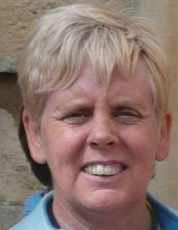  Edwina Miller | Lay Director’s News Letter October 2013  Dear Cursillistas  Have you ever sat on a pebbled beach and tried to imagine how many pebbles there must be just around you? And if you were to pick up a handful, which is what most of us like to do, notice how each pebble is different. Some big some small, some grey and some brown, some broken…
If your thoughts then turn into “well it’s like people really, they are all different, and all have corners knocked off and often become rounded by the tumble of life’s waves”. God made us all different and unique and Jesus made us one in Him. The Gospel we proclaim is about inclusiveness that it’s for everyone, those of all faiths and those of none.
Unlike the pebbles we have a voice and we need to tell others what we have experienced. The Cursillo weekend is one such way that we can help others to grow in faith and witness.
The secretariat (your committee leading Peterborough Cursillo) is planning a Clergy Day on the 20th May 2014, we need the support and backing of you all. Until this time we would like you to tell your clergy about the Cursillo movement and how it can support Parish Church growth, gently suggest your clergy may like to attend the day in May, and pray for its success.
My prayer for you all, those who have just made their Cursillo on Peterborough #7 and those who are
longstanding Cursillistas is that you are strengthened by your Group Reunion and I look forward to seeing you at the Welcome Back Ultreya on 6th November.
Peterborough # 7
YOU are invited to “The Welcome Back Ultreya”
7.30pm on Wednesday 6th November 2013
At St Michael's Church, Garfield Street,
Kettering NN15 7HX
***Floating Group Reunion - Lay Witness Talk - Responses***
There will be light refreshments…
GOD’S MOMENTS AT PETERBOROUGH #7 Launde Abbey Oct 17th -20th 2013
Each Cursillo weekend, as we all know, is unique special and never to be repeated! The tried and tested Cursillo framework within which God places each group of staff and pilgrims provides them with opportunities to share experiences of HIS unconditional love.
As Eddie has remarked, that love is inclusive, recognises and celebrates diversity and represents God’s quiet gentle invitation to hear his call again and draw closer. Here are some of the moments He gave staff and pilgrims at Launde during Peterborough #7…
OF BUTTERFLIES AND LIGHT
On arrival the Cursillista receptionist at Launde was thrilled to report that a butterfly had emerged from a chrysalis in her house that morning. The puzzle took shape piece by piece until we took ownership of it after our hearty Ultreya shout. This change of direction towards home was confirmed by a staff member who reported another butterfly leaving her room on the last day. Many of us witnessed double rainbows and golden sunset clouds as we left Launde.
OF FELLOWSHIP AND WITNESS
Relationships grew over the weekend as we carefully listened to each other and shared experiences of God’s presence of Love in our lives. Many were brave, courageous and poignant and carried an authenticity that touched and blessed us all. Many of us had arrived with health problems but gradually over the weekend needs were addressed and God’s love brought healing sufficient for us to journey together and be renewed.
OF LAUGHTER AND CELEBRATION
Skits, place mats and party tables carefully prepared by diligent unseen staff all provided moments of laughter. But some of us nearly ended up in “deep water” at our photograph call and others went as far as falling off of their chairs. Wake up and reunion with sponsors and the joyful singing that followed lifted each of us towards a new and personal dawn.
OF STILLNESS AND PEACE
This Peterborough #7 Weekend was dedicated to St. Ignatius. His spiritual exercises have taught generations to find God in all things. We certainly discovered Him in the voices at the Stations of the Cross and the accompanying pictures projected on to the altar cloth in the darkness of the Chapel, in the two minutes of silence requested by pilgrims after each talk, the meditations and the glowing faces of Pilgrims at Clausura.
All these moments orchestrated, as we were reminded, by Bishop John at Clausura by Our Great Conductor. God invites us into our 4th day journey travelling together in the rhythm of His strong footfall and no other.
THANKS BE TO GOD FOR HIS PRESENCE IN EACH OF THESE MOMENTS AND MANY OTHERS EXPERIENCED AT CURSILLO WEEKENDS UP AND DOWN THE LAND
Gilly Beardmore Lay Rector Peterborough #7

Two members of the Peterborough Cursillo Secretariat recently travelled to Zimbabwe, Africa.
Here, Liz Medlock shares her thoughts…
Reflections on a Recent Zimbabwe Visit
Eddie and I have returned recently from a visit to Zimbabwe, and our thoughts and prayers have been on sharing the world’s resources.
Our church of St Botolphs Longthorpe, Peterborough, sponsor Sarah and Graham Giles towards their missionary work in the new community of St Peters Mazwi village, the people were moved from their squatter shacks in the bush by the government a year ago, with the promise of some land to build a home. They were housed in tents with bush toilets and a bore hole to collect water.
The newly formed church meet in a tent no longer needed, and from the first meeting with 9 people, it has grown in a year to just over a hundred. They have a sense of God’s presence and It is wonderful to hear the children singing ‘I am special because God loves me’.
During our visit, Graham the church leader along with a member of the New Creation church in Bulawayo, were helping the people to clear the bush land and to plant maize before the rains come in November so that they can provide for their families by growing their own food.
There is though the financial implication of buying the seeds and fertilizer, and also of keeping the poorest families alive with food parcels until the harvest next April.
The churches in Bulawayo pass on any surplus cabbages, spinach etc, to share, and the community itself is taught to look out for each other and share whatever food they have.
We pray that funding will be provided for the desperate situation the people of Mazwi village find themselves in.

God’s Blessing on you all.
Liz Medlock and Eddie Miller
The New Community at St Peters Near Bulawayo Zimbabwe Called Mazwi village.
Graham Giles writes: Nearly a year ago informal settlers (Shack dwellers) from Trenance, Killarney and Esigodine, were moved from their locations to the outskirts of Bulawayo to a place called St Peters. The shack dwellers were moved to this new area. They were provided with a temporary dwelling made of gum poles, plastic sheeting’s for walls and a zinc roof, with the promise of a two roomed house to be built for them.
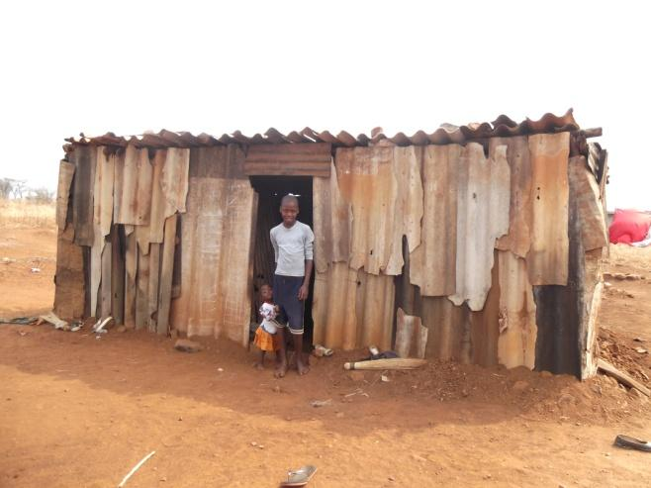 | 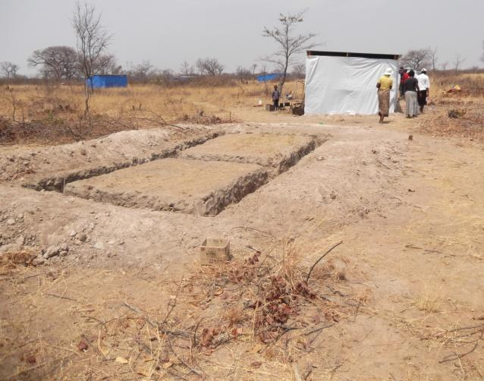
Our initial involvement as a Church was that five of our families and some of our school sponsorship children were amongst those that were moved.
After trying to take them back to Trenance each Sunday we found this to be a logistical nightmare and consequently started our third Thembalezizwe Congregation in Mazwi Village St Peters.
St Peters is an existing community of people with a primary school. Mazwi village is a huge add-on to this existing community. The above photo shows the temporary dwellings with the blue ones in the distance. There are 197 of these dwellings.
Our first Congregational launch was very exciting and right from the start we have experienced God’s presence and power with us. We had nine people at the first meeting.  As everything was still new and a lot of development still had to be done and houses to be constructed, IOM (International organisation for migration) World Vision and the Bulawayo City Council in partnership were spear heading this new development.  This development is 50 Km from where we live in the City of Bulawayo and is past one of the high density areas |  | 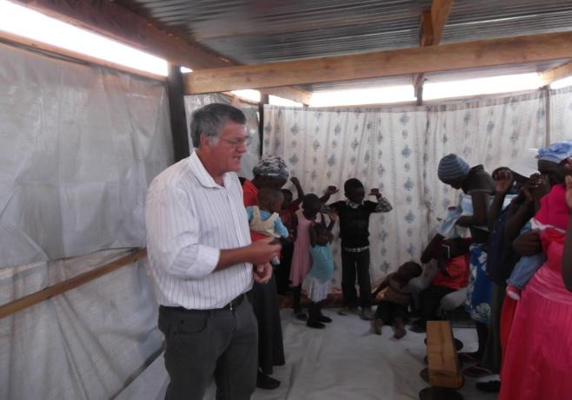
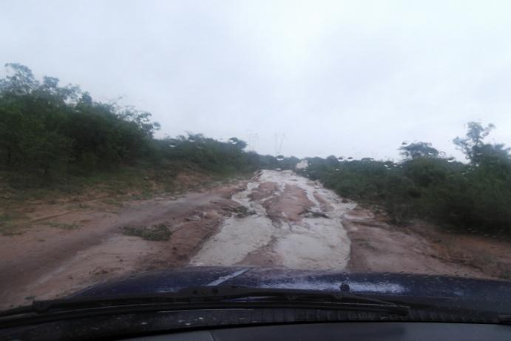 | 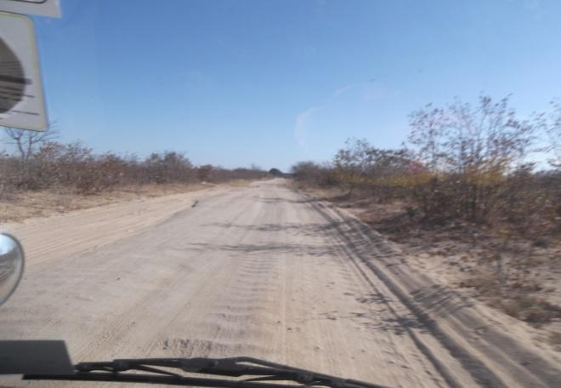
called Pumula, you have to travel a further 8 Km on a dirt road to get there…
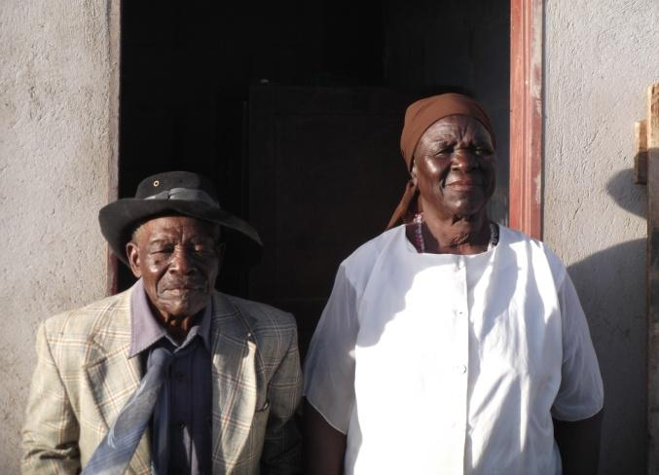 | 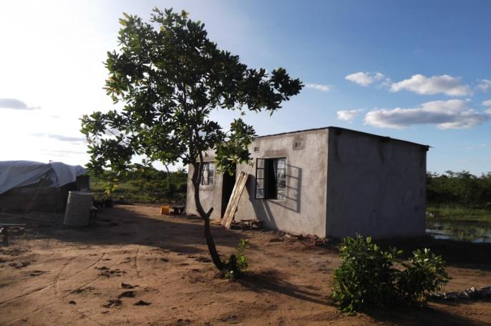
Over the last year we have watched the community develop with the houses being built and we celebrated with thanks giving each time a house was completed for one of our congregation members.  The above Baba (Father) who’s name is Amos is 93 years old and this is his first house.  The three organisations were working with the community people with various programs called food for work, a local building company provided the expertise required and the house inheritors the labour. | 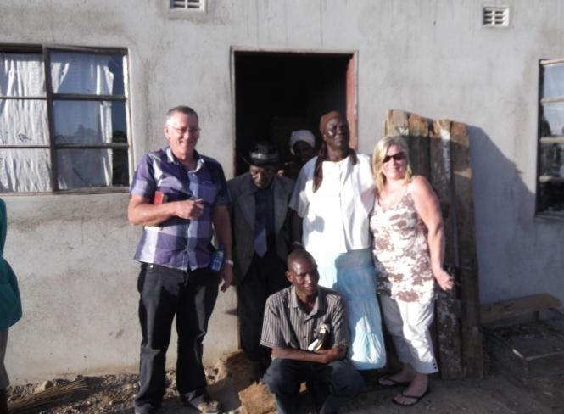
.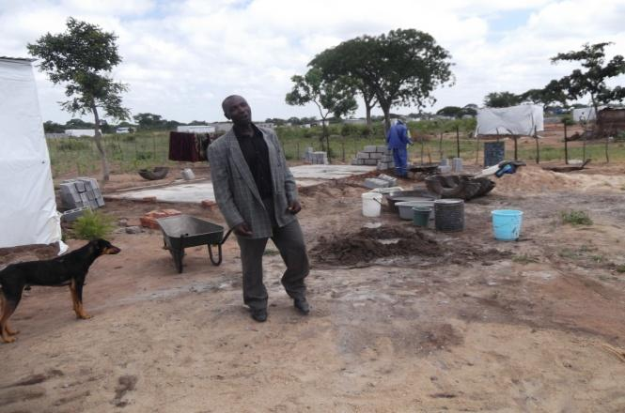 | 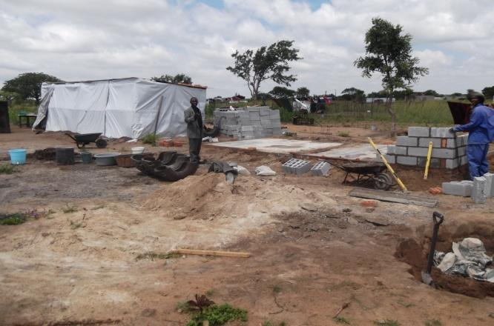
The above two photos are of Mr Ngwenyas house being built, we had our Sunday meetings inside his temporary dwelling - the white tent.
As time went on the Congregation started to grow and so did the children’s work.
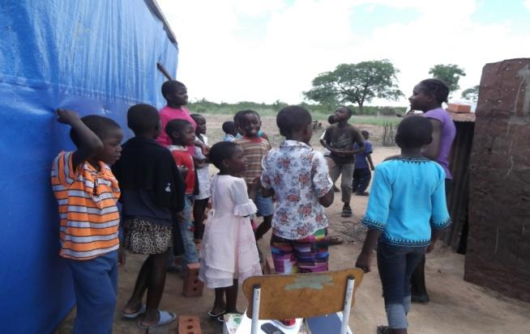 | 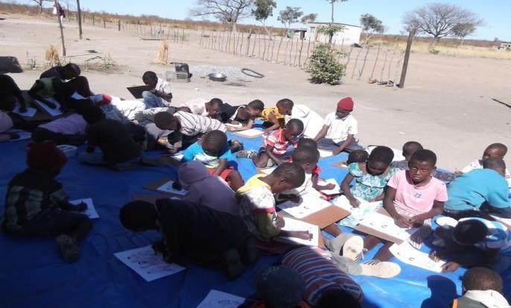
When Mr Ngwenyas house was finished we turned up to a temporary structure for us as a congregation to meet in constructed of the materials left over from the temp dwelling. I was blown away by this man’s generosity, love, care and compassion for the Church.

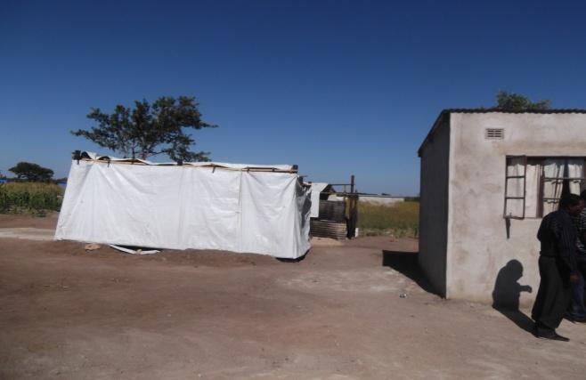 | 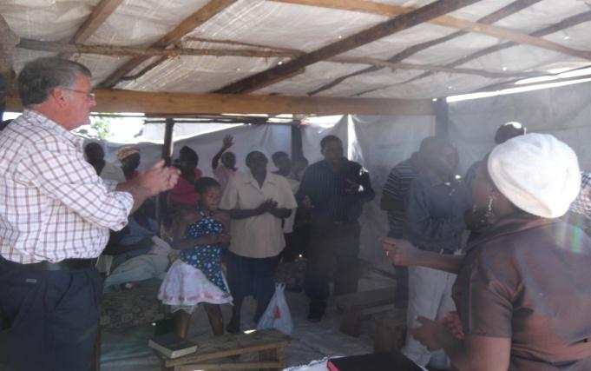
Linda is our kids worker and she used her mums completed house to do Sunday kid work and its tight...
Then came the elections…
and everything stopped in the village…
including the food…
People’s initial joy was hit hard with the reality of life of things not properly sorted out.
They had been moved, given a plot of land, had a house built...
But now it’s completed, what now?
Too far to travel - costs $3 every trip to the city - there is no work no means of income…
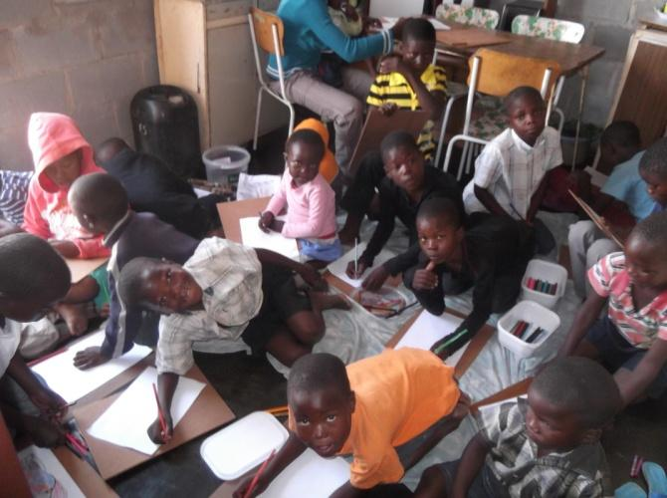 | 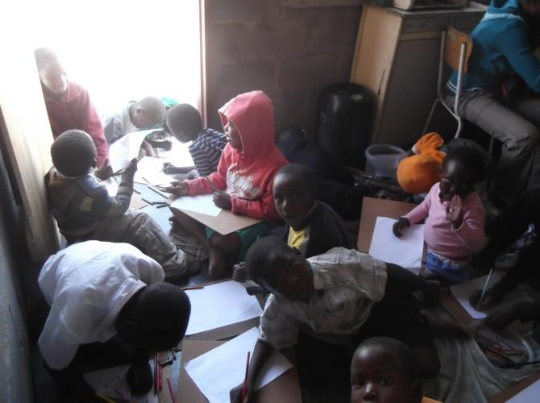
In this time of shortage and hard ship we were able as a congregation to supply food packs per person.
This was due to the generosity of a UK church we know who had given us funds to do three food delivery runs.
This we have done but it ran out at the beginning of this September.
Some personal friends of ours from Cape Town came to our aid to feed our hungry people this month, but alas we are facing the same again.
We are thankful to God for people he has connected us with who have a heart to help and sow into the work here. Our message is ALL IS NOT LOST. IOM is back on Tuesday to try to implement some means of income for some of the residents.
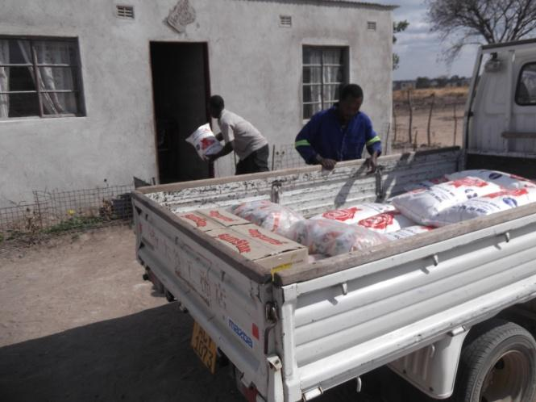 | 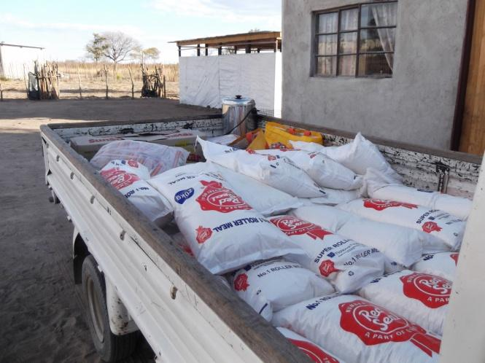
I have been preaching what has God given us in our Hands, each house hold has a piece of land and we are embarking on helping to grow and establish a maize crop for each household for next harvest, the challenges we face to do this are hard but not surmountable, each pack will cost us $ 50 to give all the inputs to grow a crop that will feed a family of six for a whole year.
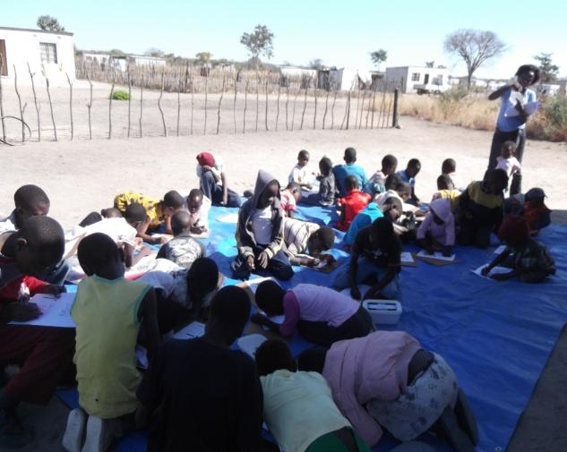 |  | 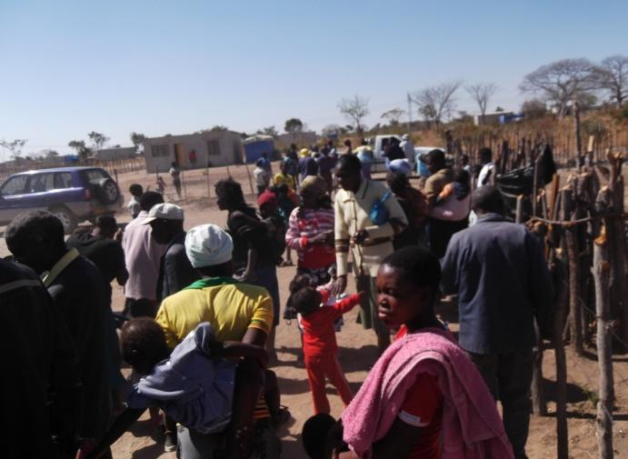
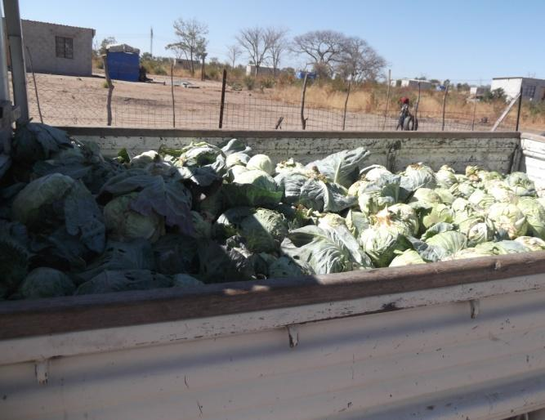 | 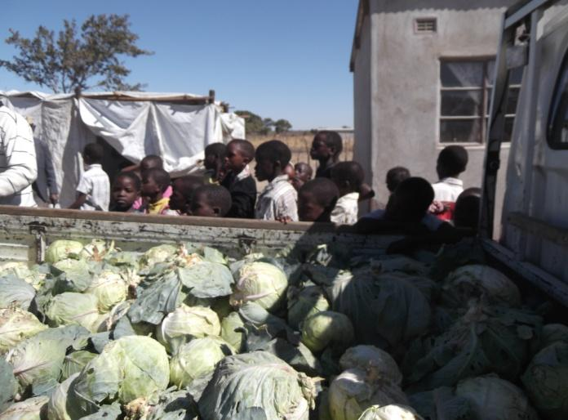
A year ago we started with nine we now have over sixty adults and fifty children, more are coming each week and we have found the Gospel in action is what people are loving. We can feed someone today and its gone tomorrow, at the same time we want to teach people to do foundations for farming and use what God has given them in their hand. We also received a gift from Javia Baptist Church which enabled us to deepen our worship times with African drums.
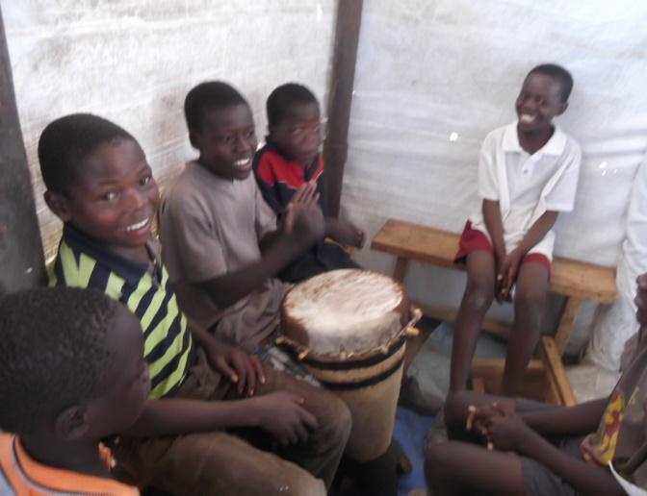 | 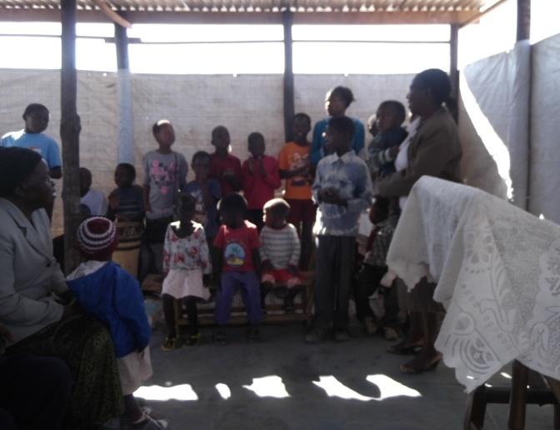
We have been able to extend and widen our meeting place to accommodate 100+.
We need a similar structure to accommodate the kids’ work. We applied for a piece of land to build a community centre where we can have our Sunday services as well as kid work, clinic, pre-school, youth work, demonstration of farming, sport recreation soccer pitch, and everything else God may lead us in to.
Please stand with us as we endeavour to build into the lives of these wonderful people who live in
this community. God Bless you all.
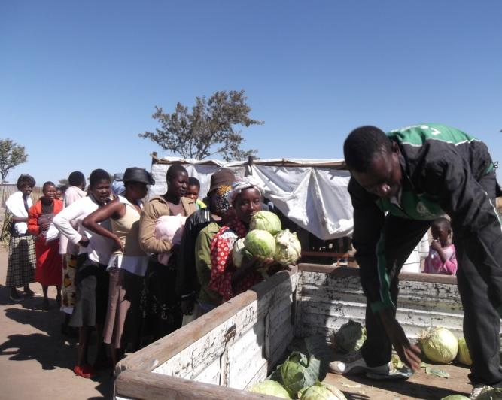
Maize for Mazwi
You can help....
Contact: Graham and Sarah Giles gilesrsf@hotmail.com

conatct
The families in Mazwi Village, St Peters, Bulawayo, Zimbabwe
need help with planting their first crop in this new community.
2 Maize Packs will feed a family of 4 for a year. Each pack costs £20 and consists of seed, fertilizer, measuring cups and top dressing.
We need to help people conserve water. A container to collect this in costs £10.

That’s all for this issue
– Keep in touch.

ULTREYA!

