Our Next Cursillo Weekend will be at Launde Abbey on the weekend of:

**Thursday 14th to Sunday 17th May 2020**

**More Information is available at our website:**

**Peterborough-cursillo.btck.co.uk**

**Or Email:**

**pbcursillo@gmail.com**



**WHAT**

**IS**

**CURSILLO?**

|  |  |
| --- | --- |
| http://btckstorage.blob.core.windows.net/site7771/Header/CURSILLO.jpg |  |

**Peterborough Anglican Cursillo**

**Affiliated to the British Anglican Cursillo Council**

**Registered Charity No: 1119601**

**Cursillo…**

Cursillo® is a powerful renewal movement which supports the mission of the local church.

It only happens in a Diocese at the invitation of the Bishop, and is very much part of the diocesan strategy to enable mission and personal growth in faith and witness.

Bishop John has been on a Cursillo weekend and writes: -

*‘As a way to deepen understanding, strengthen faith and renew our passion for God it was inspiring. Having seen God use it to change lives, I’m pleased to commend Cursillo to the diocese.’*

We asked a few people to describe how Cursillo had influenced them in their Christian journey:-

*‘My life was changed by Cursillo, it enabled me to let God into my life in a way I had never done before and it continues to nurture and sustain me as I journey with Christ.’* Revd. Paula York.

*‘I came away with a far more balanced understanding of the Trinity.  Through this and the love of God given on the weekend my confidence grew rapidly and I have been more active in church.’*

June Vajda

*‘The Cursillo method has given me a rule of life focusing on prayer, study and action and to be out in the world doing good works as Christ’s hands and feet.’*

Cheryl Goddard

*‘Cursillo emphasised to me (1) the importance of a spiritual discipline, (2) that Christians are more effective collectively than alone, and (3) that there is a lot of Christian love going for us all, if we will only allow ourselves to recognise it and absorb it.’*

Revd. Ray Hemingray

‘*The river on the Peterborough Cursillo banner reminds me of the river of God’s grace flowing down through the centuries and on into the future’.*

Edwina Miller (Former Lay Director)

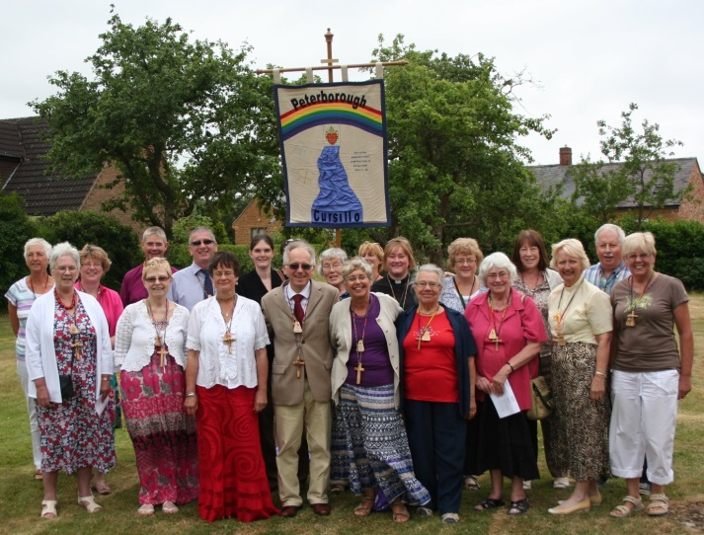

*Celebrating their Summer Event*

‘Cursillo’ is a Spanish word meaning ‘short course’ and the Cursillo experience usually starts with a three day residential led by a team of clergy and lay people.

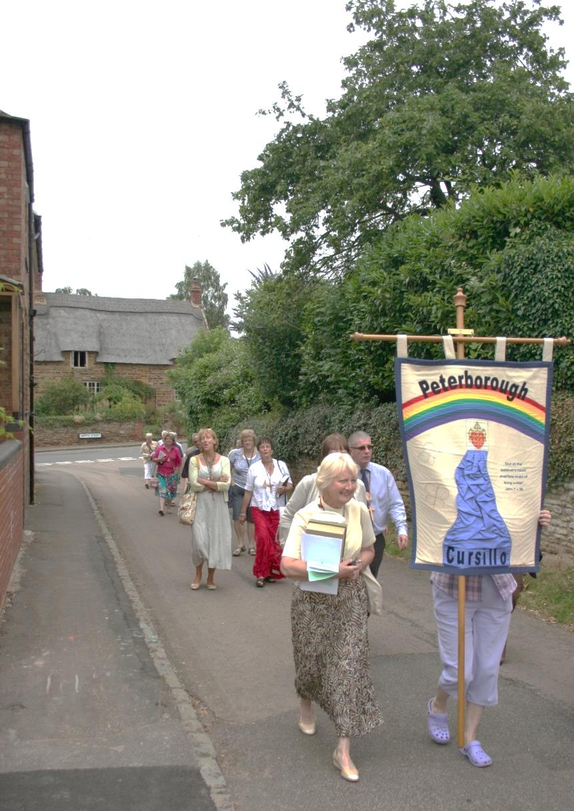

The combination of short talks, many given by lay people, sharing, worship and community life has led many to deep renewal in faith, growth in confidence, and many vocations to lay and ordained ministry as well as supporting and encouraging folk in living out their Christian life day to day.

This is done through meeting regularly with a small group for an hour or so every two or three weeks to share how our lives of prayer, study and action are progressing.