The GB Ultreya at Wakefield Cathedral
On Saturday September 7 2014
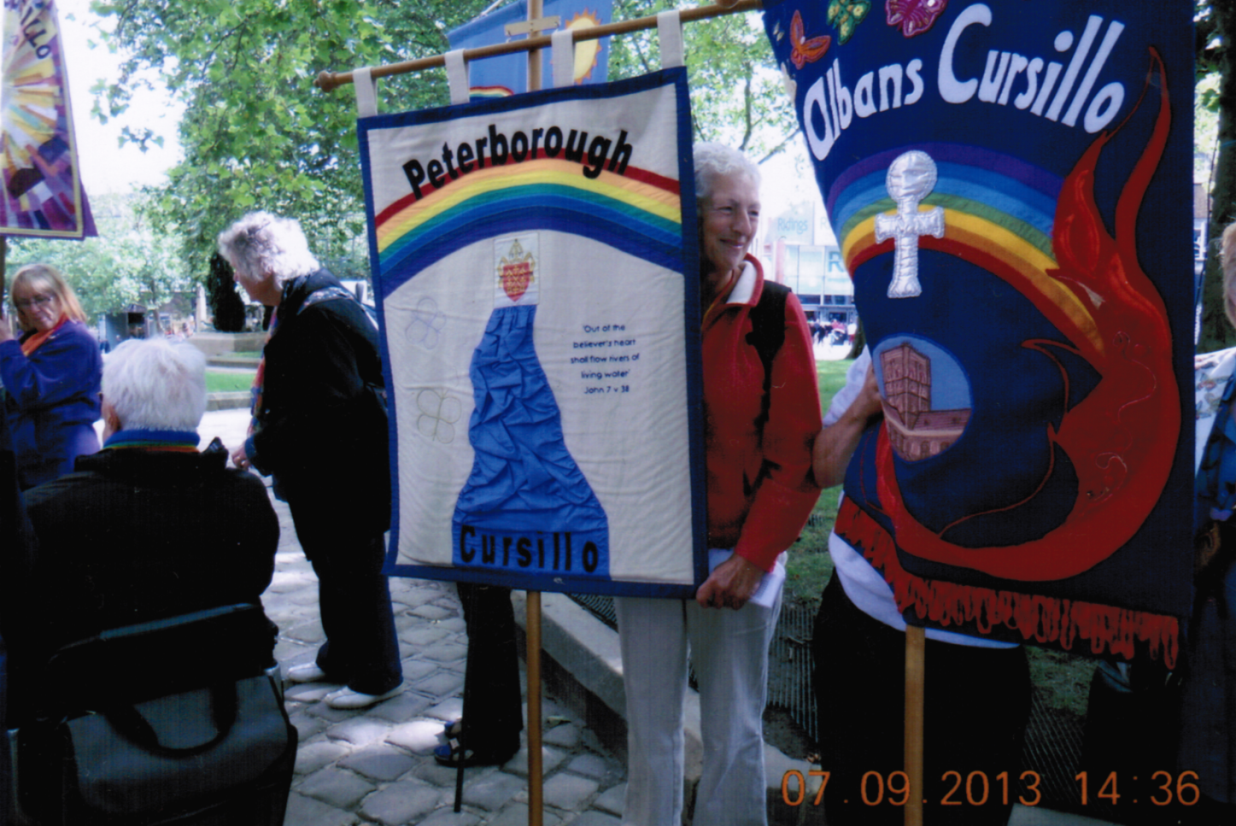
Peterborough Pride…
Liz Medlock writes: A warm welcome was received from Wakefield Anglican Cursillo as Revd. Judy Craig Peck, June Vjada and I, entered Wakefield cathedral. They were hosting the National Ultreya for the third time in their history and on their 21st birthday, in a very newly refurbished cathedral.
On our entrance, we were all presented with a small Wakefield Cross. This represented the head of the Ninth Century Cross shaft discovered on the cathedral site. The cross is the symbol of the 125th Anniversary and regeneration of the diocese.
There was the traditional hearty singing giving praise to our God; group re-union and a witness talk with responses in the morning, followed by a BACC Business talk from Lyn our BACC president.
Lyn informed us that:
Canterbury would be hosting the National Ultreya on Saturday August 30 in 2014
Sally Henniker-Major from the Durham diocese will be the BACC president following the AGM in May 2014.
The new Cursillo Leaders’ Workshop convenor will be Paul Thacker following the AGM in May 2014.
Ann Cullen is retiring from her post as BACC Resources Officer in May, volunteers requested to apply.
There are new metal crosses and chains on sale that will take the place of the wooden ones from America in the future.
These will be approximately £3.50p when purchasing 50 or more.
The AGM and Catch The Vision will take place at High Leigh, Ware, in May 2014.
In the afternoon the Walk of Witness procession of all the diocesan banners, including Peterborough, followed a musical band around the centre of Wakefield to the sounds of ‘Onward Christian Soldiers’. The Eucharist led by the Dean, The Very Revd. Jonathan Greener ended with a rousing ‘Thine be the Glory’ as the banners paraded out in the midst of God’s Love.
Ultreya!
Liz Medlock
Welcome To
Launde Abbey for
Peterborough #7
October 17 - 20

Dear Peterborough Cursillistas…
So, what’s with a Summer Supplement?
Always reminds me of Captain Kirk of the Starship Enterprise intoning: “Captain's log, Stardate 41153.7 Supplemental. Our destination is planet Deneb IV..."
Well, we’ve not launched Eddie and Liz into orbit, not quite – they have just gone off to Zimbabwe, which is exciting enough. We look forward to receiving a report from them (with pictures) later in the year. You see, whilst we were rushing around over the summer, the problem never occurred to us before, but in fact, the Comm Squad are all involved, in one way or another, with Peterborough #7.
Gilly in particular.
So actually finding time to put together the online magazine that you deserve would not be easy…
As we looked at this problem, we also felt that the ideal time to bring out the next, fully fledged issue of your Peterborough Pilgrim is, in fact, at the Fourth Day, in that time betwixt and between the last event of the weekend and the Welcome Back Ultreya.
In this way our new cursillistas can feel part of our movement immediately.
As that will be way back into the late autumn, the summer items would be long forgotten, so hence, this Supplement.
We hope that you enjoy it. The next issue is going to be full of a great deal of exciting news and events, by all accounts. And we promise we will not keep you waiting for that.
Colin - On behalf of The Comm Squad
KEEPING IN TOUCH…
The Peterborough Pilgrim
The Peterborough Pilgrim will continue to come out four times a year, but will be co-ordinated more closely with the Cursillo Weekend (or Weekends) and other events such as the AGM.
This way we can keep you more up to date.
(Please let us know if you happen to run into a fellow cursillista who has not seen the latest Peterborough Pilgrim. We understand that most cursillistas prefer to read it online, but we do mail out copies to those who prefer to read it in that way - but folk move, and no mailing list is ever completely up-to-date…).
The Website
Either type in Peterborough Anglican Cursillo into your search engine, or simply go to: www.peterborough-cursillo.btck.co.uk
The website is updated on a regular basis and the more you use it and send us items and pictures to post on it, the better it becomes.
It will be getting an updated look later next year.
Email Address
You can contact us directly through our email: pbcursillo@gmail.com
This email address is regularly accessed by the Comm Squad so that a message can be easily forwarded to the appropriate person.
The Facebook Page
Set up a Facebook account in the normal way and then look for, or ‘Friend’, Peterborough Cursillo.
It is a Closed Group so that only cursillistas who have been authorised can join, so there will be a short delay after you apply as Paula ensures that you have made your cursillo.
This means that anything posted on our Facebook page is only viewed by other members of Peterborough Anglican Cursillo (please set your security at “Friends”) and so we can pray for particular groups or individuals and still maintain their, and your, privacy.
Facebook is probably the fastest way of getting into contact with other cursillistas from Peterborough Anglican Cursillo as it is used just about every day.

Thank you for reading your Autumn Supplement.
Best Wishes and
ULTREYA!

