PRINCESS CHALLENGE

This Challenge badge is based on fictional characters which have been used in films. The original tales are summarised at the beginning of the section for your information. The challenges have been based on these tales.
The badge can be used as a Princess themed evening, party or sleepover. Or it could be linked with the following - Roundabout the World/World Culture Badge/Culture Badge/International Octant although the other challenges will fit into the Section programmes quite easily.
You can concentrate on one or two of the characters or take challenges from any of them.
It is suggested that Rainbows take part in 4 challenges, Brownies 6, Guides 8, and Senior Section/Adults 10. But this is entirely down to the discretion of the girls and Leaders on how it will fit into your Programme.
We hope you will enjoy taking part and help us fundraise for unit International trips.

Princess Badroulbadour - arabia (better known as Jasmine)

Jasmine is based on the character Princess Badroulbadour from the Arabic folk tale, Aladdin. She was being forced by an age-old law to marry a prince in time for her 16th birthday. She wished to marry someone she loves for who they are even if they are poor. She meets and marries Aladdin.

- Make a list of values that are personal to you. Try and eliminate them until you are left with only one. (Full instructions on website listed in Appendix.)
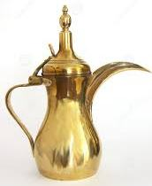
- Make an Arabian pot from plasticine, clay or similar.
- Make Cookies from Coffee Dough (Recipe in Appendix)
- Try Arabian Dancing
- Research Arabian Art and make your own design using pens/sand/icing or similar.
- Write three goals (wishes) for your future.

Pocahontas – Native American Indian

Pocahontas' name means "Little Mischief" or the "Naughty one". She is based on the real historical figure, and was born into a Native American culture. She offers kindness and guidance to those around her and loves adventure and nature. Pocahontas saves Captain John Smith who was captured and sentenced to death when trying to make peace with the Indians.

- Discover some interesting facts about the history and culture of Native American Indians and their tribes.
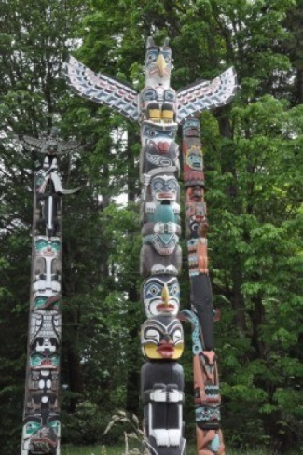
- Go for a walk in a wood, park, garden or similar. Identify 6 different species of plant/tree flowers etc.
- Build a Tepee or a Totem Pole, small or large whichever you want!!
- On your own or with your unit raise money for a charity of your choice.
- Learn what signs are used for tracking. Make up a game using these or lay a track for others to follow. (Shown in Appendix).
- Play a wide game.

Hua Mulan - china (better known as Mulan)

Mulan is based on the legendary Hua Mulan from the ancient Chinese poem - the Ballad of Mulan. She disguises herself as a man in order to become a soldier and join the army instead of her injured father who was being forced to enlist.

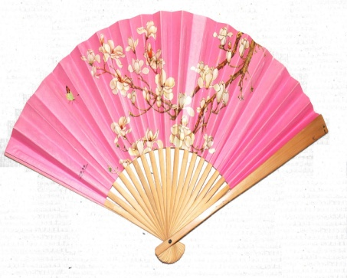
- Make or decorate a fan or lantern.
- Write your name in Chinese Alphabet.
- Try a dish new to you, from a Chinese Restaurant /Takeaway menu.
- Think of something you can do for a member of your family, e.g. write a poem/ letter to them and/or good turn.
- Take part in a game using chopsticks/or learn to eat with them.
- Obtain as much information as you can about a local war hero or a relative who has served in a war e.g. World War I or II and have an evening of Remembrance. Maybe you could dress up in the fashion and eat food from the era.

Belle – France

In the French fairy tale, La Belle et la bête, Belle has to go and live with the Beast following an agreement between the Beast and her father. She accepts lavish presents but refuses to marry him. She eventually returns home and fails to go back after a week as agreed. She had been given a mirror to see what was happening in the castle and a ring to return immediately. She sees via the mirror that the Beast is half dead and returns immediately. Her tears turn the Beast into a prince.

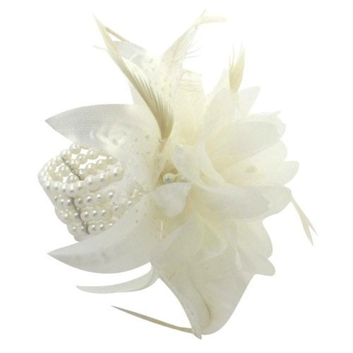
- Make a corsage (flower(s)) which can be pinned on or worn round the wrist.
- Go for a bike ride for a mile or longer or use an exercise bike. Could this become a sponsored event?
- Make crepes (thin pancakes) or buy them, be creative with toppings new to you. Or hold a French patisserie evening. (Bake meringues, croissants, and apple or pear flan for example.)
- Adapt old clothes to create your own Designer outfit or create one using recycled items such as newspaper.
- Make a Stained glass window or try glass painting.
- Try Jewellery making, make an item of your choice.

Rapunzel – Germany
Rapunzel is based on the character of the German fairy tale by The Brothers Grimm. Rapunzel, is born with long, magical golden hair, and is abducted as an infant and raised by Mother Gothel, who keeps her locked in a secluded tower for eighteen years. A prince hears her singing and is keen to meet her. He sees Rapunzel lower her hair to the ground to let her captor enter the tower. He uses the same method to enter the tower and falls in love.

- Have a Sausage tasting evening – compare German with other Countries of your choice. (Aldi and Lidl stock German meats). Alternatively make marzipan. (Web site for Recipe in Appendix.)
- Go climbing on a boulder wall/climbing tower or throw a rope to a high window.
- Have an evening of trying different hairstyles, learn to plait, or maybe invite a hairdresser to your meeting to give you hair care advice.
- Play Jenga or build a tower use your imagination what materials you could use. Challenge each other to build the tallest.
- Have a singing evening – maybe try karaoke or have a camp fire sing song.
- Anyone born 18 years ago would have been born in the 1990’s. Research what the uniform of your section was at that time- what was the programme? Alternatively play music of the era, look at the fashion, and find out what events happened in this decade.

Tiana – American
Tiana is loosely based on Princess Emma, the heroine of E. D. Baker's novel ‘The Frog Princess’, and the princess who appears in The Brothers Grimm fairy tale. Forced to marry her worst enemy, Emma runs away and meets Price Eadric who has been turned into a frog. When she kisses him she too turns into a frog. The couple set off to find the witch who had turned him into a frog to change them back, unfortunately she has disappeared. With the help of her aunt, the Green Witch, they return to their human form. A dog who has accompanied them in their search is returned to the Prince’s horse.

- Hold an American evening. Try Baseball, eat American food etc.
- Make an origami frog.
- Toast marshmallows on a fire or over nightlights and make Smores.
- Play a game which uses your brain e.g. Kim’s Game.
- Visit an Aquarium, or Sea Life centre.
- Try a water based activity new to you such as aqua aerobics, rowing, scuba diving, windsurfing, etc.

sleeping beauty known as princess Aurora- England
Based on the character from ‘The Beauty Sleeping in the Wood’ by Charles Perrault which was adapted by the Brothers Grimm. At the christening of a king and queen's long-wished-for child, seven fairies are invited to be godmothers to the infant princess they offer gifts. However, a fairy that was overlooked shows her anger by placing an enchantment that the princess would prick her hand on a spindle and die. One fairy, who hadn't given her gift, reverses the curse, partially: that the princess would fall into a deep sleep for 100 years and be awoken by a king's son. The King forbids spinning wheels in the Kingdom, but when he and the Queen are away. The Princess finds one in the Palace; she pricks her finger and falls asleep. The Good Fairy puts everyone else asleep and the castle is shielded with a forest. 100 years later a prince from another family enters the castle and kisses the princess who awakes. The couple are married.

- Attend a sleepover.
- Design your own bedroom or your own wallpaper.
- Make a tourism leaflet about your area, to highlight the places to visit. Or, find out about the history of 3 places in your area.
- Learn how to sew, stitch a button on, or try cross stitch. If you can already sew, learn to embroider or how to use a sewing machine. Make a garment or item.
- Learn simple first aid, take the First Aid badge or attend a First Aid course.
- Plant some seeds, or do some gardening for someone else, maybe at your meeting place, a neighbour’s house, or a community centre.

the little mermaid known as ARIEL – Denmark
Based on Hans Christian Andersen's "The Little Mermaid" story. A mermaid lives under water, with her family. When she was 15, she was allowed to rise up to the surface, she sees a ship with a handsome prince, and falls in love with him from a distance. A great storm hits the ship, and the Little Mermaid saves the prince from nearly drowning. He does not see the Mermaid. Longing for the Prince she drinks a potion, becomes a human but becomes dumb in exchange for the potion. They spend time together. However the prince is told to marry by his father. He believes that a princess had rescued him and it is she who he marries breaking the Little Mermaid’s heart. She returns to the sea as a mermaid.

- Go for a swim, learn a new stroke, gain a qualification. E.g. Swimmer badge, Swimming certificate, or a gain a Lifesaver qualification.
- Make up a game which involves water and share it.
- Go for a welly walk in the rain.
- Make a paper cup and drink from it.
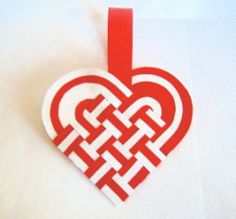
- Make something out of ice. Carve a sculpture or make something like a Smoothie.
- Make a Danish heart (instructions in Appendix)

the princess diaries
In the books written by Meg Calbot, Mia is a normal 14 year old living in New York. The next minute she is the heiress to the throne of Genovia. She has to attend Princess lessons, get a makeover and be allocated a bodyguard. She is unhappy with the situation, however over the years she accepts her new role and realises that she should do her duty to become the ruler of the country. The books follow her progress in becoming the ruler of the country.

- Have a Princess party, dress up as your favourite Princess.
- If you were a ruler of a country, what laws would you make?
- Make up a song, dance or a play about the meaning of your Section Promise and/or Law.
- Have a Relaxation evening, learn how to hand massage, or manicure. Invite someone to help you use make up and to take care of your skin.
- Choose a country where you would like to live. Find out as much information as you can. e.g. what the climate is like, national dress, food. Would you still like to live there? Now plan your journey to get there.
- Take part in a Treasure Hunt.

Help if you require it

Coffee Dough
4 cups plain flour
1 cup Salt
¼ cup Instant coffee
1 ½ cup Warm water

1. Dissolve the coffee in the warm water.
2. In another bowl, mix the flour and the salt.
3. Make a hole in this and add 1 cup of the coffee water into it.
4. Mix with a fork or hands until smooth.
5. Add more coffee water if needed: dough should be smooth and satiny, not sticky or crumbly.
Store in a plastic bag to prevent drying of the dough.
Use cookie cutters in camel and palm tree shapes. Bake finished designs in a Gas mark 2 -300 degree oven for 1 hour or more (until hard).

Useful websites

Personal Values Exercise.

http://www.selfcounseling.com/help/personalsuccess/personalvalues.html

German recipes

http://uktv.co.uk/food/homepage/sid/446

Timeline – 1990’s

http://history1900s.about.com/od/timelines/tp/1990timeline.htm

Origami - Frog

http://www.origami-instructions.com/origami-frog.html

tracking signs

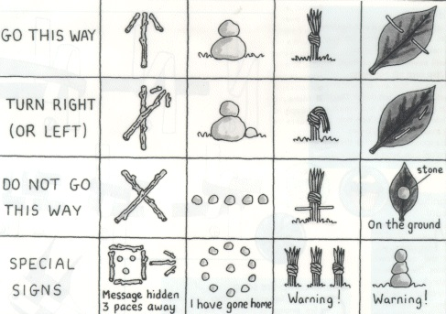

instructions for danish hearts

- Two 9" by 12" pieces differently colored construction paper
- Scissors
- Pencil
- Fold each piece of paper in half so that it measures 6" x 9" . Measure a 3" by 5" rectangle on each piece of your colored paper. Use the folded edge of the paper as one 3" side to your rectangle, so that you create two, two-layered rectangles that would be 3" by 10" if opened, one in each color. Cut out the rectangles. Do not cut through the folded edge.
- With your paper still folded, round the corners on the half of each rectangle opposite the fold, to about 1/2" in from the edge. This will leave you with two tongue shaped pieces of double-layered paper. Draw a light pencil line horizontally across the rectangle from one end of the rounded corner to the other.
- Measure and mark three equal spaces along the folded, square-cornered edge of the paper pieces with your ruler. If you cut a 3" by 5" piece, each space will be one inch wide. Use the ruler to draw a straight line from your marks to the horizontal line on the opposite side of the paper.
- Cut each line so you have three strips on each piece of paper. Unfold the paper, then refold it inside out so that the pencil marks are hidden from view.
- Hold the papers with the rounded ends next to each other, forming a heart shape. If you are using red and white papers, weave the first red strip into the middle of the first white strip. Weave the second white strip through the red strip, then the red strip through the middle of the third white strip. For the second row, alternate the weaving pattern, placing the first white strip through the middle red strip, then the red strip through the middle white strip and, finally, the last white strip through the red strip. The third row is woven exactly as the first row.
  - Cut a strip of paper to your desired handle length and glue to the inside of the heart at the top, center point. Open the heart to fill with treats or hang on your tree.
http://www.ehow.com/how_8285859_make-danish-christmas-hearts.html

BADGE ORDER FORM

Name………………………………………………………………………………………………………….
Unit …………………………………………………………….…………….……….……………………..
Address………………………………………………………………………………………………………

...............................................................................................................................................................

Postcode………………………………

Contact details. (Email or Telephone)

...............................................................................................................................................................

This form will be returned as your receipt.

I wish to order _________ badges at £1 each Total £ __________

Please make cheque payable to
202nd Liverpool Rangers

And send to:

Princess Challenge Badge
C/o 24 Boundary Drive
Crosby
Merseyside
L23 7UZ

Please send a stamped addressed envelope with your order.

Up to 10 badges - A5 envelope, large letter stamp
10 ~ 30 - A4 envelope, 2 large letter stamps

If you have any questions you can email us on
202liverpool@blueyonder.co.uk

