2012
Wednesday 17th October
Joint meeting with the Civic Soc.
‘WHOSE HERITAGE IS IT ANYWAY?’
By Doreen Grove

Wednesday 21st November
‘BERWICK’S VICTORIAN FOOD HERITAGE’
By Derek Sharman

Wednesday 12th December
‘BARMOOR CONNECTIONS’
By John Ferguson

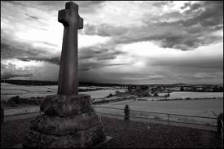
Memorial at Flodden Field

2013
Wednesday 16th January
‘THE HISTORY OF FREEMASONRY IN BERWICK’
By Steve Newman

Wednesday 20th February
‘NORTHUMBRIAN IDENTITY’
Through
MUSIC, SONG AND DANCE
By Kim Bibby-Wilson

Wednesday 20th March
‘MEDICINES FROM THE MUD’
Recent Investigations at Soutra Medieval Hospital
By Dr. Brian Moffat

Wednesday 17th April
A.G.M. at 7:00 p.m.
‘STRATEGIC DECISIONS AT FLODDEN’
By Dr Chris Burgess

