2016
Wednesday 19th October
Joint meeting with the Civic Soc.
‘Northumberland’s Forgotten Appeaser  Viscount Runciman of Duxford’s  Mission to Czechoslovakia in  1938’  By Mike Fraser | 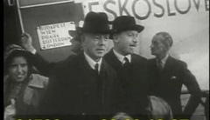  Viscount  Runciman of Doxford  1938
Wednesday 16th November
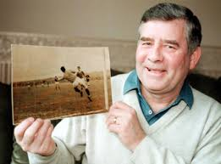  Sammy Reid Hero of ‘67 | ‘Berwick’s  Local  Sporting  Heroes’  By Henry Gray
Wednesday 21st December
‘Methodists  in  Berwick  From  Wesley to  Where?’  By Sir Alan Beith | 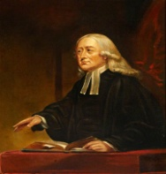John Wesley  (1703-1791)

2017
Wednesday 18th January
St.Cuthbert  c.634–687 | ‘Rediscovering Cuthbert-  The Man Behind the Saint’  By John Woodhurst
Wednesday 15th February
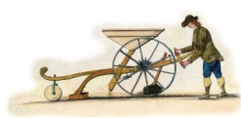  Seed Drill | ‘Northumberland’s Agricultural Revolution’  By Howard Cully
Wednesday 15th March
‘Berwick 900  &  The Our Families Project’  By Linda Bankier | 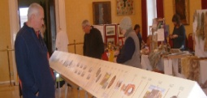  Celebrating Berwick 900
Wednesday 19th April
*A.G.M. held at 6:45 p.m.
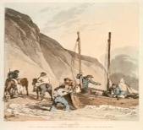  ‘Smugglers’ by  John Atkinson | ‘Smuggling on the North East of England Coast  in the  18th Century’  By Tony Barrow

