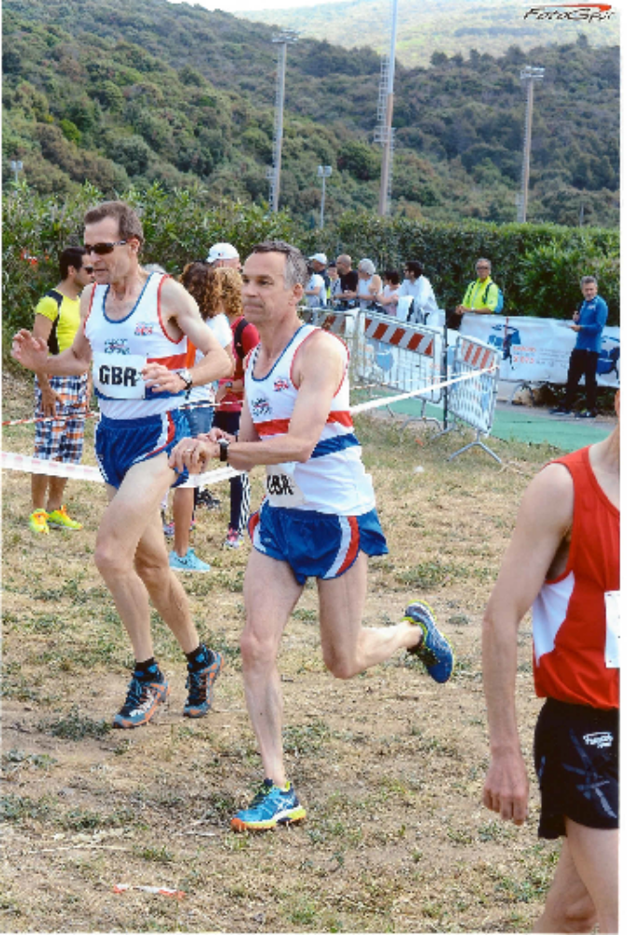
Alex Rowe handing over to Nick Tawney in the European Masters Cross Country Relay

A group of five Wesham members joined the Great Britain team in the European Masters Non-Stadia Championships last week in Grosseto in Italy. The British Masters had a small team and were up against strong opposition from the home team and as usual the Germans and Swiss. Alan Hudson however came home with two team bronze European medals for GB in the 10k and cross country relay events. On Friday in the late afternoon there were three 10km road races for different age category groups. In the M55+ race Hudson placed 74th overall, 13th M65 in a time of 44:27. He headed the team of Peter Duhig (47:03) and Alan Davidson (51:33) to fall in behind the Swiss and Italians and over 5 minutes ahead of Germany. In the same race Alex Rowe finished 8th M55 (8th in the race overall as well) with 36:37; John Collier was 14th M60 in 40:43, and Phil Leaver 24th with 46:09. Russell Mabbett running in the M35-54 race placed 54th in 47:25. The following day staged cross country relays in neighbouring Catiglione, 3 x 2km for the Over-60s and 3 x 4km for the M35-59 categories. Hudson ran second stage with Peter Duhig and Alan Davidson picking up the M65 team bronze medals with 25:17. In the second event Rowe ran first stage for the GB M55 team, with Nick Tawney and Mark Cross running a combined time of 44:37 to finish 5th. Mabbett also ran first stage for the M50 team who clocked 50:42 with Stephen Feest and Alan Roberts to come in 8th. John Collier ran the second stage for the M60 ‘A’ team 6th with 22:08 with Douglas Cowie and Alan Newman. Phil Leaver ran in the ‘B’ team with John white and David Proffitt placing 8th in 25:05. On Sunday in hot conditions the half marathon hit the city streets with a three lap course finishing in the stadium. Rowe finished 6th M55 in 1:21:20, in 53rd place overall. John Collier came in 12th M60 in 1:33:37, 144th overall, and Phil Leaver was 21st M60 with 1:49:53, 261st overall.

Rob Danson won his second Inter Club race in the series this year at the Lytham race on Thursday evening completing the 5 miles in 26:21. Karl Lee was 2nd with 27:47 as strangely Preston and Blackpool clubs failed to turn out their top runners. With James Mulvaney 5th and Steve Waterhouse 8th (27:58 and 28::39) Wesham were assured of their first overall win for some years. Competition as hotter in the women’s ranks and Catherine Carrdus lead the Wesham ladies to 3rd place with 31:48 backed up by Nicola Unsworth and Sharon Cooper. Wesham were also given the overall Masters and M50+ team wins but could not complete an M60 team with the European Masters Championships taking place in Italy.

Wesham had a good entry in the Worden Park 10k in Leyland on Sunday after it was added to the club championship for 2015. Rob Danson returned to winning ways following his triumph in the London marathon, crossing the finish line in first place after 32:49, a great performance on this undulating course. James Mulvaney was right behind giving good team support in 3rd place with 35:09. Peter Cruse was 14th and 2nd M50 in 38:53 with Garry Barnett 16th and 3rd M45 with 38:58, pushing each other to the line. Graham Cunliffe also returned to action to place 2nd M55 with 42:47 for 43rd place and the M55s were in form with George Kennedy 6th and 91st overall in 46:31. Nicola Unsworth was 12th woman and 92nd overall in 46:32, 4th W40; Alan Taylor 122nd in 49:07; Nicky Omar 173rd in 52:47. John Howorth was 6th M60 and 219th in 56:20; Dave Young 4th M65 and 259th with 60:33.

Simon Eaton was the only Wesham runner in the Brathay Marathon on Sunday, clocking 3:26:59 over the undulating 26.2 miles and finishing 77th overall, 13th M40, a very creditable performance. In previous years there have been several Wesham runners in this race but this year the London Marathon has taken precedence.

Mick Edge finished 11th in the Keswick Mountain Festival Trail 10k, an event incorporated into a weekend outdoor festival encompassing many sporting activities. The 10 trail event was one of many running competitions and was set off in waves with Mick heading Wave 2 with a time of 50:20.

