Wesham Road Runners & AC

Beginners Group Information Pack
A 12 week course, starting on Wednesday 18th January.
Ending with an optional 5km race at Lytham Hall Parkrun.
The course is for complete novices and aimed at anybody aged over 18.
Main Session
We’ll be meeting at Kirkham & Wesham Cricket Club every Wednesday at 6.20pm for a 6.30pm start.
There will be a UKA level 1 coach in charge of the session with other members of the running club assisting and providing encouragement.

Other Sessions
We recommend going out for 2 extra sessions as well as the main Wednesday evening session, this will help improve your fitness and stamina. It’s always easier to run with a group and for that reason, we recommend using our public Facebook page to contact each other, give and receive encouragement to others taking part on the course and arrange with others where and when to meet and go for a run. Other members of the club often go out in smaller groups throughout the week and you’re also welcome to join them as and when you feel comfortable / able to do so.
https://www.facebook.com/WeshamRoadRunners/?fref=ts

Warm Up
Before you begin a session, you need to warm up. The warm up lasts for 5 minutes and includes skipping, high knees, heel flicks, and swinging arms side to side. This increases the heart rate and warms up the muscles and surrounding tissues and prepares your body for the coming session.

Cool Down
A cool down is important after each session. It contains static stretches which allows your heart rate to slowly come down and your muscles relax. It also aids the dissipation of waste products including Lactic Acid. Each static stretch should last approx 10-15 seconds.

Weekly Plan

Week | Main Session | 2nd Session | 3rd Session
1 | 5 x 1 minute running, 90 seconds recovery | 5 x 1 minute running, 90 seconds recovery
2 | 3 x 2 minutes running, 2 minutes recovery | 2 x 3 minutes running, 2 minutes recovery
3 | 2 x 4 minutes running, 3 minutes recovery | 1 x 5 minutes running | 1 x 5 minutes running
4 | 2 x 5 minutes running, 3 minutes recovery | 1 x 7 minutes running | 2 x 5 minutes running, 3 minutes recovery
5 | 2 x 2 minutes running, 90 seconds recovery  1 x 10 minutes running | 1 x 8 minutes running | 1 x 12 minutes running
6 | 2 x 3 minutes running, 2 minutes recovery  1 x 12 minutes running | 1 x 10 minutes running | 1 x 14 minutes running
7 | 2 x 2 minutes running, 2 minutes recovery  1 x 15 min | 1 x 15 minutes running | 1 x 18 minutes running
8 | 5 x 1 minute running, 1 minutes recovery  1 x 20 minutes running | 1 x 15 minutes running | 1 x 22 minutes running
9 | 1 x 25 minutes running | 2 x 10 minutes running, 3 minutes recovery | 1 x 20 minutes running
10 | 1 x 30 minutes running | 2 x 12 minutes running, 3 minutes recovery | 1 x 25 minutes running
11 | 1 x 35 minutes running | 1 x 15 minutes running | 1 x 15 minutes running
12 | 1 x 30 minutes running | REST | 5K Race – Lytham Parkrun

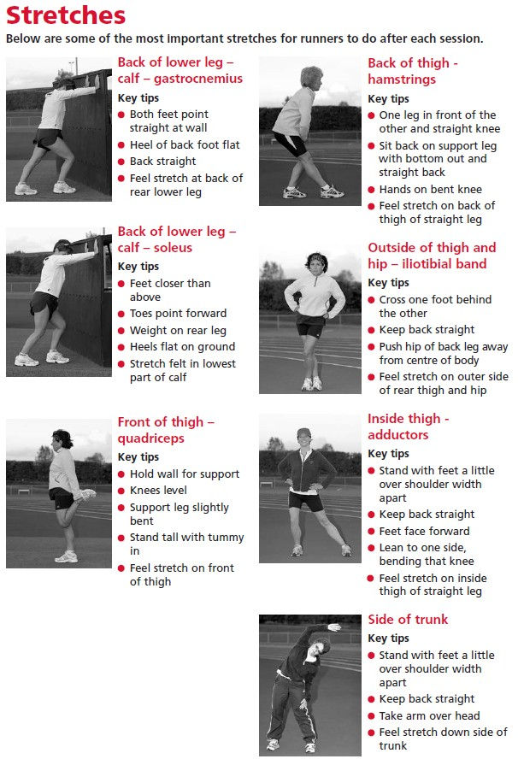

Frequently Asked Questions

Why run?
- Running, especially recreational running is very much a mixed, varied and inclusive sport as well as a family sport.
- Anyone with the inclination can run and all abilities can join in together. Look at any Fun Run.
- Age isn’t a barrier, fitness isn’t a barrier and with guidance health issues rarely present a barrier. Check out the British Heart Transplant Games.
- Running is recognised as one of the best sports for managing weight and aiding weight loss. Running burns around 100 kcal per mile so if you start running and eat sensibly you will see a change in shape and size.
- Benefits also include improved heart and lung function, reduced blood pressure, stress reduction, reduced risk of some cancers and an aid to prevention of osteoporosis in some bones.

What are the advantages of joining a club or group?
- Safety!
- The right advice: pace, effort, distance, stretching, avoiding injury
- Access to events, coaching and governing body affiliation
- Friends to run with at other times
- A social group

Isn’t running expensive?
- Running is cheap compared to the great majority of sports or other forms of exercise.
- You can run any time anywhere for no extra cost.

When shouldn’t I run?
- If you have any pain that continues or worsens as you run
- If you have a temperature
- If you are unusually tired
Most early injury niggles resolve quickly without intervention with rest from running and a gentle stretch of the area perhaps with a 10 min ice treatment three times a day over the first 72 hours. Those that persist or worsen should be assessed by an appropriate professional, a physiotherapist, sports therapist, osteopath etc. Your GP will be able to refer you to a professional if you don’t know of one.

Is running bad for your joints?
There is no supporting evidence to suggest that running specifically is injurious to your joints but if you have a pre-existing condition then take your GP’s advice before starting a running programme. Running is so adaptable in terms of effort, pace, surfaces and distance that many people will find they can still participate.

Do I need to do anything before or after I run? Always
- Warm up…before you put in any effort.
- Walk, jog, skip, circle arms, feel your heart rate increase and your body temperature rise. If you are planning to run quickly then use some short quicker strides (short bursts of faster running for 10-20 seconds) at the end of your warm up. Be prepared for what you intend to do
- Stretch….after you run.
- Stretch the main muscles you used in your session.

Eat

- Running needs fuel. Don’t expect to run well on an empty tank.
- Regular meals based around good carbohydrate foods like pasta, rice, potato, fruit and veg.

  - Fish and lean meats.
  - Ensure you have a snack about an hour before exercise; a piece of fruit, a yoghurt, a cereal bar, some dried fruit for example

Rest and Recover
  - Between sessions you will gain most benefit from your training effort if you recover well. The body adapts to the new stress you have introduced when it has a chance to rest. You will then reap the reward of training and not the demoralisation of injury

What to wear
Ladies: Ensure you have a well supporting bra designed for running. You don’t have to spend the earth, many stores have a good range at sensible prices and a good sports bra will be a good investment regardless of whether you get the running bug.
Everyone: Any comfortable shorts, T-shirt or top will do until you spot the real gear beckoning from the sports rails.

Dress for the weather: Check out the local weather forecast and be prepared with layers including a light wind/water proof

Wear Appropriate Kit
Winter: Layering is the key because as you warm up, you can remove layers. Do consider how you can carry them however; a long sleeved tee can be tied around the waist, gloves tucked into your waist band. Consider the design of your kit, some jackets come with removable arms which can be stowed in your pockets or alternatively the whole thing can fold up small and fit into a bumbag. Buy running kit made of breathable fabrics. Don’t let the rain put you off, your skin is after all water proof! Invest in a jacket which is at least shower proof and preferably water proof, to keep the worst off. A baseball cap will keep water out of your eyes.
Summer: In the summer you will need light and airy clothes. A wicking T-shirt or vest will help to keep you cool in the midday sun. You can also get cool packs which sit around the neck to help keep your temperature down! Most important wear sun block! A pair of shorts will also help to keep the temperature down and keep you cool. Also sunglasses are an essential to protect your eyes and even more so keep the wrinkles at bay! All year around!

Running Shoes
Running shoes are specific to running. They have two main functions: cushioning and guidance.

Feet differ. Take your trainers to your nearest specialist shop and get the right advice from the outset. You may save a lot of injury time, and money!

For any runner the most important part of their running kit is what they wear on their feet. Running shoes have evolved over the years and are specifically designed for the task, protecting your feet from the hammering and twisting forces they get as they hit the ground. Just as you wouldn’t play tennis with a cricket bat, you shouldn’t wear a general sports shoe once you start to run more consistently.
For women it is important to try and get a women’s specific trainer as these are made on a last that is appropriate to their different foot shape.
Activate at Ribby Hall will do a gait analysis and advise you on the right type of trainers free of charge. http://www.ribbyhall.co.uk/eat-drink-play-shop/activate-sports-store

You will come across a lot of jargon such as:
- Pronation
- Over-pronation
- Supination (or more correctly under-pronation)
- Neutral

You will also come across a number of different running shoes:
  - Neutral
  - Support
  - Motion-Control
  - Trail shoes are also available for off road running.

Safety

We should all take responsibility for own safety when we go out running and most of this is just plain common sense. The following suggestions may just make a difference:
  - Best of all, run with a friend! If going alone, text a friend your route and time
  - Carry a mobile phone and/or money for a call box
  - Don't wear headphones. lf you're wearing headphones you won't hear what's going on around you. These days it's common to share paths with cyclists who may approach you quietly from behind
  - During the day time wear light or fluorescent clothing so that other road users can see you. At night, wear reflective clothing or at least clothing that has reflective strips incorporated. Headlights can make out reflective clothing up to three times further away than non-reflective materials. Pale clothing will also help you to be seen but fluorescent clothing needs daylight to be really effective
  - Run facing the traffic if there is no pavement. However if you're approaching a blind corner cross over to the other side when it is safe to do so. Cars will then be able to see you more clearly
  - Be aware of your surroundings, so you can evade or avoid anything you’re not comfortable with – people, dogs, cars etc
  - Run in well-populated, lit areas if you are by yourself
  - Vary your route and the times you run. Apart from anything else it could get boring!
  - Carry a tag card with your name and emergency contact details. lf the worst should happen, you can be identified and friends or family notified

Cross Training

Cross Training can help to make you stronger overall and particularly for running. Cross training will certainly help develop your core strength.
What is your core?
Your core is the middle bit of your body including your trunk and pelvis. This is supported and stabilised by specific muscles. If those muscles are weak and don’t do the job properly then other muscles have to step in. These muscles aren’t designed to do the job so can be left short or tight, or pulling the body out of alignment.

Reasons for Cross Training:
  - Extra training without the load
  - Develops strength
  - Makes your core muscles stronger which are essential when running
  - Injury prevention

Examples of Cross Training:
  - Yoga : This refers to the practice of physical postures or poses. It helps to mentally calm and develop inner strength particularly of the core muscles.
  - Pilates: This focuses on the core postural muscles which help keep the body balanced and which are essential to provide support for the spine. In particular, Pilates exercises teach awareness of breath and alignment of the spine and aim to strengthen the deep torso muscles.
  - Gym: The gym can be used as a great additional session to develop strength particularly of the legs and overall core stability. If you are injured the gym is the best possible place for you.
  - Fitness classes: Examples include aerobics, step, body pump, dance and many others. These are a great additional session you can build into your weekly workouts.
  - Cycling: Less weight bearing than running, cycling could substitute running in cases of injury and also help as an extra session in the early days when you are still building up the amount of runs you can do it in the week. Cycling can also be good when recovering from a run. If you don’t like roads try the gym or off road.
  - Swimming: Great for flexibility and recovery from pounding.

Eating and Drinking

Running is one of the best forms of exercise for weight management. Have a think…would you rather be lighter on the scales or a smaller clothes size?
Most people will say the latter. Appearances are usually a higher priority! As you train, you develop more muscle tissue that weighs more than fat tissue. So you may see a small weight increase in the early days, but along with this a shift in body shape and tone, as the balance shifts towards more lean body tissue. The lean tissue uses fuel so this will help use up excess calories!

Understanding what we eat:
  - Look out for hidden fats in meats, biscuits, cakes, pastries and many processed and packaged foods
  - Start to look at food labels and identify any obvious and regular pitfalls
  - Even if weight change is not an issue, exchanging some of those fats for carbohydrates will improve your energy levels and your vitamin and mineral intake
  - Look at distribution of food through the day – try and spread your food over 6 smaller meals. This will maximise efficient storage of food.

How can you tell if you’re getting it right?
Most importantly is how you feel. If you feel well generally, healthy and full of energy most of the time then the chances are you are getting it approximately right for your needs.

Avoiding Injury

Injuries happen and whilst there is no magic formula for avoiding them, a greater understanding of some of the pitfalls may just be enough to keep you on your feet.
Poor running style
We might aspire to perfection but in reality most of us need to adopt a style that feels natural and doesn’t leave us open to a higher risk of injury. Try “running tall” and your head will lift and spine lengthen. Add to that relaxed arms and shoulders and you’re half way there. Push your chest up and forwards, try to keep your pelvis level (imagine it’s a bucket full of water that you don’t want to spill) and keep your bum and tummy tucked in.

What are you running in?
Are your wearing running shoes as opposed to fashion trainers? Are your shoes suitable for your gait (the way you run)? Do they fit? Are they suitable for the surface you run on? Are they worn out?

Go to a specialist running shop to get advice.

Don’t do too much, too soon.
If you want to avoid injury, then patience really is a virtue. Don’t increase your weekly mileage by more than 3 or 4 miles a week (less if you are a beginner). A general rule of thumb is to increase it by no more than 10% each week.

Insufficient Strength
You’ve probably heard of core stability but what’s it got to do with running? Your core is the middle bit of your body including your trunk and pelvis. This is supported and stabilised by specific muscles. If those muscles are weak and don’t do their job properly then other muscles have to step in. These other muscles are not designed to do the job, so can be left short or tight, pulling the body out of alignment and therefore leaving you more susceptible to injury. Work on your core stability and this is less likely to be a problem.

The Joys of Events
Events can be very special, and the best way to make them that way is to run with others!

Why events?
Events provide a challenge if you want it and give you a chance to have a goal to keep you going. Many new runners find that by having a target event, it will help to keep them motivated.
What better reason to run than for charity? A questionnaire in 2008 showed that one of the main reasons beginners run is for charity. Having that extra commitment helps with dedication to your running and gives you that little more incentive.

How do I enter events?
The following sites list local events and allow you to book online.
  - http://bookitzone.com/
  - http://ukroadraces.info/
  - http://www.runningdiary.co.uk/
  - http://www.ukforms.net/
  - http://www.ukresults.net/

