Alternative Routes
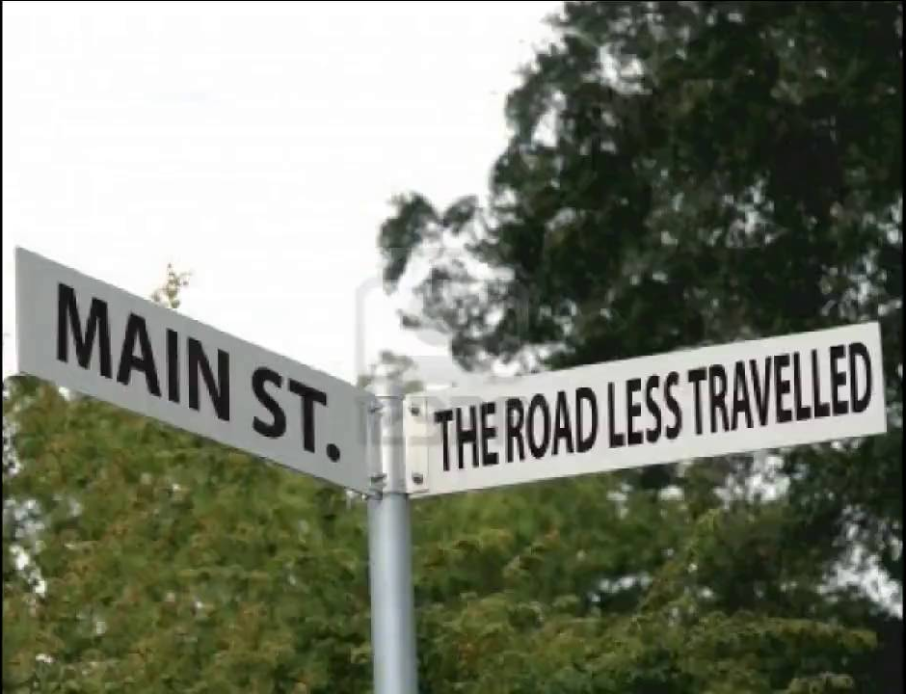
Different Ways into the World of Work

Calling all Secondary Pupils to ENGAGE with the questions of Career Choice and Career Path. Especially for those who might want to do things a little differently.

- WHEN? 24 January 2017, from 6:30 to 8 p.m.
- WHERE? Best Western Braids Hill Hotel, 134 Braid Road
- WHO? Avril Mahon, Founder & Director, Women Run Strong
Harris Cains, Business Development Manager, RF Com Ltd
Dr James Howie, Director, ASCUS Art & Science Lab
Mark Kerr, Co-Owner, The Canny Man’s
Caitlin & Hannah Matheson, Co-Owners, SisCo
Hair & Nail Salon
- HOW MUCH? £5 per family, at the door. Places limited so please register
in advance at engage@boroughmuir.org

‘ENGAGE’—A Boroughmuir Parent Council Initiative Connecting Pupils to Professionals
Also open to pupils from James Gillespie’s and George Watson’s schools

